Supplementary material 16. Flux distribution related to succinic acid production in wild type Mannheimia succiniciproducens (A) and its pckA mutant (B) in complex media. The solid arrows indicate active reactions and thickness of the arrows is proportional to the corresponding flux value. For example, the succinic acid production rates are 13.32 mmol∙g DW⁻¹∙h⁻¹ (A) and 0.005 mmol∙g DW⁻¹∙h⁻¹ (B), respectively. Dashed arrows indicate inactive reactions under the optimal growth condition.

(A)
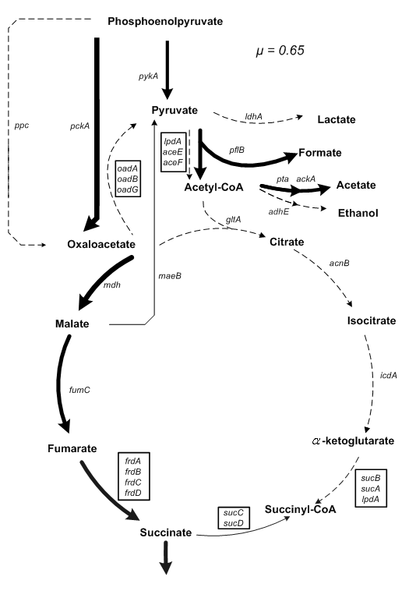
(B)
