Supplementary material 4. Reannotation of Mannheimia succiniciproducens and phylogenetic relationships.

Reannotation result of M. succiniciproducens

Annotation results using the recent version of reference databases were slightly different from the previous results of gene function assignment. Selection of the putative role of each open reading frame was mainly based on the calculation of the best hits obtained from the Basic Local Alignment Search Tool (BLAST) sequence analysis. The numbers of the genes which matched to genes of specific organisms are listed in Table S4-1. The best hits of the genes were classified into groups to compare the trend of matches between the original and updated annotation results. 17 new ones were added to the list of organisms and 5 species were eliminated from the list. Newly added species include Cac (Clostridium acetobutylicum), Rso (Ralstonia solanacearum), Sme (Sinorhizobium meliloti), Sty (Salmonella typhimurium) and Ype (Yersinia pestis) etc. The species including Buc (Buchnera sp.), Hal (Halobacterium sp.), Hpy (Helicobacter pylori), Pab (Pyrococcus abyssi) and Rpr (Rickettsia prowazekii) had only 1 or 2 best hits. The increase in the number of species led to the decrease in the number of best hits in several species. They include Bha (Bacillus halodurans), Bsu (Bacillus subtilis), Eco (E. coli K-12), EcZ (E. coli O157:H7 EDL933), Pae (Pseudomonas aeruginosa) and Man-S (Mannheimia-specific, no homology). It can be inferred from the results that phylogenetically close species were included and distant species were eliminated from the list of best hits as the COG was expanded. Especially, the specific functions could be assigned to many genes previously identified as Man-S (species-specific ones). 13% of the no-homology genes were assigned to specified functions (Fig. S4-1). The number of genes that is related to a specific organism was calculated from the annotation table (Fig. S4-1A). The numbers of matched orthologs based on the original and updated annotation results are shown in Figure S4-1B.

(A)
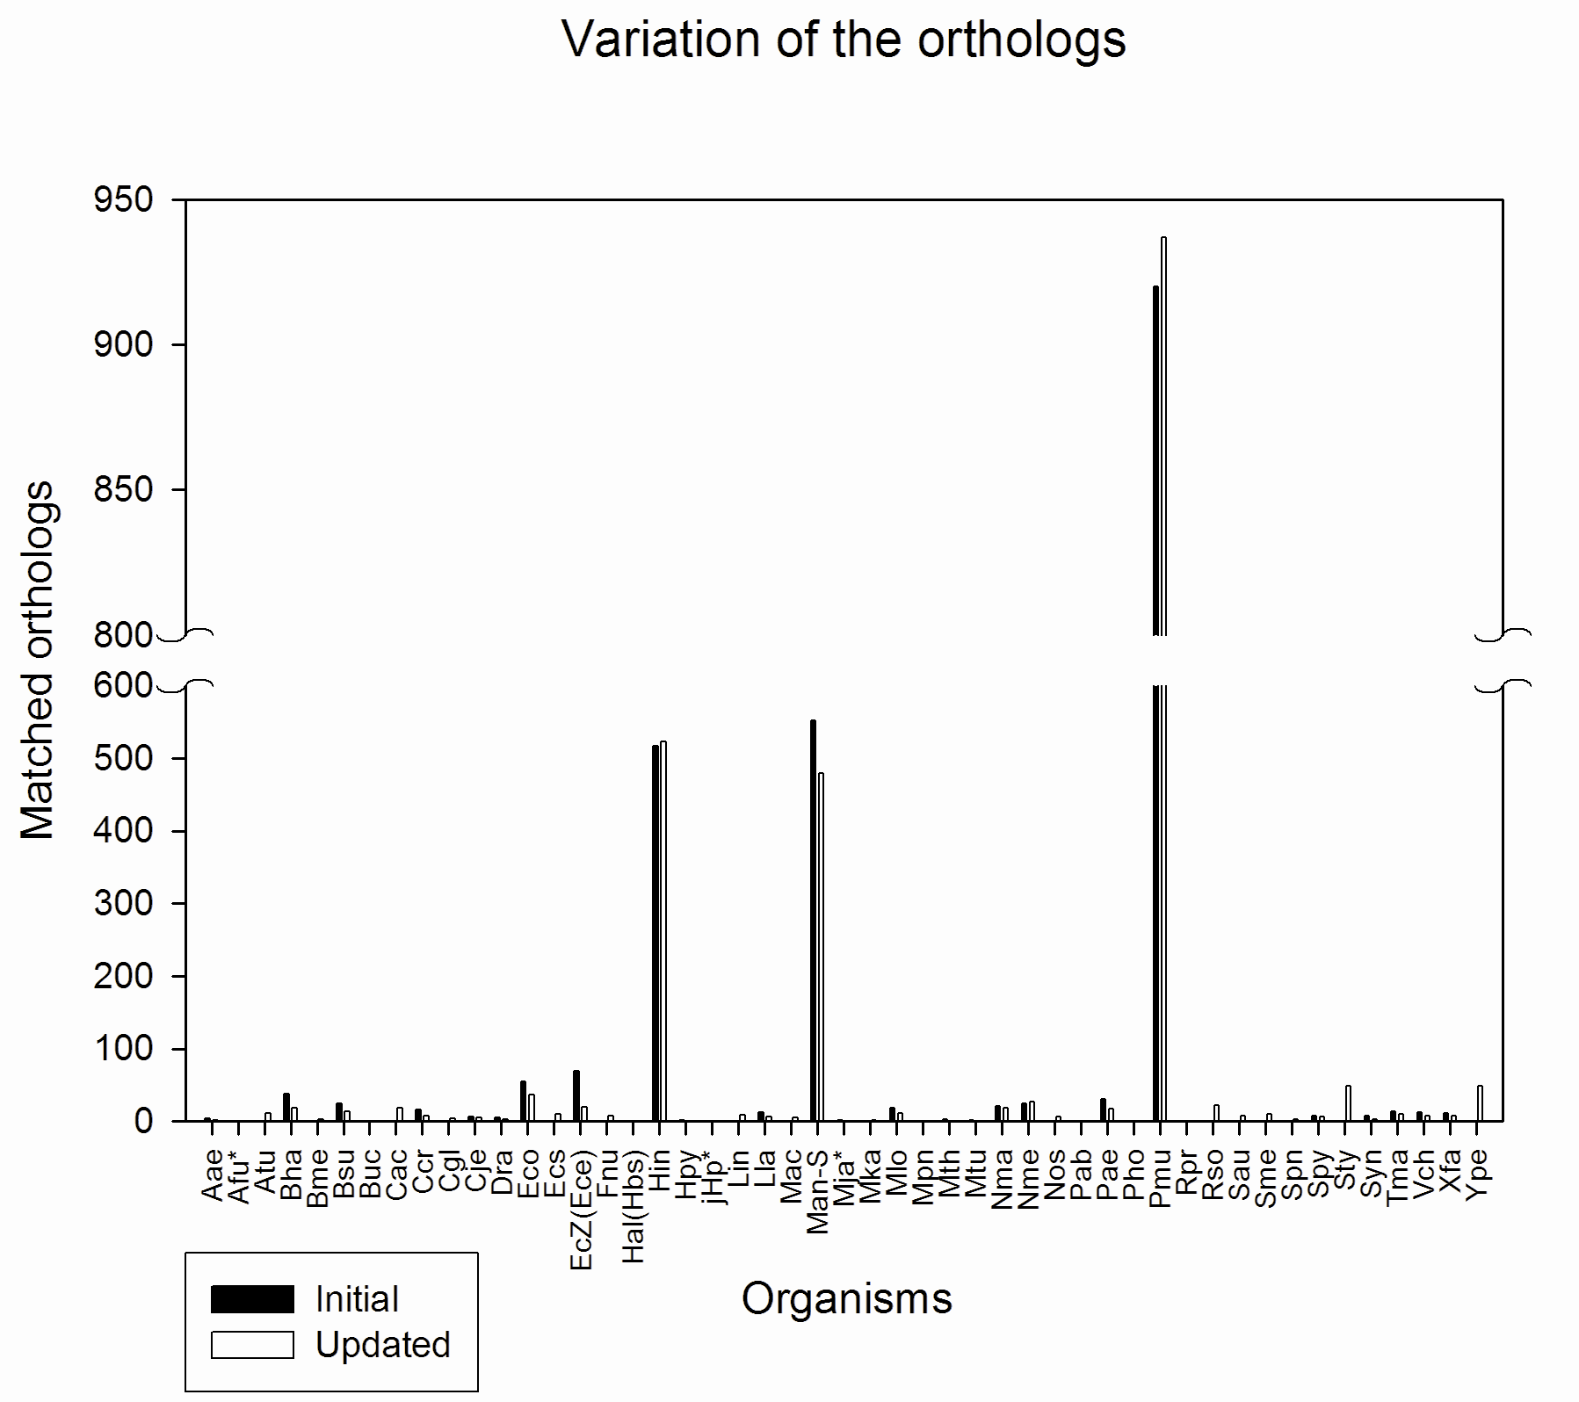
(B)

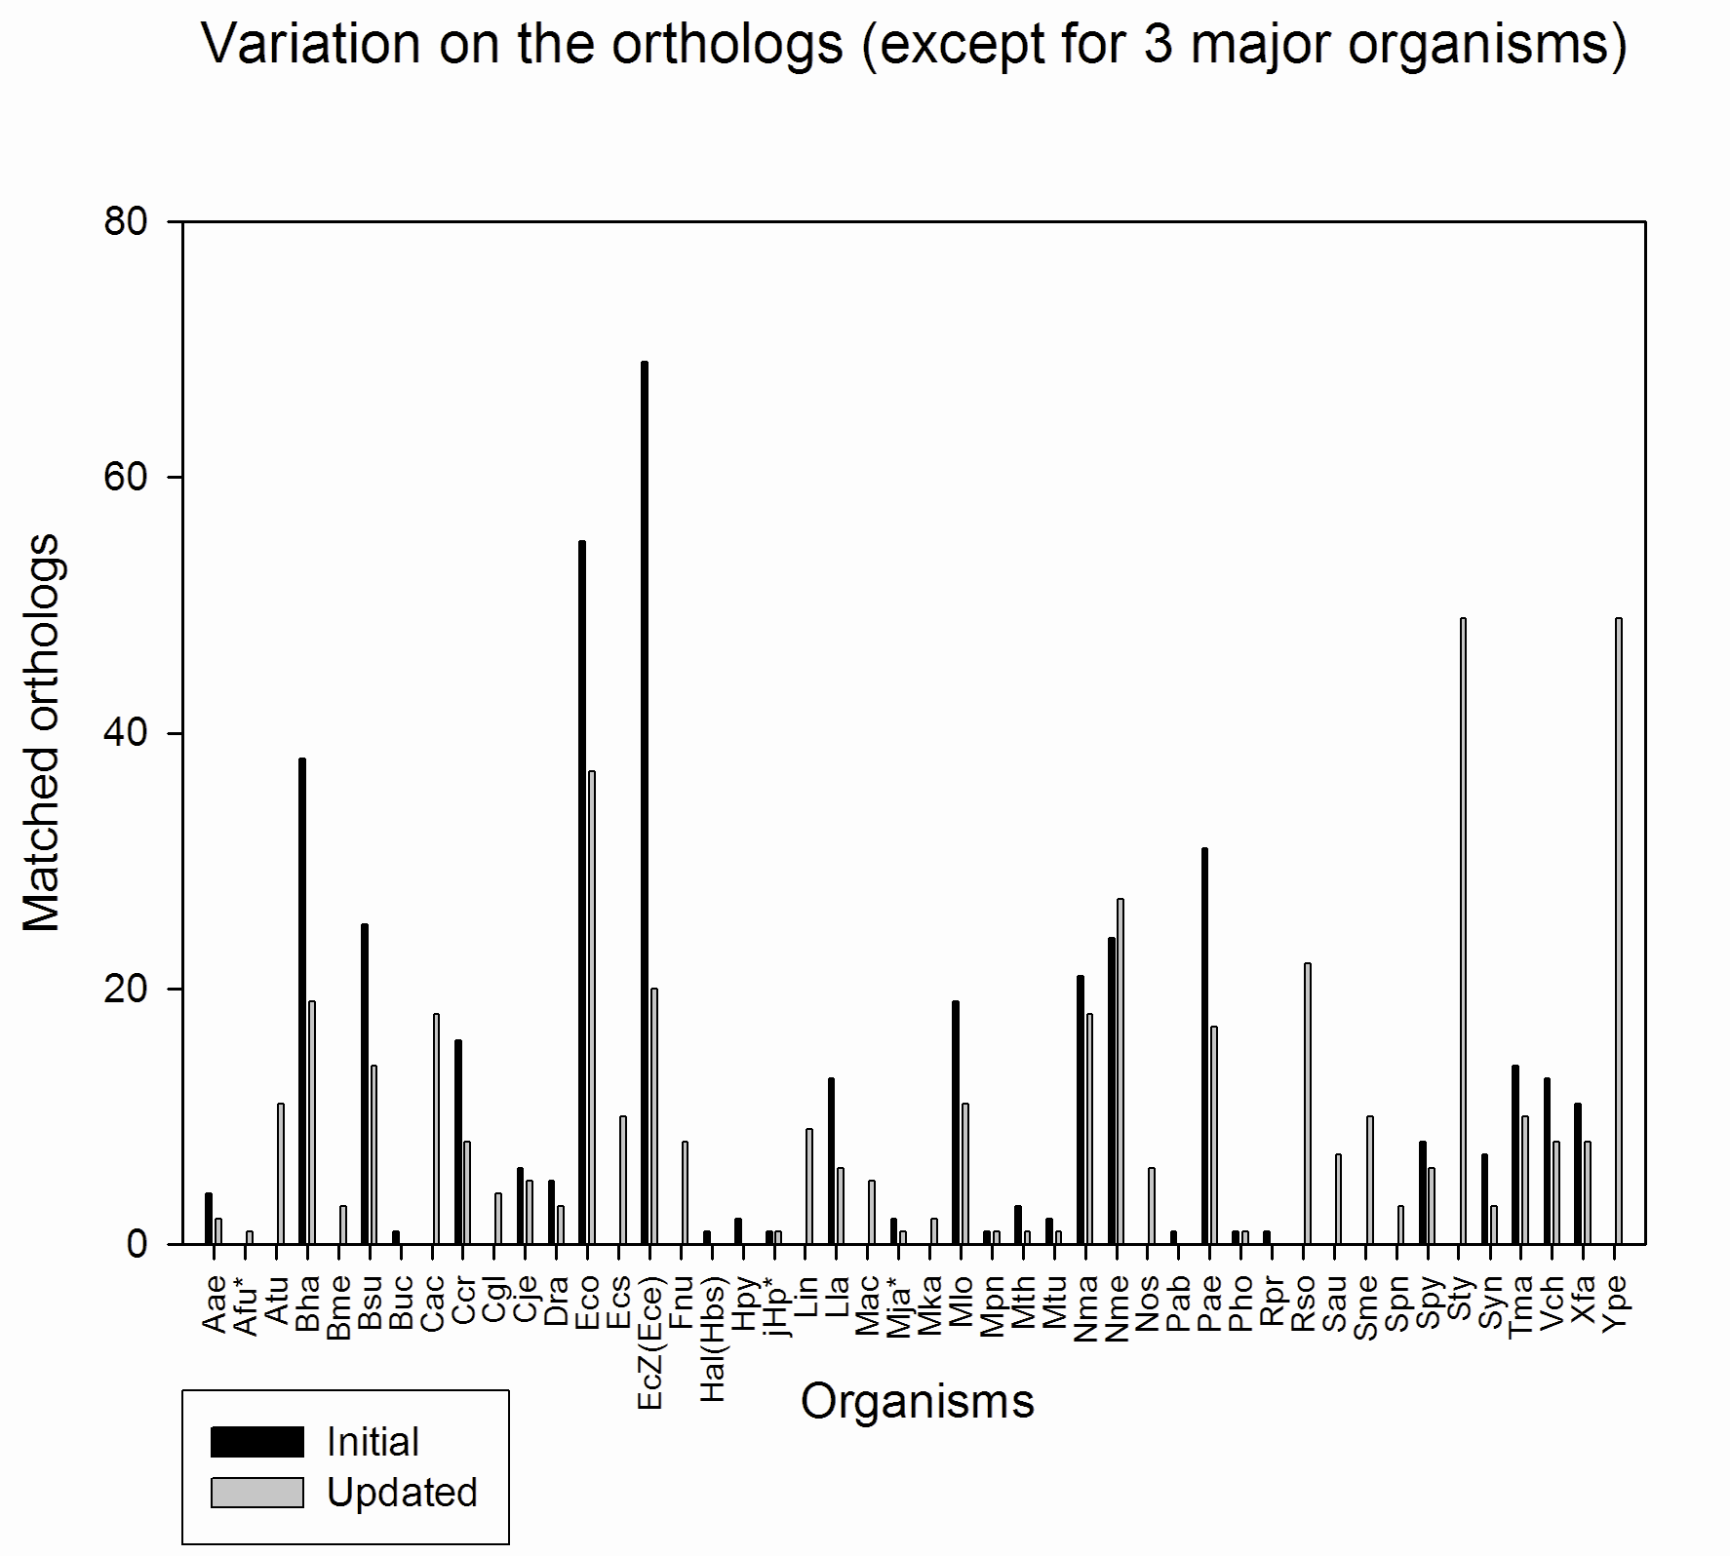

Figure S4-1. The matched orthologs according to the organisms based on old and updated databases

Phylogenetic relationships

The 16S rRNA sequences of the 48 organisms were clustered using ClustalX software. As a result of applying neighbor-joining algorithm, the distances among the branches and the bootstrap values were obtained (Fig. S4-2). The changes in the number of genes involved in the best hits in the BLASTP homology analysis were represented (Fig. S4-2A). The upward and downward arrows indicate the region of increase and decrease, respectively, in the number of genes matched to the specific organisms. The degree of increase or decrease was expressed by the darkness of the colors. As the color approaches to red through yellow, the degree of increase becomes larger. On the contrary, the degree of decrease becomes larger for the color being closer to blue through green. This result suggested that the new annotation results became more resonable because the more homologous genes were found in the species that are more closely related to M. succiniciproducens.
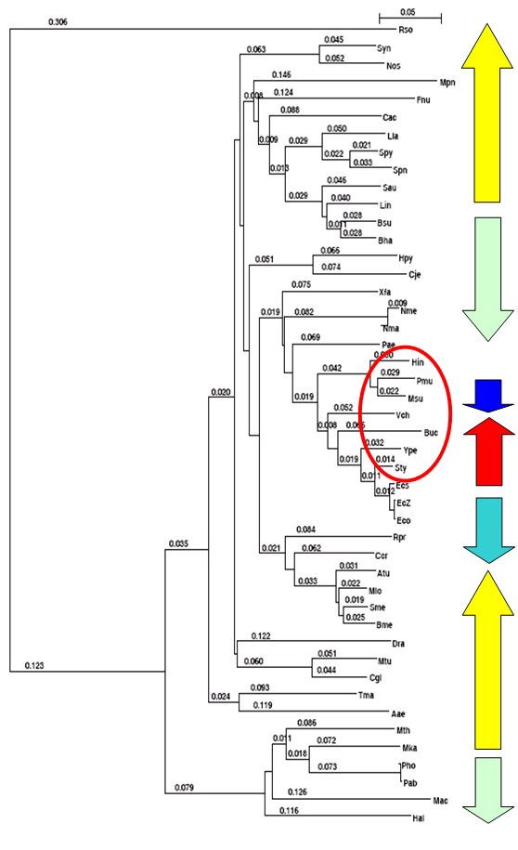
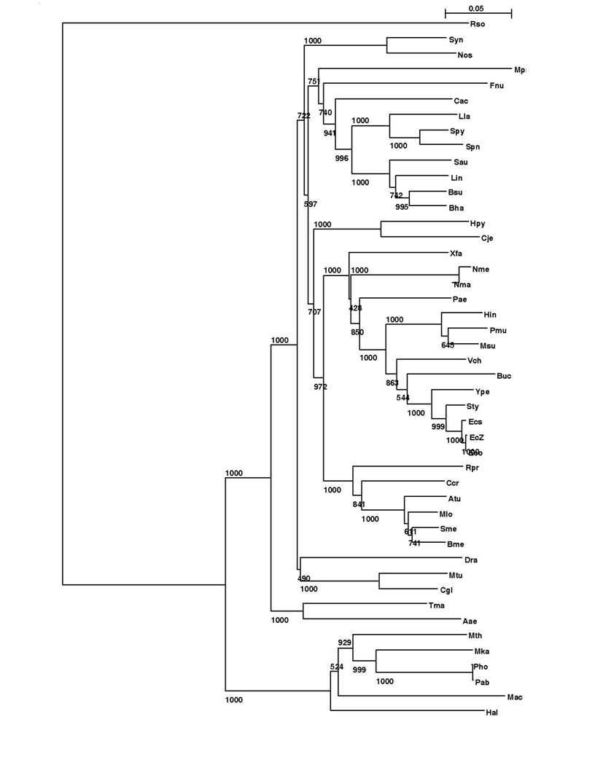
(A) (B)

Figure S4-2. Phylogenetic relationships of the organisms that are involved in the best hits of the genes of M. succiniciproducens (A) distance (B) bootstrap value.

Table S4-1. Summary of the changes of annotation - number of best hits based on the organisms.
Abbr. | Organism (Full name) | Newª | Old^{b} | Diff.^{c}
Aae | Aquifex aeolicus | 2 | 4 | -2
Afu* | Archaeoglobus fulgidus | 1 | 0 | 1
Atu | Agrobacterium tumefaciens strain C58 (Cereon) | 11 | 0 | 11
Bha | Bacillus halodurans C-125 | 19 | 38 | -19
Bme | Brucella melitensis | 3 | 0 | 3
Bsu | Bacillus subtilis 168 | 14 | 25 | -11
Buc | Buchnera sp. APS | 0 | 1 | -1
Cac | Clostridium acetobutylicum | 18 | 0 | -8
Ccr | Caulobacter crescentus | 8 | 16 | -8
Cgl | Corynebacterium glutamicum | 4 | 0 | 4
Cje | Campylobacter jejuni NCTC11168 | 5 | 6 | -1
Dra | Deinococcus radiodurans R1 | 3 | 5 | -2
Eco | Escherichia coli K-12 MG1655 | 37 | 55 | -18
Ecs | Escherichia coli O157:H7 | 10 | 0 | 10
EcZ(Ece) | Escherichia coli O157:H7 EDL933 | 20 | 69 | -49
Fnu | Fusobacterium nucleatum | 8 | 0 | 8
Hal(Hbs) | Halobacterium sp. NRC-1 | 0 | 1 | -1
Hin | Haemophilus influenzae Rd | 523 | 517 | 6
Hpy | Helicobacter pylori 26695 | 0 | 2 | -2
jHp* | Helicobacter pylori J99 | 1 | 1 | 0
Lin | Listeria innocua | 9 | 0 | 9
Lla | Lactococcus lactis IL1403 | 6 | 13 | -7
Mac | Methanosarcina acetivorans str. C2A | 5 | 0 | 5
Man-S | No homology | 479 | 552 | -73
Mja* | Methanococcus jannaschii DSM2661 | 1 | 2 | -1
Mka | Methanopyrus kandleri AV19 | 2 | 0 | 2
Mlo | Mesorhizobium loti MAFF303099 | 11 | 19 | -8
Mpn | Mycoplasma pneumoniae M129 | 1 | 1 | 0
Mth | Methanobacterium thermoautotrophicum deltaH | 1 | 3 | -2
Mtu | Mycobacterium tuberculosis H37Rv (lab strain) | 1 | 2 | -1
Nma | Neisseria meningitidis Z2491 (serogroup A) | 18 | 21 | -3
Nme | Neisseria meningitidis MC58 (serogroup B) | 27 | 24 | 3
Nos | Nostoc sp. PCC 7120 | 6 | 0 | 6
Pab | Pyrococcus abyssi | 0 | 1 | -1
Pae | Pseudomonas aeruginosa PA01 | 17 | 31 | -14
Pho | Pyrococcus horikoshii OT3 | 1 | 1 | 0
Pmu | Pasteurella multocida PM70 | 937 | 920 | 17
Rpr | Rickettsia prowazekii Madrid E | 0 | 1 | -1
Rso | Ralstonia solanacearum | 22 | 0 | 22
Sau | Staphylococcus aureus N315 | 7 | 0 | 7
Sme | Sinorhizobium meliloti | 10 | 0 | 10
Spn | Streptococcus pneumoniae TIGR4 | 3 | 0 | 3
Spy | Streptococcus pyogenes M1 | 6 | 8 | -2
Sty | Salmonella typhimurium LT2 | 49 | 0 | 49
Syn | Synechocystis sp. PCC6803 | 3 | 7 | -4
Tma | Thermotoga maritima MSB8 | 10 | 14 | -4
Vch | Vibrio cholerae El Tor N16961 (serotype O1) | 8 | 13 | -5
Xfa | Xylella fastidiosa 9a5c | 8 | 11 | -3
Ype | Yersinia pestis | 49 | 0 | 49
Total |  | 2384 | 2384 | 0
ªNumber of best hits obtained using the updated version of COG database.
^{b}Number of best hits obtained using the initial version of COG database.
^{c}Changes in the number of best hits between the initial and updated version of COG databases.
*16S rRNAs were not found.

