Supplementary material 9. PTS/glucokinase assay of Mannheimia succiniciproducens MBEL55E.

In order to identify whether M. succiniciproducens MBEL55E utilizes phosphotransferase (PTS) system as a major glucose uptake system, we performed two different sets of the following ¹⁴C-labeled glucose phosphorylation assays. In this experiment, we employed E. coli W3110 as a control, which is well known for its PTS-glucose uptake system.

1. First assay is to identify the concentration of proteins from the crude extract suitable for the assay. In this experiment, the crude extracts containing 0, 50 or 100 μg of proteins was added into the solution containing 10 mM of ¹⁴C-labeled glucose, reaction buffer, and 10 mM of ATP or phosphoenolpyruvate (PEP). According to the results (Table S9-1), the radioactivity of the labeled glucose 6-phosphate increased as the protein concentration increased from 50 to 100 μg in E. coli, indicating that the corresponding enzyme activity of the transporter increased. However, M. succiniciproducens showed not much increase under the same condition. Based on such notable differences detected between these organisms, we postulated that the concentration of proteins from crude extract that is a little bit higher than their concentrations used in this assay would be suitable for glucose phosphorylation assays, which is 200 μg. We used this value throughout the following assays.

Table S9-1. PTS/glucokinase assay with cell crude extract between M. succiniciproducens MBEL55E and E. coli W3110 depending on protein concentration of crude extract.
Strains | Substrate (10mM) | Protein from crude extract(µg) | Radioactivity (cpm)
Strains | Substrate (10mM) | Protein from crude extract(µg) | Elute | Increment
E. coli W3110 | – | 50 | 14,282
E. coli W3110 | – | 100 | 28,246 | 13,964
E. coli W3110 | PEP | 50 | 17,637
E. coli W3110 | PEP | 100 | 62,335 | 44,698
E. coli W3110 | ATP | 50 | 182,572
E. coli W3110 | ATP | 100 | 297,705 | 115,133
M. succiniciproducens MBEL55E | – | 50 | 2,278
M. succiniciproducens MBEL55E | – | 100 | 2,338 | 60
M. succiniciproducens MBEL55E | PEP | 50 | 2,117
M. succiniciproducens MBEL55E | PEP | 100 | 3,254 | 1,137
M. succiniciproducens MBEL55E | ATP | 50 | 225,631
M. succiniciproducens MBEL55E | ATP | 100 | 356,207 | 130,576
Control |  | – | 2,516
2. With the determined concentration of proteins from crude extract (200 μg), we investigated the substrate-dependency of enzyme activity on PEP and ATP in order to deduce the type of the transporter in M. succiniciproducens ; this was done by referring to the correlation between the substrate (PEP and ATP) concentration and the radioactivity of the glucose phosphorylated (¹⁴C-labeled glucose 6-phosphate). In the experiment, we separately added 0.1, 0.5, 1.0 or 10.0 mM of PEP or ATP into the solution containing 10 mM ¹⁴C-labeled glucose, 200 μg proteins from crude extract, and reaction buffer. We, then, measured the radioactivity of ¹⁴C-labeled glucose 6-phosphate after adding it into the solution. Results (Fig. S9-1) clearly showed that the radioactivity of ¹⁴C-labeled glucose 6-phosphate drastically increased with the increment of PEP concentration in E. coli whereas such correlation is not observed in M. succiniciproducens. On the other hand, M. succiniciproducens showed drastically increased radioactivity with the increment of ATP concentration.

Based on these results, we concluded that M. succiniciproducens does not use to PTS system for the glucose uptake. Moreover, the resulting ¹⁴C-labeled glucose 6-phosphate was postulated to be catalyzed by glucokinase-type of enzyme that is not identified yet: Glucose + ATP → Glucose 6-phosphate + ADP.

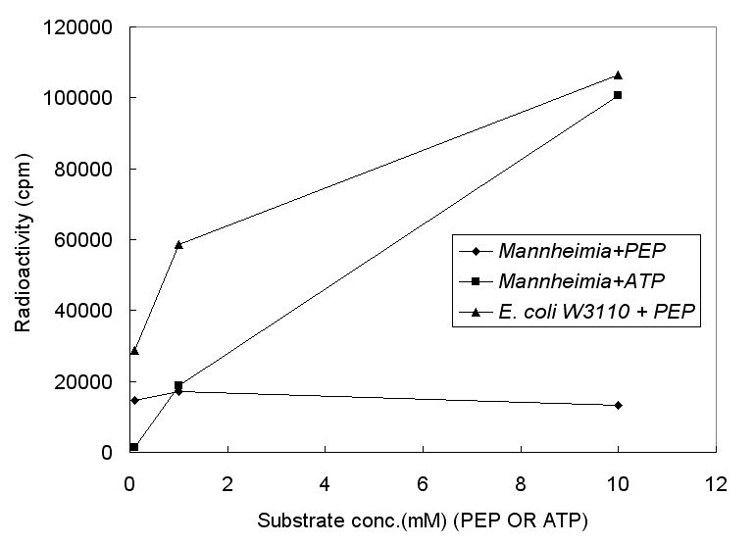
Figure S9-1. The activities of glucose transport system in M. succiniciproducens MBEL55E and E. coli W3110.

