Supplementary material

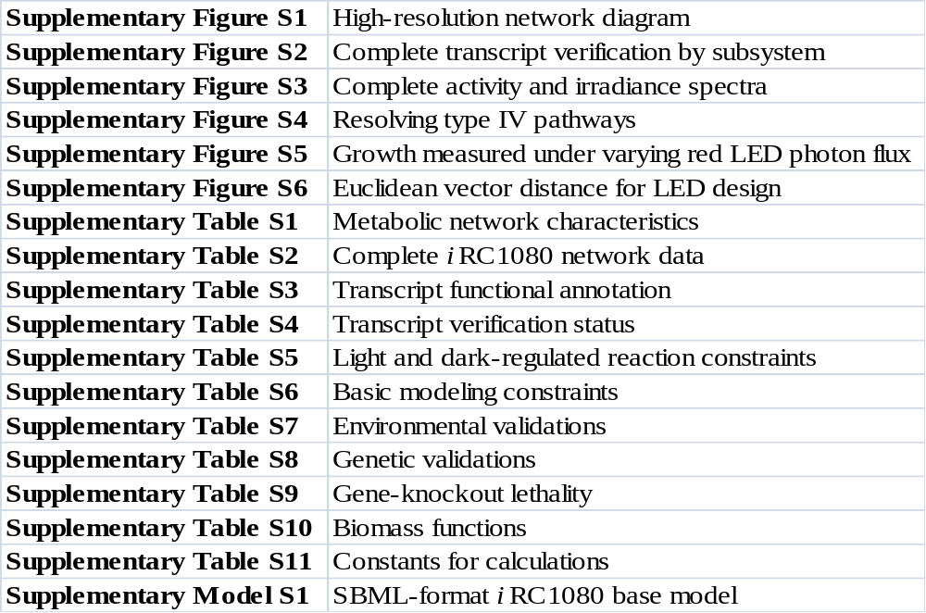

Supplementary methods
Metabolic network reconstruction
A standardized process of metabolic network reconstruction has been described elsewhere . Here, we provide only a brief description of the approach, with a focus on details specific to our effort.
Beginning with our previously published manual reconstruction of C. reinhardtii central metabolism , we added pathways to the reconstruction one-by-one according to the list of target pathways chosen for the reconstruction effort (see Selection of pathways for reconstruction below). To initiate reconstruction of each individual pathway, KEGG and classical biochemistry references were used as a starting point, with functional EC annotation (Supplementary Table S3) used to indicate which enzymes in the pathway were genomically present. Each pathway was then manually curated using available literature evidence from C. reinhardtii and related species to establish presence of particular enzymes and associated reactions, reaction directionality, and cofactors involved in particular reactions. Individual reactions were localized by experimental evidence as reported in the literature and supplemented with PASUB localization predictions (see Sub-cellular localization prediction below) as needed.
After thorough manual curation of each pathway, we followed up with gap-filling to account for dead-ends in conversion of included intermediates and cofactors. As a general rule, enzymes absent from the EC annotation were only included in the network reconstruction if either literature evidence was deemed sufficient to establish presence of the enzymes; or else only one reaction was needed to fill the gap between intermediates in the pathway and available literature evidence did not contradict presence of the associated enzyme; or else the reactions were necessary for functionality of pathways known to be present in C. reinhardtii.
Reaction curation and localization for each pathway included in the network model was followed by assignment of transporters needed for functional conversion of pathway intermediates. Literature evidence and publicly available databases were used as available to assign family and stoichiometry of transporters. In the absence of other evidence, transporters were inferred from other organisms or else assumed to take the form of passive diffusion.
Having reconstructed individual pathways of the network, we took steps to integrate these pathways. Initial and final reactants and products of each pathway were investigated to identify potential dead-ends, and additional metabolic or transport reactions were incorporated as appropriate. In addition to these manual quality control steps for pathway integration, modeling-based gap-filling was also performed in the framework of flux balance analysis, with the addition of reactions needed for in silico growth (see Simulations below).
With a complete set of reactions for the metabolic network reconstruction in place, we performed global quality control, including elemental balancing and elimination of free energy loops.
Since sub-cellular compartmentalization is a prominent feature of C. reinhardtii metabolism, in conjunction with performing elemental balancing, we accounted for protonation states of all compounds based on compartment-specific pH, derived from C. reinhardtii literature when possible and supplemented by data from other organisms sharing the same sub-cellular compartments. Cytosolic pH was determined to be 7.1, when the extracellular pH was 7.0. The chloroplast and its sub-compartments, the thylakoid and eyespot, were all assumed to share the same pH determined for the chloroplast to be 8.0 in light conditions . The extracellular pH was assumed to be 7.0 based on standard minimal growth medium for culturing C. reinhardtii . The flagellum pH was assumed to be identical to that of the cytosol, 7.1, as there is not an impermeable barrier such as a membrane separating the flagellum and cytosol . The glyoxysome pH was assumed to be 8.2 as determined in peroxisomes of human fibroblasts . This is a safe assumption given that plant glyoxysomes are known to have a relatively basic pH and glyoxysome enzymes function most efficiently in vitro at pH levels between 7 and 9 . The pH of the Golgi apparatus has been determined to be 6.5 at steady state in COS7 cells ; although Golgi pH can range from 6.2 to 7.0, it is in general slightly more acidic than cytosolic pH . The pH of the mitochondrial matrix has been measured at 7.8. Nuclear pH has been experimentally measured consistently as slightly higher than cytosolic pH in several mammalian cells , on average about 5% higher. Therefore the nuclear pH was estimated at 7.4 based on this average difference and a cytosolic pH of 7.1.
Chemical formulas of metabolites at neutral pH were obtained from KEGG , and InChI strings and formal charges for each metabolite were obtained from PubChem (http://pubchem.ncbi.nlm.nih.gov/). Protonation states for each metabolite at relevant compartmental pHs were determined using the web implementation of ChemAxon:Marvin (http://www.chemaxon.com/marvin/sketch/index.jsp) to compute the difference in charge states between neutral and compartmental pH. The neutral chemical formulas were adjusted by this difference to represent compartment-specific protonation states. The resulting chemical formulas were then manually curated to ensure accuracy, and a neutral protonation state was assumed for metabolites lacking InChI strings in PubChem. Referencing this curated set of chemical formulas, we compiled an E-matrix (Elemental matrix) containing elemental composition of all metabolites in the network (Supplementary Table S2). This E-matrix was then combined with the S-matrix (Stoichiometrix matrix, representing all reactions in the model), and a check of E∙S=0 ensured elemental balance for all included reactions.
Next, our metabolic network was evaluated to identify and eliminate type III pathways, or internal thermodynamically infeasible loops . Because of the intractability of enumerating all such loops in a network of this scale by any existing methodology, we focused on eliminating only those that affected biomass flux or the ATP maintenance function. These loops were eliminated by a combination of revisiting the manual curation of reaction directionality and imposing minimally deleterious additional constraints on a small set of transporter reactions.
A novel type of problematic extreme pathway was also identified in iRC1080 as a product of the inclusion of photons in the stoichiometric matrix, leaving the matrix elementally unbalanced as the photon is not converted to another form of matter but is absorbed as energy causing electron excitation in the photosystems. We term this scenario a type IV pathway, where there exists a metabolic input to the pathway, photons in this case, but no output of the pathway (Supplementary Figure S4). Flux capacity through a type IV pathway is limited only by the input flux, again photon flux in this case, and not by any other intermediate of the pathway. The result is a thermodynamically infeasible pathway similar to the type III pathway. Reactions such as photosystem II formed type IV pathways with several other network reactions. Multiple possible resolution strategies for type IV pathways were conceived (Supplementary Figure S4), including imposing additional constraints as described to resolve type III pathways, adding demand reactions to allow dissipation of the input flux without using the type IV pathway, and subverting a metabolite or designating a unique identifier for a pathway intermediate so that it no longer serves as a pathway intermediate but instead serves as an output of the pathway. We employed all three approaches to resolve the photosystem II type IV pathway in iRC1080: we re-curated reaction directionalities throughout the network, added individual wavelength photon demand reactions to effectively model light transmission through and scattering from the cell, and subverted the O₂ molecule evolved photosynthetically by the PSII reaction, redubbing it “O₂D,” and added a demand reaction to remove it from the system. The metabolite subversion approach must be used sparingly and carefully in resolving type IV pathways as it may introduce unrealistic deleterious gaps into the model; however, in this case it is seen as appropriate given that photosynthetically evolved O₂ cannot effectively drive other cellular processes such as mitochondrial respiration and mostly diffuses out of the cell, which is in fact how PSII activity is measured experimentally. Too much accumulation of photosynthetically evolved O₂ actually leads to photo-oxidative damage of the photosynthetic machinery in vivo , supporting that this process likely cannot provide the cell with sufficient O₂ for other processes.

Functional annotation of transcripts
Early efforts for the genome-scale reconstruction were performed using JGI v3.1 annotation published previously , which was generated by BLAST sequence comparison of translated v3.1 transcripts against publicly available protein databases. After a newer version of the C. reinhardtii genome was released (JGI v4.0), transcripts based on this assembly were functionally annotated and used to inform the majority of reconstruction efforts using two separate annotation approaches and including transporters as previously annotated mapped to TC terms .
The first annotation approach for transcripts from the C. reinhardtii Augustus update 5 (Au5) gene models (http://augustus.gobics.de/predictions/chlamydomonas/) assigned enzyme classification (EC) terms to the translated Augustus 5 open reading frame (ORF) models using UniProt and AraCyc enzyme protein sequences and their EC annotations as the basis. The transfer of enzyme annotations to ORF models was done by:
- Carrying out and deciphering reciprocal best-hits, if any, for each of the translated ORF models to the UniProt and AraCyc sequences, then transferring the EC from the best-hits UniProt/AraCyc sequences to the corresponding ORF models, using a BLASTP E-value threshold of 0.001.
- Identifying paralogs in the entire collection of translated Augustus models and transferring EC annotations from the EC-assigned ORFs to their unassigned paralogs. This was done using BLASTCLUST with a sequence identity cut-off of 35% and length cut-off of 70%.
The second annotation approach for Au5 gene models followed from association with JGI v3.1 functional annotations (http://erik.freshboom.com/chlamy/), translated, and annotated with EC annotations using a combination of results from the BLASTP-based method, AutoFACT , InterProScan , and the enzyme-specific profile approach, PRIAM, with gene- and genome-specific profiles . Functional hits with EC annotations were directly transferred and those with Gene Ontology terms were converted to EC numbers when possible . EC assignments per transcript were made from the union of all hits. Using the number of occurrences in the union set as a confidence indicator along with a method confidence ranking of InterProScan > PRIAM-gene > PRIAM-genome > AutoFACT, EC numbers were assigned and accepted after manual inspection.
The comprehensive annotation is presented in Supplementary Table S3.

Sub-cellular localization prediction
Cellular compartment assignment of functionally predicted enzymes encoded in the C. reinhardtii genome was performed primarily by mining literature evidence, and supplemented by sub-cellular localization predictions generated using PASUB, the Proteome Analyst Specialized Sub-cellular Localization Server , where necessary. In the absence of any literature or sequence-based evidence, localization was assigned based on neighboring pathway reactions and model functionality requirements.

Selection of pathways for reconstruction
Initially, pathways targeted for our genome-scale reconstruction effort were selected by pooling universal pathways common to metabolism of known organisms (e.g. glycolysis; citric acid cycle; pentose phosphate pathway; and other pathways of central carbon metabolism, amino acid synthesis pathways, nucleotide synthesis pathways, fatty acid metabolism) with pathways integral to C. reinhardtii metabolism (e.g. photosynthesis, carbon fixation, chlorophyll synthesis, retinol metabolism).
In order to ensure full coverage of our model at the genome scale, we supplemented this literature-based list of target pathways with a set of pathways representing overlap of our functional genome annotation with KEGG pathways . EC annotation of JGI v3.1 was mapped onto the full set of metabolic pathways in KEGG to identify all pathways with genomic coverage or at least 10 EC terms or at least 5 EC terms and 40% coverage of all ECs represented in the pathway. In this way, we systematically generated a list of KEGG pathways to target for the genome-scale reconstruction, and each of these pathways was slated for reconstruction unless further literature evidence indicated that the semi-automatically identified pathways were not functional in vivo in C. reinhardtii.

Chlamydomonas reinhardtii strains and growth conditions
For transcript verification experiments, C. reinhardtii strain CC-503 was grown in tris-acetate-phosphate (TAP) medium containing 100 mg/L carbamicillin without agitation, at room temperature (22-25 °C) and under continuous illumination with cool white light at a photosynthetic photon flux of 60 μE/m²/s.
For growth experiments under 660 nm peak LED light, C. reinhardtii strain UTEX2243 was grown in a bubble column photobioreactor (length 30 cm, diameter 4 cm) at 23-27 °C with P49 medium for variably 3 or 4 days, depending on average light intensity. The total volume of algal culture was 300 mL, and the gas supply was 180 mL/min air with 2.5% CO₂. The 660 nm peak LED light supply was set at 10 kHz frequency and different duty cycles to get varied average incident photon fluxes of 42 µE/m²/s, 85 µE/m²/s, 128 µE/m²/s, and 170 µE/m²/s. Biomass was measured daily at for each experiment. Biomass curves were approximated by finding the lowest order, best fit Fourier series using Matlab (Supplementary Figure S5A). Growth rates were then computed as the first derivative of the biomass curves (Supplementary Figure S5B), and the maximum growth rates were taken as reported in Figure 4B.

RNA isolation and quality assessment
Total RNA was isolated from C. reinhardtii cells, grown under the permissive condition described above, at mid-log phase using TRIZOL reagent (Invitrogen Life sciences) and treated with DNase I (Ambion) to remove cellular DNA. The integrity of the RNA was assessed by Agilent 2100 Bioanalyzer (Agilent) using RNA Pico 6000 kit and by following the manufacturer’s instruction. The fraction of RNA with RNA Integrity Number (RIN) of more than 7.5 was used for cDNA synthesis. The concentration of the RNA was measured spectrophotometrically.

Structural verification of Au5 metabolic ORFs by reverse transcription-PCR
The verification of the annotated metabolic ORFs was performed by targeted amplification of reverse-transcribed RNA by PCR. Reverse transcription of RNA was carried out using Superscript III reverse transcriptase (Invitrogen Life Sciences) following the manufacturer’s instructions using random N6 and dT(16) (Ambion), supplemented with 1.2 M betaine (Sigma-Aldrich) to prevent premature terminations due to the high GC-content of C. reinhardtii transcriptome. ORF-specific primers tailed with Gateway-compatible sequences were designed automatically using the OSP program . The ORF-specific segment of each forward primer starts from the start codon and is flanked with the Gateway B1.1 sequence at its 5’ end. The reverse primers start from the codon immediately before the termination codon and carry the Gateway B2.1 sequence at their 5’ ends. All primers (synthesized by Bioneer Inc.) have a melting temperature between 55 °C and 65 °C. KOD hot start DNA polymerase (Novagen) catalyzed the amplification of the annotated ORFs individually in separate 50 µl reaction mixtures containing 1.2 M betaine and an estimated 0.25 µg reverse transcribed DNA.

Gateway cloning of the ORFs and amplicon generation for sequencing
The generated amplicons were recombinationally cloned into the pDONR223 Gateway vector and transformed into chemically competent E. coli DH5α. The positive transformants, selected and grown in 96-well format plates containing LB and 100 mg/L spectinomycin, were used as templates in PCR reactions containing 1.2 M betaine and KOD hot start DNA polymerase (Novagen) to amplify the inserts for sequencing using universal vector primers.

ORF model verification by 454FLX sequencing
The 454FLX Titanium sequencing system (454 Life Sciences Corp., Roche) was used for sequencing of the generated ORF amplicons. The amplicons generated in RT-PCR reactions, or the PCR products of the entry clones, were pooled in equimolar ratios then partially purified using Qiagen MinElute PCR purification kit following the manufacturer’s instruction. Five micrograms of DNA from each sample was subjected to nebulization for 90 seconds under nitrogen gas pressure of 30 psi (2.1 bar). After purification, the sheared DNA fragments, size 300-800 base pairs, were end repaired and ligated with 454 adaptors. After melting into single stranded DNA molecules, the resulting single stranded DNA libraries were then purified and used in emulsion PCR reactions according to the manufacturer’s instruction (454 Life Sciences Corp., Roche). Following amplification, the emulsions were broken and the beads carrying the amplified DNA library were recovered and enriched. Approximately 800,000 DNA-carrying beads were sequenced by the Roche 454 Genome Sequencer in 200 flow cycles using the XLR70 Titanium Sequencing Kit. The generated data were processed using the GS FLX data analysis software v2.3. For alignment of the obtained reads to reference ORF sequences, the vector sequences and the Gateway tail sequences were trimmed, and the reads shorter than 20 nucleotides were filtered out. The reads were then aligned against Au5 reference sequences using the GS Reference Mapper application (gsMapper v2.3). Minimum overlap length of 40 nucleotides and minimum overlap identity of 90% were used to align the reads against the Au5 reference sequences. The verification percentage of Au5 ORFs (Figure 2, Supplementary Figure S2, Supplementary Table S4) is the percent coverage of the full-length model sequence by 454 reads.
ORFs encoding transporter proteins were verified by capillary Sanger sequencing. This approach as expected was not capable of sequencing the full length of some of the longer transcripts for transport proteins, >800 nucleotides in length. For many of these, only either the 5’ or 3’ ends or both were verified experimentally. Because having verified both ends implies the presence of the full length transcript, we considered verification of the 5’ and 3’ ends of transporter transcripts to constitute 100% verification, and we considered verification of just one end to constitute 50% verification.

Deriving biomass equations
The biomass formation equations used for all in silico growth simulations were derived according to previously reported methods . First, we estimated the proportion of dry weight biomass composed of protein, DNA, RNA, carbohydrate, fatty acid, glycerol, lipids, chlorophyll, and xanthophylls using available literature and genomic evidence. Each of these basic components was further broken down by subtypes where possible. For example, protein composition was estimated at the level of amino acid frequencies, with different frequencies reported for autotrophic, mixotrophic, and heterotrophic growth conditions . We also incorporated a model-based value of growth associated ATP maintenance and non-growth associated ATP maintenance.
The DNA content of the cell was estimated at 0.40%, assuming 0.19 pg DNA/cell and a total dry weight of 48 pg/cell . Assuming an RNA:DNA ratio of 28 gave an RNA content of 11.1%. Retinal-bound rhodopsin was assigned a content of 0.0000279%, based on 30,000 rhodopsin molecules per cell . Finally, chlorophyll was taken to account for 2.4% and xanthophylls 0.37% of dry weight in the photoautotrophic case.
After accounting for DNA, RNA, retinal, chlorophyll and xanthophylls, composition of the remaining cellular components was estimated from previously published data on relative abundance of carbohydrates, lipids, protein, and fatty acids, as previously published . Components reported at less than 0.1 g/L were omitted, and the remaining components (carbohydrates, including starch; glycerol; lipid, including triglyceride; protein; and volatile fatty acids, representing the sum of acetic, propionic, butyric, and valeric acids) were normalized to 86.2%, the proportion of dry weight that was not accounted for by DNA, RNA, retinal, chlorophyll, and xanthophylls.
Finally, these data were synthesized into different full biomass equations for each growth condition (Supplementary Table S10) accounting for the aforementioned classes as follows:
- Protein content: The relative abundance of amino acids, as mole fraction, was drawn from previously reported experimental values, which are separated by autotrophic, mixotrophic and heterotrophic conditions . These values were converted to mmol/gDW.
- DNA content: The prevalence of the four nucleotides in DNA was calculated assuming a GC content of 64%, and these values were converted to mmol/gDW.
- RNA content: RNA abundance was determined using the same procedure applied for protein and DNA. In doing so, we assumed the same GC content of 64% that was reported for DNA and converted to units of mmol/gDW.
- Carbohydrate content: Under autotrophic conditions, measurements from the whole C. reinhardtii cell establish 81% of the dry weight accounted for by carbohydrates is composed of starch . The remaining carbohydrates were assumed to be sugars found in glycoproteins of the cell wall, consisting of mannose (22.5%), arabinose (29.9%), and galactose (47.7%) . In the absence of light, we assumed zero starch production. Production of the remaining carbohydrate components in mmol/gDW was assumed unchanged under heterotrophic versus autotrophic and mixotrophic conditions.
- Fatty acid content: We estimated that volatile fatty acids , consisting of acetic, propionic, butyric and valeric acids, compose 0.67% of the C. reinhardtii dry weight. Because we were unable to identify additional literature sources characterizing the presence of valeric acid in C. reinhardtii, and this compound was not connected to any particular pathway in KEGG , we assumed the dry weight attributed to volatile fatty acids is equally distributed among acetic, propionic and butyric acids for the purpose of our biomass equation.
- Glycerol content: After weighting the proportion of glycerol to account for the presence of DNA, RNA, and chlorophyll that were not reported in the analysis of C. reinhardtii biomass, we estimated glycerol composes 0.11% of dry weight biomass.
- Lipid content: The total lipid contribution to biomass was taken as previously published . The contribution of triacylglycerides to the total lipids was derived from a previous study focusing on this class of lipids , where it was determined to make up 37% of total lipids. The remaining distribution of other lipid classes and their percentage of total lipids were derived from another experiment . This breakdown was further specified to account for individual lipid species by giving the relative percentage of species detected within each lipid class , which covered species of all lipid classes present in C. reinhardtii except for 2'-O-acyl-sulfoquinovosyldiacylglycerols and triacylglycerols. For these exceptional classes, an unbiased distribution was assumed.
- Chlorophyll content: Under photoautotrophic conditions, chlorophyll was assumed to account for 2.4% of dry weight, broken down as 0.9% chlorophyll a and 1.5% chlorophyll b . Using photoautotrophic growth as a base condition, production of chlorophyll under mixotrophic and heterotrophic conditions was weighted according to the relative fraction of dry weight assigned to each chlorophyll component under the respective growth conditions .
- Retinal content: Rhodopsin-bound retinal is required for phototaxis in C. reinhardtii. There are approximately 30,000 rhodopsin molecules per cell . The retinal component of the rhodopsin molecule has the molecular formula C₂₀H₂₈, which has a molecular weight of 268.44 g/mol. Given a total dry weight of 48 pg/cell , the biomass contribution of retinal is then 1.038×10⁻⁶ mmol retinal/gDW.
- Xanthophyll content: The ratio of xanthophylls to chlorophyll a were measured in cultures exposed to high light (1,160 μE/m²/s) for 15 minutes . These xanthophylls included alpha-carotene, antheraxanthin, beta-carotene, loroxanthin, lutein, neoxanthin, violaxanthin, and zeaxanthin. The contribution of these xanthophylls to biomass was then simply calculated as the product of these ratios and the contribution of chlorophyll a to biomass .
- ATP maintenance: Growth associated ATP maintenance of 29.89 mmol ATP/gDW was incorporated in the full biomass equations .

Non-growth associated ATP maintenance was determined by maximizing the ATP maintenance function in the model given the experimentally determined maintenance coefficient for acetate in heterotrophic culture . The maintenance coefficient for acetate uptake was 0.011 g acetate/gDW/h, which is equal to 0.183 mmol acetate/gDW/h. The maximum heterotrophic ATP maintenance flux in the model given this acetate uptake was 0.183 flux units because the maximum ATP yield in the heterotrophic model is equal to 1. Thus, the non-growth associated ATP maintenance flux is 0.183 mmol ATP/gDW/h, and this value was set as an absolute constraint for all subsequent simulations in this study.

Light-utilization efficiency calculations
The efficiency of light-utilization by our model under different light sources was computed in terms of two main criteria. The first criterion is the energetic efficiency of absorbed photons (Figure 4C), which is defined as the proportion of photon energy that is metabolically absorbed out of the total incident photon energy. To compute the energetic efficiency, first we performed growth simulations using each prism reaction, leaving the prism reaction flux unbounded and using FVA to determine the minimum photon flux required to achieve maximum growth rate. The incident flux for each photon wavelength in the prism reaction was then calculated as the product of the prism reaction flux (normalized by the effective photon flux conversion factor) and the effective bandwidth coefficient. Absorbed photon flux for each photon wavelength was calculated as the difference between the incident photon flux and the flux through wavelength-specific demand reactions. These wavelength-specific demand reactions represent the non-metabolically-utilized photon flux. The photon energy associated with both wavelength-specific incident and absorbed photon fluxes was then calculated according to equation 2, using the wavelength of maximum activity for each effective spectral bandwidth (except for the rhodopsin-associated bandwidth, for which the median activity wavelength was used). Finally, the energetic efficiency was computed as the ratio of the sums of metabolically absorbed photon energies to incident photon energies as in Supplementary Equation 1.
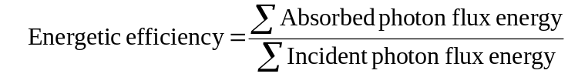 (1)
The second criterion for evaluating light-utilization efficiency by our model is the biomass yield on light (Figure 4C). This parameter is simply a calculation of the units of biomass resulting from incident photon units. The same simulation approach was used as described above for determining the energetic efficiency, taking the minimum prism reaction photon flux to achieve maximum biomass flux. The biomass yield on light was calculated from the simulation results using Supplementary Equation 2.
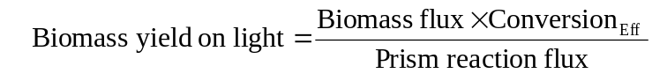 (2)

Prism reaction derivation
In order to generate the prism reactions, representing the spectral composition of different light sources, we first defined the spectral bandwidths that effectively drive each photon-utilizing reaction in iRC1080. The following describes the general procedure used to define effective spectral bandwidths for reaction activity, but there are amendments to this procedure for certain activity spectra, which are noted below in the results for each reaction. Activity spectra for each reaction were obtained from published literature (Supplementary Figure S3), drawing preferentially from C. reinhardtii experiments when available. The procedure to define effective spectral bandwidths for each reaction began with extracting digital data from published activity spectral curves (used Engauge Digitizer available at http://digitizer.sourceforge.net). The experimental data was a measure of reaction activity in relative units varying with shifts in the wavelength of light exposure. Subsequent analysis of the data was performed using Matlab. The data was linearly interpolated to obtain 1 nm wavelength resolution across the entire experimentally-surveyed spectrum; this step was necessary to obtain relatively precise effective bandwidth bounds. The maximum reaction activity value in the interpolated data was identified and used to calculate the full width half maximum (FWHM) spectral bandwidth, which corresponds to the spectral range bounded by the wavelengths at which half the maximum activity was achieved, denoted by dashed lines in Supplementary Figure S3. This spectral bandwidth was accepted as the effective range of photon wavelengths capable of driving the associated reaction in the network. The following are the resulting effective spectral bandwidths for each photon-utilizing reaction in the network:
- Photosystem I: The absorbance spectrum for the photosystem I-light harvesting complex I supercomplex (PSI-LHCI) was analyzed. Both red and blue spectral ranges of light can be absorbed by PSI-LHCI; these were treated separately by duplicating the PSI reaction in the network and assigning each of these spectral ranges to one duplicate reaction set. The maximum activity within each range was determined, and the FWHM was determined for each range separately. The resulting effective spectral bandwidths for PSI were from 406 to 454 nm, with maximum absorbance at 437 nm, and from 662 to 691 nm, with maximum absorbance at 680 nm.
- Photosystem II: The absorbance spectrum for the photosystem II-light harvesting complex II supercomplex (PSII-LHCII) was analyzed. Again, both red and blue spectral ranges of light can be absorbed by PSII-LHCII; these were treated separately by duplicating the PSII reaction in the network and assigning each of these spectral ranges to one duplicate reaction set. The maximum activity within each range was determined, and the FWHM was determined for each range separately. The effective spectral bandwidths for PSII were from 378 to 482 nm, with maximum absorbance at 438 nm, and from 659 to 684 nm, with maximum absorbance at 673 nm.
- Protochlorophyllide photoreductase and divinylprotochlorophyllide photoreductase: The activity spectrum for protochlorophyllide photoreductase was analyzed. Two distinct spectral ranges of light can effectively transform protochlorophyllide into chlorophyllide. Since these ranges are roughly equally effective at driving this reaction, they were treated separately by duplicating these reactions in the network and assigning each of these spectral ranges to one duplicate reaction set. The maximum activity within each range was determined, and the FWHM was determined for each range separately. The result was two effective spectral ranges: the first effective spectral bandwidth was from 608 to 666 nm, with maximum activity at 646 nm, and the second was from 417 to 472 nm, with maximum activity at 450 nm.
- Vitamin D₃ synthesis: The activity spectrum for this spontaneous reaction was taken from published models . There exist two conflicting models of the precise effective spectral range for this reaction . However, it is universally accepted that the approximate effective spectral range is bounded by 230 and 320 nm, which overlaps mostly with the UVB range. The two conflicting models are as follows: an approximately normal activity distribution centered at about 295 nm or an incompletely determined bimodal distribution with one peak centered near 305 nm and one more ill-defined near 275 nm. Since the peak of activity in the first model closely corresponds to the median of the possible bimodal distribution and since data for the first model is more complete , the single-peak model centered at 295 nm was accepted for this study. The resulting effective spectral bandwidth was from 281 to 306 nm, with maximum activity at 298 nm.
- Rhodopsin photoisomerase: The activity spectrum for rhodopsin photoisomerase was analyzed. C. reinhardtii encodes two distinct phototactic rhodopsin proteins (CSRA and CSRB) that require one and two photons, respectively . The effective spectral ranges for CSRA and CSRB are centered at 510 nm and 470 nm, respectively, but these ranges cannot be reliably resolved given the available experimental data (i.e. FWHM bandwidths for two peaks of activity overlap). Therefore, one composite effective spectral range was determined for this reaction. The experimental data includes two measurements, one for CSRA-enriched and one for CSRB-enriched C. reinhardtii cells. The composite effective spectral range was derived by taking the maximum sensitivity value at each of the two peaks, computing the FWHM with respect to each, and merging the overlapping bandwidths into one range. The resulting effective spectral bandwidth was from 451 to 526 nm, with a median activity at 490 nm.

The effective spectral bandwidths that drive each photon-utilizing reaction, as defined above, were used as the basis for deriving the stoichiometric coefficients of the prism reactions used to model different light sources according to the composition of their photon flux spectra. We obtained published light intensity data for each light source. The data for some of these spectra was already in digital format, but for those that were published as graphical plots, we extracted digital data (used Engauge Digitizer). The following describes the general procedure followed to analyze the data. Light intensity data was typically reported as spectral irradiance in units of W/m²/nm or as photon flux units of µE/m²/s. We converted all spectral irradiance data to photon flux units according to Supplementary Equation 3 and Supplementary Equation 4.
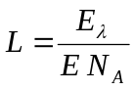 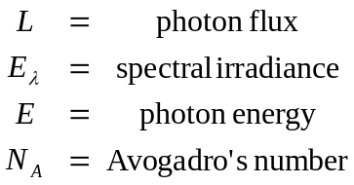 (3)
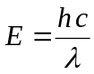 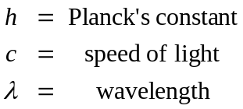 (4)
Supplementary Equation 3 is the relationship between photon flux and spectral irradiance, and Supplementary Equation 4 is the classical Planck-Einstein equation relating wavelength to photon energy. The photon flux data was subsequently analyzed using Matlab. Linear interpolation of the data was used to obtain the highest resolution represented in the dataset, the minimum distance between any two measured wavelengths. Interpolation set the data points at regular intervals, which is required for the subsequent use of the trapezoidal rule for approximation of definite integrals. Coefficients for each of the effective spectral bandwidths for photon-utilizing reactions defined above were then computed based on Equation 1.
Each coefficient represents the ratio of photon flux in the defined effective bandwidth to total visible photon flux, defined as the spectrum from 380 to 750 nm. The composite trapezoidal rule using a uniform grid was implemented to approximate the definite integrals in Equation 1 within the effective spectral bandwidths defined for each photon-utilizing reaction. Finally, all effective bandwidth coefficients were compiled into a single reaction as in Equation 2.
The resulting prism reaction equations, formed according to Equation 2, were added to iRC1080 (Supplementary Table S2) to enable light source-specific simulations, and the absolute constraint (Supplementary Table S6) on each prism reaction flux was derived from the total visible photon flux determined by the definite integral of the spectrum from 380 to 750 nm. This total visible photon flux represents the light emitted from a source and not light incident on a C. reinhardtii cell or the effective light available to the cell’s metabolic system. This discrepancy was accounted for through additional mathematical transformations of this definite integral (see Dimensional and effective photon flux conversion factor derivation below). We generated prism reactions for 11 different light sources (Supplementary Figure S3). Descriptions of each light source for which we report prism reactions follow:
- Solar, lithosphere: The ASTMG173 spectrum (http://rredc.nrel.gov/solar/spectra/am1.5) is of sunlight measured from Earth’s ground level. This spectrum is the result of a composite analysis from several measurements taken from different locations under cloudless conditions in the 48 contiguous U.S. states and multiple data normalization procedures.
- Solar, exosphere: Spectral irradiance data measured on October 16, 2009 from NASA’s SORCE satellite project was collected through an interactive web interface. The satellite orbit reaches a maximum distance from Earth’s surface of 7002 km. This spectrum closely resembles the solar lithosphere spectrum but includes a higher proportion of spectral irradiance in the UV range.
- Soft white incandescent bulb: Spectral irradiance of an Airam 60 W soft white incandescent light was collected from an online resource (http://www.mv.helsinki.fi/aphalo/photobio/lamps.html).
- Warm white fluorescent tube: The relative intensity spectrum in arbitrary units for a Sunbrite 18 W warm white fluorescent light was obtained from an online resource (http://www.ledmuseum.org). Theoretical irradiance units were computed by multiplying intensity values by the energy per photon of given wavelength. These theoretical irradiance units were converted to realistic units of spectral irradiance by multiplying each theoretical value by the ratio of 18 W to the total area under the theoretical irradiance curve, which is also in W units.
- Cool white fluorescent tube: Spectral irradiance of a Sylvania 215 W high output cool white fluorescent tube was collected from an online resource (http://www.mv.helsinki.fi/aphalo/photobio/lamps.html).
- Metal halide lamp: The spectral irradiance of a General Electric MVR 250 metal halide lamp with a clear polycarbonate filter was collected from an online resource (http://www.mv.helsinki.fi/aphalo/photobio/lamps.html).
- High pressure sodium lamp: Spectral irradiance of a Sylvania LU 250 high pressure sodium lamp with a clear polycarbonate filter was collected from an online resource (http://www.mv.helsinki.fi/aphalo/photobio/lamps.html).
- Growth room: The Spectral irradiance of a Conviron growth room with fluorescent level 3 and incandescent level 3 was collected from an online resource (http://www.mv.helsinki.fi/aphalo/photobio/lamps.html).
- White LED: Spectral irradiance of a Hewlett Packard HLMP-CW31 white LED was collected from an online resource (http://www.mv.helsinki.fi/aphalo/photobio/lamps.html). The effective incident photon flux after conversion (see Dimensional and effective photon flux conversion factor derivation below) was insufficient to support photosynthetic growth in our light model. Therefore, we took the total photon flux to be 31.9 µE/m²/s, the minimum required for growth in our model, or approximately the combined power of 7 individual white LEDs.
- 653 nm peak red LED array: The spectrum of a red LED with peak intensity at 653 nm was obtained through a web applet presenting spectral measurements from an NSF-funded research and education project (http://mo-www.harvard.edu/Java/MiniSpectroscopy.html). The intensity units of this spectrum were relative, so this spectral intensity data was combined with total irradiance data taken from a 144-red LED array , where the total irradiance was 123 W/m². This total irradiance was normalized by the total area under the curve from the spectral data to derive a conversion factor, which was subsequently multiplied by every relative intensity value to obtain realistic spectral irradiance values in the correct units.
- 674 nm peak red LED: Spectral irradiance of a Quantum Devices QDDH68002 red LED with peak intensity at 674 nm was collected from an online resource (http://www.mv.helsinki.fi/aphalo/photobio/lamps.html).

Simulations
Growth simulations in this study were performed using flux balance analysis (FBA) and flux variability analysis (FVA) as implemented in the COBRA toolbox for Matlab. FBA and FVA are optimization algorithms that have been extensively used to simulate metabolic states and have been reviewed elsewhere . The Tomlab linear programming solver was used for all optimizations.
Initially, fluxes of all reversible reactions were left unbounded, while irreversible reactions were given a lower bound of zero to preserve directionality. Different environmental conditions were modeled by appropriately setting reaction flux constraints in iRC1080 (Supplementary Table S6). These reactions consist of environmental exchanges, non-growth associated ATP maintenance, O₂ photoevolution, starch degradation, and light or dark-regulated enzymatic reactions (Supplementary Table S5). Prism reactions were all constrained to zero flux except when simulating photosynthetic growth, in which case a single prism reaction, representing the light source under investigation, was set with a non-zero constraint. Constraint values were derived from published sources unless otherwise noted (Supplementary Table S6) and imposed only under appropriate environmental conditions. Minimal condition in Supplementary Table S6 signifies a constraint that is used under all environmental conditions. The appropriate biomass reaction was set as the objective function for optimizations depending on environmental conditions as well.

Dimensional and effective photon flux conversion factor derivation
Typically photon flux is experimentally measured with respect to the light emitted from a light source rather than with respect to the light that is either incident upon a cell or metabolically absorbed. This assumption is of course based on the practicality of such measurements, but nonetheless presents a challenge for accurately modeling metabolic light usage in silico and performing comparisons between simulated and experimental results. As such, we derived conversion factors that address this problem. The dimensional conversion factor accounts for the light that is incident upon a single C. reinhardtii cell by incorporating cellular geometry and cellular dry weight into dimensional analysis (Supplementary Table S11). The effective photon flux conversion factor accounts for the amount of light that is effectively available for metabolic absorption and not instead otherwise absorbed, reflected, transmitted, or scattered by the cell by fitting a base simulation outcome to its experimental analog (Supplementary Table S11). Taken together, these two conversion factors allow direct comparison of simulated and experimental photon flux values.
The dimensional conversion factor incorporates key cellular parameters collected from C. reinhardtii literature: major and minor cell diameters and cellular dry weight . The geometry of the cell is assumed to be a prolate spheroid as was previously reported . We also assumed for this study that all light sources are positioned on one side of a C. reinhardtii cell and sufficiently distant to be considered a point light source. Under that assumption, the orientation of the cell determines how much photon flux is incident upon the cell. A distant point light source implies that prior to incidence upon the cell surface, all photons transmit along essentially spatially parallel paths. Therefore, it is most appropriate to consider the cross section of the exposed orientation of the cell when determining incident photon flux, rather than some measure of the cell surface area. The smallest cross sectional area of a prolate spheroid with the given dimensions (Supplementary Table S11) is 47.88 µm², and the largest cross section is 54.52 µm². As we do not know the orientation of the cell at any given time, we will assume that all orientations are equally probable. Thus, we took the cross section as the average of the smallest and largest cross sections, 51.15 µm², and the dimensional conversion factor was computed as in Supplementary Equation 5.
(5)
The effective photon flux conversion factor accounts for the discrepancy between incident light and light available for metabolic use. The optical properties of the cell cause some light to be reflected or scattered, and some light is absorbed by the cell through mechanisms other than the metabolic reactions represented in iRC1080. Ideally these phenomena would be accounted for explicitly using optical parameters of a C. reinhardtii cell, and although some experimental measurements have been made previously concerning optical parameters, there is still insufficient data to explicitly perform this conversion. In light of this fact, we chose to approximate this relationship by fitting a base simulated photon flux to experimentally measured photon flux via a common reference point. The common reference point chosen was the minimum solar photon flux sufficient for photosynthetic saturation measured as O₂ evolution . The experimental measurement was taken at 80% of the maximum photosynthetic activity and was determined to be 1007 µE/m²/s. The base simulation was performed using the solar lithosphere prism reaction and iteratively increasing the flux through this reaction from 0 to 2000 model flux units while optimizing autotrophic biomass. The resulting base simulated photon flux at which 80% maximum O₂ photoevolution was reached was equal to 145 mE/gDW/h, and the effective photon flux conversion factor was computed as in Supplementary Equation 6.
(6)
This result signifies that the model suggests only 3.75% of incident photons are absorbed metabolically by the cell. These conversion factors were used to report all photon flux results in this study in terms of incident photon flux and to compute light-utilization efficiency (see Light-utilization efficiency calculations). Dividing simulated photon flux by the product of both conversion factors results in a value that is directly comparable to experimentally measured photon flux emitted from a given light source.

Random sampling of prism reaction space and significance test
For a given prism reaction, first the sum of the stoichiometric coefficients was calculated, representing the total quantity of metabolically-active photons per incident photon from the specified light source. Next, to sample the space of prism reactions, 10,000 random prism reactions with the same sum of stoichiometric coefficients were generated and used in growth simulations. In these simulations, input photon flux was constrained to the reported experimental values, generating a set of simulated results (biomass or photosynthetically-evolved O₂ flux, depending on the experimental parameter) with one value corresponding to each experimental data point. The Euclidean distance between the sampled and experimental results was calculated for each of the 10,000 randomized prism reactions (Figure 5). The significance of the experimental agreement with simulations reported for a given prism reaction derived directly from analysis of irradiance spectra was established by comparison between the corresponding Euclidean distance and the distribution of distances from the randomly sampled prism reactions. Probability of achieving equal or closer results to experiments by chance was computed as the proportion of smaller values in the randomly sampled distribution of 10,000 distances.

Procedure for efficient LED design
In order to perform simulations to explore the space of possible light sources in our model, we temporarily added free exchange reactions for each photon wavelength to the model in place of the use of prism reactions. This addition allowed any possible combination of wavelength-specific photon fluxes to potentially be used in simulation. With this state of the light model, we ran a simulation to determine the most efficient LED design for growth. We used FVA to determine the minimum of each wavelength-specific photon flux sufficient to achieve maximum photoautotrophic growth rate. For the photon requirement of protochlorophyllide photoreductase, we favored the lower energy, longer wavelength effective spectral bandwidth so as to bias our search towards a lower energy light source. The resulting wavelength-specific photon fluxes represent a model-based ideal light source for growth but are not necessarily achievable through existing lighting technology in reality. Therefore, we sought to determine an LED spectrum that most closely resembled this theoretical maximum efficiency lighting regime. To do so, we took the ratios of the wavelength-specific photon fluxes to the total photon flux, paralleling the procedure described above for prism reaction derivation, to obtain a vector of theoretical prism reaction coefficients.
With measured photon flux spectra in hand for a 674 nm peak LED, we used the shape of this distribution to model our efficient LED design. We normalized the 674 nm LED spectrum by the ratio of the total photon flux from the 674 nm LED to the total simulated photon flux in the theoretical maximum efficiency result described above. Next, we iteratively shifted the center of this normalized LED spectrum across the visible spectrum in 1 nm increments and computed the Euclidean vector distance between prism reaction coefficients for the iteratively-centered LED spectrum and the vector of prism reaction coefficients for the theoretical maximum efficiency lighting regime (Supplementary Figure S6). The iteration corresponding to the minimum vector distance represents the LED spectrum that most closely resembles the theoretical maximum efficiency lighting regime. This spectrum is presented in the bottom plot in Supplementary Figure S3 and is nearly equivalent to the 674 nm peak LED spectrum. A prism reaction was computed from this designed LED spectrum, and light-utilization efficiency evaluations were also performed (Figure 4C and Supplementary Table S7).

Supplementary figures and tables
(Supplementary figures and tables that cannot be optimally displayed in their entirety in this file are available as separate files online.)

Supplementary Figure S1 High-resolution network diagram. This network diagram displays all metabolites (nodes) and reactions (complex edges) included in iRC1080. Metabolites are color-coded based on compartment localization. Reversibility and irreversibility are represented by the placement of arrows at the ends of edges connecting metabolites (i.e. substrates of irreversible reactions do not have arrows on the edges connecting to them). Labels follow the abbreviation conventions used in iRC1080 (Supplementary Table S2). Visually resolving node and edge labels requires zooming to at least 6400% on most displays.

Supplementary Figure S2 Complete transcript verification by subsystem. The transcript verification status for all gene-associated subsystems of iRC1080 is displayed. The graph follows the same format as Figure 2.

Supplementary Figure S3 Complete activity and irradiance spectra. The irradiance spectra are shown for all light sources used in this study. The graphs follow the same format as Figure 3A.

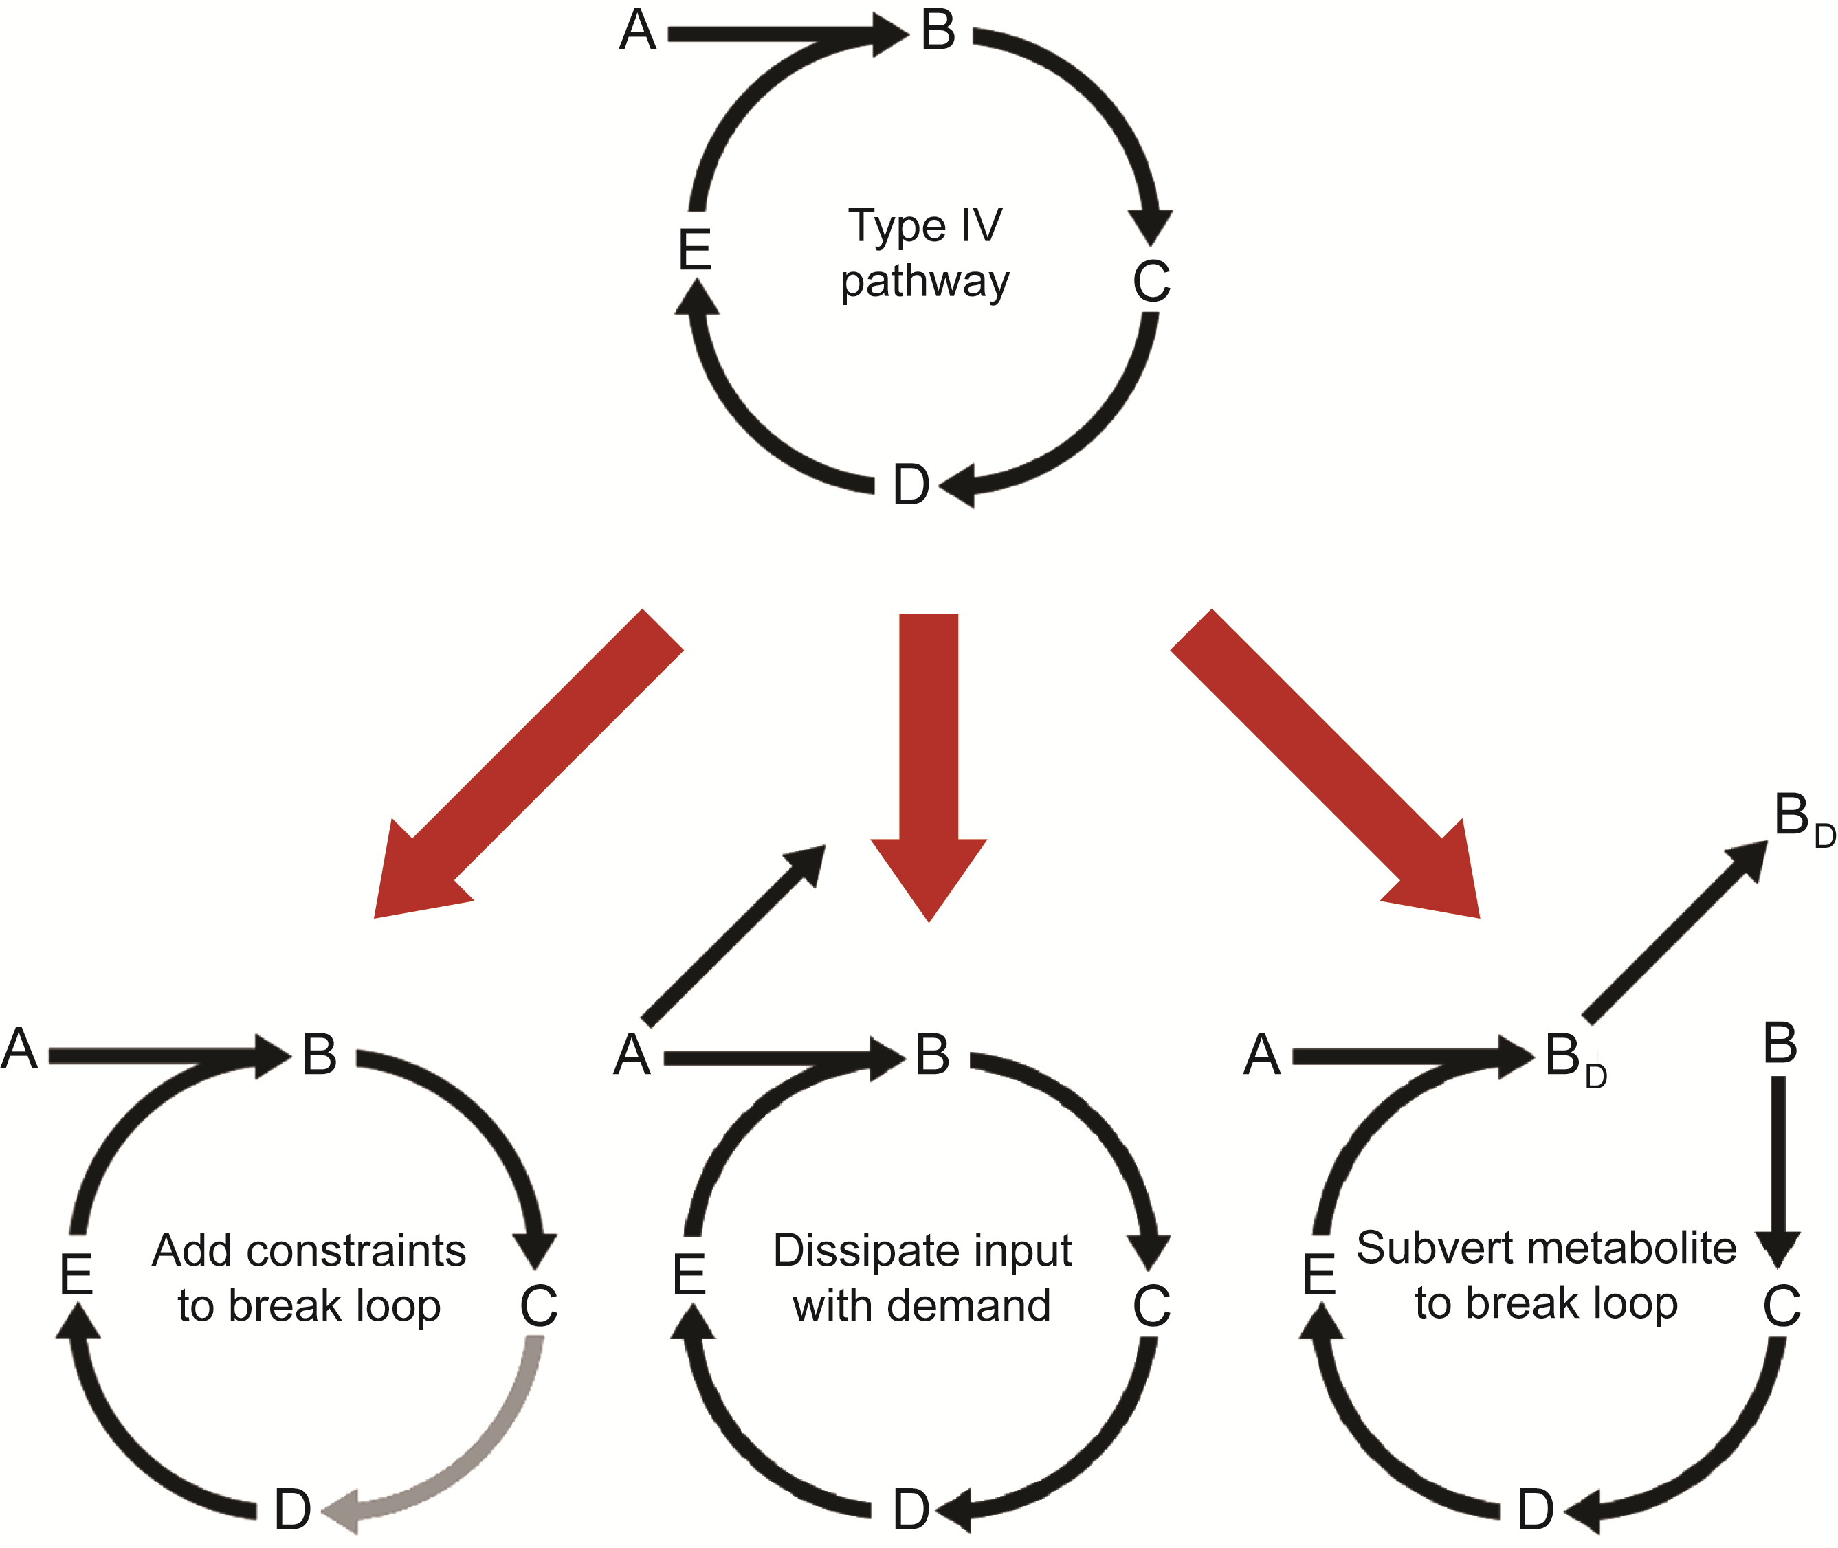
Supplementary Figure S4 Resolving type IV pathways. The top pathway diagram illustrates the basic concept of a type IV metabolic pathway with one input and no output, where capital letters represent hypothetical metabolites and arrows represent reactions. The bottom row of diagrams illustrates the approaches devised in this study to resolve type IV pathways so that they do not impact simulations using our photosynthetic models (see Metabolic network reconstruction in the Supplementary Methods).

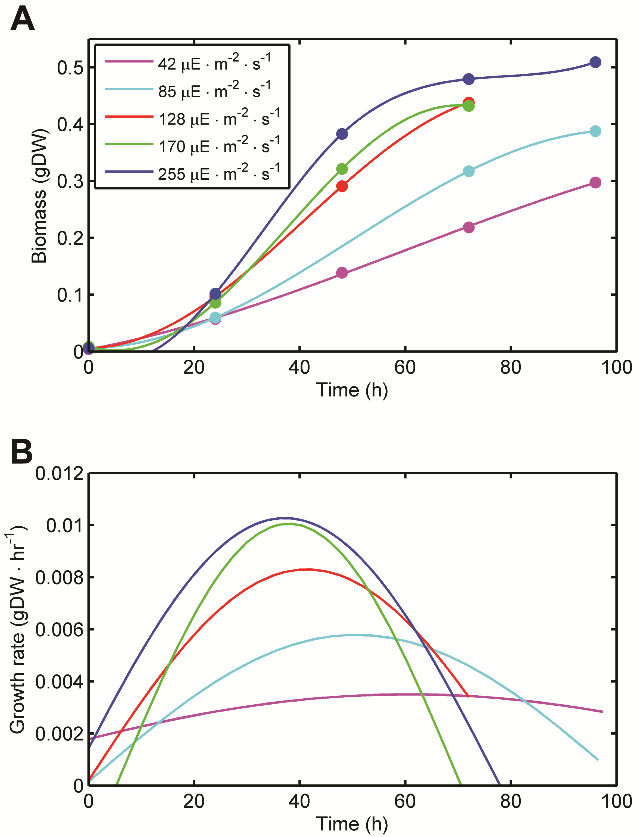
Supplementary Figure S5 Growth measured under varying red LED photon flux. (A) Biomass curves. Points represent experimentally-measured values. (B) Growth rate curves. The color legend is identical for both plots (see Chlamydomonas reinhardtii strain and growth conditions in the Supplementary Methods).

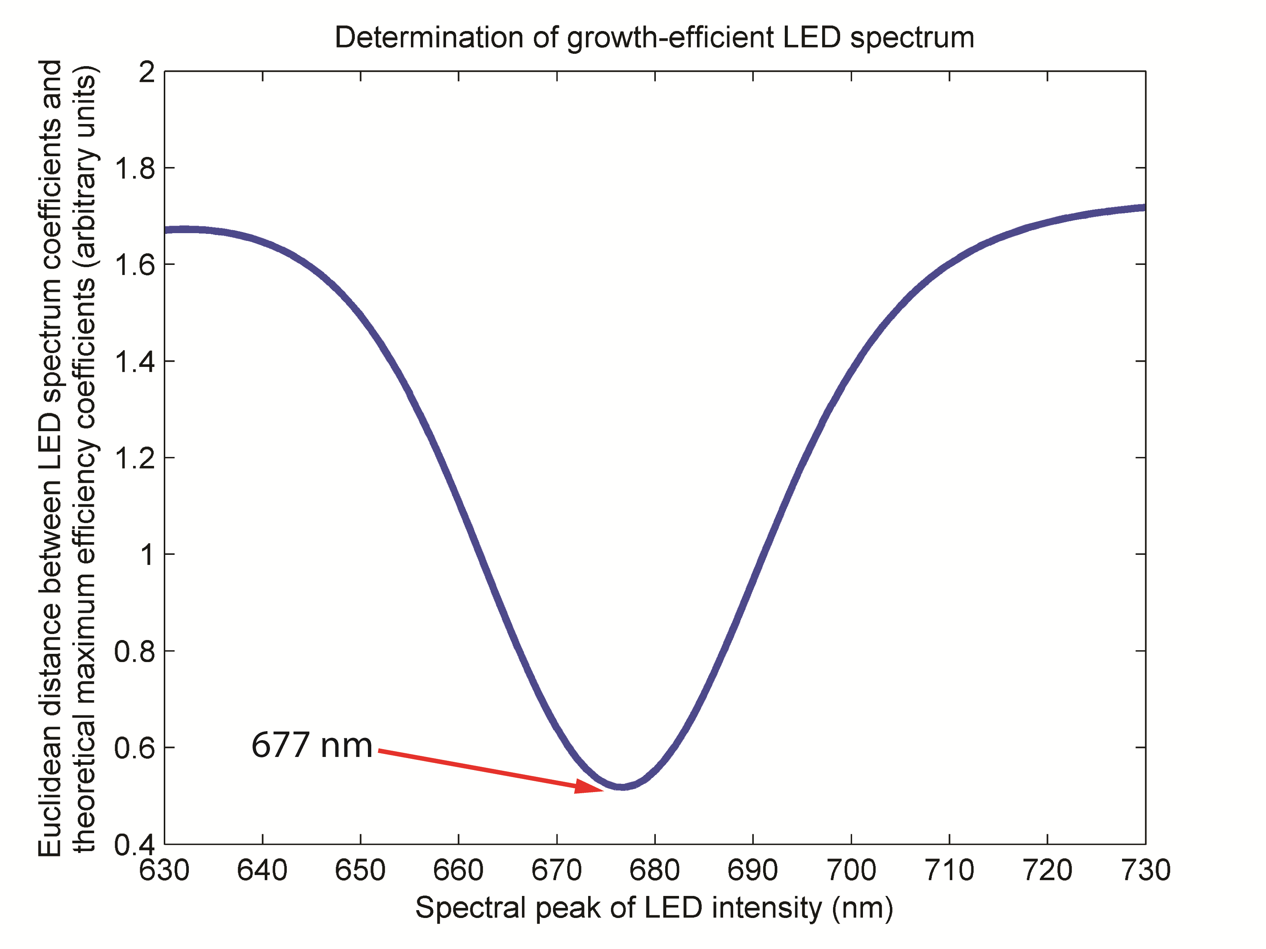
Supplementary Figure S6 Euclidean vector distance for LED design. The curve displays the Euclidean vector distance computed for prism reaction coefficients from iteratively higher-wavelength-centered LED spectra with respect to the simulated most efficient coefficients. The minimum distance corresponds to the LED spectrum most closely resembling the simulated most efficient coefficients and is centered at 677 nm.

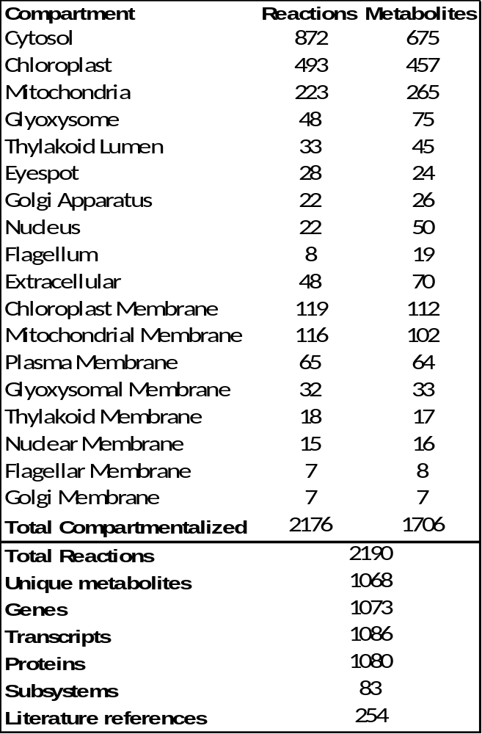
Supplementary Table S1 Metabolic network characteristics. Compartmental distributions of reactions and metabolites are given, in addition to the genetic and subsystem content of iRC1080. The number of literature references used in the reconstruction process is also noted.

Supplementary Table S2 Complete iRC1080 network data. All data included in the iRC1080 network are presented here including but not limited to lower and upper flux bounds (LB and UB, respectively) and all literature references used during the reconstruction. The flux bounds highlighted in yellow represent model input and output parameters that were varied when performing the various simulations presented in this study, and the values in these columns only represent defaults and not the actual values used in any specific simulation.

Supplementary Table S3 Transcript functional annotation. The full set of metabolic functional annotation of transcripts is presented, including but not limited to those functions and transcripts represented in iRC1080. The rightmost column denotes the method by which the annotation was obtained: 1 corresponds to the first method we implemented for annotation, 2 corresponds to the second method we implemented for annotation, 3 corresponds to both methods, TCDB signifies annotation resulting from a bidirectional BLAST search comparing TCDB to the C. reinhardtii genome (JGI v4.0), and literature references signify those annotations taken directly from published literature.

Supplementary Table S4 Transcript verification status. The percentage of sequence length verification is given for all experimentally tested transcripts included in iRC1080 (see Transcript verification experiments in the Supplementary Methods for more details). Those transcripts verified by capillary Sanger sequencing are denoted by an asterisk.

Supplementary Table S5 Light and dark-regulated reaction constraints. Reaction regulation under light and dark conditions, used in this study for constraint-based modeling, are summarized.

Supplementary Table S6 Basic modeling constraints. Precise values of parameters used to constrain models in simulations are presented.

Supplementary Table S7 Environmental validations. Outcomes of simulations are compared to experimentally measured results to validate model function with respect to environmental parameters.

Supplementary Table S8 Genetic validations. Outcomes of knock-out simulations are compared to the analogous experimentally measured mutant phenotypes to validate model function with respect to genetic parameters.

Supplementary Table S9 Gene-knockout lethality. Growth or subsistence, in the case of anaerobic dark growth, phenotypes of all single-gene knockout simulations are presented. Phenotypes are classified in relation to the objective flux achieved relative to the wild type simulation: wild type phenotype (WT), reduced relative to wild type phenotype (R), and lethal (L).

Supplementary Table S10 Biomass functions. Stoichiometric coefficients for all biomass components accounted for to simulate growth in this study are presented under three growth conditions: photoautotrophic, heterotrophic, and mixotrophic.

Supplementary Table S11 Constants for calculations. The basic cellular parameters assumed for calculations in this study and the derived conversion factors (see Dimensional and effective photon flux conversion factor derivation in the Supplementary Methods) are presented.

Supplementary Model S1 SBML-format iRC1080 base model. This file contains the reactions, metabolites, and gene-protein-reaction associations included in iRC1080 in SBML format for ease of use of our network in performing simulations. Constraints set in this file represent a default state and need to be set properly prior to simulation.

References
Apweiler R, Bairoch A, Wu CH (2004) Protein sequence databases. Curr Opin Chem Biol 8: 76-80

Ashburner M, Ball CA, Blake JA, Botstein D, Butler H, Cherry JM, Davis AP, Dolinski K, Dwight SS, Eppig JT, Harris MA, Hill DP, Issel-Tarver L, Kasarskis A, Lewis S, Matese JC, Richardson JE, Ringwald M, Rubin GM, Sherlock G (2000) Gene ontology: tool for the unification of biology. The Gene Ontology Consortium. Nat Genet 25: 25-29

Barta DJ, Tibbitts TW, Bula RJ, Morrow RC (1992) Evaluation of light emitting diode characteristics for a space-based plant irradiation source. Adv Space Res 12: 141-149

Becker SA, Feist AM, Mo ML, Hannum G, Palsson BO, Herrgard MJ (2007) Quantitative prediction of cellular metabolism with constraint-based models: the COBRA Toolbox. Nat Protoc 2: 727-738

Beckmann M, Hegemann P (1991) In vitro identification of rhodopsin in the green alga Chlamydomonas. Biochemistry 30: 3692-3697

Berberoglu H, Pilon L, Melis A (2008) Radiation characteristics of Chlamydomonas reinhardtii CC125 and its truncated chlorophyll antenna transformants tla1, tlaX and tla1-CW+. International Journal of Hydrogen Energy 33: 6467-6483

Berg J, Tymoczko J, Stryer L (2007) Biochemistry: W. H. Freeman.

Bjorn L (2007) Photobiology: The Science of Life and Light: Springer.

Boyle NR, Morgan JA (2009) Flux balance analysis of primary metabolism in Chlamydomonas reinhardtii. BMC Syst Biol 3: 4

Chavali AK, Whittemore JD, Eddy JA, Williams KT, Papin JA (2008) Systems analysis of metabolism in the pathogenic trypanosomatid Leishmania major. Mol Syst Biol 4: 177

Chen F, Johns MR (1994) Substrate inhibition of Chlamydomonas reinhardtii by acetate in heterotrophic culture. Process Biochemistry 29: 245-252

Claudel-Renard C, Chevalet C, Faraut T, Kahn D (2003) Enzyme-specific profiles for genome annotation: PRIAM. Nucleic Acids Res 31: 6633-6639

Couture M, Das TK, Lee HC, Peisach J, Rousseau DL, Wittenberg BA, Wittenberg JB, Guertin M (1999) Chlamydomonas chloroplast ferrous hemoglobin. Heme pocket structure and reactions with ligands. J Biol Chem 274: 6898-6910

Dansen TB, Pap EHW, Wanders RJ, Wirtz KW (2001) Targeted fluorescent probes in peroxisome function. Histochem J 33: 65-69

Feist AM, Herrgard MJ, Thiele I, Reed JL, Palsson BO (2009) Reconstruction of biochemical networks in microorganisms. Nat Rev Microbiol 7: 129-143

Forster J, Famili I, Fu P, Palsson BO, Nielsen J (2003) Genome-scale reconstruction of the Saccharomyces cerevisiae metabolic network. Genome Res 13: 244-253

Giordano M, Norici A, Forssen M, Eriksson M, Raven JA (2003) An anaplerotic role for mitochondrial carbonic anhydrase in Chlamydomonas reinhardtii. Plant Physiol 132: 2126-2134

Giroud C, Gerber A, Eichenberger W (1988) Lipids of Chlamydomonas reinhardtii. Analysis of molecular species and intracellular site(s) of biosynthesis. Plant Cell Physiol 29: 587-595

Harder JW, Lawrence GM, Rottman GJ, Woods TN (2000) Spectral Irradiance Monitor (SIM) for the SORCE mission. Earth Observing Systems V 4135: 204-214

Harris E, Stern D, Witman G (2008) The Chlamydomonas Sourcebook: Introduction to Chlamydomonas and its laboratory use: Academic Press.

Hegemann P, Marwan W (1988) Single photons are sufficient to trigger movement responses in Chlamydomonas reinhardtii. Photochem Photobiol 48: 99-106

Helm M, Luck C, Prestele J, Hierl G, Huesgen PF, Frohlich T, Arnold GJ, Adamska I, Gorg A, Lottspeich F, Gietl C (2007) Dual specificities of the glyoxysomal/peroxisomal processing protease Deg15 in higher plants. Proc Natl Acad Sci U S A 104: 11501-11506

Hillier L, Green P (1991) OSP: a computer program for choosing PCR and DNA sequencing primers. PCR Methods Appl 1: 124-128

Igamberdiev AU, Lea PJ (2002) The role of peroxisomes in the integration of metabolism and evolutionary diversity of photosynthetic organisms. Phytochemistry 60: 651-674

Ike A, Toda N, Tsuji N, Hirata K, Miyamoto K (1997) Hydrogen photoproduction from CO2-fixing microalgal biomass: Application of halotolerant photosynthetic bacteria. Journal of Fermentation and Bioengineering 84: 606-609

Kanehisa M, Goto S (2000) KEGG: kyoto encyclopedia of genes and genomes. Nucleic Acids Res 28: 27-30

Kargul J, Nield J, Barber J (2003) Three-dimensional reconstruction of a light-harvesting complex I-photosystem I (LHCI-PSI) supercomplex from the green alga Chlamydomonas reinhardtii. Insights into light harvesting for PSI. J Biol Chem 278: 16135-16141

Koski LB, Gray MW, Lang BF, Burger G (2005) AutoFACT: an automatic functional annotation and classification tool. BMC Bioinformatics 6: 151

Lee JM, Gianchandani EP, Papin JA (2006) Flux balance analysis in the era of metabolomics. Brief Bioinform 7: 140-150

Lu Z, Szafron D, Greiner R, Lu P, Wishart DS, Poulin B, Anvik J, Macdonell C, Eisner R (2004) Predicting subcellular localization of proteins using machine-learned classifiers. Bioinformatics 20: 547-556

MacLaughlin JA, Anderson RR, Holick MF (1982) Spectral character of sunlight modulates photosynthesis of previtamin D3 and its photoisomers in human skin. Science 216: 1001-1003

Manichaikul A, Ghamsari L, Hom EF, Lin C, Murray RR, Chang RL, Balaji S, Hao T, Shen Y, Chavali AK, Thiele I, Yang X, Fan C, Mello E, Hill DE, Vidal M, Salehi-Ashtiani K, Papin JA (2009) Metabolic network analysis integrated with transcript verification for sequenced genomes. Nat Methods 6: 589-592

Merchant SS, Prochnik SE, Vallon O, Harris EH, Karpowicz SJ, Witman GB, Terry A, Salamov A, Fritz-Laylin LK, Marechal-Drouard L, Marshall WF, Qu LH, Nelson DR, Sanderfoot AA, Spalding MH, Kapitonov VV, Ren Q, Ferris P, Lindquist E, Shapiro H et al (2007) The Chlamydomonas genome reveals the evolution of key animal and plant functions. Science 318: 245-250

Messerli MA, Amaral-Zettler LA, Zettler E, Jung SK, Smith PJ, Sogin ML (2005) Life at acidic pH imposes an increased energetic cost for a eukaryotic acidophile. J Exp Biol 208: 2569-2579

Mitchell SF, Trainor FR, Rich PH, Goulden CE (1992) Growth of Daphnia magna in the laboratory in relation to the nutritional state of its food species, Chlamydomonas reinhardtii. J Plankton Res 14: 379-391

Mueller LA, Zhang P, Rhee SY (2003) AraCyc: a biochemical pathway database for Arabidopsis. Plant Physiol 132: 453-460

Nakamura N, Tanaka S, Teko Y, Mitsui K, Kanazawa H (2005) Four Na+/H+ exchanger isoforms are distributed to Golgi and post-Golgi compartments and are involved in organelle pH regulation. J Biol Chem 280: 1561-1572

Nield J, Kruse O, Ruprecht J, da Fonseca P, Buchel C, Barber J (2000) Three-dimensional structure of Chlamydomonas reinhardtii and Synechococcus elongatus photosystem II complexes allows for comparison of their oxygen-evolving complex organization. J Biol Chem 275: 27940-27946

Niyogi KK, Bjorkman O, Grossman AR (1997) The roles of specific xanthophylls in photoprotection. Proc Natl Acad Sci U S A 94: 14162-14167

Orth JD, Thiele I, Palsson BO (2010) What is flux balance analysis? Nat Biotechnol 28: 245-248

Peers G, Truong TB, Ostendorf E, Busch A, Elrad D, Grossman AR, Hippler M, Niyogi KK (2009) An ancient light-harvesting protein is critical for the regulation of algal photosynthesis. Nature 462: 518-521

Polle JE, Kanakagiri SD, Melis A (2003) tla1, a DNA insertional transformant of the green alga Chlamydomonas reinhardtii with a truncated light-harvesting chlorophyll antenna size. Planta 217: 49-59

Price ND, Famili I, Beard DA, Palsson BO (2002) Extreme pathways and Kirchhoff's second law. Biophys J 83: 2879-2882

Reed JL, Famili I, Thiele I, Palsson BO (2006) Towards multidimensional genome annotation. Nat Rev Genet 7: 130-141

Ren Q, Chen K, Paulsen IT (2007) TransportDB: a comprehensive database resource for cytoplasmic membrane transport systems and outer membrane channels. Nucleic Acids Res 35: D274-279

Riekhof WR, Ruckle ME, Lydic TA, Sears BB, Benning C (2003) The sulfolipids 2'-O-acyl-sulfoquinovosyldiacylglycerol and sulfoquinovosyldiacylglycerol are absent from a Chlamydomonas reinhardtii mutant deleted in SQD1. Plant Physiol 133: 864-874

Roberts K (1974) Crystalline glycoprotein cell walls of algae: their stucture, composition and assembly. Philos Trans R Soc Lond B Biol Sci 268: 129-146

Saier MH, Jr., Yen MR, Noto K, Tamang DG, Elkan C (2009) The Transporter Classification Database: recent advances. Nucleic Acids Res 37: D274-278

Seksek O, Bolard J (1996) Nuclear pH gradient in mammalian cells revealed by laser microspectrofluorimetry. J Cell Sci 109 ( Pt 1): 257-262

Shioi Y, Sasa T (1984) Chlorophyll formation in the YG-6 mutant of Chlorella regularis: spectral characterization of protochlorophyllide phototransformation. Plant Cell Physiol 25: 139-149

Sineshchekov OA, Jung KH, Spudich JL (2002) Two rhodopsins mediate phototaxis to low- and high-intensity light in Chlamydomonas reinhardtii. Proc Natl Acad Sci U S A 99: 8689-8694

Stein SE, Heller SR, Tchekhovski D (2003) An Open Standard for Chemical Structure Representation - The IUPAC Chemical Identifier. In Nimes International Chemical Information Conference Proceedings, pp 131-143.

Tatsuzawa H, Takizawa E, Wada M, Yamamoto Y (1996) Fatty acid and lipid composition of the acidophilic green alga Chlamydomonas sp. J Phycol 32: 598-601

Thiele I, Palsson BO (2010) A protocol for generating a high-quality genome-scale metabolic reconstruction. Nat Protoc 5: 93-121

Valle O, Lien T, Knutsen G (1981) Fluorometric determination of DNA and RNA in Chlamydomonas using ethidium bromide. J Biochem Biophys Methods 4: 271-277

Walhout AJ, Temple GF, Brasch MA, Hartley JL, Lorson MA, van den Heuvel S, Vidal M (2000) GATEWAY recombinational cloning: application to the cloning of large numbers of open reading frames or ORFeomes. Methods Enzymol 328: 575-592

Zdobnov EM, Apweiler R (2001) InterProScan--an integration platform for the signature-recognition methods in InterPro. Bioinformatics 17: 847-848

