Supplemental - Model Gaps Filled and Extant
Like any metabolic reconstruction, the presented reconstruction of Methanosarcina acetivorans contains gaps in the genome annotation due to an incomplete knowledge about its metabolism. Many of the pathways in the Bacteria domain differ from those in the Archaea, and much progress has been made illuminating those differences. However, as this supplemental shows, there is clearly more work to be done to completely understand metabolism in the Archaea, and particularly in M. acetivorans.
Presented here are two lists. First we present a list of gaps found in the previously-published M. barkeri reconstruction that have been filled or partially filled in the presented reconstruction. Second, we present a list of known gaps in the metabolic network of M. acetivorans as of the time of publication of our model. The names of the metabolites in the plots below correspond to the metabolite IDs in the metabolic model. Some of the pathways described here have other biochemical evidence such as carbon labeling, but the evidence was described in other organisms and no genes have been identified to carry out the proposed functions. Other pathways or reactions have known genes in other organisms but they have no significant sequence homology with any genes in M. acetivorans.
The genome of Methanosarcina acetivorans contains over 1000 ORFs annotated as hypothetical proteins. It is our hope that this list will be useful for assigning functions to some of them and furthering the general knowledge of archaeal metabolic functions.
Figure Key
The key to the figures in this section is shown in table A.1 below. If a gene product in another organism has been verified to perform the reaction, the gene locus is shown in parenthesis (e.g. (MJ_0001) ). Any genes in M. acetivorans predicted to perform the same reaction are shown adjacent (no M. acetivorans gene is shown if there was no sequence similarity with the verified genes).
Table A.1. Key to model gap figures.
Color | Pattern | Meaning
Red |  | Genetic evidence suggests the genes needed to perform the reaction are not present in M. acetivorans.
Blue |  | No genes associated with the reaction are known, but there is evidence aside from genetic evidence for the pathway's existence in other closely related organisms
Green |  | At least one gene associated with the reaction is predicted or known to be present in M. acetivorans

Filled Gaps from the Feist et al. Methanosarcina barkeri Reconstruction and the Kumar et al. Methanosarcina acetivorans Reconstruction
Aromatic Amino Acid Biosynthesis
6-deoxy-5-ketofructose 1-phosphate (dkfp) is an intermediate known to be involved in the synthesis of aromatic amino acids in some methanogens, including Methanocaldococcus jannaschii (23). Until recently, the steps involved in synthesis of this compound were unclear. After publication of the original M. barkeri model, the genes and exact biochemistry involved in synthesis of this compound were elucidated in M. jannaschii (24). Since the genes that were characterized have strong homologues in M. acetivorans, the uncharacterized pathway was replaced with the newly-characterized pathway.
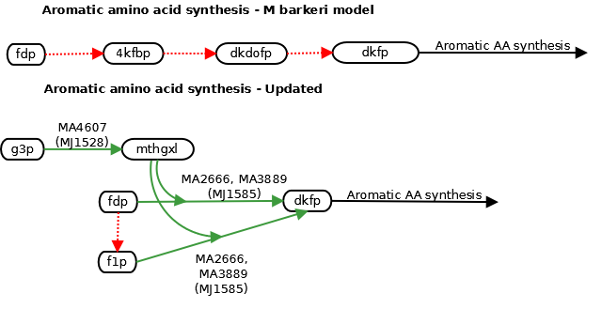
Coenzyme M Biosynthesis
Coenzyme M is one of the methyl carriers in the methanogenesis pathway. A coenzyme M synthesis pathway has been identified in Methanocaldococcus jannaschii, and the genes in the first part of the pathway have been characterized (3, 5, 6). The first part of this pathway seems to be missing from the Methanosarcina, and indeed, an alternative pathway has been characterized in M. acetivorans, and the genes involved have been identified (4). The genes responsible for the last steps in the pathway have not yet been identified. The pathways in M. jannaschii and in M. acetivorans are shown below.
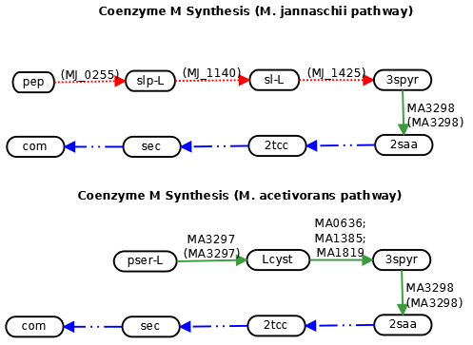

Mevalonate Synthesis
The mevalonate pathway is one of the critical parts of isoprenoid lipid synthesis, concluding in the synthesis of isopentenyl diosphate (ipdp). No genes were found homologous to the existing mevalonate pathway in yeast. A modified pathway has recently been identified in Methanocaldococcus jannaschii, in which the order of the decarboxylation and phosphorylation steps of 5-phosphomevalonate are reversed (8). Since the verified protein product in the new pathway (MJ0044) has a strong homolog in M. acetivorans, the pathway in M. barkeri was replaced with the one characterized in M. jannaschii.
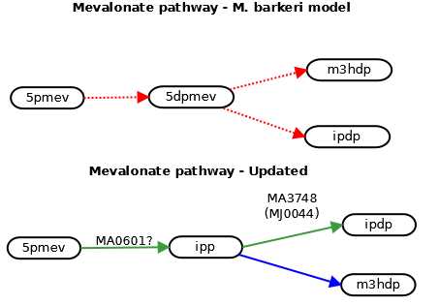
Ribose Synthesis
It is well known that many methanogens, including Methanosarcina acetivorans, Methanosarcina barkeri, and Methanocaldococcus jannaschii , are missing clear homologues for enzymes in the non-oxidative branch of the pentose phosphate pathway. The M. barkeri model included this pathway for synthesis of ribose. However, M. jannaschii has recently been shown to possesses a ribulose monophosphate pathway (RuMP) that can perform the essential function of ribose synthesis (9). The genes involved in the newly described pathway have strong homologues in M. acetivorans, and therefore the pathway was included instead of the oxidative pentose phosphate pathway.
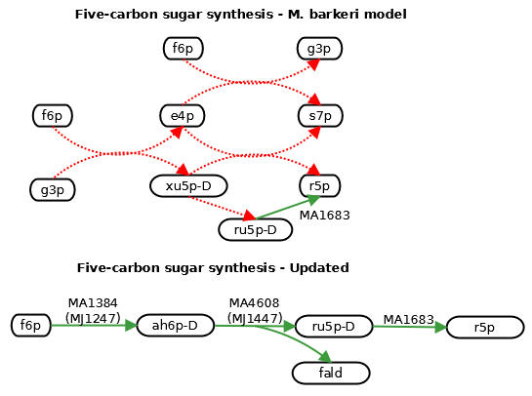

Known Knowledge Gaps Present in the Current Model of M. acetivorans

4-aminobenzoate Biosynthesis
4-aminobenzoate (4abz) is an intermediate required for synthesis of both folates and tetrahydromethanopterin according to the proposed pathways for each. Methanosarcina barkeri has to be supplemented with this compound to grow, but M. acetivorans does not. This could be because M. acetivorans possesses folate-independent versions of the folate-dependent enzymes in M. barkeri (for an analysis of folate in M. barkeri, see (2) ). It could also be due to the ability of M. acetivorans but not M. barkeri to synthesize 4abz de novo.
The genes for the canonical pathway for 4abz synthesis in E. coli are apparently missing in Methanosarcina. However, an alternative pathway has been proposed in Methanococcus maripalidus (which also lacks the canonical pathway) based on carbon labeling (15). No genes in this proposed pathway have been identified yet, so it is unknown if the pathway could exist in M. acetivorans. It has been added based on the lack of need to uptake 4abz from the medium.

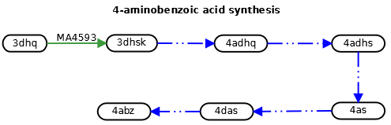
Biotin Biosynthesis
Unlike in Methanocaldococcus jannaschii, none of the genes in the canonical pathway for biotin synthesis appear to be present in M. acetivorans. Except for the first reaction, suggested in a review of cofactor synthesis pathways (22), the reactions listed here are all from KEGG. Note that many archaea do not possess these genes, and it has been suggested that M. jannaschii acquired them by lateral gene transfer from the bacteria (17).
Only the biotin synthase has (weak) homology with a M. acetivorans gene, and that gene has been suggested to have a role in pyrrolysine synthesis rather than biotin synthesis (12). It is unknown if M. acetivorans actually synthesizes biotin - the pathway has been included under the assumption that it does.
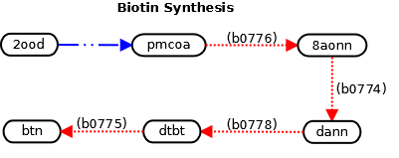

Coenzyme A Biosynthesis
The canonical pathway for coenzyme A biosynthesis is different in the archaea than in the bacterial domain. Some work has already been done to unravel the pathway in the archaea (MM2281 and TK1686 encode novel archaeal reactions) (25). However, if M. acetivorans can synthesize (R)-pantothenate de novo, the pathway for doing so remains unknown, for the canonical genes for both of the known pathways seem to be missing (one pathway shown). The gene responsible for catalyzing the final step in the synthesis is also unknown.
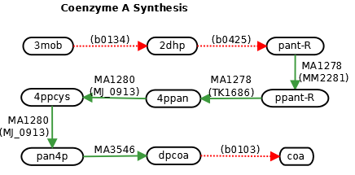
Coenzyme F₃₉₀ Metabolism
Coenzyme F₃₉₀ is a derivative of Coenzyme F₄₂₀ that appears to function in a redox-sensing mechanism in methanogenic archaea (20). The coenzyme F₃₉₀ synthetase has been characterized in M. thermoautotrophicum str. Marburg and has a strong homologue in M. acetivorans (19). However, although the Coenzyme F₃₉₀ hydrolase enzyme has been purified (20), the gene encoding this enzyme is still unknown.

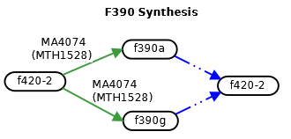

Coenzyme F₄₂₀ and Riboflavin Biosynthesis
Both the canonical beginning of the pathway for riboflavin synthesis and the alternate pathway characterized in M. jannaschii (7) appear to be missing in M. acetivorans, based on lack of homology with characterized genes. The third step has a characterized gene in M. jannaschii and is homologous to a gene in M. acetivorans (E ~ 1E-40), and the fourth step has no known gene.
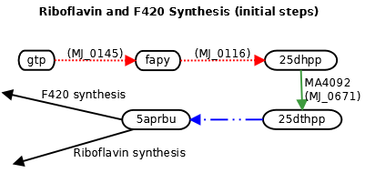

Coenzyme F₄₃₀ Biosynthesis
Coenzyme F₄₃₀ is a nickel-containing coenzyme essential in some of the energy-conserving steps in methanogenesis, including MCR (14, 18). Coenzyme F₄₃₀ synthesis has been studied relatively little compared to pathways for synthesis of the other methanogenic cofactors, but a potential pathway has been proposed for its synthesis from dihydrosirohydrochlorin in five steps (14). No genes were identified. The exact chemical structure of most of the intermediates is unknown except for 15,173-seco-F430-173-acid (sf430a), which was identified in Methanobrevibacter arboriphilus (14).
It has been suggested that genes annotated as magnesium chelatases may in fact be nickel chelatases involved in this pathway (21). This is especially possible since the heme synthesis pathway in the Methanosarcina is likely to be different from the canonical pathway (see "Heme biosynthesis"), and therefore Protoporphyrin IX, the usual precursor for magnesium chelatase, would not necessarily be synthesized.
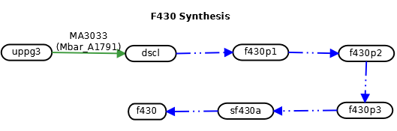

Folate and Methanopterin Biosynthesis
Most of the steps in folate and methanopterin biosynthesis have no characterized genes in the archaea. As discussed in the main text, even some of the genes that have been identified for these functions in M. jannaschii have no homologues in Methanosarcina. It is not clear how Methanosarcina synthesizes folates, but there is evidence that Methanosarcina barkeri possesses enzymes that depend on tetrahydrofolate for activity (2), and the same is assumed true of M. acetivorans. Therefore, there are likely novel enzymes and possibly a novel pathway to be discovered in this genus.
Most of the genes in the pathway have no gene association so it is difficult to tell the extent of the possible differences between the Methanocaldococcus and Methanosarcina synthesis pathways. However, even from those genes that are known, there are clear differences. The central part of the pathway seems to be the same but the initial synthesis and the addition of the hydroxyglutarate moiety to methanopterin apparently differ from the mechanisms in Methanocaldococcus. An alternate reaction for synthesis of dihydroneopterin (dhnpt) was suggested from KEGG, but the precursor metabolite for this reaction (ahdt) has no clear synthesis pathway in M. acetivorans, so this path seems more unlikely than that from Methanocaldococcus. It has been shown for completeness.
Previous work has suggested that there may be two pathways for synthesis of methanopterin in M. barkeri, one of which does not depend on synthesis of 4-aminobenzoate (4abz). However, the genetic evidence indicates that even if M. acetivorans has multiple synthesis pathways, they may both be different from that found in M. jannaschii. The nature of the differences between the pathways will become clearer as more genes in the pathway are identified and characterized.
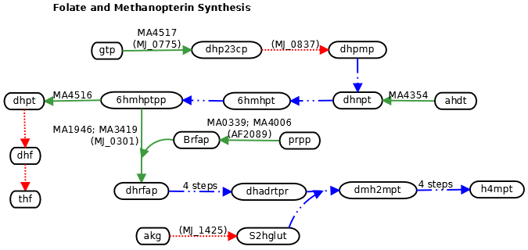

Heme Biosynthesis
Since Methanosarcina is a genus of methanogens with cytochromes (10), it must have a way to synthesize heme. Many genes in the later part of the canonical protoheme synthesis pathway (from uroporphyrinogen III to protoheme) are missing. The one gene that KEGG suggests to be present in M. acetivorans (HemG) would encode a reaction requiring oxygen for function, although M. acetivorans is strictly anaerobic. Therefore, it is highly likely an alternative pathway exists for synthesis of heme in Methanosarcina and other cytochrome-containing methanogens.
Although it is not fully characterized, an alternate pathway for heme (protoheme) synthesis has been suggested and partially characterized in Methanosarcina barkeri. The alternate pathway branches from precorrin 2 and involves SAM proteins (1). The only characterized genes which may be involved in the pathway are already annotated for their correct functions (16). Two different starts to the pathway have been suggested. In one possible pathway, precorrin-2 is oxidized to sirohydrochlorin with PC2-DH and then proceeds to protoheme by an unknown set of reactions (16). In another, precorrin 2 is decarboxylated and synthesis of protoheme proceeds from there (1). The latter pathway is shown below.
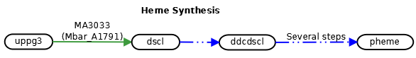
Lysine Biosynthesis
There are at least four known pathways for de novo lysine synthesis (11). The known genes involved in the pathways from thdp to 26dap-M appear to be missing in M. acetivorans. It has recently been reported that M. jannaschii utilizes the DapL pathway for lysine synthesis (11). One of the genes in this pathway has strong homology to a M. acetivorans gene, but one of them has no genes with significant sequence identity.
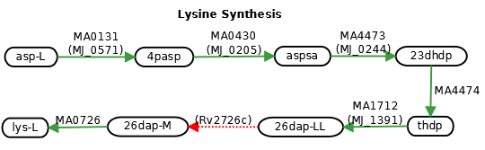
Methanofuran Biosynthesis
The methanofuran biosynthesis pathway, as reported in metacyc, was incorporated in the model with no genetic evidence, except for the reaction TYRCBOX. The gene responsible for that reaction was characterized in M. jannaschii and has a strong sequence homology with M. acetivorans gene MA0006. The remainder are hypothetical reactions based on chemical identification of some of the intermediates in M. jannaschii (22).
Note that M. barkeri (and probably M. acetivorans) uses methanofuran (b), while Methanococci use methanofuran (a). According to the difference in these structures, M. acetivorans probably does not need to synthesize hexane-1,3,4,6-tetracarboxylate as an intermediate in methanofuran synthesis. Instead, it appears that the final steps would be the addition of two additional glutamate residues to 4-[N-gamma-L-glutamyl-gamma-L-glutamyl-)-p-(ß-aminoethyl)phenoxy-methyl]-2-(aminomethyl)furan .
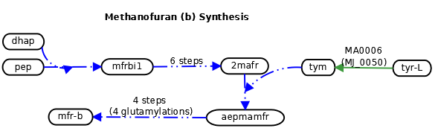

Methanophenazine Biosynthesis
Unlike the other methanogenic cofactors, the authors are not aware of any proposed pathways for synthesis of methanophenazine in any organisms, including M. acetivorans. Even though quinones have not been found in methanogens, there are 14 genes annotated for functions in ubiquinone synthesis in M. acetivorans. On the other hand, M. jannaschii, which does not use methanophenazine in its methanogenic pathways, contains no genes annotated for ubiquinone synthesis functions (KEGG predicts three through clustering analysis, but none of them agrees with the annotation). It is possible that some of these genes in M. acetivorans are involved in the synthesis of methanophenazine, which performs a similar function to quinones in that organism. Phenazines are synthesized as antibiotics in many Bacteria and some genes are known (13), but no sequence homology was identified (with the exception of phzF, MA3532). Biochemical experimentation will be necessary to identify the genes and pathways actually involved.

Purine Synthesis
Although most of the genes for synthesis of purines are present, two critical enzymes seem to be missing in Methanosarcina: IMP dehydrogenase, and GMP kinase. Both of these enzymes are predicted to be present in Methanocaldococcus based on sequence homology. They have been included in the model because they perform critical functions in nucleic acid synthesis.
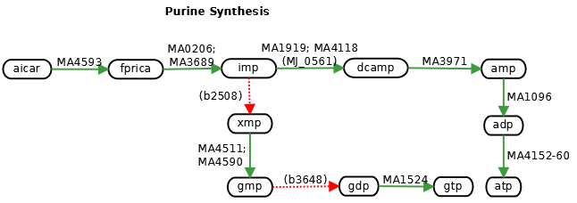
References
1. Buchenau, B., J. Kahnt, I. U. Heinemann, D. Jahn, and R. K. Thauer. 2006. Heme biosynthesis in Methanosarcina barkeri via a pathway involving two methylation reactions. J Bacteriol 188:8666-8668.
2. Buchenau, B., and R. K. Thauer. 2004. Tetrahydrofolate-specific enzymes in Methanosarcina barkeri and growth dependence of this methanogenic archaeon on folic acid or p-aminobenzoic acid. Arch Microbiol 182:313-325.
3. Graham, D. E., M. Graupner, H. Xu, and R. H. White. 2001. Identification of coenzyme M biosynthetic 2-phosphosulfolactate phosphatase. A member of a new class of Mg(2+)-dependent acid phosphatases. Eur J Biochem 268:5176-5188.
4. Graham, D. E., S. M. Taylor, R. Z. Wolf, and S. C. Namboori. 2009. Convergent evolution of coenzyme M biosynthesis in the Methanosarcinales: cysteate synthase evolved from an ancestral threonine synthase. Biochem J 424:467-478.
5. Graham, D. E., H. Xu, and R. H. White. 2002. Identification of coenzyme M biosynthetic phosphosulfolactate synthase: a new family of sulfonate-biosynthesizing enzymes. J Biol Chem 277:13421-13429.
6. Graupner, M., H. Xu, and R. H. White. 2000. Identification of an archaeal 2-hydroxy acid dehydrogenase catalyzing reactions involved in coenzyme biosynthesis in methanoarchaea. J Bacteriol 182:3688-3692.
7. Grochowski, L. L., H. Xu, and R. H. White. 2009. An iron(II) dependent formamide hydrolase catalyzes the second step in the archaeal biosynthetic pathway to riboflavin and 7,8-didemethyl-8-hydroxy-5-deazariboflavin. Biochemistry 48:4181-4188.
8. Grochowski, L. L., H. Xu, and R. H. White. 2006. Methanocaldococcus jannaschii uses a modified mevalonate pathway for biosynthesis of isopentenyl diphosphate. J Bacteriol 188:3192-3198.
9. Grochowski, L. L., H. Xu, and R. H. White. 2005. Ribose-5-phosphate biosynthesis in Methanocaldococcus jannaschii occurs in the absence of a pentose-phosphate pathway. J Bacteriol 187:7382-7389.
10. Heiden, S., R. Hedderich, E. Setzke, and R. K. Thauer. 1994. Purification of a two-subunit cytochrome-b-containing heterodisulfide reductase from methanol-grown Methanosarcina barkeri. Eur J Biochem 221:855-861.
11. Liu, Y., R. H. White, and W. B. Whitman. 2010. Methanococci use the diaminopimelate aminotransferase (DapL) pathway for lysine biosynthesis. J Bacteriol 192:3304-3310.
12. Longstaff, D. G., R. C. Larue, J. E. Faust, A. Mahapatra, L. Zhang, K. B. Green-Church, and J. A. Krzycki. 2007. A natural genetic code expansion cassette enables transmissible biosynthesis and genetic encoding of pyrrolysine. Proc Natl Acad Sci U S A 104:1021-1026.
13. Mavrodi, D. V., V. N. Ksenzenko, R. F. Bonsall, R. J. Cook, A. M. Boronin, and L. S. Thomashow. 1998. A seven-gene locus for synthesis of phenazine-1-carboxylic acid by Pseudomonas fluorescens 2-79. J Bacteriol 180:2541-2548.
14. Pfaltz, A., A. Kobelt, R. Huster, and R. K. Thauer. 1987. Biosynthesis of coenzyme F430 in methanogenic bacteria. Identification of 15,17(3)-seco-F430-17(3)-acid as an intermediate. Eur J Biochem 170:459-467.
15. Porat, I., M. Sieprawska-Lupa, Q. Teng, F. J. Bohanon, R. H. White, and W. B. Whitman. 2006. Biochemical and genetic characterization of an early step in a novel pathway for the biosynthesis of aromatic amino acids and p-aminobenzoic acid in the archaeon Methanococcus maripaludis. Mol Microbiol 62:1117-1131.
16. Storbeck, S., S. Rolfes, E. Raux-Deery, M. J. Warren, D. Jahn, and G. Layer. 2010. A novel pathway for the biosynthesis of heme in Archaea: genome-based bioinformatic predictions and experimental evidence. Archaea 2010:175050.
17. Streit, W. R., and P. Entcheva. 2003. Biotin in microbes, the genes involved in its biosynthesis, its biochemical role and perspectives for biotechnological production. Appl Microbiol Biotechnol 61:21-31.
18. Thauer, R. K. 1998. Biochemistry of methanogenesis: a tribute to Marjory Stephenson. 1998 Marjory Stephenson Prize Lecture. Microbiology 144 ( Pt 9):2377-2406.
19. Vermeij, P., R. J. van der Steen, J. T. Keltjens, G. D. Vogels, and T. Leisinger. 1996. Coenzyme F390 synthetase from Methanobacterium thermoautotrophicum Marburg belongs to the superfamily of adenylate-forming enzymes. J Bacteriol 178:505-510.
20. Vermeij, P., E. Vinke, J. T. Keltjens, and C. Van der Drift. 1995. Purification and properties of coenzyme F390 hydrolase from Methanobacterium thermoautotrophicum (strain Marburg). Eur J Biochem 234:592-597.
21. Walker, C. J., and R. D. Willows. 1997. Mechanism and regulation of Mg-chelatase. Biochem J 327 ( Pt 2):321-333.
22. White, R. H. 2001. Biosynthesis of the methanogenic cofactors. Vitam Horm 61:299-337.
23. White, R. H. 2004. L-Aspartate semialdehyde and a 6-deoxy-5-ketohexose 1-phosphate are the precursors to the aromatic amino acids in Methanocaldococcus jannaschii. Biochemistry 43:7618-7627.
24. White, R. H., and H. Xu. 2006. Methylglyoxal is an intermediate in the biosynthesis of 6-deoxy-5-ketofructose-1-phosphate: a precursor for aromatic amino acid biosynthesis in Methanocaldococcus jannaschii. Biochemistry 45:12366-12379.
25. Yokooji, Y., H. Tomita, H. Atomi, and T. Imanaka. 2009. Pantoate kinase and phosphopantothenate synthetase, two novel enzymes necessary for CoA biosynthesis in the Archaea. J Biol Chem 284:28137-28145.

