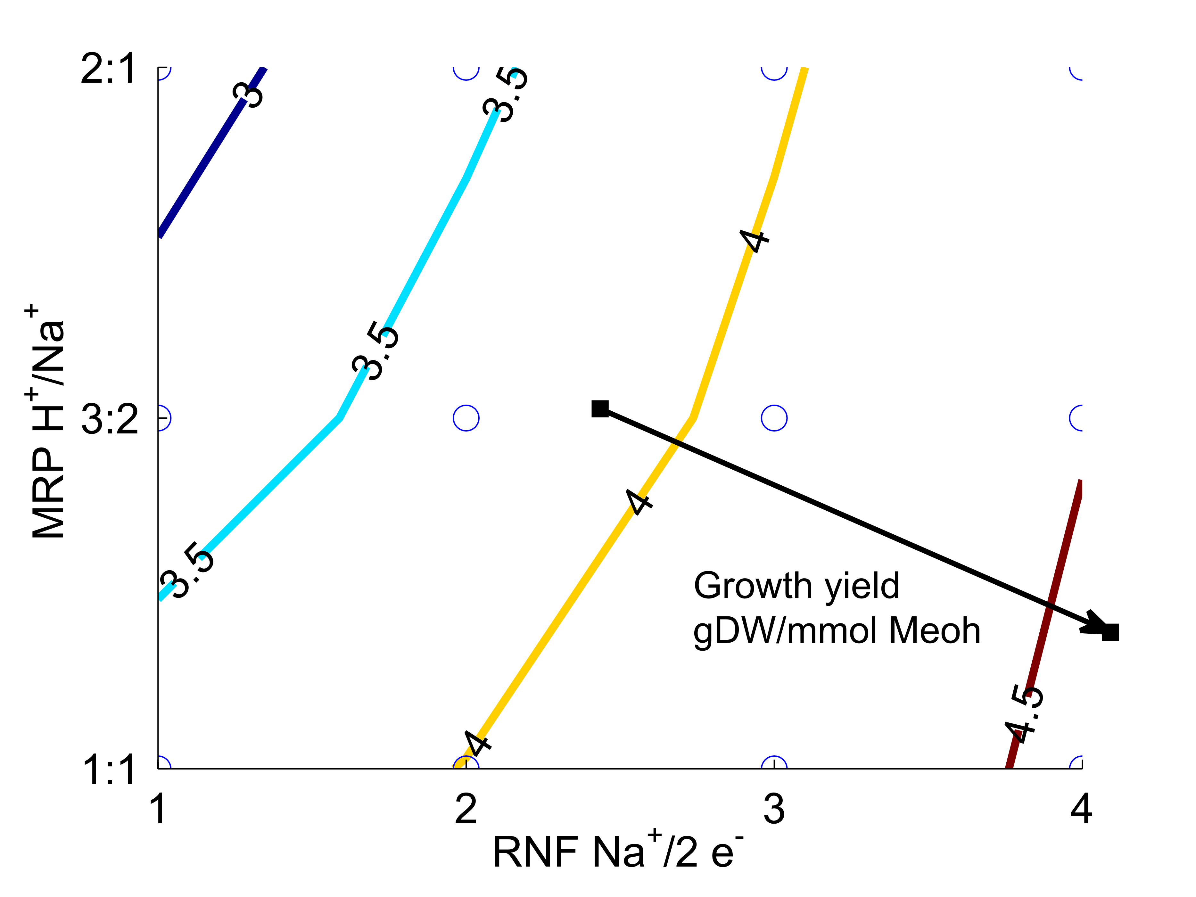
Figure S1: Analysis of the effects of RNF and MRP stoichiometry on methanol growth yields. The experimental growth yield on this substrate is 5.2 gDW/mol methanol. Note that although a combination of 1 Na pumped by RNF and a 3:2 ratio in Mrp produced a good prediction for growth on acetate, using the same values causes a great underprediction in the growth yield on methanol.

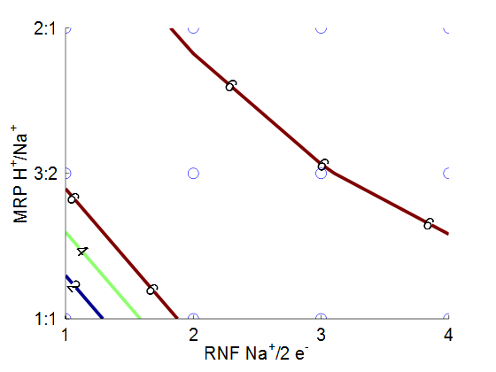
Figure S2. Methane secretion rate predctions were not strongly affected (except for (1, 1.1), a point at which no growth occurred) by the chosen reaction stoichiometries during growth on acetate (note that both of the brown bands represent 6 mmol/gDW/hr of methane production).No growth (and thus no methane secretion) was predicted when RNF only pumped one sodium and the sodium:proton exchange ratio was 1:1.
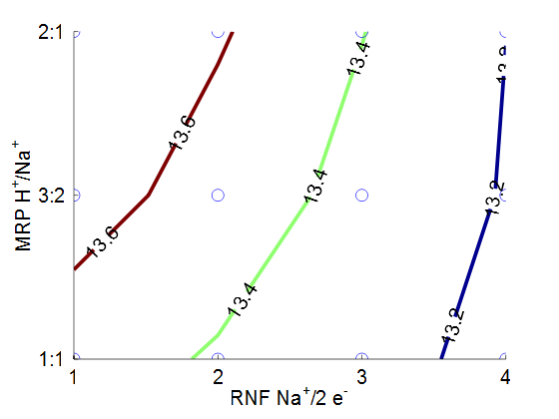
Figure S3 Methanogenesis predictions were not strongly affected by the chosen reaction stoichiometries during growth on methanol.

