**Wellness Center Appointment Services**

**Group Members: -**

|  |  |  |
| --- | --- | --- |
| **S. No** | **Team Member Name** | **Role** |
| 1 | Rehaman Naguru Abdur | Backend Developer & Database Administrative |
| 2 | Chaitanya Punaati | Backend Developer |
| 3 | Reshma Reddy Sunkireddy | Backend Developer & Database Administrative |
| 4 | Pulugurtha Vinay Madhur | Frontend Developer |
| 5 | Swapna Dasari | Frontend Developer |
| 6 | Hitesh Reddy Tirumala Reddy | Backend Developer |

Submitted in partial fulfillment

Of the requirements of

CSIS 44-691 Graduate Directed Project 1

Technologies & Platforms used

1. CSS
2. ReactJS
3. Node JS
4. Database (Firebase Authentication & Firebase Realtime Database)
5. Microsoft Visual Studio
6. GitHub

# 

**Table of Contents**

**Table of Contents**

1. Introduction
   1. Purpose
   2. Scope
   3. Definitions, Acronyms, and Abbreviations
   4. References
   5. Overview
2. General Description
   1. Product Perspective
   2. Product Functions
   3. User Characteristics
   4. General Constraints
   5. Assumptions and Dependencies
3. Specific Requirements
   1. External Interface Requirements
      1. User Interfaces
      2. Hardware Interfaces
      3. Software Interfaces
      4. Communications Interface
   2. Functional Requirements
   3. Use Cases
   4. Class/Objects
   5. Non-Functional Requirements

3.5.1. Performance

3.5.2. Reliability

3.5.3. Availability

3.5.4. Security

3.5.5. Portability

3.6. Inverse Requirements

3.7. Design Constraints

3.8. Logical Database Requirements

3.9. Other Requirements

3.10. Use Case Diagrams

4. Design

4.1. ER diagram

4.2. GUI

4.3 UI diagram

5. Analysis Models

5.1. Data Flow Diagram

5.2. Sequence Diagram

**1.Introduction**

Our university wellness center provides many services to make sure everyone is healthy. It is one of the great opportunity our university provides to us, but the challenge here is when we want to know what all the features are it is offering and when we want to book an appointment the only option, we have is either to call or email. There is no website or application for this. So, we would like to implement a website and do our best to help our university students/faculty/staff.

* 1. **Purpose**

To provide user friendly environment to college students/faculty/staff where they can get all the required details about university wellness center and find their medical history.

* 1. **Scope**

The scope of this project is to design a website for our university wellness center. This website contains what services wellness center is offering, how many doctors are available and their details like designation available days etc., how to book general and emergency appointment, reviewing medical history, information about blood donation vaccination drives etc.,

**1.3. Definitions, Acronyms, and Abbreviations**

**Abbreviations**

WCAS: is an abbreviation for Wellness Center Appointment Services.

**Acronyms**

The Wellness Center Appointment Services (WCAS) is a program that provides appointments for individuals who need to see a doctor, therapist, or other health care provider.

**1.4. References**

Following are the references we have used to complete our project.

For Website design

<https://reactjs.org/tutorial/tutorial.html>

<https://firebase.google.com/docs/web/setup>

For test cases

<https://jestjs.io/docs/getting-started>

**1.5. Overview**

This is a website which has public access to view information about university wellness center and certain features like booking appointment, view health history will be accessible through user login. Anyone can login to this website by signing up with their information. We used Firebase to store the user information (login details, medical appointment details etc.,)

**2. General Description**

User can see the information on the website, but if they want to book an appointment or to review their medical history, they need to sign into the website. User will be able to register to the website with their university credentials such as 919 id and password. Guest users can register in using their personal email address.

**2.1 Product Perspective**

The Wellness Center offers a variety of appointment services for students, faculty, staff, and people. These services include

* Wellness Consultations
* Nutrition Counseling
* Personal Training
* Health Coaching
* Fitness Classes

**2.2 Product Functions**

* The Wellness Center Appointment Service should allow a user to book an appointment with a health professional at a time that is convenient for the user.
* The Wellness Center Appointment Service should allow a user to view a list of available appointments.
* The Wellness Center Appointment Service should allow a user to cancel an appointment.
* The Wellness Center Appointment Service should allow a user to reschedule an appointment.
* The Wellness Center Appointment Service should allow a health professional to reschedule an appointment.

**2.3. User Characteristics**

The following are user characteristics for Wellness Center Appointment Services

* The user is looking for a wellness center that offers appointment services.
* The user wants to be able to schedule an appointment with a specific provider at a specific time.
* The user wants to be able to cancel or reschedule an appointment if necessary.
* The user wants to be able to view their upcoming appointments.
* The user wants to be able to view their past appointments.

**2.4. General Constraints**

There are a few general constraints that should be considered when providing wellness center appointment services.

**First,** the wellness center should have a clear and concise policy regarding how appointments are made and canceled. This will help to ensure that appointments are made in a timely manner and that cancellations are handled in a way that is fair to both the provider and the client.

**Second,** the provider should have a clear understanding of the client’s needs and expectations to provide the best possible service.

**Finally,** the provider should be aware of any medical conditions or medications that the client is taking to avoid any potential conflicts.

**2.5. Assumptions and Dependencies**

**Assumptions**

* The Wellness Center offers appointment-based services.
* Clients can book appointments online or over the phone.
* Clients can cancel or reschedule appointments online or over the phone.
* The Wellness Center has a limited number of appointments available each day.
* The Wellness Center offers a variety of services, each with a different length of time.
* Clients can only book one appointment at a time.

**Dependencies**

* The Wellness Center needs to be open in order for clients to book appointments.
* The Wellness Center needs to have staff available to provide the services.
* The Wellness Center needs to have the necessary equipment and supplies for the services.

**3. Specific Requirements:**

**3.1. External Interface Requirements**

* **User authentication:** Users must be able to create accounts and log in with secure usernames and passwords.
* **Scheduling:** Users must be able to search for and book wellness appointments based on their availability and preferences.
* **Notifications:** Users must be able to receive notifications about upcoming appointments and any changes to their appointments.
* **Reminders:** Users must be able to set up reminders for their appointments.
* **Cancellations and rescheduling:** Users must be able to cancel and reschedule their appointments.
* **Feedback:** Users must be able to provide feedback about their experiences with the service.

**3.1.1 User Interfaces**

The Wellness Center Appointment Service web app is designed to provide a user-friendly and convenient interface through which users can book appointments, manage their appointments, and access information relating to their upcoming appointments. The app is designed to provide a convenient interface that makes booking and managing appointments easy, while also giving users the ability to access information related to their appointments. The app is designed to be used by users of all ages and abilities.

**3.1.2 Hardware Interfaces**

The hardware interfaces for the appointment scheduling software will be implemented using Web services. Web services are software components that can be invoked over the Internet using standard protocols. By using Web services, the appointment scheduling software can be easily integrated with other software and hardware components.

**3.1.3 Software Interfaces**

Once the needs of the wellness center have been considered, it is important to choose a software interface that is user-friendly and easy to use. The interface should be intuitive and allow staff to schedule appointments quickly and easily. It should also allow patients to easily schedule their own appointments online.

When choosing a software interface for appointment scheduling, it is important to consider the needs of the wellness center. For example, if the center offers a variety of services with different appointment times, a software interface that allows for flexible scheduling may be necessary. If the center has a large number of appointments, a software interface that allows for automated appointment reminders may be helpful.

**3.1.4 Communications Interface**

The Wellness Center Appointment Services communications interface provides a way for patients to communicate with appointment service staff in order to make, cancel, or reschedule appointments. This interface can be accessed through the Wellness Center website or through the patient portal.

The interface also allows patients to schedule, cancel, or reschedule appointments. Appointment times and dates are displayed to the patient, and the patient can select the time and date that works best for them. Appointment service staff can see when a patient has scheduled, canceled, or reschedule an appointment.

**3.2. Functional Requirements**

The Wellness Center Appointment Services shall enable a Client to view a list of available Service Providers.

The Wellness Center Appointment Services shall enable a Service Provider to view a list of available doctors.

The Wellness Center Appointment Services shall enable a Service Provider to reschedule an appointment.

**3.3. Use Cases**

* A user wants to schedule an appointment for a specific service at a specific time.
* A user wants to cancel an appointment.
* A user wants to reschedule an appointment.
* A user wants to view a list of available appointments.
* A user wants to view a list of upcoming appointments.
* A user wants to view a list of past appointments.

**3.4 Class/Objects**

**Class**

* **Appointment:** This class would store data about an individual appointment, such as the date, time, type of service, and the customer.
* **Service:** This class would store data about the various services offered by the wellness center, such as the type of service, duration.
* **Customer:** This class would store data about the customers of the wellness center, such as their name, contact information.
* **Scheduling:** This class would contain methods for scheduling appointments and managing waitlists.
* **Reminders:** This class would contain methods for sending reminders to clients about upcoming appointments.

**Objects**

* **Appointment**: It represents an appointment booked at the wellness center.
* **Patient:** It represents a person who has booked an appointment.
* **Therapist:** It represents a specialist who provides treatments at the wellness center.
* **Treatment:** It represents a type of service provided by the therapist.
* **Date:** It represents the date of the appointment.
* **Time:** It represents the time of the appointment.
* **Scheduling System:** It represents the system used to manage appointments at the wellness center.

**3.5. Non-Functional Requirements**

**3.5.1. Performance**

We would like to improve the performance of our wellness center appointment service. The performance metric we will use to measure the performance of our appointment service is the percentage of appointments that are completed on time. There are a number of factors that can impact the performance of our appointment service, including the number of appointments, the length of appointments, the number of staff members available, and the number of cancellations. To improve the performance of our appointment service, we will need to increase the number of staff members available, reduce the length of appointments, and reduce the number of cancellations.

**3.5.2. Reliability**

The Wellness Center Appointment Services is reliable. The center has a good reputation and has been in business for many years. The center offers a variety of services, and the staff is knowledgeable and friendly. The center is clean and well-organized, and the appointments are easy to schedule.

**3.5.3. Availability**

The Wellness Center Appointment Services are available Monday through Friday from “ 8am to 5pm ”.

**3.5.4. Security**

When making an appointment with a wellness center, it is important to be aware of the security measures that are in place to protect your personal information. The first step is to make sure that the website you are using is secure. You can do this by looking for a “https” at the beginning of the URL. This means that the site is using a secure socket layer (SSL) to encrypt your personal information. Another security measure to look for is a privacy policy. This should be easily accessible on the website and should outline how your personal information will be used and protected. Finally, you should always pay attention to the security measures in place when you arrive for your appointment. This includes things like security cameras and guards, as well as any measures that have been put in place to protect your personal belongings.

**3.5.5. Portability**

The portability for Wellness Center Appointment Services is a web-based application that can be accessed from any computer with an internet connection.

**3.6. Inverse Requirements**

The health and wellness center is staffed with a variety of medical professionals who provide various services to the community. The health and wellness center requires all patients to make an appointment in order to be seen. The health and wellness center requires that all patients be 18 years of age or older.

**3.7. Design Constraints**

It should be able to be used by people of all ages -It should be able to be used by people with different types of disabilities -It should be available in multiple languages.

**3.8. Logical Database Requirements**

The logical database requirements for the Wellness Center Appointment Services are as follows: The database should be able to track appointments. The database should be able to track patient information. The database should be able to track provider information.

**3.9. Other requirements**

Additional requirements for this project is checking the website frequently and taking care of downtime. Updating the website whenever it is required. Taking actions against user feedback.

**3.10. Use case Diagrams**

1. **Design**

**4.1. ER diagram**

In our project we are using NOSQL database so we don’t have entity relationships.

**4.2. GUI**

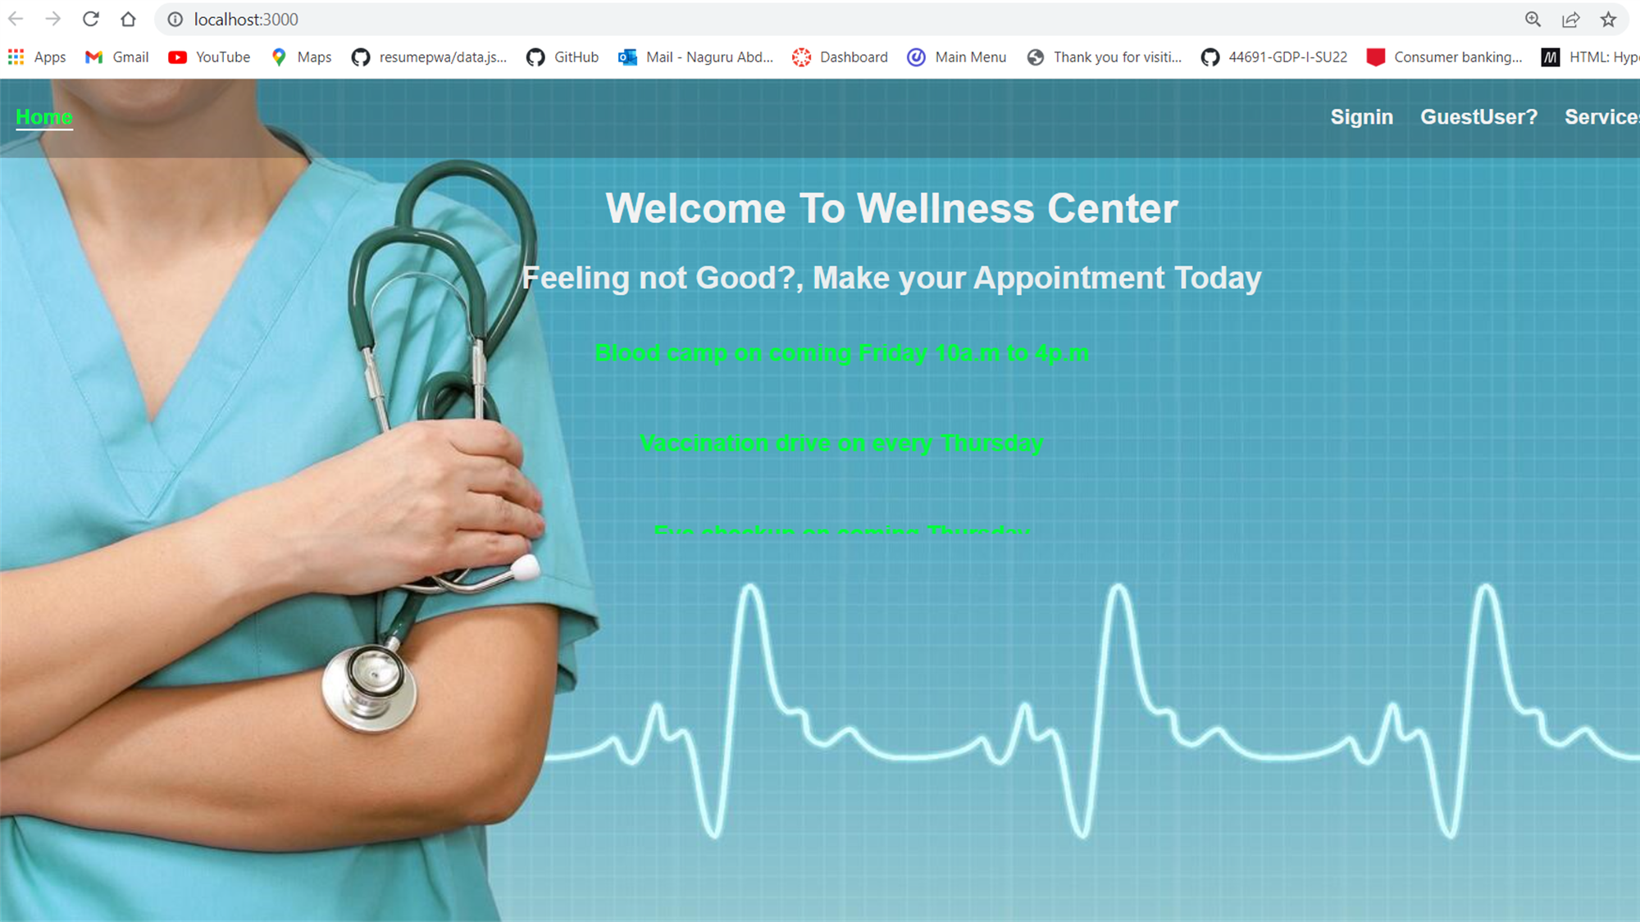

**4.3 UI Diagram**

**5.Analysis Models**

**5.1. Data Flow Diagram**

**5.2. Sequence Diagrams**

