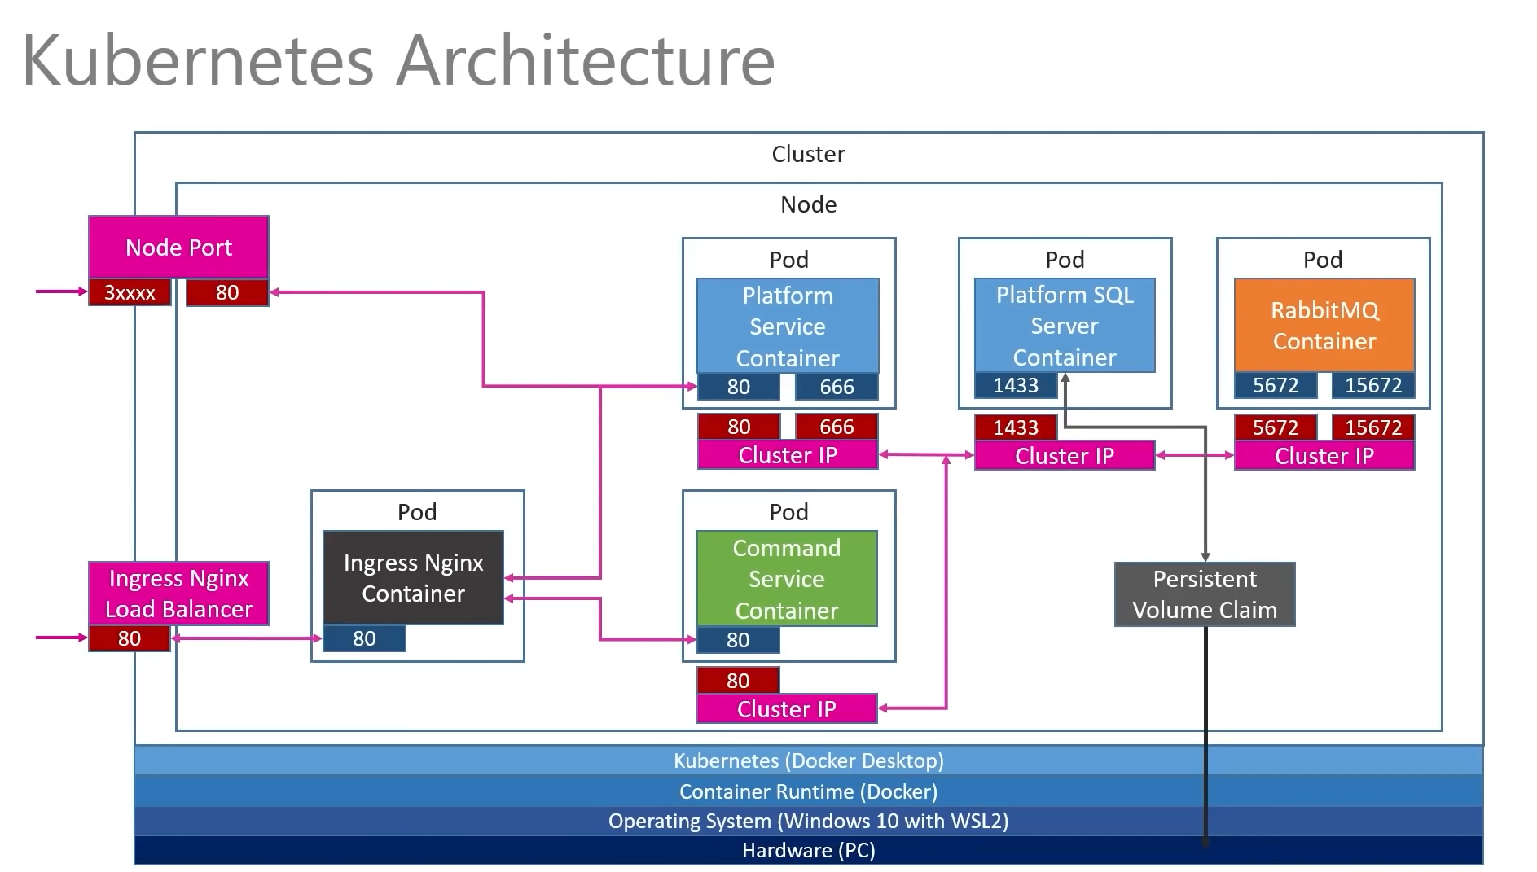

**PlatformService Dockerfile**

FROM mcr.microsoft.com/dotnet/sdk:5.0 AS build-env

WORKDIR /app

COPY *.csproj ./

RUN dotnet restore

COPY . ./

RUN dotnet publish -c Release -o out

FROM mcr.microsoft.com/dotnet/aspnet:5.0

WORKDIR /app

COPY --from=build-env /app/out .

ENTRYPOINT [ "dotnet", "PlatformService.dll" ]

**CommandService Dockerfile**

FROM mcr.microsoft.com/dotnet/sdk:5.0 AS build-env

WORKDIR /app

COPY *.csproj ./

RUN dotnet restore

COPY . ./

RUN dotnet publish -c Release -o out

FROM mcr.microsoft.com/dotnet/aspnet:5.0

WORKDIR /app

COPY --from=build-env /app/out .

ENTRYPOINT [ "dotnet", "CommandsService.dll" ]

**PlatformService Deploy Kubernetes YAML**

apiVersion: apps/v1

kind: Deployment

metadata:

name: platforms-depl

spec:

replicas: 1

selector:

matchLabels:

app: platformservice

template:

metadata:

labels:

app: platformservice

spec:

containers:

- name: platformservice

image: binarythistle/platformservice:latest

---

apiVersion: v1

kind: Service

metadata:

name: platforms-clusterip-srv

spec:

type: ClusterIP

selector:

app: platformservice

ports:

- name: platformservice

protocol: TCP

port: 80

targetPort: 80

- name: plafromgrpc

protocol: TCP

port: 666

targetPort: 666

**CommandsService Deploy Kubernetes YAML**

apiVersion: apps/v1

kind: Deployment

metadata:

name: commands-depl

spec:

replicas: 1

selector:

matchLabels:

app: commandservice

template:

metadata:

labels:

app: commandservice

spec:

containers:

- name: commandservice

image: binarythistle/commandservice:latest

---

apiVersion: v1

kind: Service

metadata:

name: commands-clusterip-srv

spec:

type: ClusterIP

selector:

app: commandservice

ports:

- name: commandservice

protocol: TCP

port: 80

targetPort: 80

**MSSQL Kubernetes YAML**

apiVersion: apps/v1

kind: Deployment

metadata:

name: mssql-depl

spec:

replicas: 1

selector:

matchLabels:

app: mssql

template:

metadata:

labels:

app: mssql

spec:

containers:

- name: mssql

image: mcr.microsoft.com/mssql/server:2017-latest

ports:

- containerPort: 1433

env:

- name: MSSQL_PID

value: "Express"

- name: ACCEPT_EULA

value: "Y"

- name: SA_PASSWORD

valueFrom:

secretKeyRef:

name: mssql

key: SA_PASSWORD

volumeMounts:

- mountPath: /var/opt/mssql/data

name: mssqldb

volumes:

- name: mssqldb

persistentVolumeClaim:

claimName: mssql-claim

---

apiVersion: v1

kind: Service

metadata:

name: mssql-clusterip-srv

spec:

type: ClusterIP

selector:

app: mssql

ports:

- name: mssql

protocol: TCP

port: 1433

targetPort: 1433

---

apiVersion: v1

kind: Service

metadata:

name: mssql-loadbalancer

spec:

type: LoadBalancer

selector:

app: mssql

ports:

- protocol: TCP

port: 1433

targetPort: 1433

**Local Persist Volume Claim**

apiVersion: v1

kind: PersistentVolumeClaim

metadata:

name: mssql-claim

spec:

accessModes:

- ReadWriteMany

resources:

requests:

storage: 200Mi

**Ingress Nginx GateWay Kubernetes YAML**

apiVersion: networking.k8s.io/v1

kind: Ingress

metadata:

name: ingress-srv

annotations:

kubernetes.io/ingress.class: nginx

nginx.ingress.kubernetes.io/use-regex: 'true'

spec:

rules:

- host: acme.com

http:

paths:

- path: /api/platforms

pathType: Prefix

backend:

service:

name: platforms-clusterip-srv

port:

number: 80

- path: /api/c/platforms

pathType: Prefix

backend:

service:

name: commands-clusterip-srv

port:

number: 80

**Node Port Kubernetes YAML**

apiVersion: v1

kind: Service

metadata:

name: platformnpservice-srv

spec:

type: NodePort

selector:

app: platformservice

ports:

- name: platformservice

protocol: TCP

port: 80

targetPort: 80

**RabbitMQ Deply Kubernetes YAML**

apiVersion: apps/v1

kind: Deployment

metadata:

name: rabbitmq-depl

spec:

replicas: 1

selector:

matchLabels:

app: rabbitmq

template:

metadata:

labels:

app: rabbitmq

spec:

containers:

- name: rabbitmq

image: rabbitmq:3-management

ports:

- containerPort: 15672

name: rbmq-mgmt-port

- containerPort: 5672

name: rbmq-msg-port

---

apiVersion: v1

kind: Service

metadata:

name: rabbitmq-clusterip-srv

spec:

type: ClusterIP

selector:

app: rabbitmq

ports:

- name: rbmq-mgmt-port

protocol: TCP

port: 15672

targetPort: 15672

- name: rbmq-msg-port

protocol: TCP

port: 5672

targetPort: 5672

---

apiVersion: v1

kind: Service

metadata:

name: rabbitmq-loadbalancer

spec:

type: LoadBalancer

selector:

app: rabbitmq

ports:

- name: rbmq-mgmt-port

protocol: TCP

port: 15672

targetPort: 15672

- name: rbmq-msg-port

protocol: TCP

port: 5672

targetPort: 5672