Applied Data Science Capstone

Introduction
The problem that is going to be presented are the perks and benefits of living in two Croatian cities: Zagreb and Varaždin. We are going to look for answers to some of the following questions: which city is better suited for a young person in their 20's regarding the numbers of interesting venues in the city, like coffee shops, restaurants, movie theaters etc in the radius of 10 kilometers from the town, and which town is better suited for a family regarding the crime rate, monthly costs etc.

Data
We are going to collect the data for the nearby venues from Foursquare to get the list of:
- coffee shops
- bars
- pubs
- clubs
- restaurants
- theaters
- shopping centers
We are also going to collect some numerical data from www.numbeo.com about
- crime rate
- quality of life index
- average salary
- cost of living
- apartment price
- rent
- preschool price
in these two cities. We are going to examine which of the two cities has more interesting venues, and after that we are going to compare which of the two cities has the smaller crime rate, living costs, rent/apartment cost, but a higher salary and quality of life index.

Methodology and results

We used the Foursquare API to get the data on interesting venues regarding Varaždin and Zagreb.
We collected the numerical data on these categories. After that we used www.numbeo.com and used Beautiful Soup to parse the statistical data on living costs, quality of life, and crime rate. The currency in Croatia is croatian kuna.

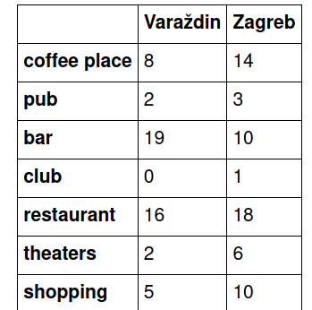

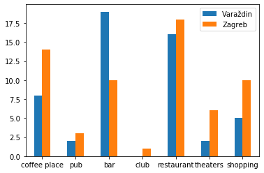

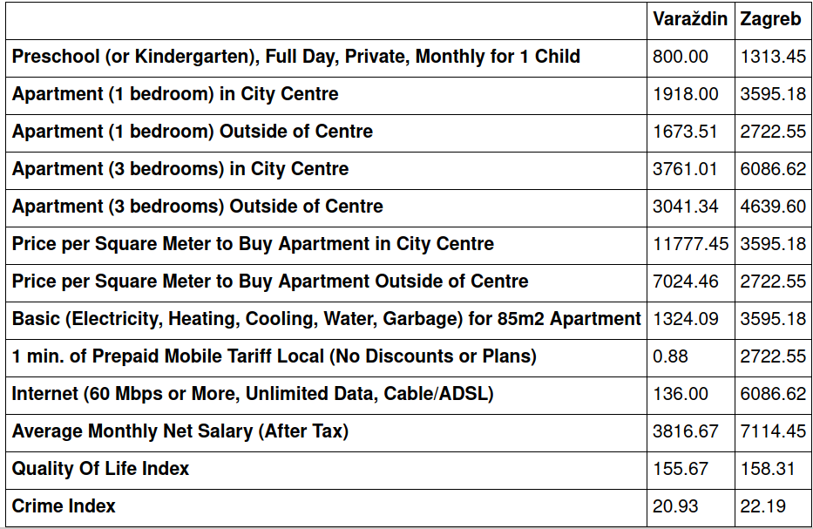

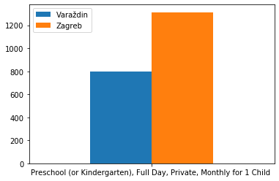

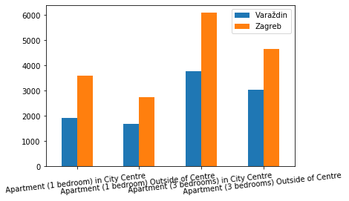

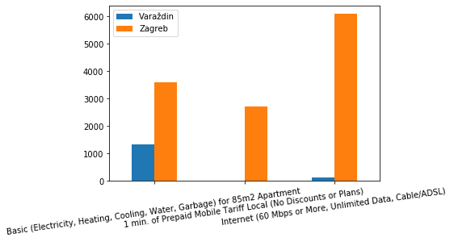

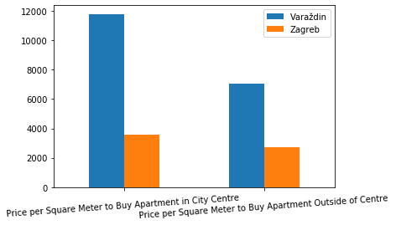

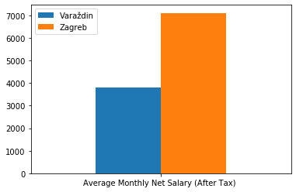

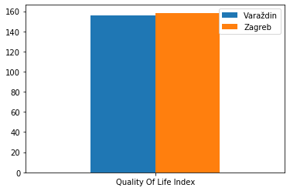

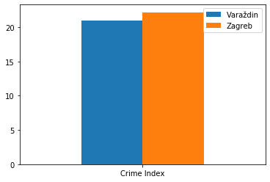

Discussion
We can see that in general Zagreb has more places to go out for your people. We can also see that it is more expensive then Varaždin in most cases, but on the other hand people do have a higher monthly salary in Zagreb then in Varaždin. Regarding all this, numbeo has the data that for a family of four Varaždin is more expensive. Quality of life index and crime rates are similar, both are slightly higher in Zagreb.

Conclusion
My conclusion is that we need more data from numbeo for Varaždin to make some assumptions regarding the prices of living. We can agree though that Zagreb would be a more interesting place to live for a younger person, but for a family that maybe wants a quiet place that is not so expensive, we can't make much conclusion with this data.

