Diploma in Software Engineering

*Yoobee College of creative innovation.*

This sheet must be signed by the student and attached to the submitted assessment.

|  |  |  |  |
| --- | --- | --- | --- |
| **Course Title:** | Introduction to Game Programming | **Course code:** | 2202-Online-DSD |
| **Student Name:** | Paulo Vitor Gehlen | **Student ID:** | 270158563 |
| **Assessment No & Type:** | 1 – Assessment 1 Proposal |  |  |
| **Due Date:** | 26/03/2023 | **Date Submitted:** | 26/03/2023 |
| **Tutor’s Name:** | Roohi Verma | | |
| **Assessment Weighting** | 100% | | |
| **Total Marks** | 15 | | |

**Student Declaration:**

I declare that:

* I have read the Yoobee College policies and regulations on assessments and understand what plagiarism is.
* I am aware of the penalties for cheating and plagiarism as laid down by the Yoobee College
* This is an original assessment and is entirely my own work.
* Where I have quoted or made use of the ideas of other writers, I have acknowledged the source.
* This assessment has been prepared exclusively for this course and has not been or will not be submitted as assessed work in any other course.
* If I am late in handing in this assessment without prior marks will be deducted, to a maximum of 50%.

**Student signature: ­­­**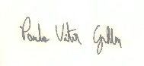

**Date: 26/03/2022**

Contents

1. Conception and Development 3

1.1 Category 3

1.2 Concept 3

1.8 Scenario 4

1.9 Mechanics 5

1.10 Concept art 5

1.11 Audio Elements 5

2. Game design 6

2.1 Characters 6

2.2 Description and physical characteristics 6

2.3 Indicators 7

2.4 Booleans 7

3. Production 8

3.1 Main interface 8

3.2 Environments 8

3.3 Parameters 9

3.3.1 Punctuation of food and drinks 10

3.3.2 Other scores 10

3.3.3 Situations for hospitalization 11

3.4 Access to bonus games 12

3.5 Initial tutorial 13

3.6 Analise SWOT (Strengths, Weakness, Opportunities, Threats) 13

3.7 Programs Used 14

3.8 References 14

# Conception and Development

It is a process-oriented mobile application related to health education.

Title (Looking after Tim)

Developed by: Paulo Gehlen

Project duration: 8 weeks

27/02/2023 – 26/03/2023

## 1.1 Category

Educational media; Health educational game; Serious games.

### 1.2 Concept

Non-communicable chronic diseases are health problems with a great impact on public health, represent a great burden and 72% of the causes of death in the world. A Chronic Kidney Disease (CKD) is included in this category. It is characterized by the loss progressive and irreversible impairment of renal function, Defects in kidney structure or function that have a negative impact on the patient's health and persist for longer than three months are known as chronic kidney disease (CKD). A significant rise in the risk of CVD is linked to CKD, and the damage it causes is typically irreversible.

In a census published in 2022 BPACNZ better medicine Chronic kidney disease (CKD) is a growing issue in New Zealand. Māori and Pacific peoples are overrepresented in our CKD statistics which is concerning as it is a major driver of cardiovascular disease (CVD), and these groups are already disproportionately affected by risk factors such diabetes, obesity, and hypertension.

In the presented context, if a patient with chronic kidney disease (CKD) reduces your hospital visits just by improving your self-care? This App suggests that patients with CKD take care of a Character (character or avatar), who also suffers from CKD, maintaining healthier eating habits, taking your medicine regularly, doing your hemodialysis sessions correctly, as well as giving a friend lot of love and fun.

#### 1.2.1 Mission

The objective of this project is to bring entertainment to young people and at the same time educate them to take better care of their health, not to overeat, sleep and rest, go to the bathroom at the right time so as not to wet their pants. The idea was to combine fun with the responsibility to take care of health. mainly focused on people suffering from chronic kidney disease.

##### 1.3 Genre

Simulator complemented by a series of action mini games. The App will simulate the daily routine of a person with CKD. The character will do things routines that all people do, such as drinking, eating, sleeping, going to the bathroom, play etc. In addition, he will have to do his weekly haemodialysis sessions and, if you take care of yourself badly, you will be admitted to the hospital unit until you are able to recover your health. As the player develops his character, he will get action mini games (immediate responses) to play and have fun.

###### 1.4 Platform

This App will be developed for tablets and smartphones with Android operating. It will require a time availability corresponding to the minimum of 15 minutes a day, with the possibility of interspersing 5 minutes in each shift of the day.

1.5 Comparative Analysis

- Pou: 2D, poorly illustrated, great diversity of games and customization of Pou

- Tone: 3D, good sound design, good animations

- My Boo: 2D, well-illustrated, good graphic interface, good sound design

- Wokamon: 2D, flat, good animations, good interface

1.6 Mission

What will be done? Who will it be made for?

An application containing a simulator of the routine of a patient suffering from CKD and playful action games. It was planned for children from 04 to 12 years old who have CKD and who seek to improve both eating habits and knowledge of your illness. However, is open from people at different age.

1.7 Synopsis

Player is on the internet buying toys. He makes the purchase and one day the purchase arrives at his house (animation: website, box, plane, boat, truck, biker, player's house). The player opens the box and character pops up. Hungry, thirsty, and sad. Your indices are all changed. From this moment, the game begins, and the player needs to perform the first care.

## 1.8 Scenario

The game takes place in environments commonly experienced by CKD patients, who are: different environments of your home and the hospital. In the house, the character will feed, take your medication, sleep, and clean yourself. The minigames will happen in the backyard of the house, while in the hospital the character will have his sessions haemodialysis or will be rescued in severe cases, being hospitalized. Environments: living room, kitchen, bathroom, bedroom, backyard, living room haemodialysis and hospitalization.

### 1.9 Mechanics

With the main purpose of correctly taking care of the character, the player needs to perform the tasks that will increase the character's health ratings. Sometimes the tasks will be requested by the character, other times the character himself player can anticipate a request and perform a task. The tasks include clicking on the food that the character will eat, clicking on the medicine that the character needs to take, click on the minigames he wants to play with the character, etc. Minigames will be action games with immediate responses. This means that there will be no need for instruction, nor environments to be explored or that need complex strategies to play.

They are simple as:

- Drag your finger over obstacles

- Find the character (shuffle the cups)

- Race over hurdles

- jump

### 1.10 Concept art

Flat, minimalist design, very colorful, without gradients or too much volume evident. The scenarios follow the pattern of the characters but without highlighting more than the characters or objects of interaction.

### 1.11 Audio Elements

In addition to the soundtrack for each environment in the game, the character also it will emit sounds that represent its behavioral state. Stomach sound when standing Hungry, for example. The character will have a rather childish voice but not it will speak words so little will it form sentences. It will only emit sounds trying to indicate its intentionality. In the minigames, each game will have its sound and the tracks will be electronic instrumental songs.

# 2. Game design

## 2.1 Characters

Player: It will be the user himself with a first-person point of view. However, the player will not see your hands or any parts of your body. Character (fictional): an inanimate toy with a protagonist archetype and it has a life of its own. He lives with a disease called Kidney Disease Chronic. Needs special and routine care about feeding, fluid intake, medication, and haemodialysis.

## 2.2 Description and physical characteristics

Tim lives in an orphanage of discarded toys. Still new was left at the orphanage for having a disease, CKD. He needs to be adopted by someone so that one day he can fulfill his dream: having a friend. Type: inanimate toy Sex/age: asexual Physical Appearance: Large head, eyes and mouth, short limbs, and chest, referring to the renal anatomy.

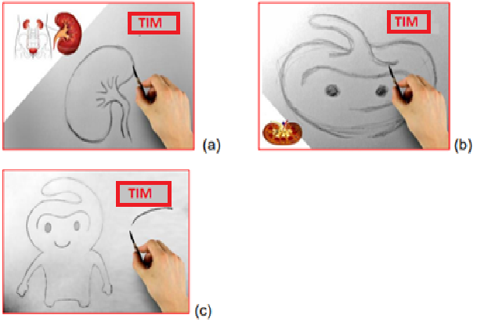

### 2.3 Indicators

Time - game chronology (indicator by analog pointer)

* 5 minutes = 1 hours in game
* 24 minutes = 1 days

with scale

* Health/Vitality (0 to 100) - whether you go to the hospital.
* Energy (0 to 10) - can or cannot play.
* 0-3: unable to play.
* 4-6: play for a fixed amount of time (ex: 3 minutes)
* 7-10: play longer (ex: 10 minutes)

### 2.4 Booleans

* Hunger (food) - wants to eat.
* Cleanliness (dirt) - want to shower.
* Medication (medicine routine) - I need to take medicine.
* Basic needs (pee and poop) - wants to go to the bathroom.
* Sleep (tiredness) - want to sleep.
* Happiness (joy/games) - wants to play.
* Hospital/Treatment (haemodialysis) - wants to go to the hospital.
* Thirst (water) - wants to drink water.

# 3. Production

## 3.1 Main interface

* Thirst icon = glass of water.
* Hungry icon = fork and knife.
* Haemodialysis icon = drops and arrows.
* Medicine icon = pills.
* dirt icon = shower.

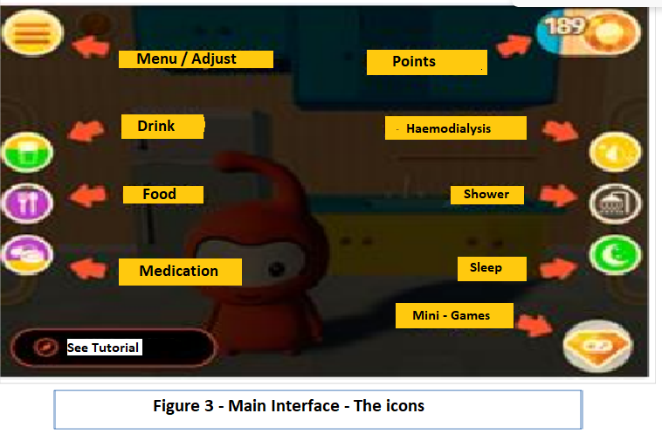

## 3.2 Environments

. External environment – ​​entrance to the house

. Kitchen (Sink, fridge, open and close fridge, get food, cupboards, take a cup, drinker)

. Bathroom (Sink + mirror, box + shower in and out + shower on and off + curtain opens and closes, toilet, makes flushing noise)

. Living room and furniture (Armchair, round rug, floor hack + television

. Bedroom (bed, bedside table + lamp)

. Hospital

. Environment 1: Armchair, haemodialysis machine

. Environment 2: Litter, serum.

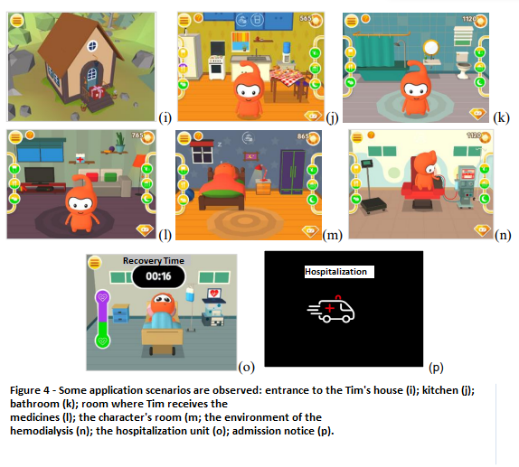

## 3.3 Parameters

. Full day = 5 minutes (300 seconds)

. Food / meals = 6x / day: breakfast, morning snack, lunch, afternoon snack, dinner, evening snack.

. Drink = 3x / day

. Medication (medicines) = 4x/day

. Hemodialysis = 1x / day

. Sleep = 1x / day

. Bath = 2x / day

|  |  |  |  |
| --- | --- | --- | --- |
| 3.3.1 Punctuation of food and drinks |  |  |  |
| **Item** | **Meal** | **Score** | **Column** |
| Oven // plate 1 (chicken) | Lunch / Dinner | 100 | 100px |
| Oven // plate 2 (steak) | Lunch / Dinner | 100 | 100px |
| Oven // plate 3 (sausage) | Lunch / Dinner | 20 | 100px |
| Oven // plate 4 (spaghetti) | Lunch / Dinner | 50 | 100px |
| Table // snacks | Afternoon Tea | -20 | 50px |
| Table // Biscuits | Afternoon Tea | -20 | 50px |
| Table // Sandwich | Afternoon Tea | 20 | 100px |
| Table // Bread | Breakfast / Afternoon Tea | 30 | 50px |
| Table // Chocolate | Afternoon Tea | -10 | 50px |
| Table // Fried | Afternoon Tea | 5 | 50px |
| Table // Fruits | Morning /Afternoon Tea | 50 | 50px |
| Table // Cake | Afternoon Tea | 40 | 50px |
| Fridge// Milk | Breakfast | 50 | 100px |
| Fridge// juice | During the alarm time | 40 | 100px |
| Fridge// Water | During the alarm time | 30 | 50px |
| Fridge// Ice Cream | Afternoon tea | 5 | 50px |

**Any food that is ingested and is not part of that type of meal, your score is worth half (½)**

**Any food that is ingested outside the time of any meal, its score will be worth its third part (⅓)**

|  |  |  |
| --- | --- | --- |
| 3.3.2 Other scores |  |  |
| **Action** | **Moment** | **Score** |
| Medication | when the alarm ring | 50 |
| Shower | when the alarm ring | 100 |
| Toilet | Anytime Tim accepts | 20 |
| Sleep | when the alarm ring | 100 |
| Injection | After finishing the haemodialysis | 300 |
|  |  |  |
|  |  |  |
| 3.3.3 Situations for hospitalization |  |  |
| **Situation** | **Hospitalization** | **Score** |
| Take medication 2x without waiting for a new alarm | 2 Minutes | -100 |
| Black food parameter | 1 minute | -50 |
| Black drink parameter | 1 minute | -50 |
| Purple medication parameter | 2 minutes | -100 |
| Purple haemodialysis parameter | 2 minutes | -100 |

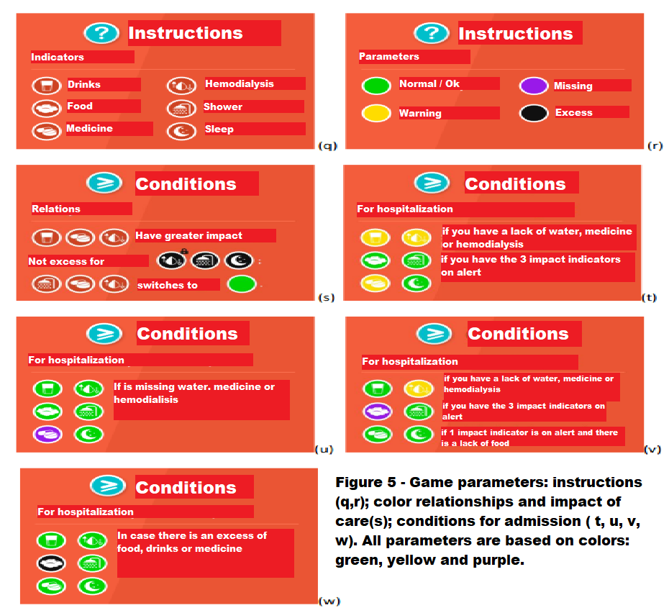

|  |  |
| --- | --- |
| 3.4 Access to bonus games |  |
| **Bonus Game** | **Cost** |
| **departure from Tim Sky** | **100** |
| **departure from Tim Sound** | **200** |
| **departure from Tim Pot** | **300** |

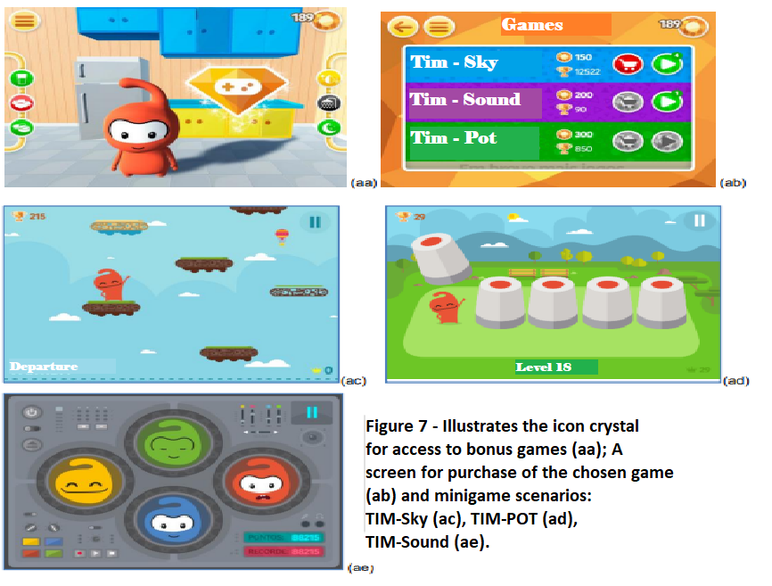

|  |
| --- |
| 3.5 Initial tutorial |
| step 1: Hello, I'm TIM. Let's learn now how this game works. |
| step 2: On the sides, we have indicators that show the current state of my health. |
| step 3: For example, these 3 indicate if I'm hungry, thirsty or medicated. |
| Arrow with the text: FOOD |
| Arrow with the text: DRINK |
| Arrow with the text: MEDICATION |
| step 4: Keep an eye on the colors of the indicators. They indicate the lack, |
| excess and the normal state of each item. |
| GREEN: everything is ok. |
| YELLOW: starting to run out. |
| PURPLE: is out of stock. |
| BLACK: is in excess. |
| step 5: These other 3 indicators show whether I underwent treatment and whether I am clean and tired. |
| Arrow with the text: HEMODIALYSIS |
| Arrow with the text: Shower |
| Arrow with the text: SLEEP |
| step 6: when you tap on an indicator, I will go to the indicator's environment. |
| For example, if you want to give me food, tapping the food indicator will |
| for the kitchen. |
| step 7: in the kitchen, pay close attention to the food you are going to give me. |
| To the higher scores are healthier foods. |
| step 8: keep an eye on the alarms that will appear at the top of the screen. if |
| being able to feed in the right time the scores will be even higher. |
| step 9: but if my indicators are bad, then it will be very sad because I will be admitted to the hospital. |
| step 10: Now, if you're taking good care of me, you'll be awarded 3 |
| fun minigames. // Accumulate points to buy matches, click on the dos button |
| minigames and have fun! Prepared? |

|  |
| --- |
| 3.6 Analise SWOT (Strengths, Weakness, Opportunities, Threats) |
| Strengths: broad educational content, strong identification with reality, |
| easy publication and access, free, good variety of games, no internet required to play |
| Weak points: small team (sound design), little innovation |
| Opportunities: identified demand, unprecedented solution in the area, partnership with university (content), good term |
| Threats: Resource payment, cautious content |

|  |
| --- |
| 3.7 Programs Used |
| Adobe Photoshop CS6 |
| Adobe Illustrator CS6 |
| Maya 3D |
| Unity 3D  https://www.fotor.com/features/ai-image-generator/?tooltype=cartoon |

## 3.8 References

Site designed and developed by bka interactive ltd, Auckland, New Zealand (www.bka.co.nz). (n.d.). Kidney disease | Health navigator NZ. Health Navigator New Zealand. <https://www.healthnavigator.org.nz/health-a-z/k/kidney-disease/>

Chronic kidney disease: The canary in the coal mine. (2022, November 11). Best Practice Advocacy Centre New Zealand. <https://bpac.org.nz/2022/ckd.aspx>

Site designed and developed by bka interactive ltd, Auckland, New Zealand (www.bka.co.nz). (n.d.). Kidney disease | Health navigator NZ. Health Navigator New Zealand. <https://www.healthnavigator.org.nz/health-a-z/k/kidney-disease/>

Chronic kidney disease: The canary in the coal mine. (2022, November 11). Best Practice Advocacy Centre New Zealand. <https://bpac.org.nz/2022/ckd.aspx>

(n.d.). Kidney Health New Zealand Tākihi Hauoro Aotearoa. <https://www.kidney.health.nz/>

Site designed and developed by bka interactive ltd, Auckland, New Zealand (www.bka.co.nz). (n.d.). Kidney disease | Health navigator NZ. Health Navigator New Zealand. <https://www.healthnavigator.org.nz/health-a-z/k/kidney-disease/>