Session 2 : HDFS
Assignment 1:
Task 1:
- Check whether /user/acadgild directory exists or not in the HDFS.
- Create a directory /user/acadgild/hadoop.
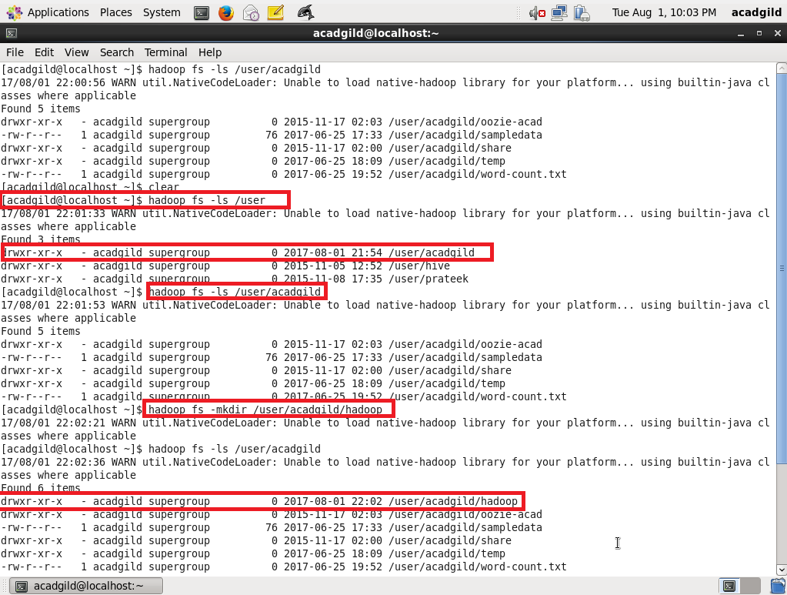

Task 2:
Create a file in HDFS under directory /user/acadgild/hadoop, with name word-count.txt.
Whatever we type on screen should get appended to the file.

