Session 2 : HDFS
Assignment 2:
Task 3:
Create a file max-temp.txt in local FS.
Put some 10-15 records of date and temperature
Move this file to HDFS at /user/acadgild/hadoop.
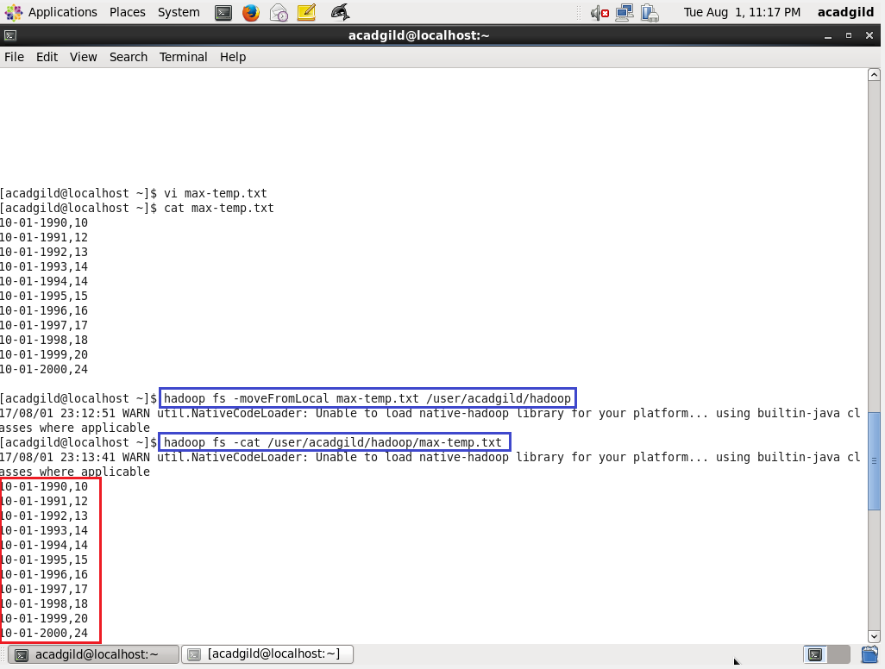

Task 4:
Change the permission of the file /user/acadgild/hadoop/max-temp.txt, such that only the owner and the group members have full control over the file. Others do not have any control over it.
(Since it is text file, execute permissions are not relevant)

