Sales Intelligence Report
AI-Powered Multi-Agent Sales Intelligence System
Dataset: Uploaded Dataset
Report Type: Executive Sales Intelligence Report
Generated by the Report Agent

1. Executive Summary
Total sales: 61,672,920. Total orders: 11,000. Total customers: 9,237. Total quantity sold: 67,551. Average order value: 5,606.63. Forecasting completed using the ARIMA model. 10 insight(s) were supplied by the Insight Agent. 5 recommendation(s) were supplied by the Recommendation Agent.

2. Dataset Overview
Metric | Value
Records | 11,000
Columns | 16

3. Data Quality and Cleaning
Metric | Value
Cleaning Status | validated
Validation Status | PASSED
Checks Passed | 9
Checks Failed | 0

4. Sales Trends
Month | Sales | Percentage Change | Absolute Change
2023-01 | ₹2,048,240 | — | —
2023-02 | ₹1,711,035 | -16.46% | -337,205
2023-03 | ₹1,809,555 | 5.76% | 98,520
2023-04 | ₹2,117,355 | 17.01% | 307,800
2023-05 | ₹1,681,950 | -20.56% | -435,405
2023-06 | ₹2,139,390 | 27.20% | 457,440
2023-07 | ₹1,524,415 | -28.75% | -614,975
2023-08 | ₹1,743,935 | 14.40% | 219,520
2023-09 | ₹1,709,320 | -1.98% | -34,615
2023-10 | ₹1,669,155 | -2.35% | -40,165
2023-11 | ₹1,679,975 | 0.65% | 10,820
2023-12 | ₹1,672,865 | -0.42% | -7,110
2024-01 | ₹1,572,830 | -5.98% | -100,035
2024-02 | ₹1,449,200 | -7.86% | -123,630
2024-03 | ₹1,669,375 | 15.19% | 220,175
2024-04 | ₹1,470,825 | -11.89% | -198,550
2024-05 | ₹1,945,575 | 32.28% | 474,750
2024-06 | ₹1,647,525 | -15.32% | -298,050
2024-07 | ₹1,724,425 | 4.67% | 76,900
2024-08 | ₹1,738,750 | 0.83% | 14,325
2024-09 | ₹1,532,600 | -11.86% | -206,150
2024-10 | ₹1,640,425 | 7.04% | 107,825
2024-11 | ₹1,720,225 | 4.86% | 79,800
2024-12 | ₹1,575,200 | -8.43% | -145,025
2025-01 | ₹1,882,350 | 19.50% | 307,150
2025-02 | ₹1,434,600 | -23.79% | -447,750
2025-03 | ₹1,567,875 | 9.29% | 133,275
2025-04 | ₹1,586,950 | 1.22% | 19,075
2025-05 | ₹1,682,150 | 6.00% | 95,200
2025-06 | ₹1,790,850 | 6.46% | 108,700
2025-07 | ₹1,935,025 | 8.05% | 144,175
2025-08 | ₹1,713,950 | -11.42% | -221,075
2025-09 | ₹1,693,500 | -1.19% | -20,450
2025-10 | ₹1,452,625 | -14.22% | -240,875
2025-11 | ₹1,650,050 | 13.59% | 197,425
2025-12 | ₹2,088,850 | 26.59% | 438,800

5. Sales and Performance Rankings

Product Sales
Product | Sales
Toys | ₹5,546,400
Clothing | ₹5,458,055
Personal Care | ₹5,457,700
Accessories | ₹5,401,025
Footwear | ₹5,380,650
Home & Kitchen | ₹5,180,750
Electronics | ₹5,162,950
Furniture | ₹5,091,950
Sports | ₹4,879,875
Beauty | ₹4,869,265

Product Quantity
Product | Quantity
Clothing | 6,542
Electronics | 6,358
Beauty | 6,038
Footwear | 6,032
Accessories | 5,552
Home & Kitchen | 5,480
Toys | 5,331
Groceries | 5,286
Personal Care | 5,269
Sports | 5,243

Regional Sales
Region | Sales
Houston | ₹3,425,005
Las Vegas | ₹3,408,075
Detroit | ₹3,346,250
Austin | ₹3,241,675
Dallas | ₹3,238,940
San Francisco | ₹3,215,735
Seattle | ₹3,205,095
San Diego | ₹3,165,525
Portland | ₹3,161,750
New York | ₹3,149,465

Customer Sales
Customer | Sales
CUST12046 | ₹105,000
CUST13334 | ₹100,225
CUST10743 | ₹100,000
CUST18707 | ₹95,000
CUST24199 | ₹95,000
CUST14791 | ₹85,150
CUST19660 | ₹78,000
CUST20193 | ₹77,000
CUST15978 | ₹71,800
CUST6525 | ₹70,000

6. Key Performance Indicators (KPIs)
Metric | Value
Total Sales | ₹61,672,920
Total Quantity | 67,551
Total Orders | 11,000
Total Customers | 9,237
Average Order Value | ₹5,606.63
Average Quantity Per Order | 6.14
Average Selling Price | ₹912.98

7. Visualizations

Daily Sales Trend
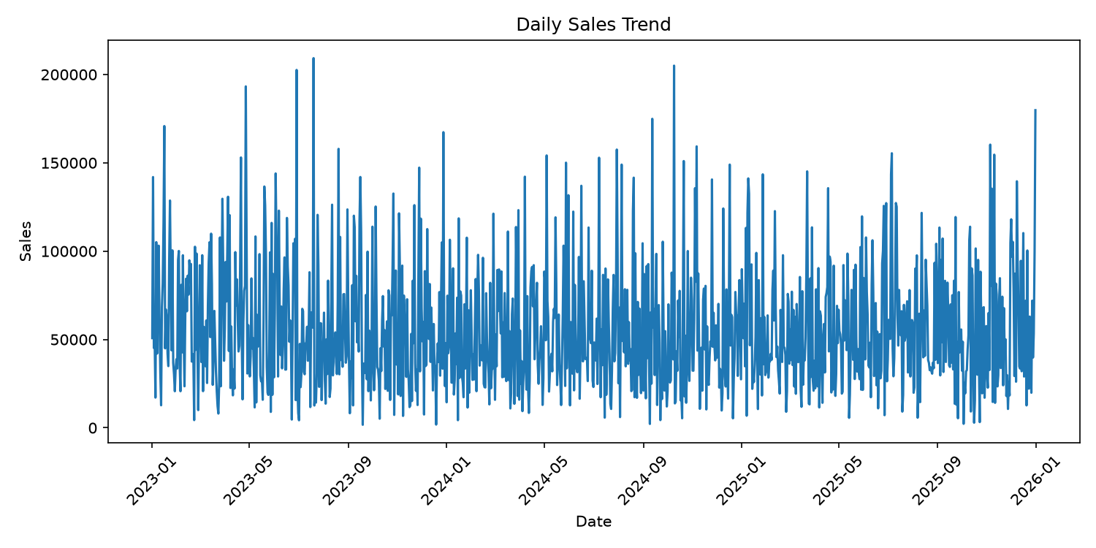

Monthly Sales Trend
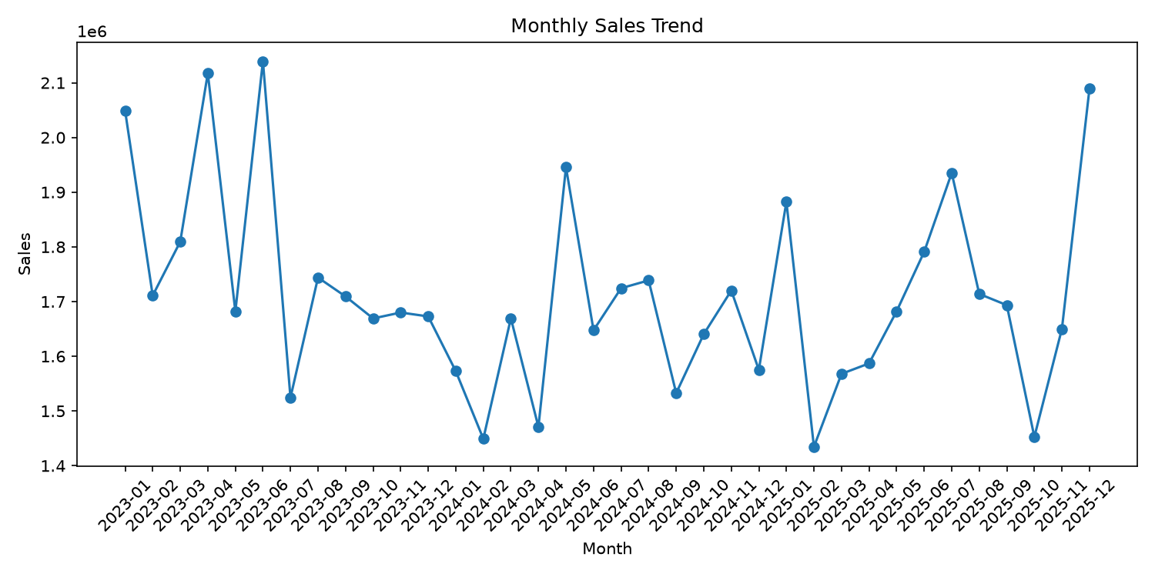

Sales by Product Category
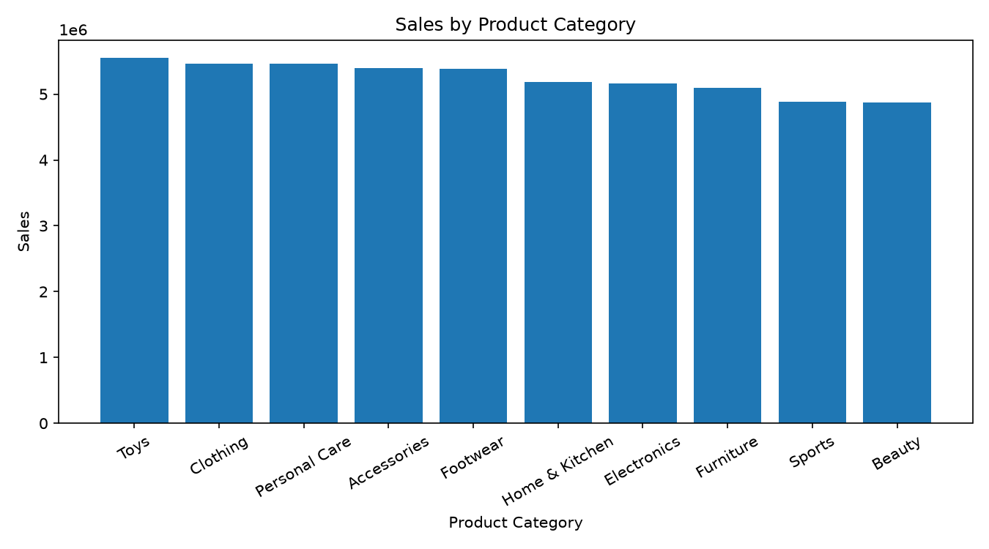

Quantity by Product Category
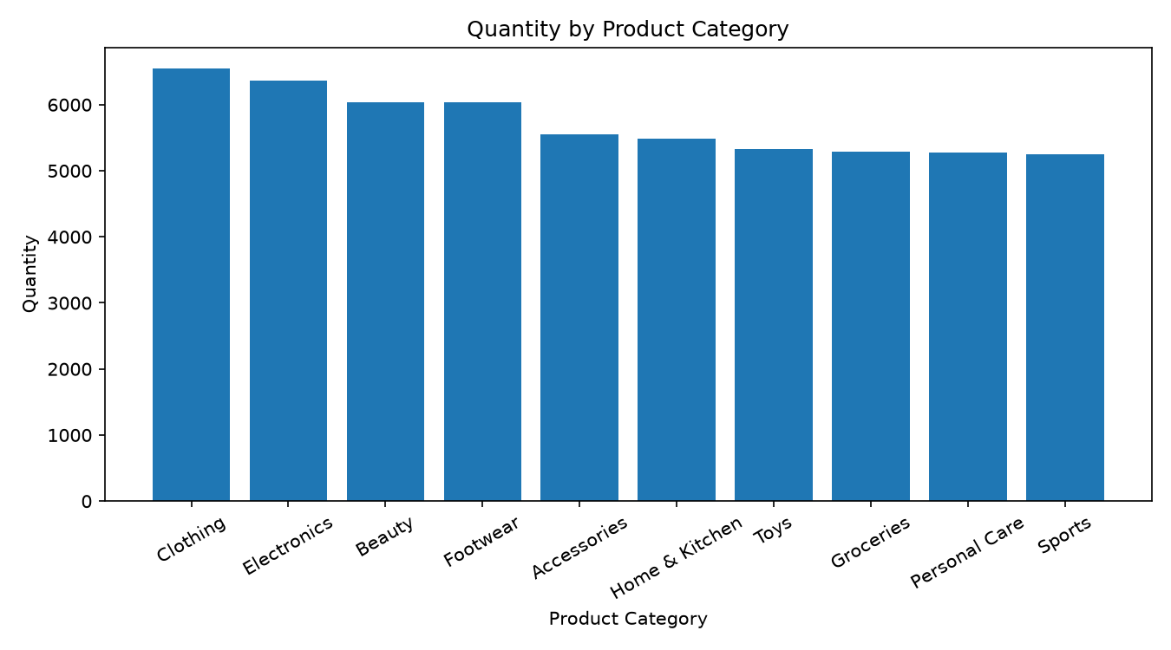

Sales by Region
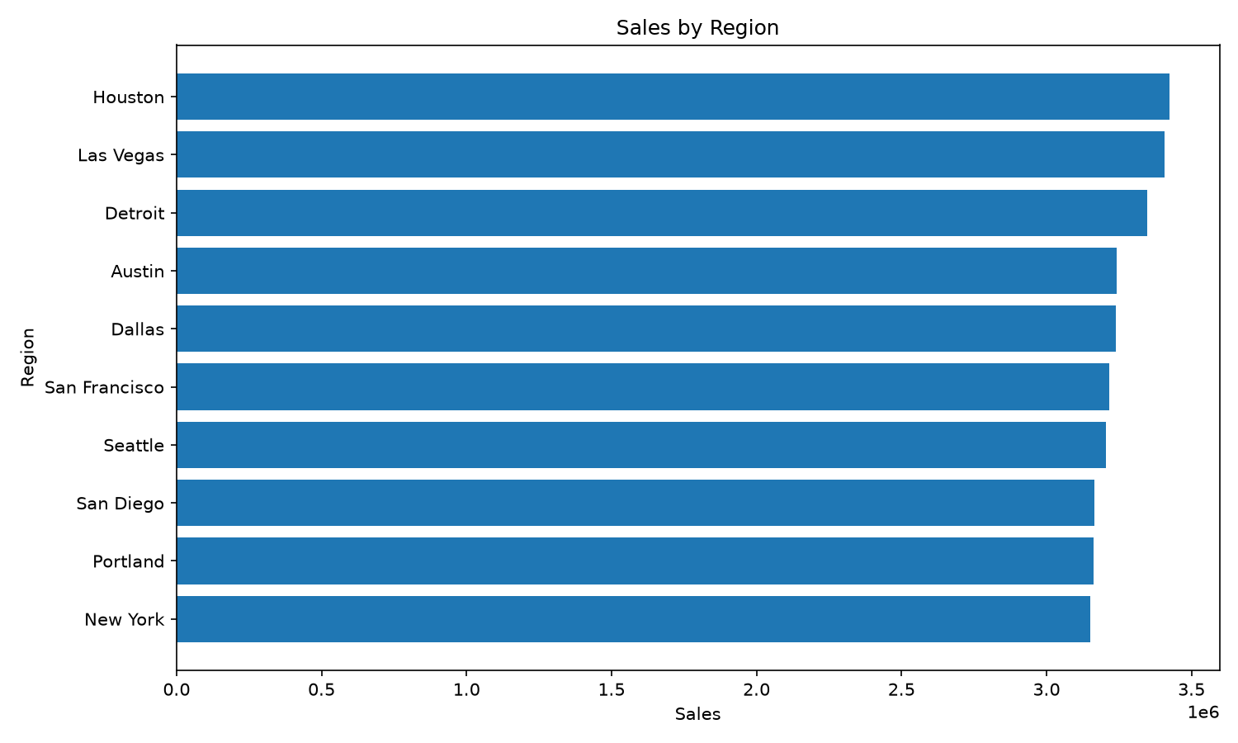

Top Customers by Sales
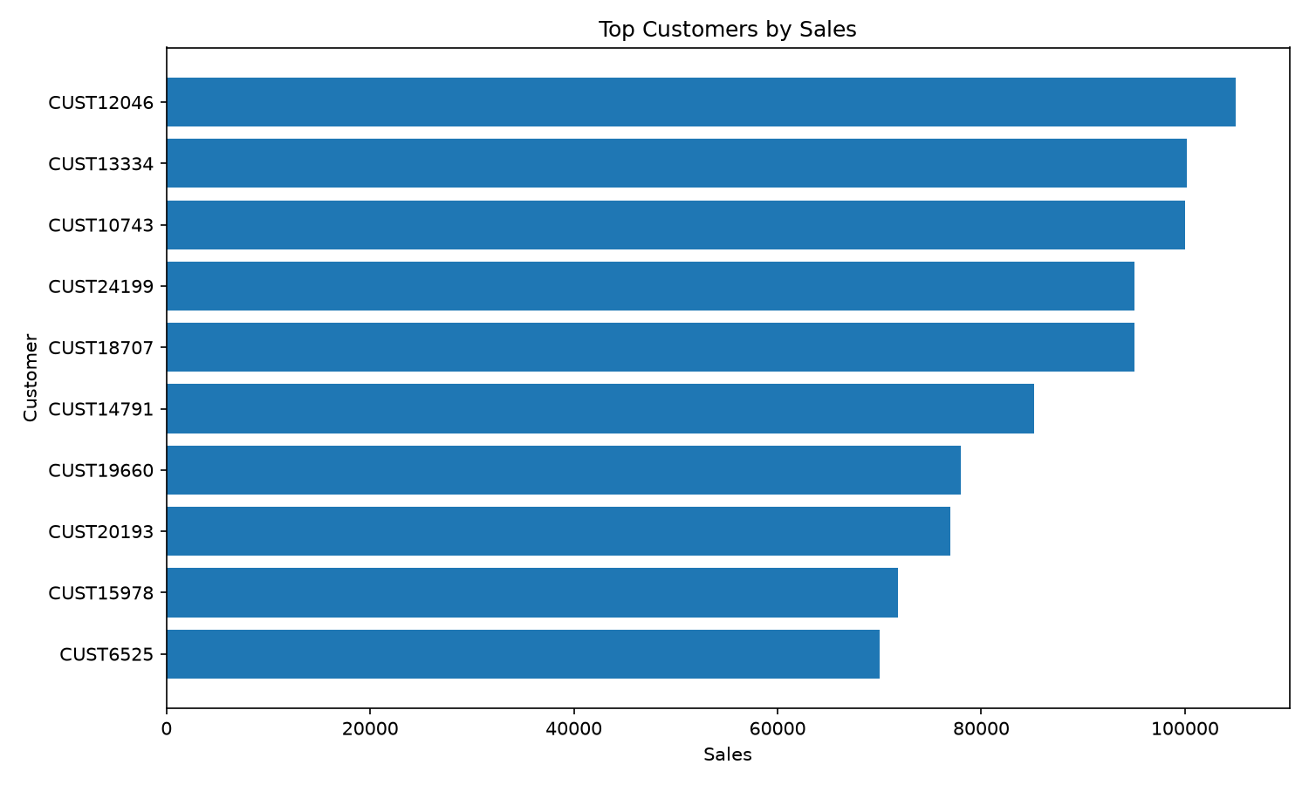
Embedded 6 chart image(s).

8. Sales Forecast
Metric | Value
Forecast Status | COMPLETED
Selected Model | ARIMA
Frequency | D
Forecast Horizon | 7
MAE | ₹32,358.46
RMSE | ₹40,386.17
MAPE | 65.37%

Forecast Values
Forecast Date | Predicted Sales
01 Jan 2026 | ₹57,212.52
02 Jan 2026 | ₹56,247.85
03 Jan 2026 | ₹56,240.25
04 Jan 2026 | ₹56,240.20
05 Jan 2026 | ₹56,240.19
06 Jan 2026 | ₹56,240.19
07 Jan 2026 | ₹56,240.19

9. Business Insights

1. Total Sales
Total recorded sales are 61,672,920.00.
Evidence: Source: validated_kpis; Metric: total_sales; Value: 61,672,920
Confidence: 1

2. Order Volume
The dataset contains 11,000 recorded orders.
Evidence: Source: validated_kpis; Metric: total_orders; Value: 11,000
Confidence: 1

3. Average Order Value
The average order value is 5,606.63.
Evidence: Source: validated_kpis; Metric: average_order_value; Value: 5,606.63
Confidence: 1

4. Highest Sales Period
The highest recorded monthly sales were 2,139,390.00 in 2023-06.
Evidence: Source: validated_monthly_trends; Period: 2023-06; Sales: 2,139,390
Confidence: 1

5. Lowest Sales Period
The lowest recorded monthly sales were 1,434,600.00 in 2025-02.
Evidence: Source: validated_monthly_trends; Period: 2025-02; Sales: 1,434,600
Confidence: 1

6. Partial Final Period
2025-12 contains a partial observation period and should not be directly interpreted as a complete-month decline compared with 2025-11.
Evidence: Source: validated_monthly_trends; Current Period: 2025-12; Current Sales: 2,088,850; Previous Period: 2025-11; Previous Sales: 1,650,050; Warning: partial_period
Confidence: 1

7. Top Product Category
Toys is the highest-ranked product category by sales, with 5,546,400.00 in sales.
Evidence: Source: validated_product_rankings; Category: Toys; Sales: 5,546,400; Rank: 1
Confidence: 1

8. Top Sales Region
Houston is the highest-ranked region by sales, with 3,425,005.00 in recorded sales.
Evidence: Source: validated_regional_rankings; Region: Houston; Sales: 3,425,005; Rank: 1
Confidence: 1

9. Top Customer by Sales
CUST12046 is the highest-ranked customer by sales, with 105,000.00 in recorded sales.
Evidence: Source: validated_customer_rankings; Customer: CUST12046; Sales: 105,000; Rank: 1
Confidence: 1

10. Selected Forecasting Model
ARIMA was selected as the best-performing forecasting model based on the evaluated models. Its MAE was 32,358.4634.
Evidence: Source: validated_forecasting_result; Best Model: ARIMA; Best Mae: 32,358.46; Horizon: 7
Confidence: 1

10. Business Recommendations

1. Boost Inventory and Promotion for Toys Category
Increase stock levels for top-selling toy SKUs and launch a targeted marketing campaign (e.g., email offers, social ads) focused on the Toys category for the next quarter.
Priority: HIGH
Business Impact: Toys generated the highest sales ($5,546,400), indicating strong demand that can be further captured.
Evidence: Category: Toys; Rank: 1; Sales: 5,546,400; Source: validated_product_rankings

2. Allocate Additional Marketing Spend to Houston
Redirect a portion of the regional advertising budget to Houston and partner with local retailers for in‑store promotions during the next sales cycle.
Priority: MEDIUM
Business Impact: Houston leads all regions with $3,425,005 in sales, representing a key revenue hub.
Evidence: Rank: 1; Region: Houston; Sales: 3,425,005; Source: validated_regional_rankings

3. Create a Loyalty Program for Top Customer CUST12046
Offer a personalized loyalty tier (e.g., volume discount, early access to new products) to CUST12046 and monitor uptake for replication with other high‑value accounts.
Priority: MEDIUM
Business Impact: CUST12046 contributed $105,000 in sales, showing high value and potential for repeat business.
Evidence: Customer: CUST12046; Rank: 1; Sales: 105,000; Source: validated_customer_rankings

4. Investigate Causes of February 2025 Sales Dip
Conduct a root‑cause analysis (e.g., inventory levels, promotional calendar, external events) for February 2025 and develop corrective actions to mitigate similar dips.
Priority: HIGH
Business Impact: The lowest monthly sales ($1,434,600) occurred in 2025‑02, suggesting a potential seasonal or operational issue.
Evidence: Period: 2025-02; Sales: 1,434,600; Source: validated_monthly_trends

5. Use ARIMA 7‑Day Forecast for Short‑Term Planning
Integrate the 7‑day ARIMA forecast (average ≈ 56,200 per day) into daily inventory and staffing plans to align supply with expected demand.
Priority: HIGH
Business Impact: ARIMA was selected as the best model with MAE ≈ 32,358, providing the most accurate short‑term sales forecast.
Evidence: Best Mae: 32,358.46; Best Model: ARIMA; Horizon: 7; Source: validated_forecasting_result

11. Conclusion
The analysis confirms that the current sales portfolio generated 61,672,920 in total revenue across 11,000 orders, serving 9,237 distinct customers and moving 67,551 units of product. The average order value of 5,606.63 indicates a relatively high‑value transaction mix, while the modest gap between the number of customers and orders suggests a baseline level of repeat purchasing activity. These headline figures provide a solid quantitative foundation for strategic planning, but they must be interpreted in the context of the data‑quality observations documented in the report.
Data‑quality diagnostics identified a substantial number of potential statistical outliers—1,263 rows each in the Total Amount and Total Price fields and 582 rows in Price per Unit—alongside a small set of calculation mismatches (five rows for Total Amount and two rows for Total Price) where the recorded totals do not align with Quantity × Price per Unit. All of these issues were flagged as high‑risk and were left unaddressed pending explicit business approval. Because the outliers and mismatches remain in the dataset, any downstream analysis, including the ARIMA‑based forecast, may be distorted by anomalous

12. Limitations
- Profitability analysis is unavailable because the required profitability fields were not identified.

Appendix: Report Metadata
Metric | Value
Report Status | completed
Report Type | Executive Sales Intelligence Report
This report was generated by the AI-Powered Multi-Agent Sales Intelligence System. The enabled workflow may use Python, Pandas, NumPy, Matplotlib, Streamlit and python-docx.

