**Code Quality:**

1. We have used, php language for building this website because to connect the website to the local host server through phpMyAdmin.
2. Database we created here is library_management_systems

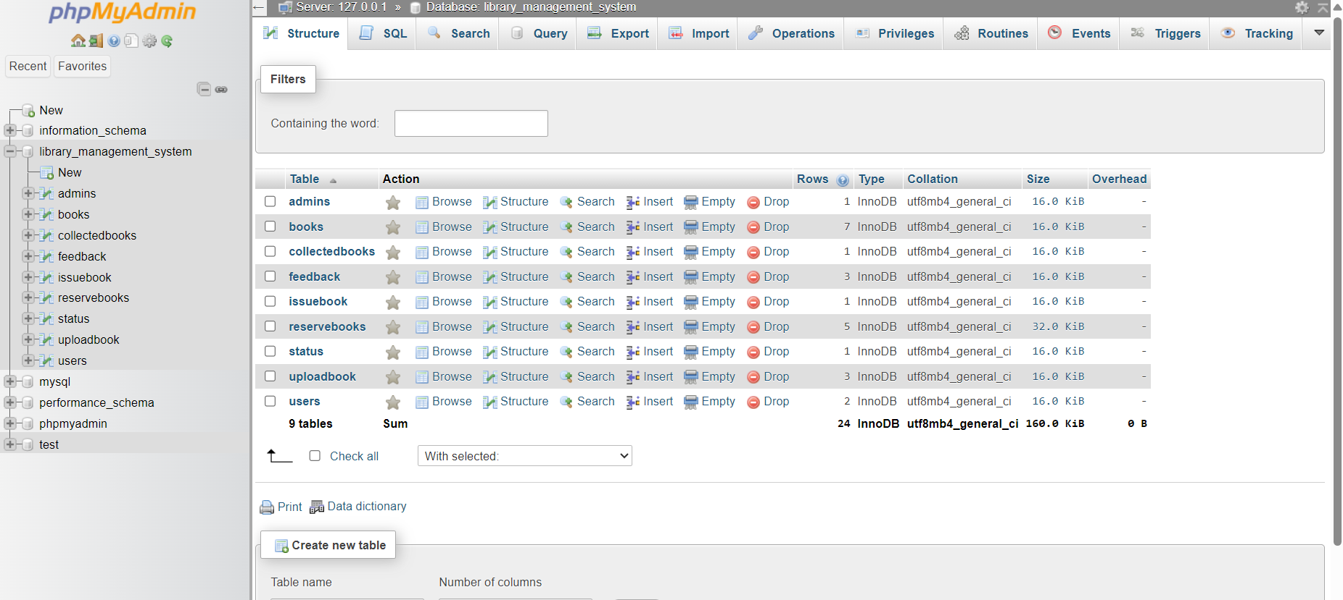

**Storage in database:**

**Login credentials:**



Here password is saved in UTF format for security.

Books:

