**Note:** Along with this Report we had attached a zip folder of this LMS. How to go through this zip folder is shown in below process.

**Process:**

1. Firstly, save the zip folder and access it.
2. Home page is a Home.php file. So start from there.
3. From there every thing is connected to other pages yo can see in website.
4. To establish a database connection, firstly install XAMPP in your system.
5. After installing, you can see this page

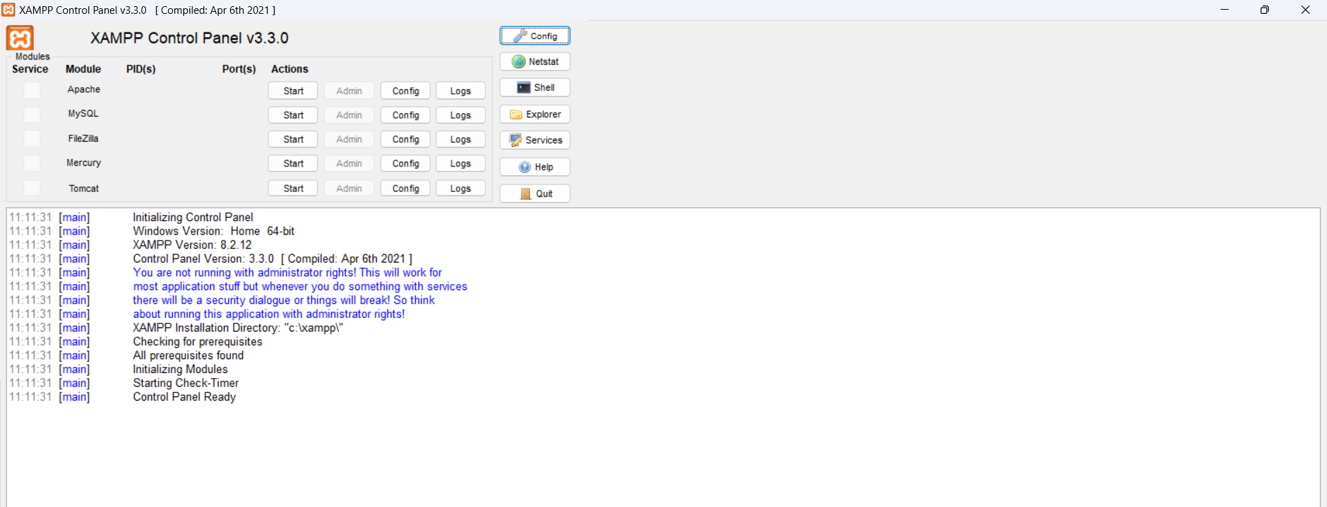

1. Click on start

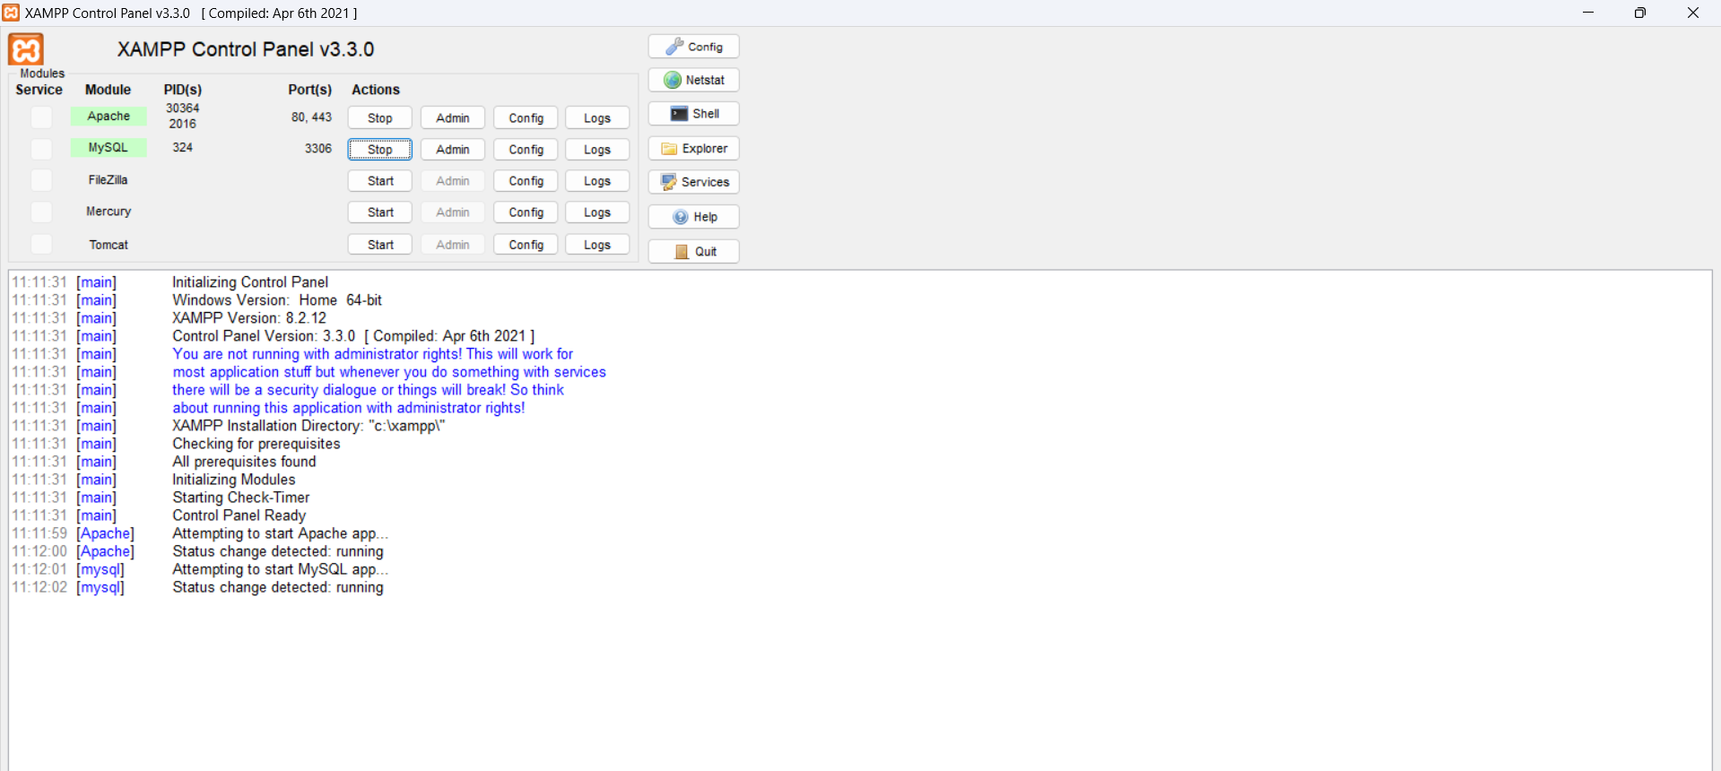

1. If you face any error like after clicking on stop it stoping automatically, try this.
2. now open search bar and type cmd. Next make it as run as administrator
3. As follows:

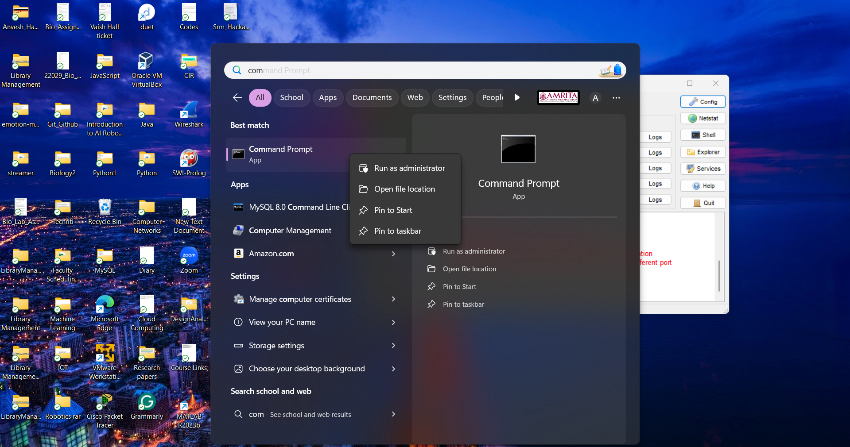

1. Try following commands

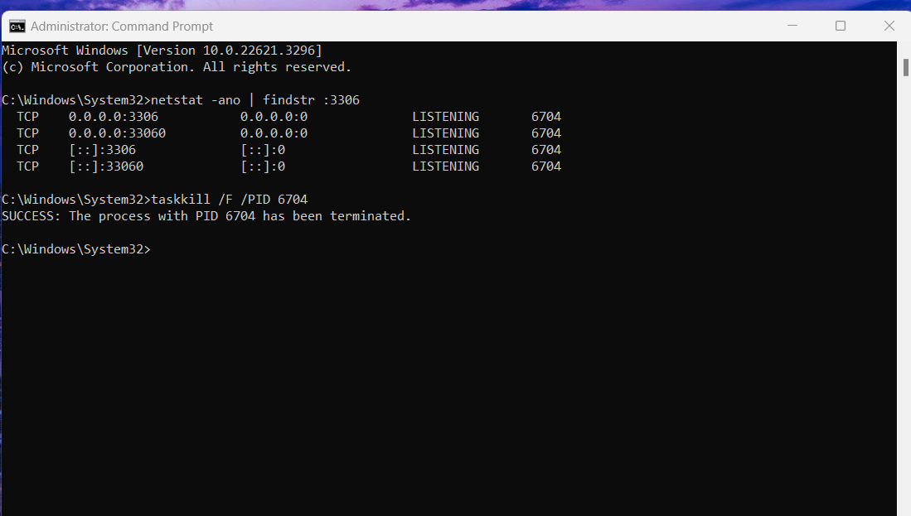

1. Now it will work.
2. So click on start again.
3. It opens a database page on browser of phpMyAdmin

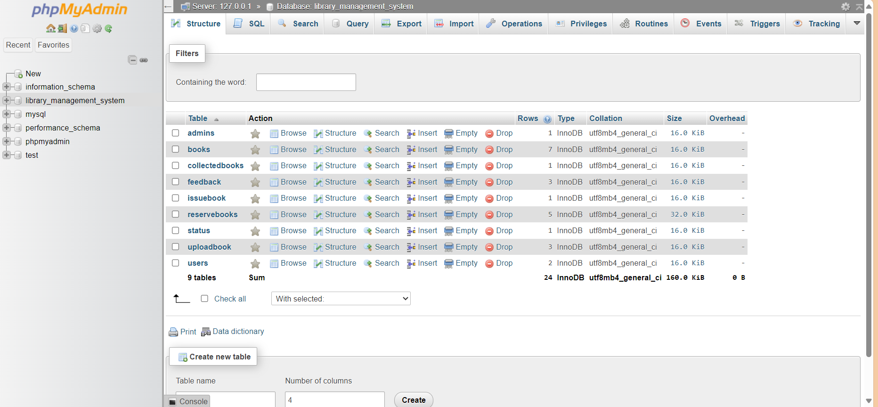

Now create the following tables

Inside them

**Admin**

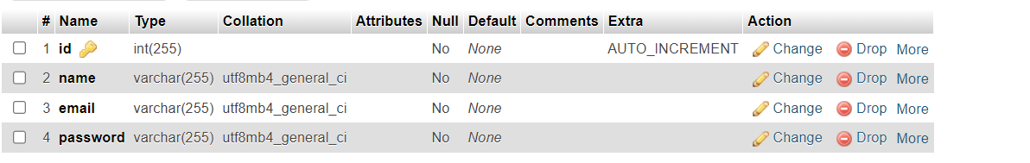

**Books**

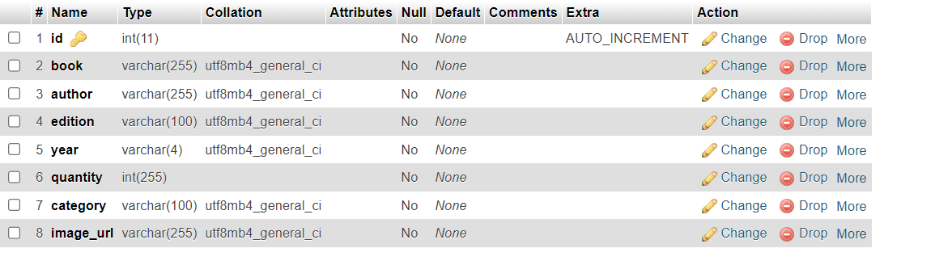

**Collected books**

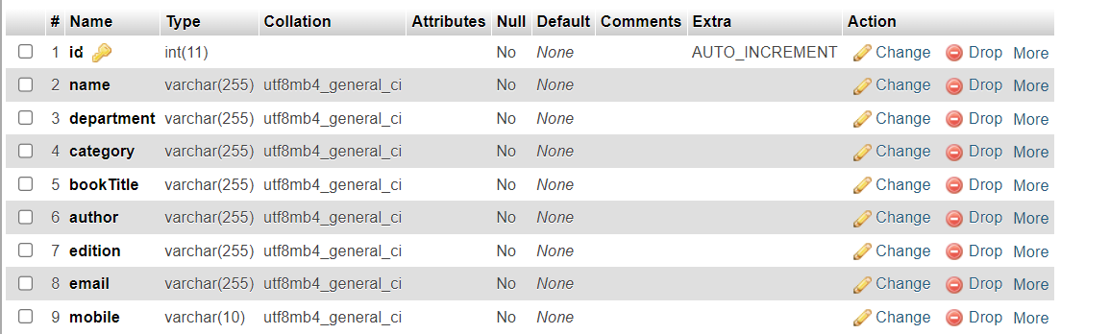

**Feedback**

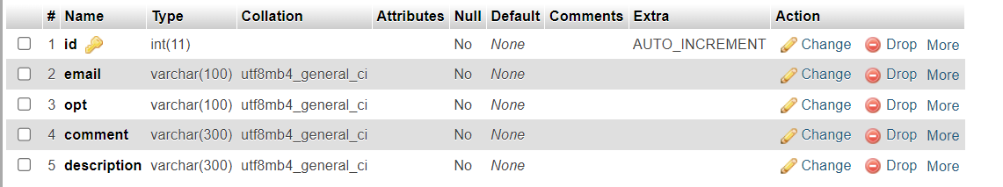

**Issuebook**

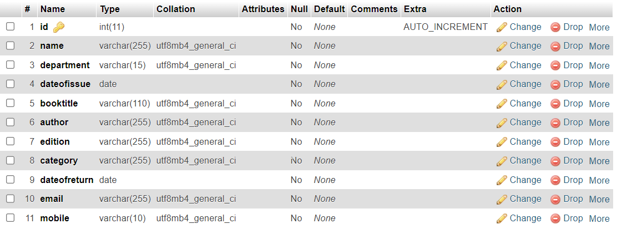

**Reserve books**

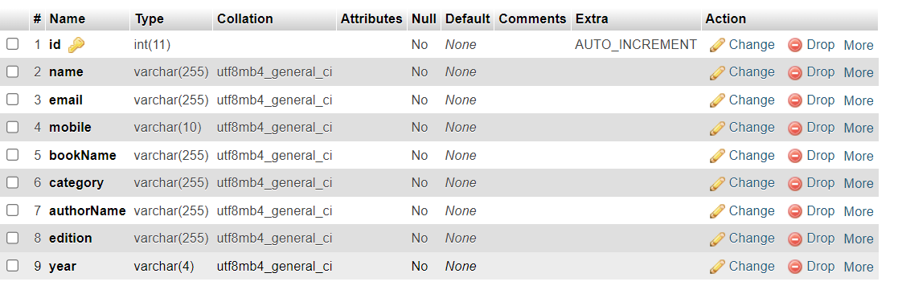

Status

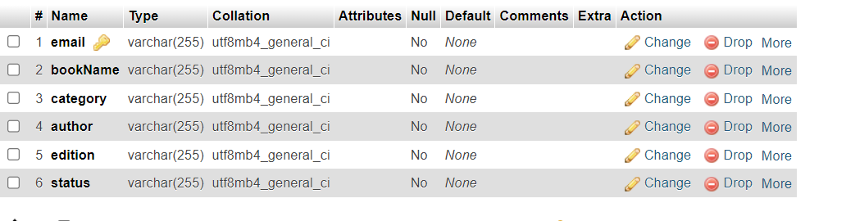

**Uploadbook**

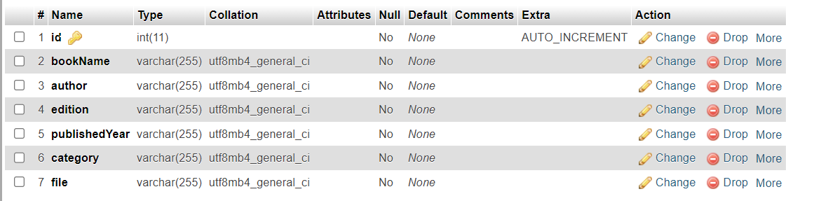

**Users**

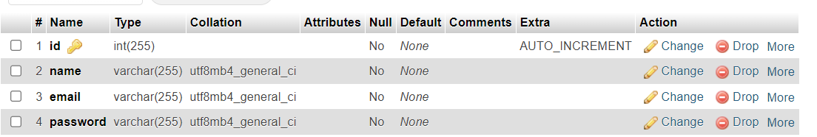

1. Now if u give input in website, that gets stored in database.