SPRING WITH MONGO DATABASE APPLICATION

#Fallow below steps for creating springwithdatabase application using docker.
- git clone https://github.com/MithunTechnologiesDevOps/spring-boot-mongo-docker.git
- cd spring-boot-mongo-docker
- mvn clean package

#create image for springwithmongodatabase application

Note:
- Dockerfile should be available inside the directory before trigger below command
- docker build -t venki22/springappmongodb .
- docker run --name springmongodbcon -p 6060->8080 -d venki22/springappdb:latest
- docker ps -a
- docker push venki22/springappdb

- If we create container without network name then all containers will be created in default network (i.e default bridge network)
- In this default bridge n/w with hostname (container name) we can't connect other container means in this case with hostname (i.e mongo) application will not connect to mongodb.
- In order to resolve this issue, we need to create custom bridge network using below command

# Create Network if not exists
docker network create -d bridge springappbridge

#Mongo database container

docker run -d --name mongo -e MONGO_INITDB_ROOT_USERNAME=devdb -e MONGO_INITDB_ROOT_PASSWORD=devdb@123 --network springappbridge mongo

#SpringApp container

docker run -d -p 8080:8080 --name springapp -e MONGO_DB_HOSTNAME=mongo -e MONGO_DB_USERNAME=devdb -e MONGO_DB_PASSWORD=devdb@123 --network springappbridge venki22/springappdb:latest

Note:
- Application hostname and database container name should be same (i.e mongo)
- While creating mongodatabase container, we are not creating port-mapping because not exposing container to outside.
- Application is maintaining data in debase
- Application and database also running container
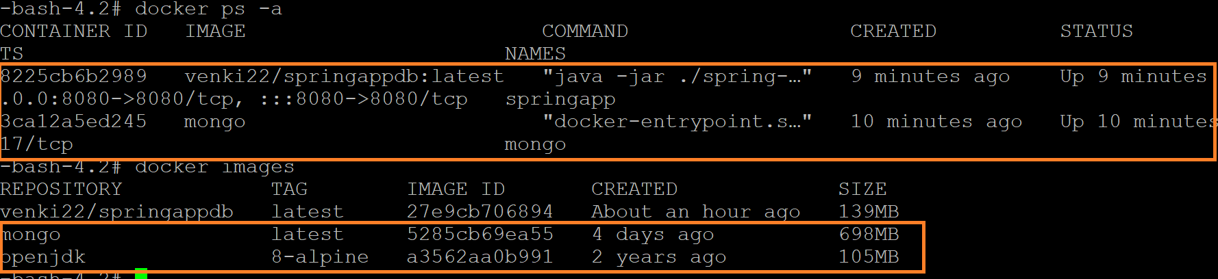

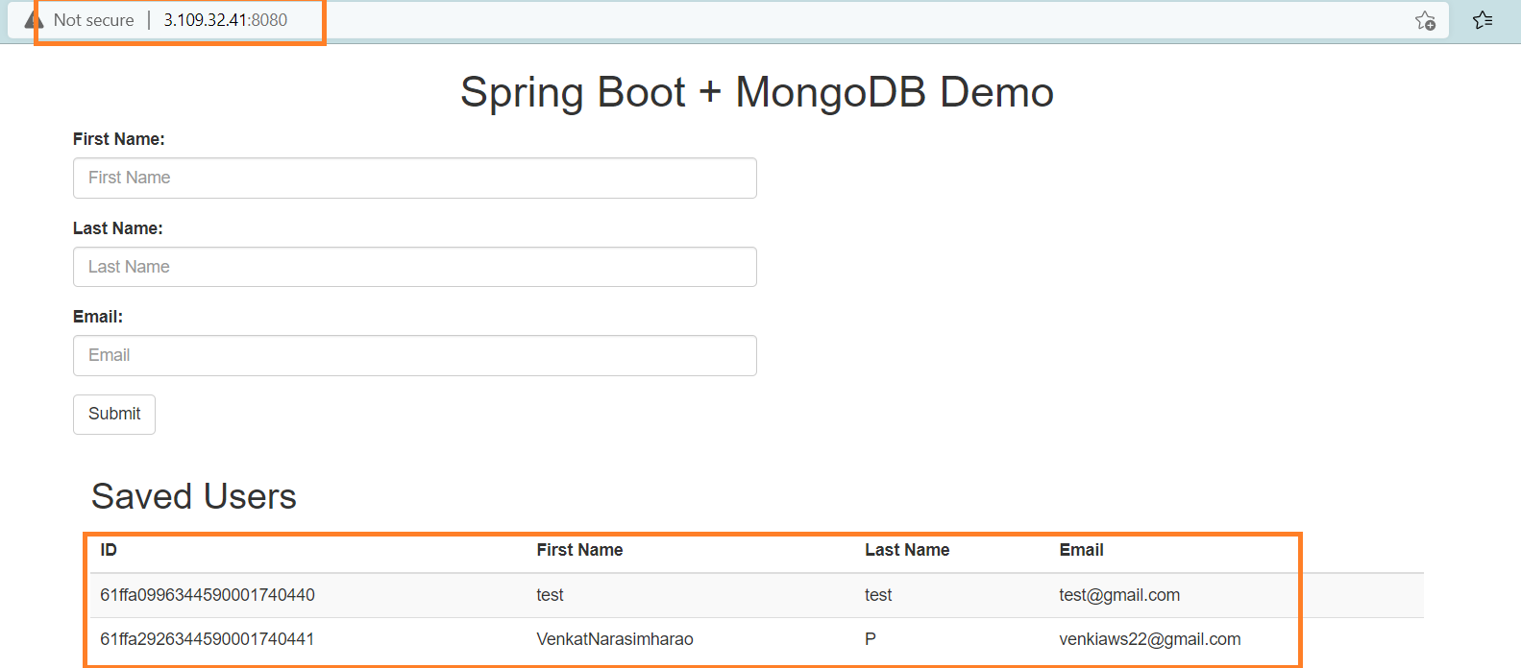

All information will be maintain below path
If the container (db container is down) in this case application will not talk to database
docker exec mongo ls /data/db
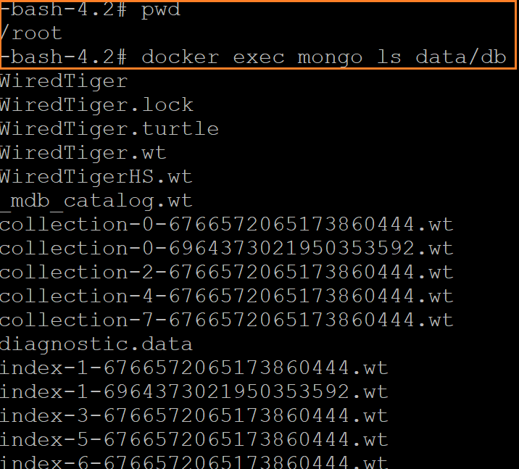

Go to inside application container
docker exec -it springapp /bin/sh
#install curl or other software inside container using below command if required
apk add curl
#login into mongo container using below command
curl -v telnet://mongo:27017
ping mongo
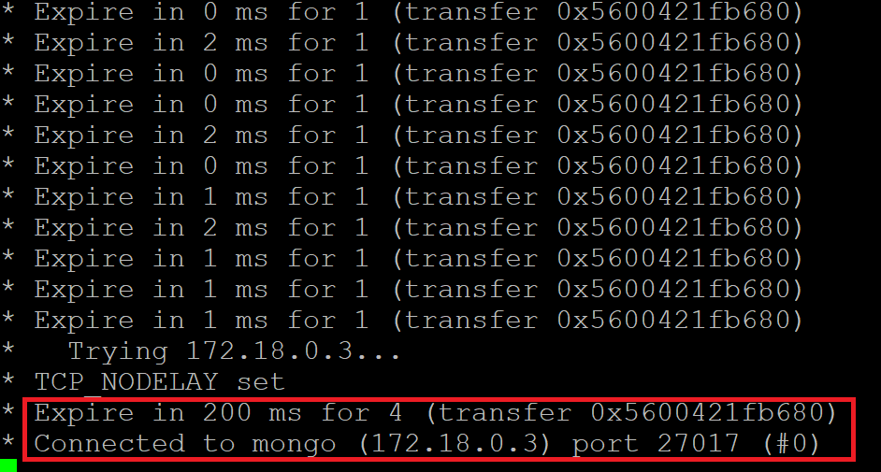
Note:
- If we stop and start the database container data will not loss
- In some case database container will be deleted and re-created same database container in this case data will be loss because container file changes are loosed.
- This is not accepted for real time, to resolve this kind of issues we will use “volume”

How to manage the data at any point of time?
We can use volume concept.

