How to copy the file from container to our local system and local system to container?

Create nginx image:

docker run --name -d nginxcon nginx:latest

Now container is up and running
Enter into inside container:
$ docker exec -it <container-id> /bin/bash

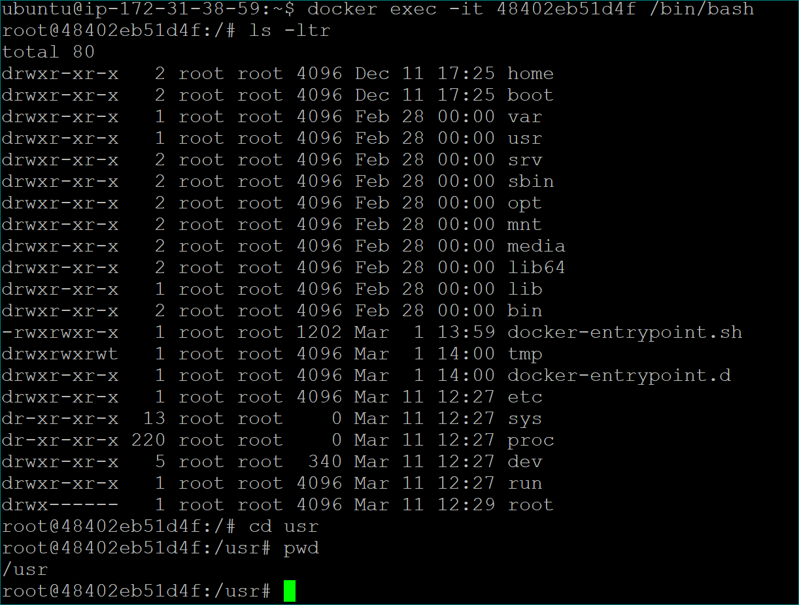

Sending local file to container location:
Exit from container machine
Create file inside local machine using below command
$ touch file1
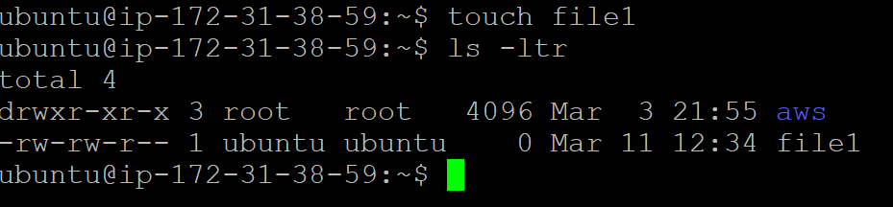

Run below command to move file from local machine to container
$ docker cp <Path in the local machine> <Container ID>:<Path of file inside the container>
$ docker cp ./file1 48402eb51d4f:/usr/file1

Enter inside the container
Go to that particular path and verify file available or not
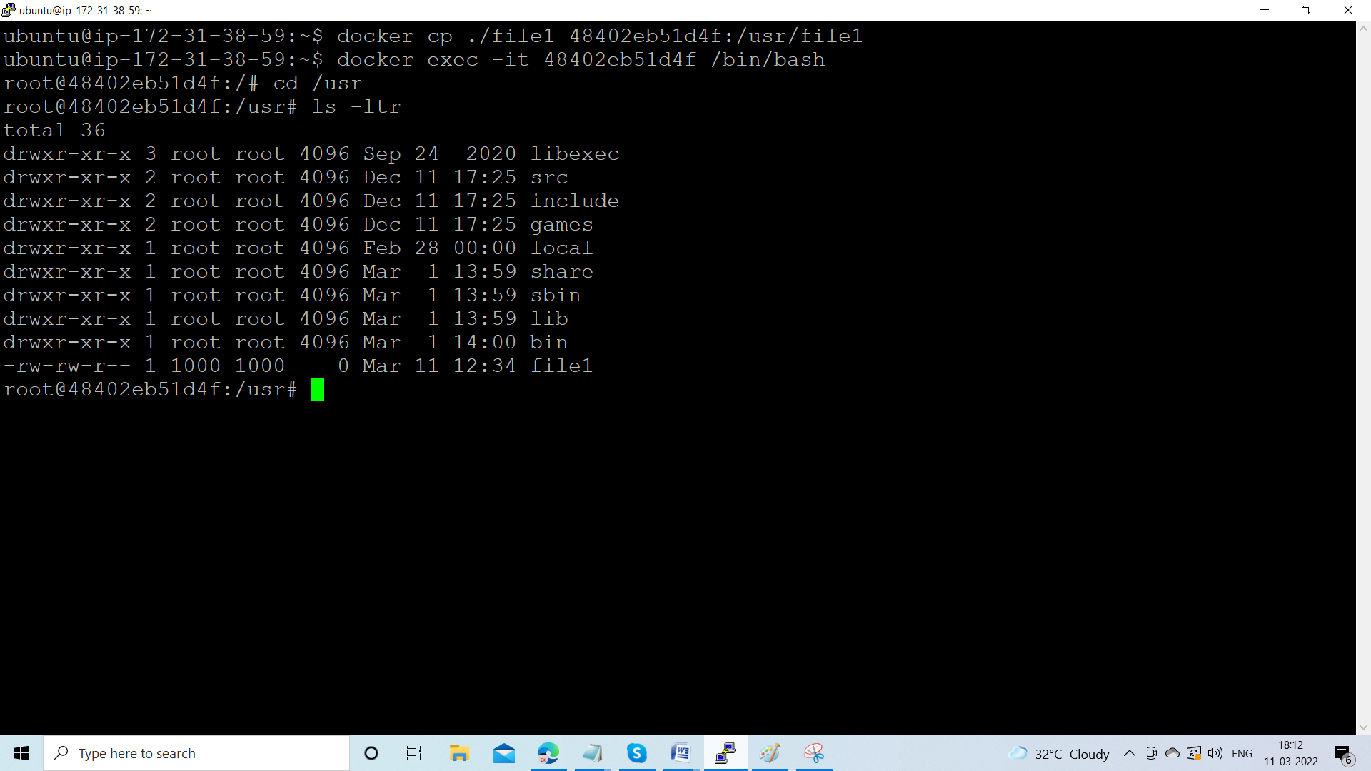

Run below command to move file from container machine to local machine:
$docker cp <Container ID>:<Path of file inside the container> <Path in the local machine>
docker cp 48402eb51d4f:/usr/file1 ./file2

