Private Registry:
ECR: Elastic Container Registry (ECR)(fully managed docker registry)
- Container registry fully managed by AWS

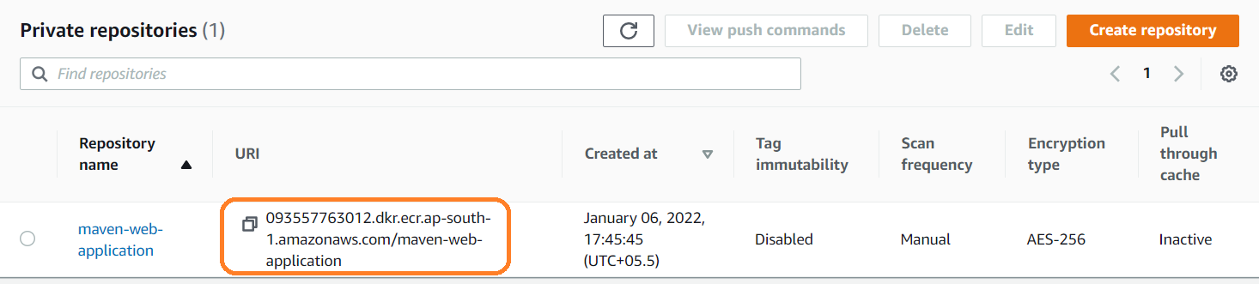

Tag immutability: If it is disable we can override same images multiple time, if we don’t want to override image then we have to enable.

- git clone https://github.com/MithunTechnologiesDevOps/maven-web-application.git
- cd maven-web-application/
- sudo apt-get update –y
- sudo apt-get install maven -y
- mvn clean package
/home/ubuntu/maven-web-application/target/maven-web-application.war
- cd maven-web-application/
Creating repository in ECR:
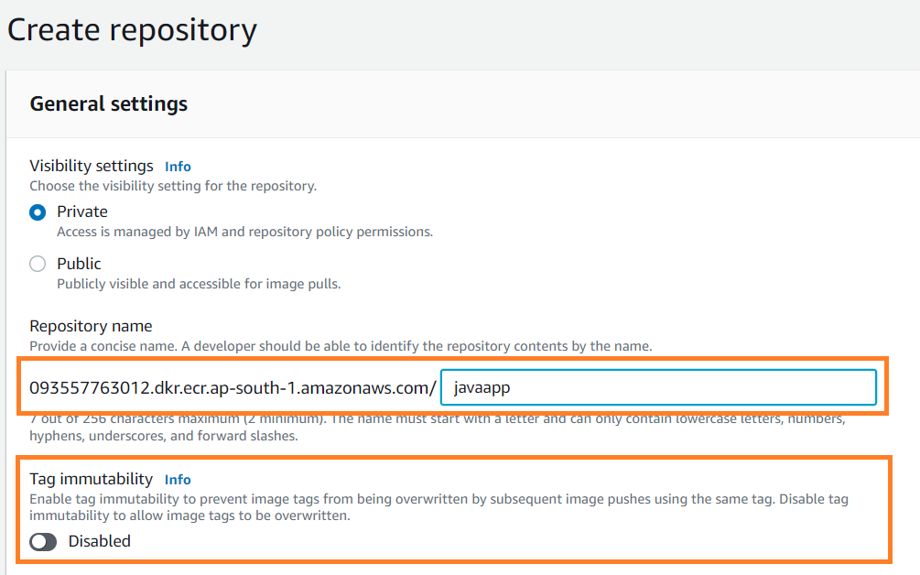

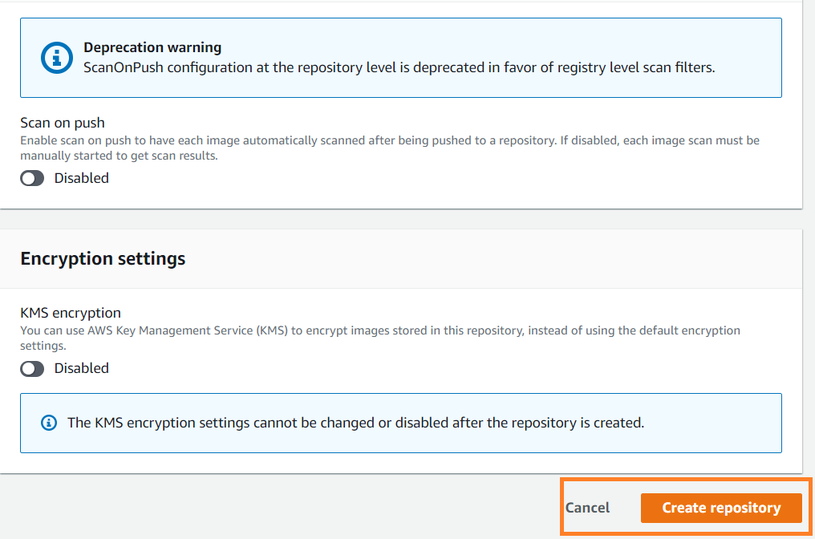

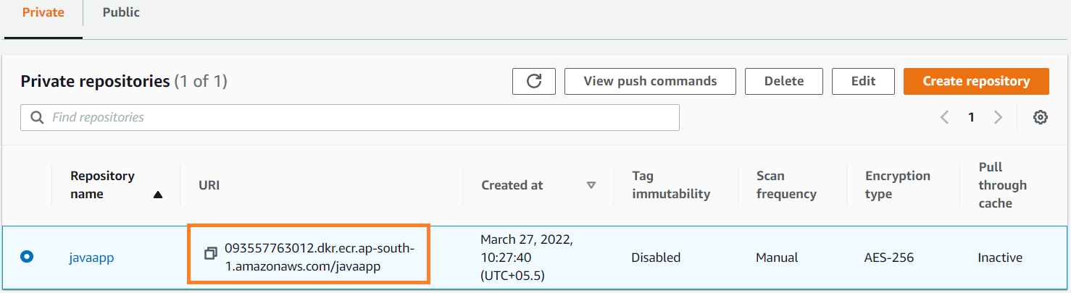
- sudo docker build -t 093557763012.dkr.ecr.ap-south-1.amazonaws.com/javaapp.
- docker image ls (image has been created)
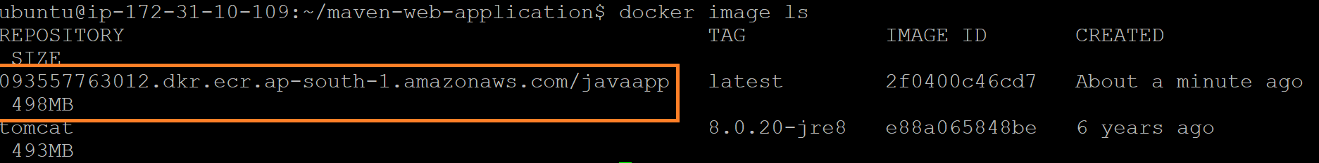
- docker push 093557763012.dkr.ecr.ap-south-1.amazonaws.com/javaapp
when we try to push image to ECR we will get below exception(i.e no basic auth credentials)
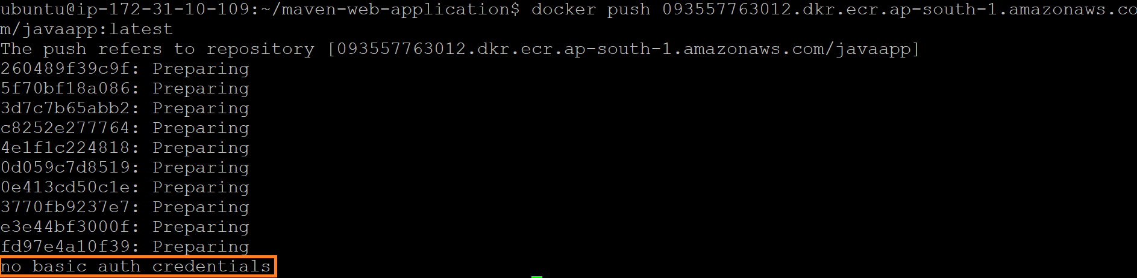

- sudo apt-get update (if Ubuntu linux)
- sudo apt-get install awscli (if Ubuntu linux)
- aws –version
aws-cli/1.18.69 Python/3.8.10 Linux/5.13.0-1019-aws botocore/1.16.19
- docker login 093557763012.dkr.ecr.ap-south-1.amazonaws.com/maven-web-application -u -p | docker login --username AWS --password-stdin 093557763012.dkr.ecr.ap-south-1.amazonaws.com
(Password we need to get from token)
s
- Go To IAM → Roles (Create role and attach role to service) your password will be stored un-encrypted in / aws ecr get-login-password --region ap-south-1 root/.docker/config.json.
- Create below role for access
- 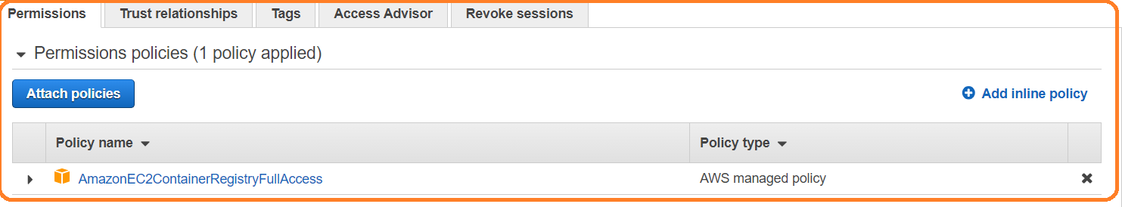
- EC2→ Actions → Security → ModifyIAMRole
- AmzonEC2ContainerRegistryReadonly:
If we attach this role we can’t push the image.
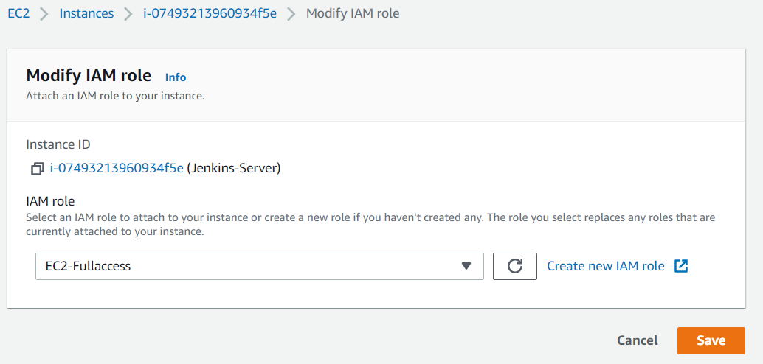

- aws ecr get-login-password --region ap-south-1 (Token will generate)
- Attach that role to server(EC2 Instance)
- Run below command and will get token
- aws ecr get-login-password –region ap-south-1

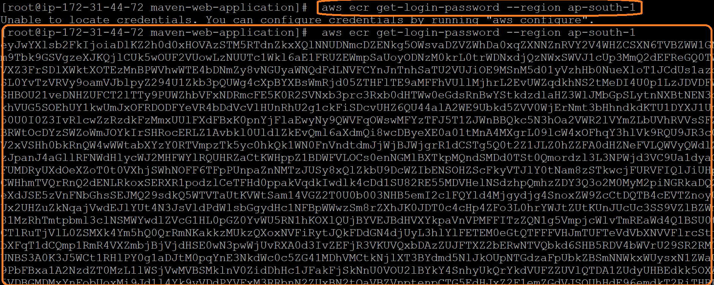

- aws ecr get-login-password --region ap-south-1 | docker login --username AWS --password-stdin 093557763012.dkr.ecr.ap-south-1.amazonaws.com

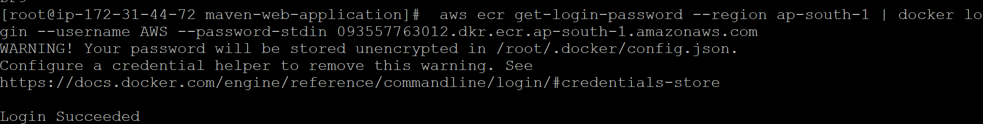

- once authentication success, we can push the image to ECR using below command.
- docker push 093557763012.dkr.ecr.ap-south-1.amazonaws.com/maven-web-application

pull image from ECR:
- docker pull 093557763012.dkr.ecr.ap-south-1.amazonaws.com/maven-web-application
- create IAM role with readonly access and attach that role to deployment server
- aws ecr get-login-password --region ap-south-1 | docker login --username AWS --password-stdin 093557763012.dkr.ecr.ap-south-1.amazonaws.com

- docker run -d --name mymvnproj -p 6060:8080 093557763012.dkr.ecr.ap-south-1.amazonaws.com/mvnwebproj
- docker pull 093557763012.dkr.ecr.ap-south-1.amazonaws.com/maven-web-application
- http://13.232.26.40:6060/maven-web-application/

Note:
- We can create multiple repositories in ECR if required
- Real time we are going to maintaining private registries only

