DOCKER-COMPOSE

- It’s a Tool for defining & running multi-container docker applications
- One application consists of multiple containers
- One container depends on another
- We can define single container using docker-compose or multiple container using docker-compose
- use yaml/yml files to configure application services(docker-compose.yml)
- can start all services with a single command: docker compose up
- can delete all services with a single command: docker compose down
- can scale up selected services when required
- dockerfile: using dockerfile we can create a images
- docker-compose: its tool for define and deploy single container and multiple container
- default name for compose file is docker-compose.yml or docker-compse.yaml
- docker-compose installation:
- sudo sudo curl -L https://github.com/docker/compose/releases/download/1.21.0/docker-compose-`uname -s`-`uname -m` | sudo tee /usr/local/bin/docker-compose > /dev/null
- sudo chmod +x /usr/local/bin/docker-compose // give executable permission
- ln -s /usr/local/bin/docker-compose /usr/bin/docker-compose
- docker-compose –version
Ubuntu Linux:
$ apt-get install docker-compose –y
Install Docker(Ubuntu)
$ apt update
$ apt install -y docker.io

Compose file format (key components):
- version:
- services:
- volumes:
- networks:
- volumes:
- image:
- build:
- restart:
- environment:
- depends_on:
- port:
- links:
Compose has a command for managing the whole lifecycle of your applications:
- Start, stop and rebuild services
- View the status of running services
- Stream the log output of running services
- Run a one-off command on a service

version: '3.1' //compose file format version(i.e. Schema)

services:
springboot:
image: dockerhandson/spring-boot-mongo:latest
environment:
- MONGO_DB_HOSTNAME=mongo
- MONGO_DB_USERNAME=devdb
- MONGO_DB_PASSWORD=devdb@123
ports:
- 9090:8080
depends_on:
- mongo
networks:
- springappnetwork

mongo:
image: mongo
environment:
- MONGO_INITDB_ROOT_USERNAME=devdb
- MONGO_INITDB_ROOT_PASSWORD=devdb@123
volumes:
- mongodbvol:/data/db
networks:
- springappnetwork

volumes:
mongodbvol:
driver: local

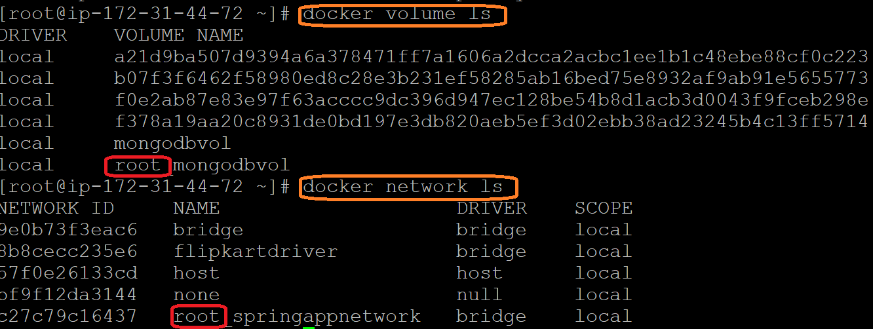

It’s taking current folder/project name
- docker-compose -v
- docker-compose --version

Create docker-compose file at any location at any location on your system
- docker-compose.yml

Check the validity of file by command
- docker-compose config
Run compose file with custom name
- docker-compose -f <custom-name> config
- docker-compose -f docker-compose-cust.yml config
Run docker-compose.yml file by command
- docker-compose up –d
Run docker-compose-customfile.yml file by command
- docker-compose -f docker-compose- customfile.yml up –d
- -d : create a services in detached mode
Bring down application by command(i.e container will be deleted)
- docker-compose down //default compose file
- docker-compose -f docker-compose-cust.yml down //if custom file
Scale docker-compose
  - docker-compose up -d --scale <container-name>=<no-of-instance>
  - docker-compose up -d --scale mydb=3

Note :
Before running all above command first docker should be running status

- docker-compose up -d
- docker-compose down
- docker-compose stop
- docker-compose start
- docker-compose restart
- docker-compose images
- docker-compose ps
- docker-compose logs

#To use existing volume without creating docker-compose we can use below option (external: true)
volumes:
mongovol:
external:true
networks:
springappbrige:
external:true
Note:
→docker-compose file won’t create volume and networks because external:true
→ we have to create manually

#docker-compose.yml
version: '3.1'
services:
springapp:
image: venki22/springappdb:latest
ports:
- 8080:8080
environment:
- MONGO_DB_HOSTNAME=mongo
- MONGO_DB_USERNAME=devdb
- MONGO_DB_PASSWORD=devdb@123
networks:
- springappbridge
depends_on:
- mongo
mongo:
image: mongo
environment:
- MONGO_INITDB_ROOT_USERNAME=devdb
- MONGO_INITDB_ROOT_PASSWORD=devdb@123
volumes:
- mongovol:/data/db
networks:
- springappbridge
volumes:
mongovol:
driver: local
networks:
springappbridge:

#if custom file
docker-compose -f <custome-file-name> config
docker-compose -f docker-compose-cust.yml config
docker-compose -f docker-compose-cust.yml up –d

#if default compose file
docker-compose config
docker-compose config up –d
#To Check the container status using docker compose(if custom file)
docker-compose -f docker-compose-cust.yml ps

