Container

Container: is nothing but running instance of image.

- Container is a self contained package which contain (application code + Its dependencies)
- A container image is a lightweight, stand-alone, executable package of a piece of software that includes everything needed to run it, code, runtime, system tools, system libraries, settings
- Each container will have an IP address
- Container name should be unique, we can’t reuse the same name
- Based on server capacity we can create any number of containers in side server
- We can run multiple process inside the container but not suggestible
- Whole purpose of container is isolation not “tight coupling”
- Docker will maintain all container information in below path

sudo ls /var/lib/docker/containers #docker working directory

Features of container:
- Light weight
- Less resources are used
- Booting of containers is very fast
- Can start, stop, kill , remove containers easily and quickly
- operating system resources can be shared within Docker

Difference between docker create and docker run?
Docker create:

# It’s just create the container it won’t start the container
- docker create <Image_Name>
- docker create --name <container-name> -p <host-port: container-port> -e <key>=<value> -v
<volume-Name :/<path> --network <network-name> <Image_Name>

Run command options
-v Used for attaching a volume to the container
--volume-from Used for sharing volume between containers
--network Used to run the container on a specific network
--link Used for linking the container for creating a multi container architecture
--memory Used to specify the maximum amount of ram that the container can use
-P(capital) Will perform automatic port mapping
-p Used for port mapping between port of container with the dockerhost port.
--name Used for giving a name to a container
-d Used for running the container in detached mode as a background process
(ctr+c) to stop the background process
-it Interactive mode

# It will create and start the container
- docker run <Image_Name>

Docker run:
- We can set the limit to the container
- It is recommended to set the resources for containers (i.e CPU/Memory utilization limits)if we don’t set the limit in this case one container is will take more CPU and more memory in this case other container may impact even though containers are isolated with process level but host machine and resource are different.
- If image is not available in locally then it will pull the image from registry
- We can't access the existing container
- Existing container we will not done port mapping/publishing this has to done while creating container itself
- If container status will be "Exited(0)" (i.e we can’t access the container)
- From image container will be created with default name, if you want to give custom name need to give below command Without giving container name, docker demon will create default name for container.
- Host-port should be unique and containers also have IP Address

Note:

docker run --name <custom-container-name> -p <host-port>:<container-port> <image-name>
docker run --name <custom-container-name> -p <host-port>:<container-port> -d <image-name>

To see the list of running and stopped containers
docker ps –a
docker ps --all

To see the list of all running containers
docker container ls
docker container ls –a

To start a container
docker start <container_name | container_id>

To stop a container
docker stop <container_name | container_id>

To restart a container
docker restart <container name | container_id>

To restart after 10 seconds
docker restart -t 10 <container name | container_id>

To delete a stopped container and containers
docker rm <container_name | container_id>
docker rm <container_name-1 | container_id-1 container_name-2 | container_id-2>

To delete a running container forcefully
docker rm -f container_name | container_id
docker rm -f $(docker ps -q) # Delete all running container forcefully

#To delete container first stop the container using (kill/stop command) and delete the container using rm
docker stop <containerName/Id>
docker rm <containerName/Id>

To stop all running containers
docker stop $(docker ps -aq)

To restart all containers
docker restart $(docker ps -aq)

To remove all stopped containers
docker rm $(docker ps -aq)

Delete only stopped container
docker container prune
docker rm $(docker ps -aq -f status=exited)

To remove all containers (running and stopped)
docker rm -f $(docker ps -aq)
Note: -f → stands for files systems

To see the logs generated by a container
docker logs <container_name | container id>

To see the ports used by a container
docker port <container_name | container id>
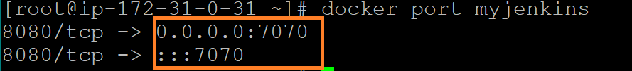

To get detailed info about a container
docker inspect <container_name | container_id>

To go into the shell of a running container which is moved into background
docker attach <container_name | container_id>

Difference between docker kill and stop?
docker stop:
- It will gracefully STOP the container (process)
docker kill:
- Single stop and Single termination
- Abnormally/forcefully stopping the container
- if some reason container is not stopping using stop command in this case we will use kill command

To check port number
docker port <container-name>
docker port appserver

80/tcp -> 0.0.0.0:49155
80/tcp -> :::49155

80 is default port
49155 is custom port

- We can check using (docker container ls)
Execute command in running container (without interactive terminal)
docker exec -it <container_name/container_id> <command>
To launch the bash shell in a container
- docker exec -it <container_name/container_id> bash
- docker exec -it <container_name/container_id> sh
- docker exec -it <container_name/container_id> /bin/bash

- docker exec javawebapp ps -ef
- docker exec javawebapp pwd
- docker exec javawebapp ls
- docker exec javawebapp date
- curl -vL localhost:8080/maven-web-application/

#Top running process inside a container
docker top <container_name | container_id>
docker history <container_name | container_id>

Re-name container
docker container rename <old_name> <new_name>

Can we run more than one process inside a container?
- Technically it’s possible, but not recommended to have more than one process inside a container
Instead of we can create 2 separate containers.

docker stats <container_id/Name>
- we can check using above command, how much memory/CPU/network input/output details is utilizing container application wise
- If application is working fine but getting slow response in this case we will use this command to treble shoot issue.

Difference between docker stop and docker kill command?

- docker kill:
Forcefully kill the process without any grace period
- docker kill <container_name|container_id>
docker stop:
It will stop the server with grace period
- pause : It will pause(sleep) the container process
docker pause <container_name|container_id>
- unpause: we can unpause using below command
docker unpause<container_name|container_id>

How to trouble shoot your applications which are running as containers?
1. Check if the container is up and running
docker ps
2. Check the logs of the container
docker logs <containerId/Name>
docker logs -f <containerId/Name>
-f: floating logs
- stout
- stderror

docker logs <container_id/Name>
docker logs --tail 10 <container_id/Name>

docker attached <container_id/Name>
- It will attached the container shell to server shell
- We can able to see the all logs information while accessing application if we attach the container using docker attached
- "ctrl + c" and try to access the application (We will not access)
docker start <container_id/Name>
- We can access now.

How can we copy files to "system to container and container to system"?
docker exec javawebapp ls logs
"we will get few .logs files"
We need to take that file from "container to system" using below command
docker cp <containerId/Name>:<containerlog-path> <system-path>
docker cp <containerId/Name>:/usr/local/tomcat/logs/catalina.20211224.log cataina.log

Copy files from "system to container"
docker cp cataina.log <containerId/Name>:/usr/local/tomcat/logs/catalina.20211224.log

What is difference between "docker cp and COPY"?
- COPY:
COPY is docker file instruction using COPY we can copy files/folders to image while creating image
- docker cp:
Using docker cp we can copy files "system to the container and container to the system"

Any changes happened inside the container will that changes will exist if container deleted/re-created ?
Yes, we can use below docker commit steps.
docker run -d -p 8080:8080 venki22/maven-web-application /bin/bash
Create some files inside the container using docker commit command we can retained the change even through container stopped or deleted.

- docker commit?
Retained container changes as a image
- docker commit <containerName/Id> <registryURL/repository:tag>
- docker commit javawebapp venki22/maven-web-application:fromcontainer
- docker images
- docker push venki22/maven-web-application:fromcontainer
- docker pull venki22/maven-web-application:fromcontainer (from other server or same server)
- docker run -d -p 8080:8080 venki22/maven-web-application:fromcontainer /bin/bash
- #verify files available or not

Create an image and push image to hub.docker.com

1.docker pull centos:latest
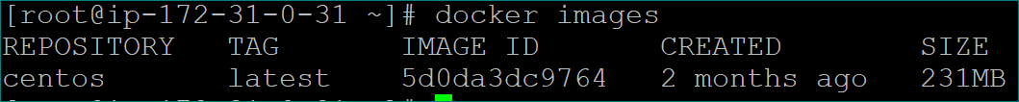

#run container using below command
2. docker run --name <container_name> <image_name>
docker run --name mycentimg centos

#commit image using below command
3.docker commit -m "mycentimg" <container_id> venki22/mydockerhandi:latest
docker commit -m "mycentimg" 754245f17bc4 venki22/mydockerhandi

4. docker push venki22/mydockerhandi

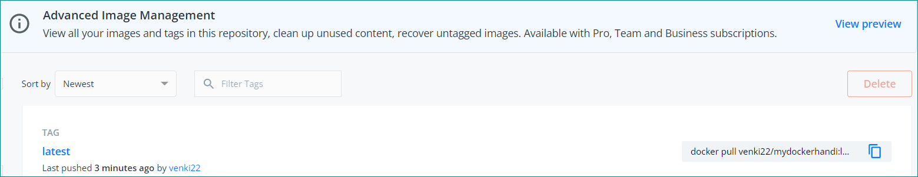

Network command:
To check current listen port numbers
- sudo yum install net-tools –y
- sudo netstat –tunlp
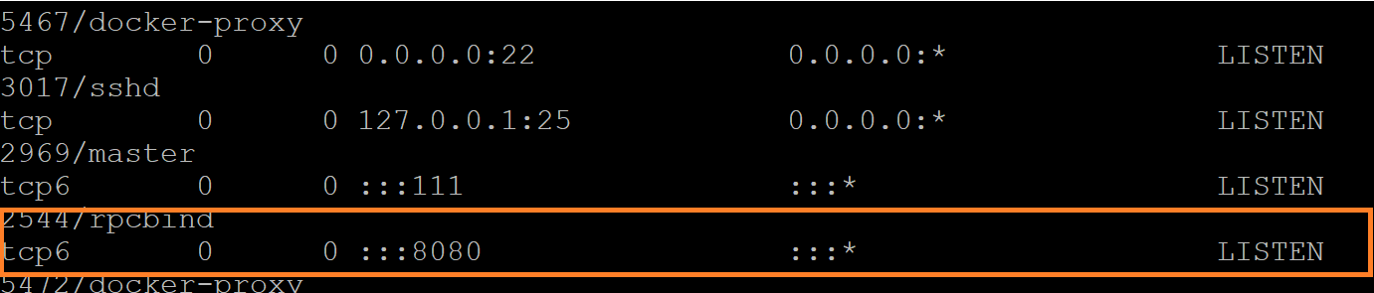
If we stop the container, then port number will be released

The docker stats command returns a live data stream for running containers. To limit data to one or more specific containers, specify a list of container names or ids separated by a space. You can specify a stopped container but stopped containers do not return any data.
docker stats <container_name|container_id>
docker stats 18a383c37763

Display container logs:
Display container application logs whatever has been send to stdout and stderror
- docker logs <container_name|container_id>
- docker logs 18a383c3776
- docker logs <container_name|container_id> --tail 10 # last 10 logs
- docker logs <container_name|container_id> -f # live stream data
- docker logs <container_name|container_id> --tail 10 > Filename.txt # store data in file
Execute the commands inside the container:
- Go to inside the container using below command
docker exec -it <container_name|container_id>
docker exec <container_name> <command>
docker exec 18a383c37763 pwd #Without interactive mode

docker exec -it 18a383c37763 bash
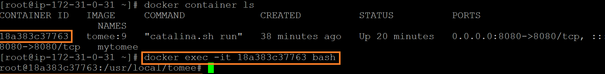
Note:
- Each and every container will have own file system
- Will not have all the module inside the container
- Container should be light weight
- Container is light weight because if we install all unnecessary packages in container there is no difference between container and server
- Container will have bare minimum software’s
- If we install any software and add date inside the container after login , will it be available after restart or stop the server container
--yes available if it is stop and restart the container
→ if we delete the container, in this case it won’t be available if we want those changes after deleting container we have to use docker commit.
docker commit <container_id|container_name> <Image_name|Image_id>
- We can create image out of container
- We can commit container changes as a image
- We can retain our changes using docker commit command
- To check status on console:
curl -v telnet<Public-IP>:<Port>
curl -v telnet://13.233.183.182:8080

docker ps --filter status=running
docker ps --filter status =paused
docker ps --filter “status =paused”

