Creating container as database

To start MySQL as container, open interactive terminal in it, create a sample table.

**# docker run --name <container-name> -d -e MYSQL_ROOT_PASSWORD=venkat mysql:<version-number>**

**# docker run --name mydb -d -e MYSQL_ROOT_PASSWORD=venkat mysql:5**

**-e** Used for passing environment variables to the container

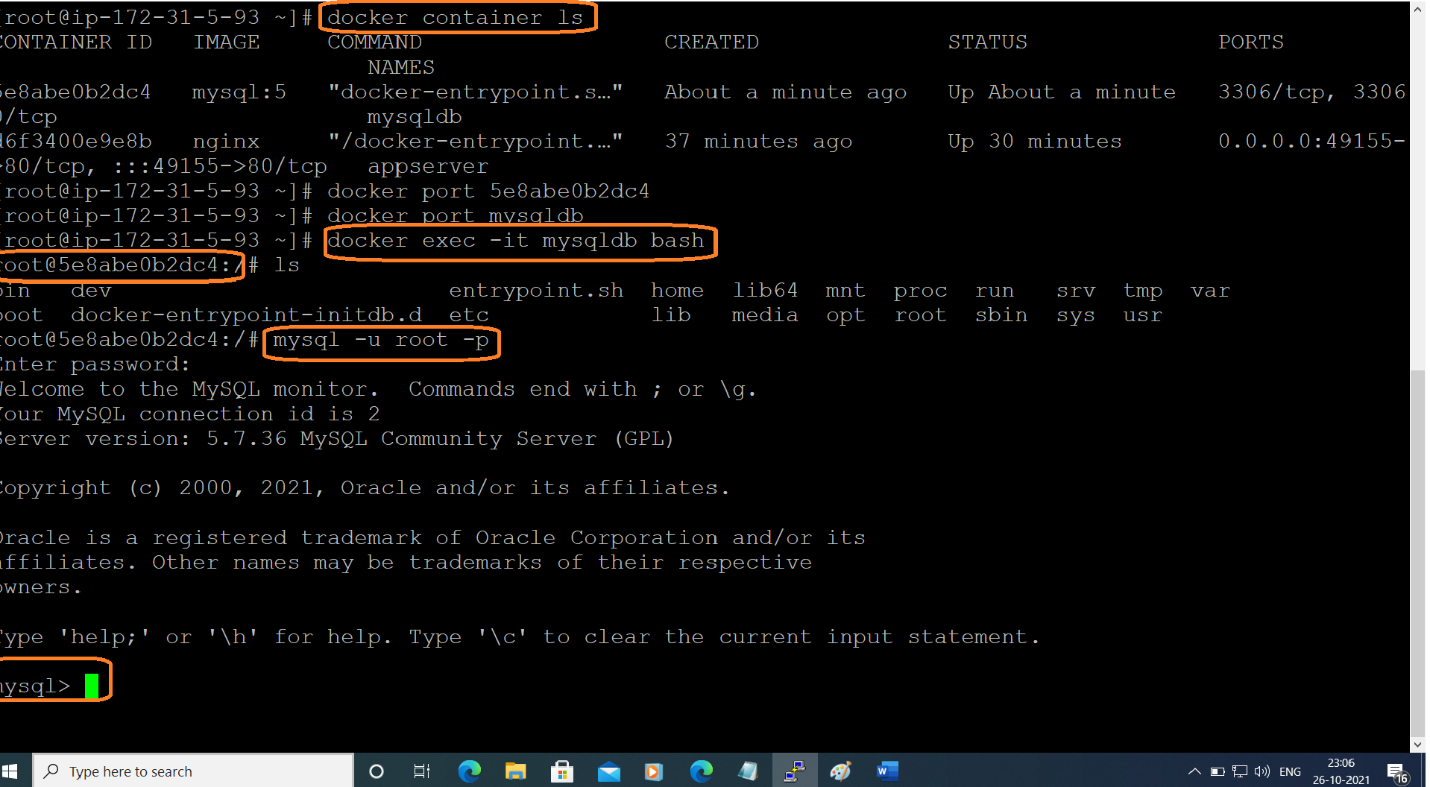

**# docker container ls**

I want to open bash terminal of MySQL

**# docker exec -it mydb bash**

To connect to mysql database

**# mysql -u root -p**

enter the password, we get MySQL prompt

TO see list of databases

**> show databases;**

TO switch to a database

**> use db_name**

**> use mysql**

TO create emp tables and dept tables

**https://justinsomnia.org/2009/04/the-emp-and-dept-tables-for-mysql/**

**> exit** exit from mysql database

**# exit** exit from mysql container