**Creating an ubuntu (operating system) container**

#To create ubuntu image

$ **docker pull <image-name>**

$ **docker pull ubuntu**

#To verify image created or not

$ **docker images (or) docker image ls**

Even operating system also we can provide in the form of container

# To create ubuntu container

**$ docker run --name <name-of-the-container> -it <image-name>**

**$ docker run --name myubuntu -it ubuntu**

**$ docker run --name mycenos -it centos**

**Run command option:**

**-it** 🡪 for opening an interactive terminal in a container (which enter into container we do the activity)

Once we run above command control enter into container if we not waiting for ip address meaning we are not pointing to docker host we are ubuntu container

To verify we need to run below command

**$ ls**

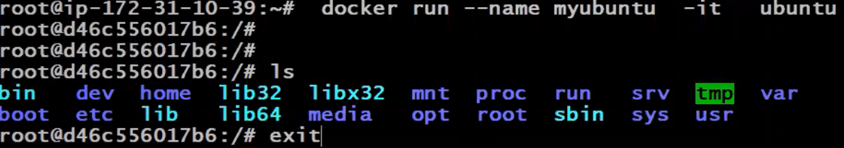

**$ exit**

Come out from ubuntu container

**Note:**

If don’t use -it controls will not enter into ubuntu container

If we use -it, control automatically enter into ubuntu container

$ls to see list of files under container