

Beyond Borders

Design Artifacts

20th Feb 2014

Trupti Saundar

Vraj Shah

Abhinav Marda

Anmol Arora

Prepared for

Open Access Academic Journal Project

Instructor: Dr. Abhishek Srivastava

Client: Dr. Nirmala Menon

Spring 2014

1. USE CASE DIAGRAM:

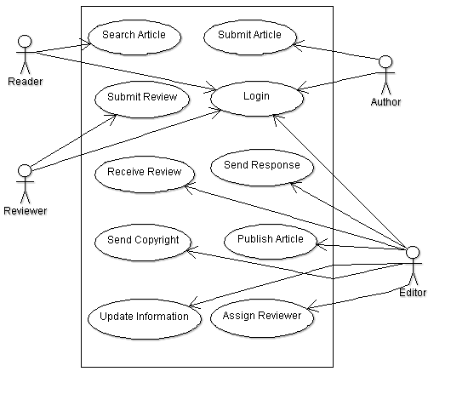

1. CLASS DIAGRAM

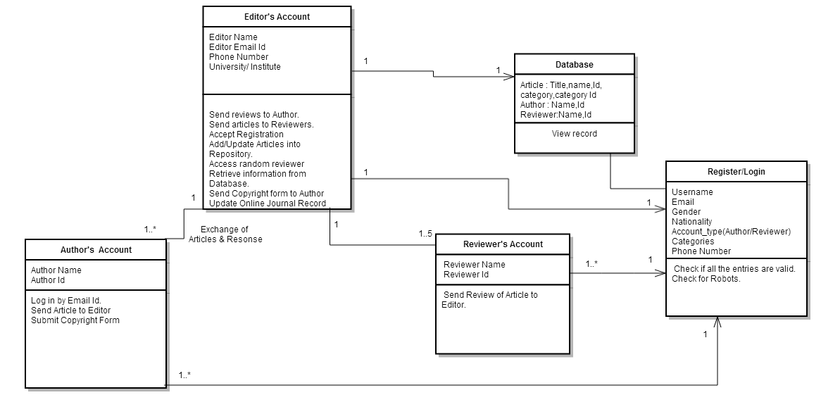

1. SEQUENCE DIAGRAM

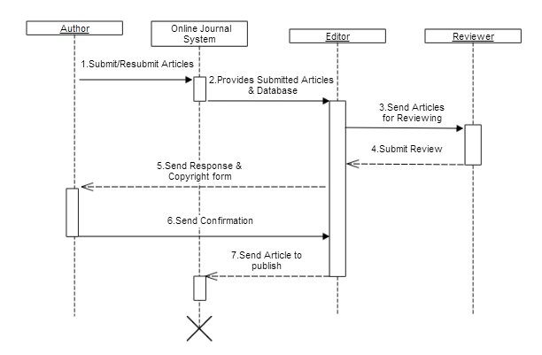

1. STATE CHART DIAGRAM

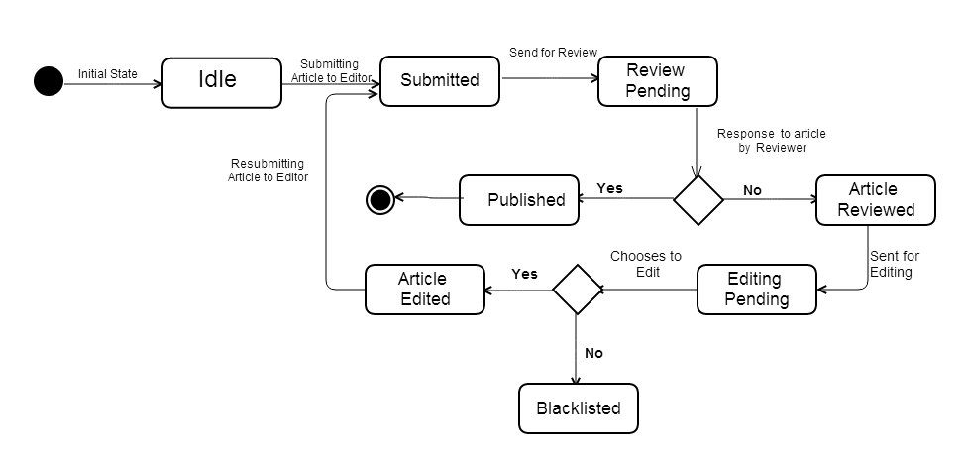(ii) 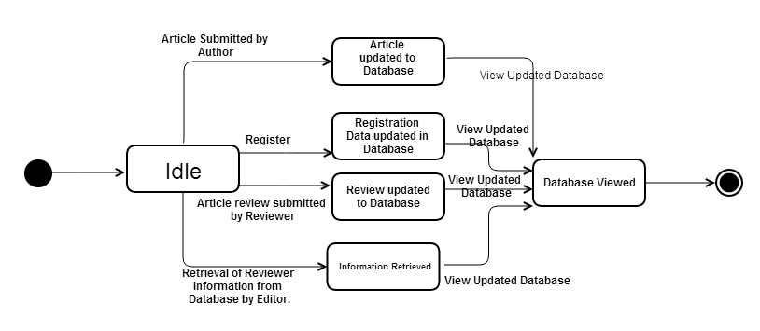

1. ACTIVITY DIAGRAM

(i)Article Submission Activity

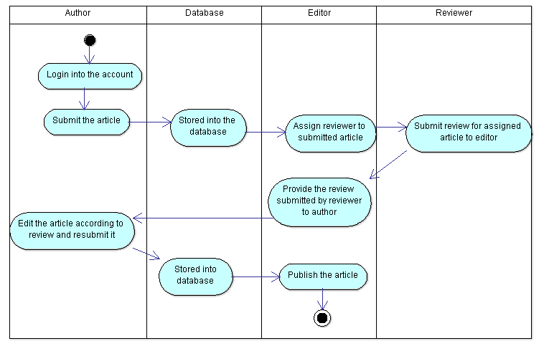

(ii)Register Activity

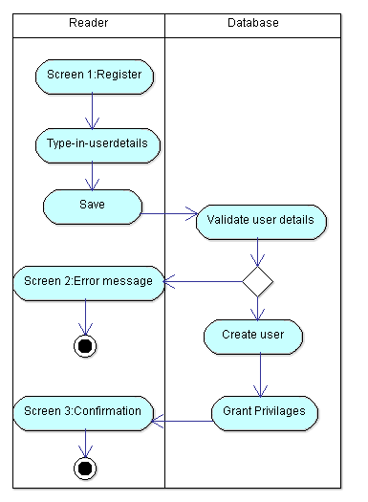

(iii)Search Article Activity

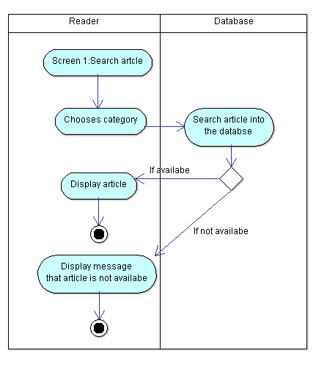

1. COMPONENT DIAGRAM

