

Beyond Borders

User’s Manual

18th April 2014

Trupti Saundar

Vraj Shah

Abhinav Marda

Anmol Arora

Prepared for

Open Access Academic Journal Project Instructor: Dr. Abhishek Srivastava

Client: Dr. Nirmala Menon

Spring2014.

1. **GENERAL INFORMATION**

**1.1 SYSTEM OVERVIEW**

Beyond Borders is an online journal management and web publishing system to expand and improve the access of research. It is open source software made freely available to research scholars worldwide for the purpose of making open access publishing a viable option for more journals, as open access can increase a journal’s readership as well as its contribution to the public good on a global scale. It will provide the facility of online submission of articles so that authors can get constructive feedback from expert reviewers and they could improve their research. It offers opportunity to readers to have an access to read journals of good quality on various topics of humanities. The website will have many features that will help research scholars to help break down barriers that hinder communication and collaboration among researchers and students of Digital Humanities, around the world. These features are:

1. Online Submission by the author and constructive feedback by reviewers
2. Communication between authors, reviewers and editor through email
3. Login and registering
4. Browse by different categories
5. Readers can download the article under *Creative Commons License*

**1.2 ORGANIZATION OF THE MANUAL**

The user’s manual consists of five sections: General Information, System Summary, Getting Started, Using the System, and Reporting.

General Information section explains in general terms the system and the purpose for which it is intended.

System Summary section provides a general overview of the system. The summary outlines the uses of the system’s hardware and software requirements, system’s configuration, user access levels and system’s behaviour in case of any contingencies.

Getting Started section explains how to get started using various functions of the websites in different roles.

Using The System section provides a detailed description of system functions.

1. **SYSTEM SUMMARY**

**2**.**1 SYSTEM CONFIGURATION**

The website should work under web browsers IE, Firefox, Google Chrome and Netscape. There is no special software or hardware interface requirement.

**2.2 USER ACCESS LEVELS**

Everyone can use website but the access of an article will be restrained to just the Abstract, but only registered Readers will have full access to pdf. Registered Authors will have clearance to submit Article for publishing in Beyond Borders Journal. Registered Reviewers can review the Article that is determined by Editor. There will be no direct communication between Author and Reviewer.

**2.3 CONTINGENCIES**

Internet Connectivity is must for accessing Website.

# 3.0 GETTING STARTED

This section explains how to have an account on the **Beyond Borders** journal and gives a basic description of the functionality of the Website**.**

**3.1 Logging On**

The user has to get an authentic username to act as either an author or a reviewer or reader for becoming member of **Beyond Borders** Journal. To create an account, first click on the ***Register***tab shown in the figure at top- left corner of the main page.

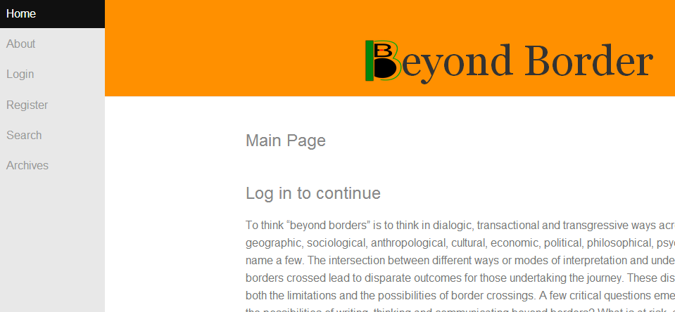

A click on the ***Register*** tab will take you to **Registration form** as shown in figure**.**

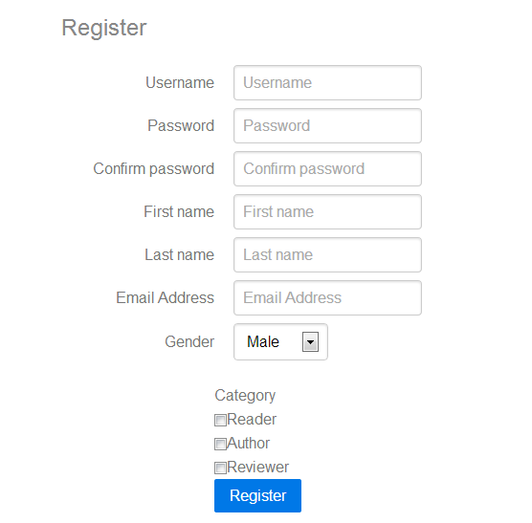

The user has to fill in these input fields and submit it .

**3.2 Home Page**

The home page has six tabs (present on the top left corner of the main page) namely

1. Home
2. About
3. Log In
4. Register
5. Search
6. Archives

**3.2.1 Home**

A click on the ***Home*** tab will send you back to the main page also known as Home page of the **Beyond Borders**. If you already are on Main page, it will reload the page.

**3.2.2 About**

This page gives you all the information about the journal, basic terms and conditions on which the Web publishing system works like Selection Policies, Peer Review Process, Publication frequency and Open Access Policies, Contact information of the Chief Editor and the Editorial team ,article-submission process and getting copyright form.

**3.2.3 Log In**

A click on ***Log In*** tab will take you to the **Log In** page as shown in figure.

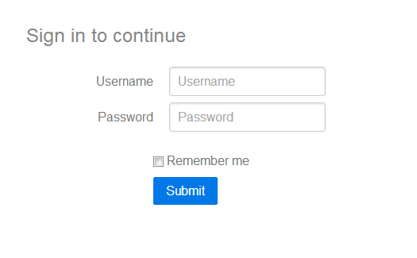

This page has two input fields.

1. Username
2. Password

This form gives you access to your personal account.

**3.2.4 Register**

If you do not have a personal account as either an author or a reviewer, you can have it by registering yourself on our journal**. Register** page has seven input fields namely- Username, Password, email, gender, category, first name and last name as shown before.

**3.2.5 Search**

A click on **Search tab** navigates you to the **Search Page.**

It has three input fields namely:

1. Search By Author
2. Search by Title
3. Search by Keyword

This page helps you search the article you want.

* + 1. **Archives**

A click on **Archive tab** navigates you to the **Archive Page.**

All the articles uploaded on the journal till-date will be found here. The articles will be packed in volumes, in accordance with their date and the publishing date.

* 1. **Profile**

**3.3.1 Changing Password and Update Details**

This functionality shall be available after logging in the Account and will be visible on the profile as shown.

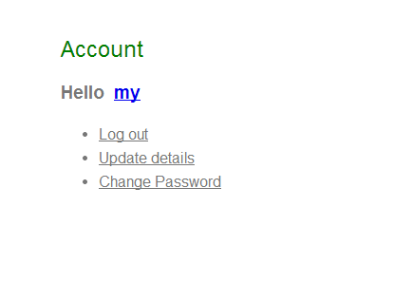

This part of Profile will be common to all Reader, Reviewer and Author.

**3.3.2 Submit Article**

This functionality will only be available for an Author Account.

**3.3.3 Articles to be Reviewed**

This functionality will only be available for a Reviewer Account as shown below.

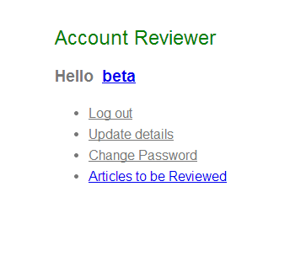

**3.3.3Admin Profile**

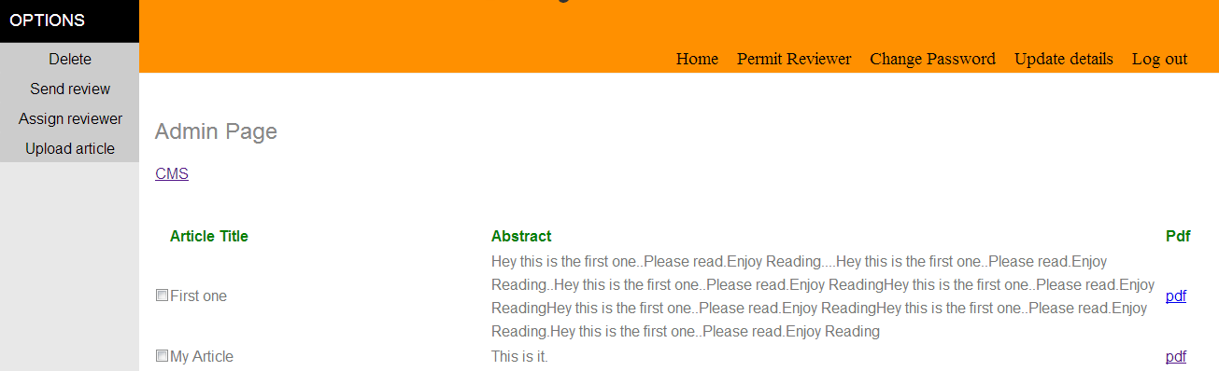

Shown Above is the Profile Page of admin.

**3.4 Exit System**

Exit the system just by closing all the tabs that has the site’s URL. Just make sure you log out From your personal account.

1. **USING THE SYSTEM**

This section gives a detailed description of the system menu.

**4.1.1 Home**

The home page of the web journal **Beyond Borders** has all the updates in the journal notified. All the latest uploaded articles will be shown in abstracts and for a reader the whole article is easily accessible in pdf format, ready for download.

From any point on the journal, a click on the **Home** button will take you back to the Main page of the Journal.

**4.1.2 Log In**

The login page has two input fields along with a **Remember me** radio button and a **Login** button.

1. Username: The input in this input field is a combination of alphabet and numerals.
2. Password: The input in this input field is a combination of alphabets, numerals, alpha numerals and symbols.

When the **login** button is clicked, if both the inputs in the input fields are correct and match with each other, the user has the luxury of accessing his personal account.

The **Remember Me** radio button, when clicked for a tick, will let you access your account each time you open the login tab.

**4.1.3 Register**

The Register page has six input fields.

1. Username: The input in this input field is a combination of alphabet and numerals.
2. Password: The input in this input field is a combination of alphabet, numerals, alpha numerals, and symbols.
3. Password Again: Retype your password here.
4. Email: An authentic email id is to be given in the field.
5. Gender: This is a drop down column where you have to select your gender. Just right click on your gender.
6. Category:

The journal provides you an account under three main categories.

1. Author: If you have an account as Author, you will be provided with 2 major functionalities –Submitting Article and Emailing Editor. All your queries can be dealt with the Editorial team via emails. When you upload a file and click **submit** button, your article will reach the Editor in pdf format.
2. Reviewer: The account of a reviewer will have the functionalities of email. The articles he has to review will be assigned by the editor. Review needs to be submitted via mail.
3. Editor: The Chief Editor of this journal will be provided with the functionalities like details of the list of articles, selecting articles, assigning reviewers, sending reviews to author via mail, deleting article and uploading article.

Editor will be provided an email system where sending of articles and reviews and receiving them can be done.

On clicking the **Select Reviewer** button ,the list of reviewers will be displayed to the editor.

The editor can choose one or more reviewers and send them the article for review.

And finally, when the article is ready for upload, it can be uploaded using the upload button.

**4.1.4 Search**

Search page has three input fields.

1. Search by Author name: Input has be a combination of alphabet and numerals.(in accordance with the user name of the author)
2. Search by Title: Input should only be in English letters ((in accordance with the Title)
3. Search by Keyword: Input should only be in English letters.

**4.1.5 Archives**

The archives page will show you the repository of all the articles that were published in the journal. The articles will be divided into volumes as per the dates of the publishing.

When you click on a volume, all the articles that were uploaded during the release of the volume will be displayed as abstracts as well as in pdf if you are logged in as a Reader.