Data Transfer on premises to AWS Cloud

**Offline**

1. **AWS Snowcone:**

* AWS Snow Family of **edge computing**, **edge storage**, and **data transfer devices**, weighing in at 4.5 pounds (2.1 kg) with **8 terabytes of usable storage.**
* with **up to 8 terabytes per device(8TB)**
* currently available in the **US East** (N. Virginia) and **US West** (Oregon) regions.
* Using Snowcone’s Wi-Fi or wired **10 GbE** networking
* Encryption keys are managed with AWS **Key Management Service** **(KMS)**, and are never stored on the Snowcone device.
* **Wi-Fi** or **wired access**, and **USB-C power** using a cord or optional battery
* **Use case:**

1. **Healthcare IoT**

### Industrial IoT

### Transportation, logistics, and autonomous vehicles

### Data collection and migration

### Content distribution

### Tactical edge computing

1. **AWS Snowball**

* Snowball Edge Storage Optimized
* Snowball Edge Compute Optimized

## Snowball Edge Storage Optimized (For Data Transfer)

|  |  |
| --- | --- |
| Storage capacity | 80 TB of usable space  Plus 1 TB of additional storage space |
| Data and network connections | Network connections:   * 10 Gb – RJ45 1 * 10 Gb – RJ45 2 * 10/25 Gb – SFP28 * 45/50/100 Gb – QSFP28 |

## Snowball Edge Storage Optimized

|  |  |
| --- | --- |
| Storage capacity | Snowball Edge devices have up to 80 TB of usable space. |
| Data and network connections | Network connections:   * 10 Gb – RJ45 * 25 Gb – SFP+ * 40 Gb – QSFP+ |

## Snowball Edge Compute Optimized

|  |  |
| --- | --- |
| Storage capacity | 42 TB of usable space  Plus 7.68 TB of dedicated NVMe SSD storage for instances |
| Data and network connections | Network connections:   * 10 Gb – RJ45 1 * 10 Gb – RJ45 2 * 10/25 Gb – SFP28 * 45/50/100 Gb – QSFP28 |

1. **Snowmobile**

* total capacity of up to 100 petabytes
* multiple **Snowmobiles** can be **used in parallel** to **transfer** exabytes of **data**. 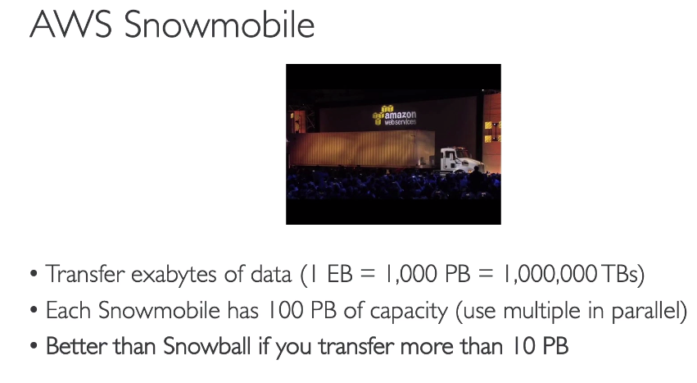
* 1 EB to GB 🡪 0.0001 EB = 1,00,000 GB
* 1 EB= 1000 PB =1,000,000 TBs = 1,000,000 * 1000 GB
* 1 TB = 1000 GB
* 1 PB = 1000 TB
* 1 EB (exabyte) = 1000 PB