Lab 2 – Heat Capacity Ratios: Spherical Resonator

Paul Nickerson

Biophysical Chemistry Laboratory

# Sample Calculations

1. Value of $γ$ for Ar:
$1 + \frac{R}{\left(\frac{3}{2}×R translational contributions\right)}=1.67$

2. Calculating heat capacity ratio for Air using Argon as a reference (ie using equation 4):
   1. Since T=T’, $f_{Air}=f_{Ar}\sqrt{\frac{γ_{Ar}M_{Air}}{γ_{Air}M_{Ar}}}$
 $M_{Air}=0.8*\frac{28.01g}{mol N_{2}}+0.2*\frac{32.00g}{mol O_{2}}=\frac{28.81g}{mol Air}$

 $\frac{f_{Air}}{f_{Ar}}$ 2. is the slope of the linear regression, $1.075$
   3. Rearranging, $γ_{Air}=\frac{{\left(\frac{f_{Air}}{f_{Ar}}\right)}^{2}γ_{Ar}M_{Air}}{M_{Ar}}=\frac{{1.075}^{2}×1.67×28.81}{39.948}=1.39$
3. Value of for CH2FCF3 assuming no vibrational contribution:
$1 + \frac{R}{\begin{aligned}\left(\frac{3}{2}×R translational contributions\right)+ \\ \left(\frac{1}{2}×R×\left(3 rotational contributions\right)\right)\end{aligned}}=1.33$

4. Value of for CH2FCF3 given full vibrational contribution:
$1 + \frac{R}{\begin{aligned}\left(\frac{3}{2}×R translational contributions\right)+ \\ \left(\frac{1}{2}×R×\left(3 rotational contributions\right)\right)+ \\ \left(\frac{1}{2}×R×\left(3×8-6 vbrational contributions\right)\right)\end{aligned}}=1.08$

5. Speed of sound through air from calculated $γ_{Air}$:
 $γ=\frac{{Mc}^{2}}{RT}$

  1. Rearranging, $c=\sqrt{\frac{γRT}{M}}$, where M is in kg/mol
$c=\sqrt{\frac{(1.39)(8.314)(296.15)}{0.02881}}=344.66\frac{m }{s}$

6. Resonator radius:
   1. Slope of plot for argon resonance frequencies vs. radial root function roots was 569. Uncertainties were noted but not included for this analysis.
   2. Speed of sound through Argon was calculated as 320.8275 m/s
   3. $ς_{v,l}=\frac{2πfa}{c}$, rearranging gives $a=\frac{ς_{v,l}c}{2πf}=\frac{\left(\frac{1}{569}\right)\left(320.8275\right)}{2π}=0.0897m$

# Error Analysis

1. Least squares slope with 95% confidence interval for air vs. argon
   1. 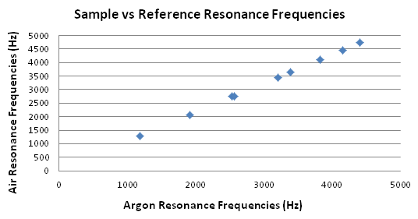
   2. From linest(), slope=1.075, stddev=1.163E-03
   3. $t_{95}=2.306$ from the lookup table with $N-1=8$ degrees of freedom, since only 1 regressor was considered
 $CI=2.306×0.001163=0.0026$

  4. So slope, with uncertainty, is $1.075±0.0026$
2. Argon frequencies vs radial function roots, with analysis
   1. 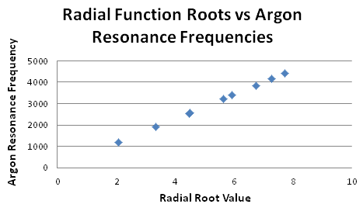
   2. From linest(), slope = 568.98 with SD=0.7156. $t_{95}=2.306$ from the lookup table with $N-1=8$ degrees of freedom, since only 1 regressor was considered. $CI=2.306×0.7156=1.7$, so slope, with uncertainty, is $569.±1.7$.

# Data and Results

1. Measured quantities:
   1. Room temperature = (23.0 ± 0.2) cm
2. Speed of sound through various gases, calculated from values for $γ$ determined in lab 1:

|  |  |
| --- | --- |
| Gas | c |
| CH2FCF3 | 174.3734 m/s |
| CO2 | 272.7791 m/s |
| Air | 324.2215 m/s |
| Ar | 320.8275 m/s |
| N2 | 476.1422 m/s |
| He | 957.329 m/s |

1. The following table lists theoretical values for γ with and without vibrational contributions:

|  |  |  |
| --- | --- | --- |
| Gas | With Vibrational Contribution | Without Vibrational Contribution |
| He | 1.67 | 1.67 |
| CH2FCF3 | 1.08 | 1.33 |
| CO2 | 1.22 | 1.4 |
| N2 | 1.33 | 1.4 |
| Ar | 1.67 | 1.67 |

# References

1. Killian, B. J. Experiments for Physical Chemistry Laboratory, Summer 2014, Target Copy,: Gainesville, 2014
2. Williams, K. R. Error Analysis in Physical and Analytical Chemistry, 3rd Ed, Target Copy: Gainesville, 2008