**CSCI 6511**

**Artificial Intelligence Project Part 1 – Project Report**

**Team 5**

**Sagar Sheth**

**Yuling Li**

**Akhil Dara**

Table of Contents

**1.** **Introduction** 3

**2.** **Templates & Facts** 4

**2.1 Station** 4

**2.2 NextStation** 5

**2.3 Line** 6

**2.4 Attraction** 7

**2.5 Fare** 8

**3.** **Relationship Between the templates** 9

**4.** **Loading Templates & Facts into Clips** 10

## **Introduction**

The project's goal is to create an expert system for the London Underground Metro System using CLIPS. The system will work on Zones 1 and 2 and will work on stations that exist on the following Lines;

* Bakerloo
* Central
* Circle
* District
* Hammersmith & City
* Jubilee
* Metropolitan
* Northern
* Piccadilly
* Victoria
* Waterloo & City

In this part of the project we have designed and developed initial set of templated and facts which would be the building blocks required to build the expert system. The facts were developed based on the data gathered from the following websites.

* <https://tfl.gov.uk/maps/track/tube>
* <https://en.wikipedia.org/wiki/List_of_London_Underground_stations>

The following are the initial list of templates designed to develop the expert system.

* Station
* NextStation
* Line
* Attraction
* Fare

## **Templates & Facts**

### **2.1 Station**

This template will capture the following information about each station.

* Name, name of the station.
* Line, the lines the station belongs to. Can have multiple values.
* Zone, the zone the station belongs to.
* Interchange, whether the station is an interchange station. Can have values either Yes/No.
* InternalInterchange, whether the station is an Internal Interchange station. Can have values either Yes/No.

Clips deftemplate

(deftemplate Station

(slot name (type SYMBOL))

(multislot line (type SYMBOL))

(slot zone (type INTEGER))

(slot Interchange (type SYMBOL) (allowed-symbols yes no) (default no))

(slot InternalInterchange (type SYMBOL) (allowed-symbols yes no) (default no))

)

Clips deffacts Sample

(deffacts Station

(Station (name Aldgate)(line Metropolitan Circle)(zone 1)(Interchange Yes)(InternalInterchange No))

)

### **2.2 NextStation**

This template will capture the following information about each station.

* CurrStation, name of the current station.
* CurrStationLine, the lines the current station belongs to. Can have multiple values.
* NextStation, name of the next station.
* NextStationLine, the lines the next station belongs to. Can have multiple values.

Clips deftemplate

(deftemplate NextStation

(slot CurrStation (type SYMBOL))

(multislot CurrStationLine (type SYMBOL))

(slot NextStation (type SYMBOL))

(multislot NextStationLine (type SYMBOL))

)

Clips deffacts Sample for Algate Station

(deffacts NextStation

(NextStation (CurrStation Aldgate)(CurrStationLine Metropolitan Circle)(NextStation TowerHill)(NextStationLine District Circle))

(NextStation (CurrStation Aldgate)(CurrStationLine Metropolitan Circle)(NextStation LiverpoolStreet)(NextStationLine Metropolitan Central Circle HammersmithandCity))

)

### **2.3 Line**

This template will capture the following information about each Line.

* name, name of the current Line.
* startingStation, the starting station of the Line from a specific direction. Note that this might not be the true starting Location, as we are only considering Zone 1 & 2. Additionally may change based on direction. May have multiple Values.
* endingStation, the ending station of the Line from a specific direction. Note that this might not be the true starting Location, as we are only considering Zone 1 & 2. Additionally may change based on direction. May have multiple Values.
* stationList, this documents the list of stations in this line. Can have multiple values.
* transferBetween, this an attribute which may be used in future parts to help identify the transfer stations on the line. Currently values are null.

Clips deftemplate

(deftemplate Line "Description of lines"

(slot name (type SYMBOL))

(multislot startingStation (type SYMBOL))

(multislot endingStation (type SYMBOL))

(multislot stationList (type SYMBOL))

(multislot transferBetween (type SYMBOL) (default nil))

)

Clips deffacts Sample for WaterlooandCity Line

(deffacts Line

(Line (name WaterlooandCity)(startingStation Waterloo)(endingStation Bank)(stationList Waterloo Bank)(transferBetween ))

)

### **2.4 Attraction**

This template will capture the following information about each Attraction.

* name, name of the Attraction.
* nearbyStations, will state the nearby station for the Attraction. If An attraction can be reached by multiple stations, there will be a separate facts for the same.
* Description, gives a short description for the attracton.

Clips deftemplate

(deftemplate Attraction "the attractions in London area"

(slot name (type SYMBOL))

(slot nearbyStations (type SYMBOL))

(slot description (type STRING))

)

Clips deffacts Sample for RoyalAlbertHall

(deffacts Attraction

(Attraction (name RoyalAlbertHall)(nearbyStations SouthKensington)(description "Historic concert hall known for hosting The Proms."))

(Attraction (name RoyalAlbertHall)(nearbyStations Knightsbridge)(description "Ornate monument to Prince Albert, commissioned by Queen Victoria."))

)

### **2.5 Fare**

This template will capture the following information about travel fare.

* StartStationZone, The Zone of the station the user starts the travel in.
* DestinationStationZone, The Zone of the station the user will end their trip.
* amount, the fare for travel between Zones. Has 4 enteries.

Clips deftemplate

(deftemplate fare

(slot StartStationZone (type INTEGER))

(slot DestinationStationZone (type INTEGER))

(slot amount (type FLOAT))

)

Clips deffacts

(deffacts fare

(fare (StartStationZone 1)(DestinationStationZone 1)(amount 2.4))

(fare (StartStationZone 2)(DestinationStationZone 2)(amount 2.4))

(fare (StartStationZone 1)(DestinationStationZone 2)(amount 2.9))

(fare (StartStationZone 2)(DestinationStationZone 1)(amount 2.9))

)

## **Relationship Between the templates**

Below Image shows the relationship between the templates.

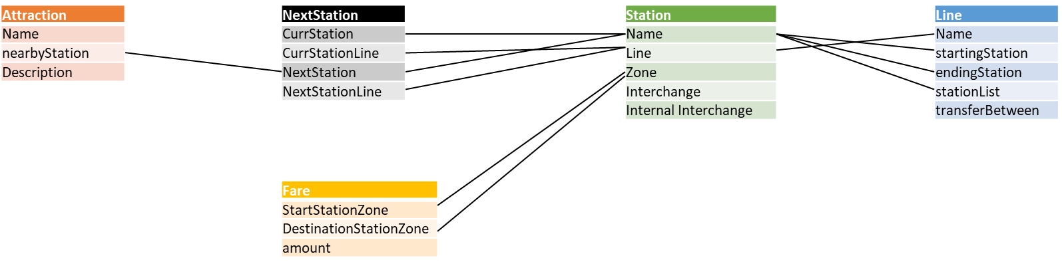

Kindly note If an attribute a is linked with an attribute b in another template, and that other attribute b is linked with another attribute c in a third template; Attribute a and c are directly linked but are not shown as part of the image to make the image more readable.

## **Loading Templates & Facts into Clips**

Using the following code we load the templates and facts into CLIPS.

The TravelerTemplates.clp contains all the templates documented above and TravelerFacts.clp contains all the facts.

(deffunction Initialize-Traveler () “Load the individual files for the Traveler Expert System”

;;; Load the Template Definitions

(load TravelerTemplates.clp)

;;; Load the Facts

(load TravelerFacts.clp)

)

Clips output

