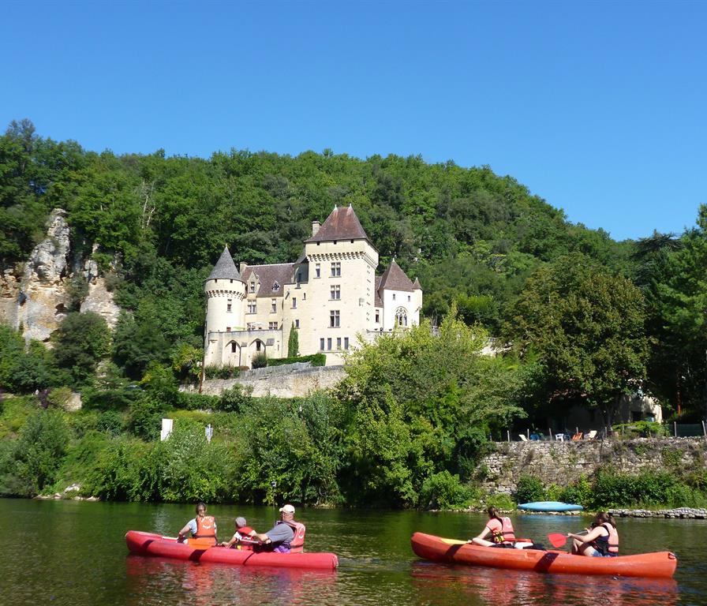
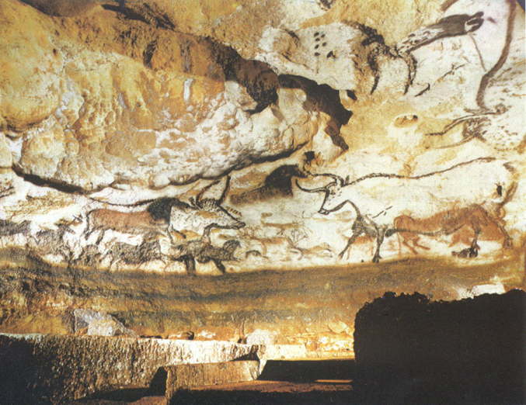
Fun ‘n French
Practice your French in the Dordogne region of south-west France!
Prices: Fully inclusive except for travel and pocket money

800€ for one week. (Sat to Sat) 1500€ for two weeks 2100€ for three weeks
You will stay with a bi-lingual family in a beautiful 1850s house with a garden and swimming-pool in the very centre of the town of Périgueux.

The idea is to live an everyday summer life in French in a family home in France. There will be a maximum of 3 students at any one time, so this is more coaching and fun than teaching!

Each morning starts with structured French classes taught by Shayne, an experienced and fully-qualified French teacher. The afternoons are for practicing your French while discovering this extraordinary area of France, with its caves (Lascaux, Padirac, etc), châteaux (Hautefort, Milandes and others), historic villages and rivers (great for kayaking!). The evenings are for relaxing, swimming and enjoying the town of Périgueux with its quaint streets and busy music-filled squares.

getting here:

We will fetch and return you to Bergerac/Limoges airports or Perigueux train station. Food requests taken into account. Single or double rooms.

Dordogne Language Studio

www.dordognelanguagestudio.fr
65 Rue Victor Hugo, 24000 Périgueux
shaynegardegirardin@gmail.com
+33 603008420

