Data Management Plan
NeuroGuide - Iteration 1 (FIT5120 TP19)

1. Product Overview and Data Role

NeuroGuide is a job-support web platform designed to reduce cognitive load for neurodivergent job seekers - particularly young adults or early career professionals with ADHD. The platform helps users capture their skills and experience in a structured way, understand job descriptions without feeling overwhelmed, and (in later iterations) give them job suitability scores and prepare for interviews. It is built on the principle that inclusive digital tools should adapt to how neurodivergent users naturally process information, rather than expecting users to adapt to standard recruitment formats.

Data Strategy - Hindsight, Insight, and Foresight
The data in NeuroGuide is structured to support a progression from evidence to action:
Layer | What It Means | How NeuroGuide Uses It
Hindsight - Past evidence | What does published research and official statistics tell us about ADHD and employment? | ABS disability employment statistics and ADHD research underpin the problem statement and justify the features being built. This data is used for context, not served to users directly.
Insight - Current reference | What occupations and skills exist in the Australian labour market right now? | The Jobs and Skills Australia taxonomy (Excel workbook) is processed into tag libraries that populate the skill and role pickers. Users select from real, current Australian occupation data.
Foresight - Future guidance | What jobs suit this user, and how should they prepare? | Planned for Iterations 2–3: ADHD productivity datasets, cosine-similarity suitability scoring, and interview preparation personalised to attention profile.

Iteration 1 Functional Modules
Iteration 1 delivers four functional modules. Two are fully data-backed by the taxonomy ETL pipeline; one uses the Gemini NLP API for live text processing; one is a front-end export feature:

Functional Module | Main Input Data | Data Source / Technology | Output
Skill & Background Capture with ADHD Profile | User-entered skills, work history, and ADHD preferences | au-skills-taxonomy.json + au-role-taxonomy.json (static JSON from Python ETL) | Searchable tag/chip dropdowns; profile draft in browser session
Skills and Job Roles Tag Library | au-role-taxonomy.json + au-skills-taxonomy.json | Static JSON - Jobs and Skills Australia workbook processed via Python | Occupation and skill chips rendered in React tag picker; filtered by user search
Job Description Simplification | User-pasted or uploaded job description text | Google Gemini API (gemini-1.5-flash) - live NLP call; no stored data | Quick Snapshot panel (top 3 requirements + 3 responsibilities); collapsible structured sections; plain-language rewrite
Save and Export Job Description | Simplified job description output rendered in the UI | PDFKit / pdfmake (client-side library) | Downloadable PDF of the simplified job summary for offline use

Data categories in Iteration 1:
- Official Australian occupation and skills statistics - Jobs and Skills Australia Excel workbook (February 2026)
- Derived static taxonomies - JSON files produced via Python ETL, version-controlled in the project repository
- Live NLP API responses - Gemini API called per user request; no response data is stored or logged by the application
- Ephemeral user profile data - held in browser session storage only; no server-side persistence in this iteration

Screenshot - NeuroGuide landing page showing the Iteration 1 modules

Iteration 2 Functional Modules
Iteration 2 significantly extends the platform by closing the loop between the user profile captured in Iteration 1 and actionable job match intelligence. Four new or enhanced modules are delivered:

Functional Module | Main Input Data | Data Source / Technology | Output
Job Compatibility Score | User ADHD profile, work-style preferences, skills from profile builder; simplified JD features from Gemini | Trained ML model (Random Forest + Logistic Regression) on ADHD_4Class + ADHD_Productivity datasets; rule-based scoring engine; Gemini API for job feature extraction | 0–100 compatibility score displayed as donut chart; breakdown by work environment, skills, and soft skills dimensions
Enhanced Job Description Simplification | Pasted job description text | Gemini API — extended prompt now also extracts job fit features (task structure, environment, cognitive load, interruptions, etc.) as structured JSON for the ML scoring pipeline | Simplified JD view plus structured job_fit_features_from_gemini payload passed to POST /predict-job-score
Occupation Lookup (ANZSCO-style) | Skills extracted from simplified JD | Internal occupation catalogue (server-side DB); ADHD-friendliness ratings, complexity scores, implied skills per occupation | occupation_id used to enrich the scoring request with DB-level occupation attributes
Save and Compare JDs and Score | Saving the history of jobs simplified and compatibility score for user reference | JSONB - format saving the entire simplified version and score for easy/write operations | Check their job description, simplified version and the score they got as entire snapshot (side drawer)

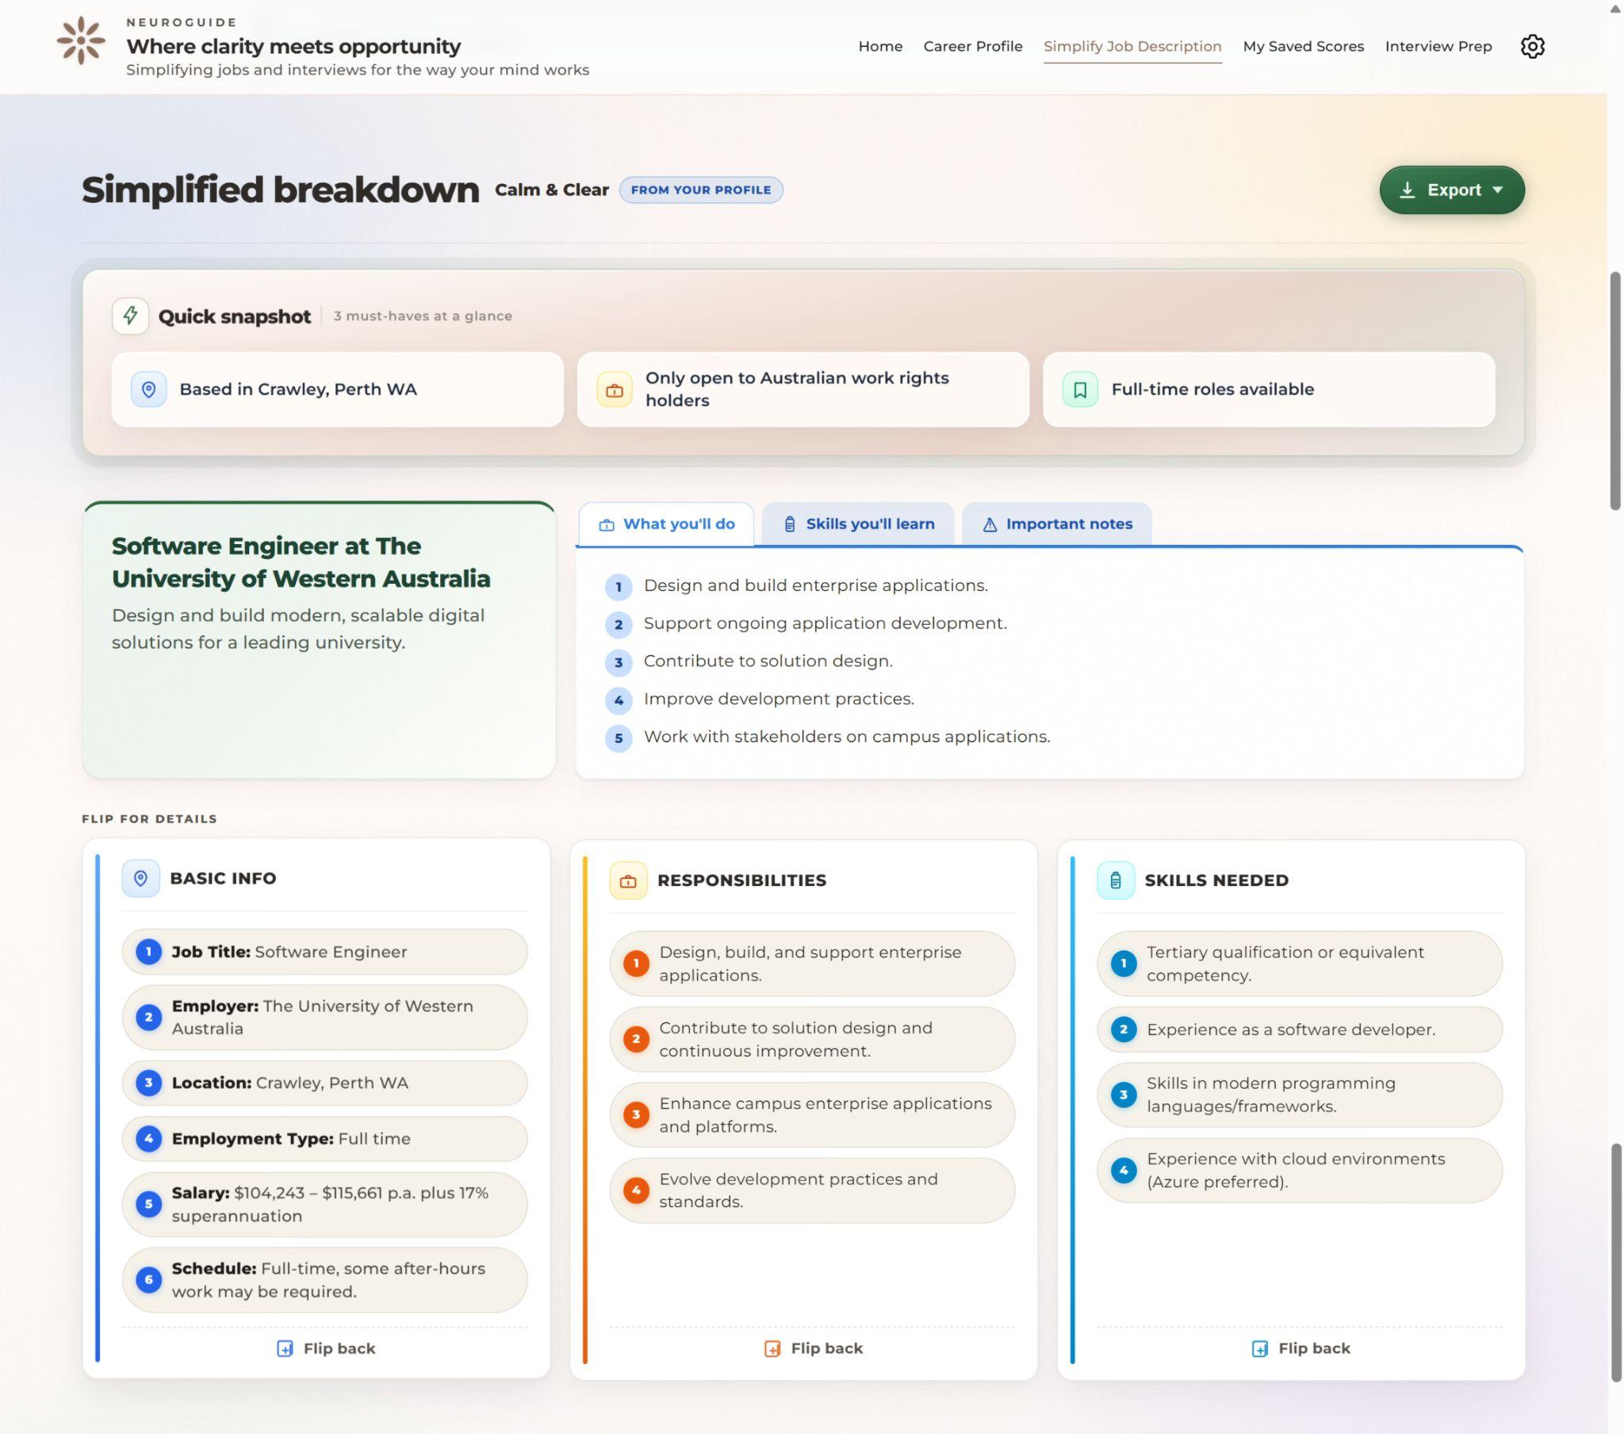
Screenshot - NeuroGuide iteration 2 Functional Module: Simplified Job Description
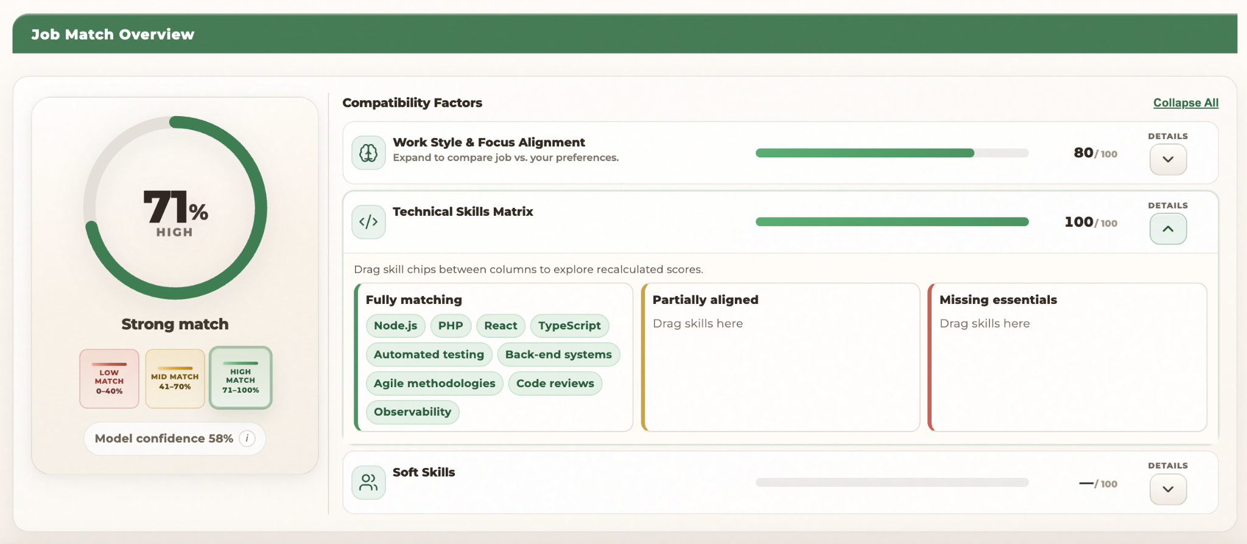Screenshot - NeuroGuide iteration 2 Functional Module: Job Score

Data categories in Iteration 2:
- Processed ADHD datasets (clinical + productivity)
  - ADHD_4Class dataset and ADHD_Productivity dataset used for feature engineering and model training
  - Cleaned, normalized, and transformed into structured training datasets via Python scripts
  - Stored as version-controlled CSV files and used to generate trained ML artifacts (.pkl)
- Derived ML artifacts (trained models and features)
  - Trained machine learning models (e.g., task success classifier) stored as .pkl files
  - Supporting artifacts such as feature schemas, scalers, and metadata JSON files
  - Loaded at runtime in backend APIs for real-time inference (no retraining during requests)
- Structured job intelligence (Gemini API outputs)
  - Job descriptions processed via Gemini API to extract structured features such as:
task structure, work environment, cognitive load, interruptions, autonomy, and soft skill requirements
  - Only structured outputs are passed to the scoring pipeline; raw responses are not persistently stored
- User profile and preference data (persistent + session-based)
  - User questionnaire data (skills, ADHD type, work preferences, support needs, energy patterns)
  - Stored in AWS RDS (PostgreSQL) for reuse across sessions
  - Some transient UI states (e.g., drag-drop skill edits, recent scores) stored in browser local/session storage
- Scoring and interaction data (optional persistence)
  - Job match scores, factor breakdowns, and feedback signals optionally stored for analytics and future model improvement
  - Includes session-level identifiers and user-adjusted inputs (e.g., skill overrides, soft skill adjustments)

2. Data Sources and Update Strategy

2.1 Open Data and API Source Table

Data Source Name | Links | Physical Access | Source Update Frequency | Granularity | License and Notes
Jobs and Skills Australia - Occupation Profiles | Link | Local file under data/; loaded with Python openpyxl in read-only mode | Per Jobs and Skills Australia publication cycle (approx. annually) | Occupation-level rows (Table_1); task statements per occupation (Table_3) | Use per Jobs and Skills Australia publication terms; attribution required; do not imply endorsement
Derived: au-role-taxonomy.json | Link | Version-controlled JSON in data/; copied to public/ for static hosting | Regenerated when source workbook is refreshed | One string per occupation title (ranked by employment proxy) | Derivative of official occupation statistics; provenance documented in this DMP
Derived: au-skills-taxonomy.json | Link | Version-controlled JSON; same build pipeline as roles | Regenerated with roles file | Curated skill chip labels (action verb mapping + transferability tags) | Derived; threshold and mapping logic documented in Section 3.2
Google Gemini API  (gemini-1.5-flash model) | Link | REST API call from React frontend via a lightweight proxy; response consumed in real time | Continuously updated by Google; model version pinned in API call | Per-request: structured JSON response containing simplified sections, Quick Snapshot items, and plain-language rewrite | Google Gemini API Terms of Service; input text (job description) is sent to Google servers; no PII should be included; API key stored in environment variable, never in client code

Recommendation & Scoring
API/Library | Provider | Purpose
Scikit-learn (Python) | Open source | Powers the suitability scoring and match percentage calculation using cosine similarity between user skill vectors and job requirement vectors
Common English Jargon & Corporate Buzzword Corpus | Custom-curated / open NLP datasets | Training and rule data for the jargon-stripping NLP pipeline; used to identify and replace corporate buzzwords with plain-language equivalents

2.2 Principles for Selecting Data Sources

- Priority is given to open, well-documented sources with clear Australian labour-market relevance, ensuring occupation and skills data reflects the local context rather than US-centric frameworks.
- Official statistics (workbook) are separated from derived artefacts (JSON) so that updates are fully reproducible via a single re-run of the build script - no manual reformatting required.
- No backend database was used in Iteration 1. The taxonomy data is small, static, and infrequently updated; serving it as flat JSON from public/ was proportionate and avoided unnecessary infrastructure.
- A backend API with a FastAPI server has been introduced in Iteration 2 to serve ML predictions and the occupation catalogue. The backend is hosted on AWS
- The Gemini API is used for job description simplification and, in Iteration 2, for structured extraction of job fit features that feed the ML scoring pipeline. The model is prompted with a structured instruction set (see Section 3.3) that controls the output format.
- The ADHD datasets were selected because they are open-licensed, sufficiently large for training a task-completion classifier, and cover the four clinically recognised ADHD subtypes. Their limitations (global rather than Australian population; synthetic productivity data) are acknowledged in Section 7.

3. Data Flow, Data Cleansing and Transformation

3.1 High-Level Data Flow
There are two separate data pipelines operating in Iteration 1:

Pipeline A - Taxonomy ETL (offline, run once per workbook release):
Pipeline A: Excel → Python ETL → JSON → React
- The Jobs and Skills Australia occupation profiles Excel file is placed under data/ in the project repository.
- Python (openpyxl) loads Table_1 and Table_3 in read-only mode.
- Cleansing, frequency analysis, vocabulary mapping, and deduplication produce two sorted string arrays.
- Results are serialised as UTF-8 JSON (au-role-taxonomy.json, au-skills-taxonomy.json) and committed to version control.
- The React build copies these files to public/; the front end fetches them at component mount - no backend API call involved.

Pipeline B - NLP Simplification (live, per user request):
Pipeline B: User input → Gemini API → JSON → Simplified UI + Job Fit Features
- The user pastes or uploads a job description in the React UI.
- The front end sends the raw text to the Gemini API (gemini-1.5-flash) with a structured prompt.
- Gemini returns a JSON response containing: Quick Snapshot (top 3 requirements + 3 responsibilities), a collapsible full section breakdown, and a plain-language rewrite.
- The React component parses the JSON response and renders it as a layered, collapsible view - no data is written to a database or server storage.

Pipeline C - ML Prediction (Iteration 2, live per scoring request):
Pipeline C: User Profile + Job Features → FastAPI → ML Model + Rule Engine → Compatibility Score]
- The React front end calls POST /predict-job-score on the FastAPI backend with the user_questionnaire and job_fit_features_from_gemini payload.
- The backend retrieves the occupation record from the internal DB using the occupation_id resolved from the job title.
- The ML layer produces an ml_score_0_100 (task-completion probability scaled to 0–100) from the trained Random Forest model.
- The rule layer produces a rule_score from skills overlap (50%), work-style fit (25%), and soft-skills alignment (25%).
- The two scores are blended (20% ML + 80% rule) and reshaped through a nonlinear spread function before being returned to the UI as a 0–100 compatibility score.

Full platform integration: blending rule-based scoring (skills, work style, soft skills) with ML predictions to deliver holistic job suitability scores.

3.2 Wrangling and Cleansing - Taxonomy Dataset (Python Operations)

3.2.1 Ingestion and Parsing
The workbook is loaded using openpyxl in read-only mode to prevent formula recalculation. Logical tables begin at fixed row offsets (min_row=8). Rows where the occupation title or task statement evaluates to None or empty string are skipped immediately - a first-pass quality filter before any downstream processing.

Code excerpt - ingestion loop with null-row skip and whitespace normalisation:
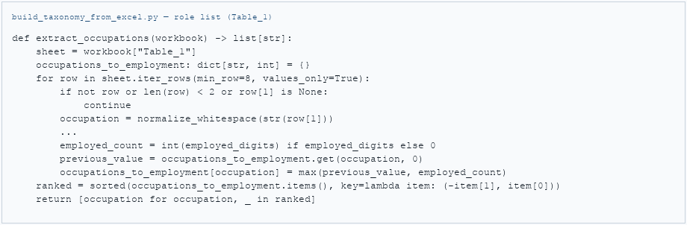

3.2.2 Cleaning and Wrangling Detail
The table below documents each transformation step - what the raw data looked like, what was done, and why - following the same structure used to validate data quality decisions with the Monash teaching team:

Dataset / Field | Raw / Original Issue | Cleaning Operation | Why This Matters
Occupation titles  Table_1, column A | Same occupation title appears 2–4 times with different employment count strings (e.g. '12,400', '12400', blank) | Parse count with regex (first numeric token); retain record with maximum value; deduplicate in dict space | Without deduplication, the role picker shows the same job title multiple times, which is confusing and misleading for ADHD users who are already overwhelmed by choice
Task statements  Table_3 - one row per task per occupation | Internal whitespace and line-break artefacts produce duplicate verb extractions | re.sub(r'\s+', ' ', value).strip() applied to every text field at ingestion | Ensures that 'Prepare' and 'Prepare' from differently formatted rows count as the same verb in the frequency analysis - preventing artificial splitting of the signal
Leading action verbs  Extracted from task statements | Long-tail verbs appear only 1–3 times across the corpus (e.g. 'Calibrate', 'Requisition') - not generalisable as skill chips | collections.Counter frequency filter; minimum threshold = 18; verbs below threshold excluded | Keeps the skill tag picker short and meaningful - an ADHD user presented with 200+ chip options experiences the same cognitive overload the app is designed to prevent
Verb-to-chip mapping  Leading verbs surviving threshold | Raw verbs are technical/grammatical (e.g. 'Liaise', 'Utilise') - not immediately meaningful to a job seeker reading a tag picker | Curated dictionary maps verb → human-readable label (e.g. 'Liaise' → 'Stakeholder Communication', 'Analyse' → 'Analytical Thinking') | Labels must be recognisable to ADHD users without specialist vocabulary. The mapping converts linguistic tokens into skill concepts the user can self-identify with
Role sort order  Final deduplicated title list | Alphabetical order surfaces 'Accountant' before 'Software Developer' - not useful as a default because it doesn't reflect labour market relevance | Sort by descending employment proxy (numeric count from workbook), then alphabetically for ties | Common roles appear first in the picker - most users will find their occupation type without scrolling, reducing friction during profile setup

Code excerpt - Counter-based frequency filter and controlled vocabulary mapping:
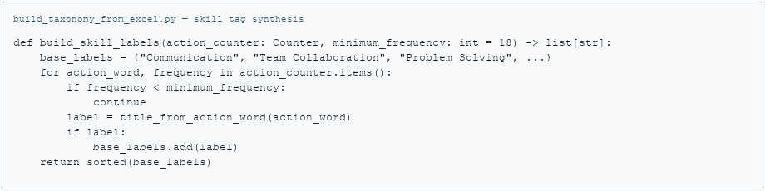

3.2.3 Client-Side Consumption
The React front end fetches the JSON arrays at component mount and applies a case-insensitive substring filter against the user's search query. A visible result cap (default: 50 items) keeps the DOM lightweight. This is a presentation-layer filter only - the canonical taxonomy data in the JSON files is not modified.

3.2.5 Summary of Techniques Used
Technique | Library / Method | Application in NeuroGuide Iteration 1
Ingestion | openpyxl (read-only mode) | Load Table_1 and Table_3 from Excel workbook; skip null rows at read time
String cleaning | re.sub(r'\s+', ' ') - Python re module | Collapse whitespace artefacts in occupation titles and task statements before any further processing
Numeric extraction | re.search(r'\d[\d,]*', value) - regex | Extract first numeric token from employment count fields for ranking and deduplication
Frequency analysis | collections.Counter | Count leading action verb occurrences across all task statements; identify minimum-frequency cutoff
Categorical mapping | Python dict lookup | Map surviving verbs to human-readable skill chip labels via a curated controlled vocabulary
Deduplication / conflict resolution | Python dict with max() conflict rule | Retain one record per occupation title; resolve duplicates by keeping highest employment count
Sorting | sorted() with key tuple | Primary: descending employment proxy; secondary: alphabetical - deterministic, auditable order
Serialisation | json.dumps(ensure_ascii=False, indent=2) | Output UTF-8 JSON with stable indentation for readable version control diffs

The taxonomy files are therefore served as flat JSON static assets from the React application's public/ directory. The logical data model (Section 6.1) provides the ER diagram as a blueprint for the Iteration 2 database that will be needed for persistent user profiles and suitability scoring.

3.3 NLP Processing - Job Description Simplification (Gemini API)

3.3.1 Prompt Engineering and Output Structure
The Gemini API is called with a structured prompt that instructs the model to return a strictly formatted JSON object - not free text. This is critical for reliable parsing. The prompt specifies:
- Extract exactly 4 must-have requirements (the non-negotiables a candidate must meet).
- Extract exactly 4 core daily responsibilities (what the person will actually do most of the time).
- Rewrite the full job description in plain English, removing jargon and corporate buzzwords.
- Organise the plain-language rewrite into labelled sections: Role Summary, Key Responsibilities, Required Skills, Nice-to-Have, and Work Environment.

In Iteration 2, the prompt is extended to extract job_fit_features_from_gemini, a structured object containing:
- Workplace characteristics: task_structure (routine/creative/mixed), environment (quiet/collaborative/open-plan), cognitive_load (low/medium/high), interruptions (low/medium/high), deadlines (flexible/moderate/strict), autonomy (low/medium/high).
- Work style: work_style (independent/team-based/hybrid), collaboration (minimal/moderate/heavy).
- Soft skill requirements: a seven-dimension object - communication, time_management, problem_solving, leadership, teamwork, adaptability, self_motivation - each rated low/medium/high.
- Extracted technical skills: job_skills_from_gemini - a list of specific technical skills mentioned in the JD, used instead of generic DB implied skills for the scoring run.

The model is explicitly instructed to return only valid JSON with no preamble, markdown formatting, or explanation - so the response can be passed directly to JSON.parse() in the React component without sanitisation.
Gemini Response for Job Description Simplification:
{
"is_job_description": true,
"rejection_reason": null,
"job_title": "Software Engineer",
"extracted_skills": ["Python", "SQL", "AWS", "Git", "Testing"],
}
},
"summary": "Plain-language role summary...",
"basic_info": "Title, location, type, pay (if stated)...",
"responsibilities": "- Build APIs\n- Collaborate with team\n- Write tests",
"skills_qualifications": "- Python\n- SQL\n- Cloud platforms",
"quick_snapshot": [
"Based in Sydney",
"Full working rights required",
"Full-time role"
],
"profile_type": {
"job_summary": ["Software Engineer at XYZ", "Strong growth and mentorship"],
"what_you_do": ["Build backend features", "Fix production bugs", "Review pull requests"],
"skills_you_learn": ["System design", "Cloud deployment", "Testing"],
"requirements": ["2+ years experience", "Strong Python", "Team collaboration"],
"important_notes": ["No visa sponsorship", "On-call rotation"]
},
}

3.3.2 Response Parsing and UI Transposition
Response Field | UX Rationale (ADHD Design)
quickSnapshot.requirements (array of 3) | ADHD users often scan for must-haves first. Showing exactly 3 at the top reduces the need to read the full description before deciding whether to apply.
quickSnapshot.responsibilities (array of 3) | Knowing what the job feels like day-to-day is the primary concern. Three items are digestible in one glance.
sections[] (labelled array) | Content is shown in small chunks with clear labels - users can self-regulate depth of engagement.
plainLanguageRewrite (string) | Provides an alternative reading mode for users who prefer a narrative over structured bullets.
job_fit_features_from_gemini (object) [Iteration2] | Structured job context allows the ML scoring layer to produce an environment-aware compatibility score without manual user input about the job.
job_skills_from_gemini (array) [Iteration2] | Extracted technical skills override generic DB implied skills, improving relevance of the skills-matching component of the score.

3.3.3 Data Handling for NLP Responses
- No Gemini response is persisted to a database or server storage in Iteration 1.
- The raw job description text submitted by the user is sent to Google's API servers. Users should be advised not to include personal identifying information in submitted job descriptions.
- The API key is stored as a server-side environment variable and is never exposed in client-side code.
- Error handling is implemented: if the API returns an unexpected format or non-JSON response, the UI displays a fallback message and does not crash.

3.4 ML Data Preparation - ADHD Datasets (Iteration 2)
This section documents the data preparation steps applied to the two ADHD datasets before model training. This is entirely an offline pipeline - no raw dataset is loaded at runtime.

3.4.1 Dataset 1: ADHD_4Class (ADHD_dataset_4_classes_u2.csv)
Attribute | Detail
Records | 6,500 individual ADHD clinical profiles
Key columns used | Focus_Score, Difficulty_Organizing_Tasks, Learning_Difficulties, Anxiety_Depression_Levels, Diagnosis_Class
Diagnosis_Class values | 0 = Unspecified, 1 = Inattentive, 2 = Hyperactive-Impulsive, 3 = Combined
Columns excluded from training | Demographic fields (Age, Gender, Educational_Level, Family_History), behavioural questionnaire items (Q1_x, Q2_x), and lifestyle fields (Sleep_Hours, Daily_Activity_Hours, Daily_Phone_Usage_Hours, Daily_Walking_Running_Hours, Daily_Coffee_Tea_Consumption) - not directly relevant to work environment suitability
Cleaning steps | Missing values in numeric fields imputed with column median. Diagnosis_Class label-encoded to integer. All continuous features normalised to [0, 1] range using MinMaxScaler before merge.

Please access the Data Wrangling Report for full details: https://docs.google.com/document/d/1w2pQuzBLwN5XaTuFMIbQPUec1YwFx5SW/edit?usp=sharing&ouid=106591582509889562909&rtpof=true&sd=true

def wrangle_tasks_unscaled(
df: pd.DataFrame,
profiles: Dict[str, Any],
rng: np.random.Generator,
) -> Tuple[pd.DataFrame, float, float]:
df = clean_task_frame(df)
df = pd.get_dummies(df, columns=["task_type"], drop_first=True)
df["task_complexity"] = map_task_complexity(df["task_complexity"])
df = df.dropna(subset=["task_complexity"])
df["task_complexity"] = df["task_complexity"].astype(int)

dur_med = float(df["estimated_duration"].median())
int_med = float(df["interruptions"].median())
df["long_task"] = df["estimated_duration"] > dur_med
df["high_interruptions"] = df["interruptions"] > int_med
df["fatigue"] = df["time_since_last_break"] * (1 - df["energy_level"])

ref_key = "1"
template_cols = list(profiles[ref_key].keys())
df["synthetic_adhd_type"] = rng.choice([1, 2, 3], size=len(df))
for col in template_cols:
df[col] = df["synthetic_adhd_type"].apply(lambda x: float(profiles[str(int(x))][col]))

return df, dur_med, int_med

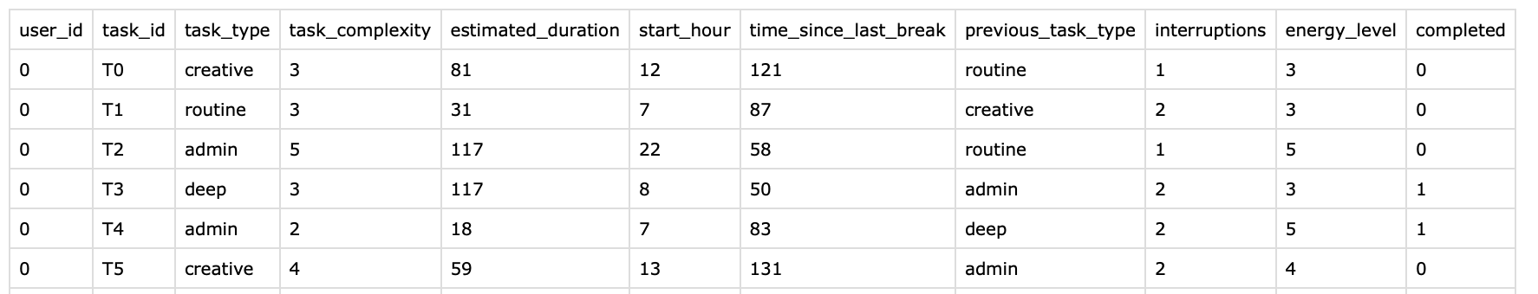
Screenshot: Sample rows for wrangled dataset

3.4.2 Dataset 2: ADHD_Productivity (Synthetic_ADHD_Task_Scheduler_and_Productivity.csv)
Attribute | Detail
Records | 10,000 synthetic task completion sessions across multiple users
Key columns used | task_type, task_complexity, interruptions, energy_level, time_since_last_break, completed (target variable)
completed column | Binary: 1 = task completed successfully, 0 = not completed
task_type encoding | Categorical column one-hot encoded: creative, routine, admin, deep (4 binary columns)
Cleaning steps | No missing values in synthetic data. Outlier check on time_since_last_break (values > 480 min capped at 480). task_complexity and interruptions normalised to [0, 1]. energy_level normalised from [1–10] range to [0, 1].

import pandas as pd

# 1) Load ADHD productivity dataset
df = pd.read_csv("data/ADHD_Productivity.csv")

# 2) Basic numeric coercion
for col in ["estimated_duration", "interruptions", "energy_level", "time_since_last_break"]:
df[col] = pd.to_numeric(df[col], errors="coerce")

# 3) Outlier capping
cap_cols = ["estimated_duration", "interruptions", "time_since_last_break"]
for col in cap_cols:
lo, hi = df[col].quantile([0.01, 0.99])
df[col] = df[col].clip(lower=lo, upper=hi)

# Domain cap used in pipeline style
df["energy_level"] = df["energy_level"].clip(lower=0.5, upper=10.0)

# 4) Drop rows still missing required fields
required = [
"task_type", "task_complexity", "estimated_duration", "start_hour",
"time_since_last_break", "previous_task_type", "interruptions",
"energy_level", "completed"
]
df = df.dropna(subset=required)

# 5) One-hot encode task_type
# (matches your backend pattern: pd.get_dummies(..., columns=["task_type"], drop_first=True))
df = pd.get_dummies(df, columns=["task_type"], drop_first=True)

print(df.head())
print(df.filter(like="task_type_").columns.tolist())

3.4.3 Creating the Training Dataset by Merging
The two datasets do not share a natural join key (one is clinical profiles, one is task logs). The merge was performed via environment-type mapping rather than a direct join:
- Step 1 - Map ADHD user work preferences to Task Environment Type. User work-style preferences from the profile (e.g. Low interruptions + Visual workflow + Short focus sprints) are mapped to one of three environment types: Structured, Dynamic, or Deep Work. This mapping is a curated lookup table built by the team.
- Step 2 - Compute ADHD-Type × Environment completion rates from Dataset 2. For each (Diagnosis_Class, Environment_Type) combination, the mean completion rate (completed tasks / total tasks) is computed from the productivity logs. This produces a lookup table of 12 base probabilities.
- Step 3 - Synthesise training rows. Each row in the training dataset combines: clinical feature scores from Dataset 1, the mapped environment type and task parameters, and the target label (Task_Completion_Probability) from Step 2 with Gaussian noise added (σ = 0.05) to avoid deterministic rounding.
- Final training dataset: approximately 500 synthesised rows covering all ADHD-type × environment-type × task-complexity combinations.

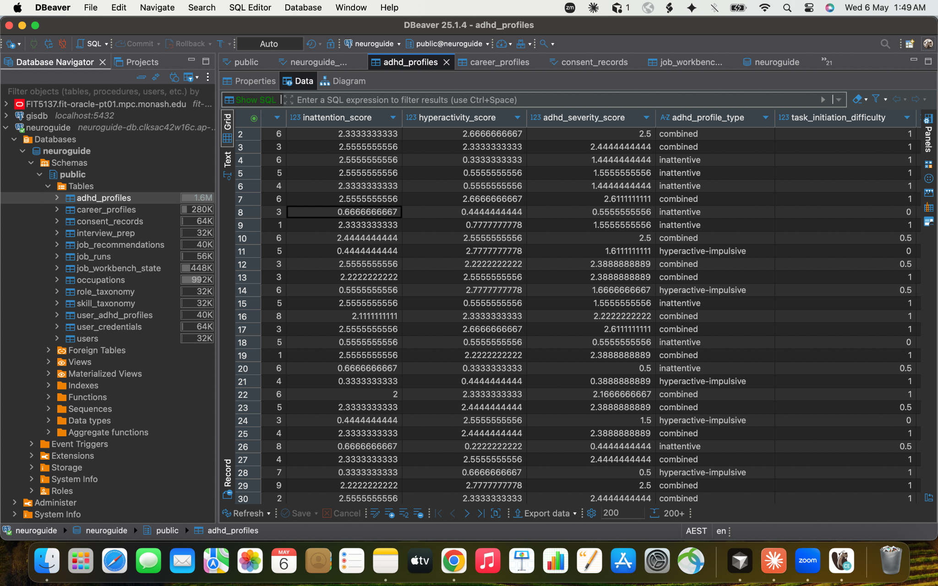
Screenshot: Sample rows from synthesised training dataset

3.4 Transposition into the Application

The table below summarises how each cleaned or processed data artefact maps to a specific UI affordance:

Data Artefact | Processing Stage | UI Affordance | User Benefit
au-role-taxonomy.json | Python ETL → static JSON → React fetch | Searchable occupation tag picker in skill capture form | User selects from validated Australian job titles rather than typing from memory - reduces blank-page anxiety
au-skills-taxonomy.json | Python ETL → static JSON → React fetch | Skill chip multi-select (grouped by transferability) | Short, action-oriented labels allow users to recognise their own skills without needing to articulate them in formal language
Gemini quickSnapshot | Live API → JSON.parse() → React state | Quick Snapshot panel (pinned, collapsible) at top of simplified view | Top 3 items surface instantly - ADHD users can make a go/no-go decision before reading any further detail
Gemini sections[] | Live API → JSON.parse() → accordion render | Collapsible section cards below Quick Snapshot | Layered reading experience: snapshot first, detail on demand - mirrors natural ADHD information processing
Gemini plainLanguageRewrite | Live API → JSON.parse() → text render | Plain-language rewrite tab | Jargon-stripped narrative for users who prefer reading over scanning structured lists
Gemini job_fit_features_from_gemini [Iteration2] | Live API → JSON payload → POST /predict-job-score [Iteration2] | Feeds ML scoring pipeline; not directly rendered to user [Iteration2] | Environment-aware scoring without requiring users to manually classify the job's work style
ML Compatibility Score [Iteration2] | FastAPI ML endpoint → blended score → React state [Iteration2] | 0–100 score donut + dimension breakdown panel [Iteration2] | Users see a single, interpretable score with transparent breakdown — reduces guesswork about role suitability

3.5 Storage and Archiving

- The source Excel and all derived JSON taxonomy files are committed to the Git repository under data/.
- The production build copies JSON into public/ for static deployment; release notes reference the workbook filename and version date.
- Superseded Excel editions are retained with a dated filename (e.g. Occupation_profiles_YYYYMM.xlsx) before replacement, preserving a data lineage audit trail.
- Gemini API responses are not stored. Each request is stateless; the response is consumed by the React component and discarded when the user navigates away.
- User profile data (questionnaire, skills, preferences) is persisted in browser localStorage only - no server-side persistence in Iteration 1 or 2 for the profile itself.
- Compatibility scores computed per session are cached in browser storage for the My Saved Scores history view. However, for the consented users, it is saved with user_id, Job_id and job_score overall view in the RDS PostgreSQL database in JSONB format.

4. Data Update Frequency and Iteration Process

Data Source | Update Trigger | Process | Who Acts
Jobs and Skills Australia workbook | New edition published by JSA (approx. annually) | Download new xlsx; replace data/Occupation_profiles_data.xlsx; re-run build_taxonomy.py; commit updated JSONs; update this DMP | Data / Dev team
au-role-taxonomy.json / au-skills-taxonomy.json | Triggered by workbook replacement only | Deterministic output of build script; diff reviewed in Git before merging | Automated by script; reviewed by Data team
Gemini API model | Google releases a new stable model | Update model parameter in API call (e.g. gemini-1.5-flash → gemini-2.0-flash); regression test simplification output quality on a sample of job descriptions | Dev team
User profile draft | Browser session - ephemeral | No update cadence; cleared on browser data clear | User-controlled
ADHD datasets + ML model | New ADHD research data becomes available, or model performance degrades | Replace dataset files in data/ml/; re-run training script; validate RMSE; update model.pkl; regression test scoring API; update this DMP | Data / ML team
Occupation catalogue (DB) | New occupations added or ADHD-friendliness ratings refined | Update via admin endpoint or DB migration script; re-deploy FastAPI service | Data / Dev team
User profile draft | Browser session - ephemeral | No update cadence; cleared on browser data clear | User-controlled

5. Storage Strategy

Data Type | Persisted? | Storage Location | Archiving Strategy
Raw occupation workbook (JSA Excel) | Yes | data/*.xlsx - project Git repository | Git history + dated filename copies before replacement
au-role-taxonomy.json / au-skills-taxonomy.json | Yes | data/ (source) → public/ (build output) | Git diff + CHANGELOG entry; previous version retained on release branch
Python ETL script (build_taxonomy.py) | Yes | scripts/ - project Git repository | Versioned with Git; all logic changes logged in commit messages
Gemini API responses (simplification) | No - ephemeral | React component state only; discarded on unmount | Not archived; stateless per request
User profile draft | Optional - browser only | Browser sessionStorage / localStorage | User-controlled; not server-backed in Iterations 1–2
API key (Gemini) | Server env only | .env file (never committed) | Never logged
ADHD training datasets | Yes | data/ml/*.csv - project Git repository | Git history; datasets are fixed snapshots - versioned by filename if updated
Trained ML model artefact (model.pkl) | Yes | data/ml/model.pkl - project Git repository; loaded by FastAPI at startup | Versioned with Git; RMSE logged in training report
Compatibility score cache | Optional - browser only | Browser localStorage (My Saved Scores history) | User-controlled; cleared on browser data clear; no server-side persistence

6. Data Modelling and Analysis

6.1 Conceptual and Logical Model
The core entities for Iteration 1 reflect the two data pipelines: the taxonomy ETL produces static reference entities; the NLP pipeline handles transient user-session entities.

Entity | Type | Key Attributes | Where Used
OccupationTag | Static reference | title : string; employment_rank : int; source_workbook_row : int | Role tag picker in skill capture form; sourced from au-role-taxonomy.json
SkillTag | Static reference | label : string; source_verb : string; category : string; transferability : [core | technical | domain] | Skill chip multi-select; sourced from au-skills-taxonomy.json
UserProfileDraft | Ephemeral session | selected_roles : string[]; selected_skills : string[]; work_rhythm : string; support_prefs : string[] | Browser sessionStorage; not persisted to backend in Iteration 1
JobPostingText | Ephemeral session | raw_text : string; submitted_at : timestamp | Input to Gemini API call; not stored after API response received
SimplifiedJobView | Ephemeral session | quickSnapshot : {requirements: string[], responsibilities: string[]}; sections : {label, content}[]; plainRewrite : string | Rendered in the Job Description Simplification UI; discarded on navigation
OccupationRecord [Iteration2] | Server-side DB [Iteration2] | occupation_id; adhd_friendliness; complexity; implied_skills[] [Iteration2] | Resolved from job title client-side; used by backend to enrich scoring request [Iteration2]
CompatibilityScore [Iteration2] | Ephemeral + browser cache | final_score : int; rule_score : float; ml_score_0_100 : float; | Displayed as donut chart + breakdown; cached to Saved Scores in localStorage

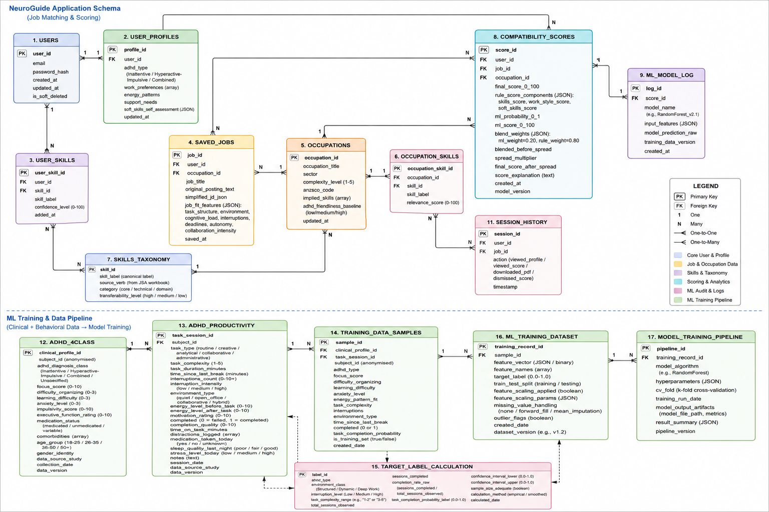
Figure - Conceptual Entity-Relationship Diagram

6.2 Iteration 1: Modelling Techniques and Rationale
This section explains each data modelling technique used in Iteration 1 - what it is in plain terms, how it is applied, what it produces, and why it is the right choice for the NeuroGuide problem.

Technique 1: Frequency Analysis (Counting)

What it is: Counting how often something appears across a large collection of text. Like tallying how many times each word appears in a book to find the most common themes.

The Jobs and Skills Australia workbook contains thousands of task statements spread across hundreds of occupations - for example, 'Prepare reports', 'Prepare financial summaries', 'Prepare client documentation'. Each task statement begins with an action verb that describes a skill. Python's collections.Counter is used to count how many times each leading verb appears across the entire corpus.

Step | Plain-language explanation | Technical detail
Count verbs | Go through every task statement in the workbook and note the first word (the action word) of each one | Extract first alphabetic token per task statement; pass all tokens to Counter({verb: n})
Find the threshold | Look at the counts and decide: how rare is too rare to be a useful skill label? A verb used only once is probably a niche specialisation, not a common transferable skill | Inspect Counter output; identify elbow in frequency distribution; set minimum_frequency = 18
Filter | Keep only verbs that appear 18 or more times - these represent skills broad enough to apply across many different jobs | Counter items where count >= minimum_frequency are promoted to candidate skill labels

Why this technique for NeuroGuide skills: An ADHD user presented with a tag picker containing 300+ options faces the same cognitive overload the app is trying to prevent. Frequency filtering ensures the skill library contains only the most widely recognised, transferable skills in the Australian labour market - keeping the list short, relevant, and quick to scan.

Technique 2: Categorical Mapping (Controlled Vocabulary)

What it is: Translating one set of labels into a more meaningful set using a lookup table. Like replacing airport codes (MEL, SYD) with city names (Melbourne, Sydney) so passengers can actually understand the board.

After frequency filtering, the surviving verbs are still raw grammatical tokens (e.g. 'Liaise', 'Utilise', 'Coordinate'). These are not how a job seeker thinks about their own skills. A curated Python dictionary maps each verb to a human-readable skill chip label that a user can self-identify with:

Raw verb (from workbook) | Mapped skill chip label | Design rationale
Analyse | Analytical Thinking | Abstract enough to cover data analysis, research, and problem-solving roles
Liaise | Stakeholder Communication | Describes the interpersonal outcome, not the mechanical act of 'liaising'
Coordinate | Project Coordination | Recognisable as a transferable skill category across sectors
Prepare | Documentation & Reporting | Groups report-writing, proposal preparation, and record-keeping under one label
Develop | Strategy & Planning | Captures roles involving planning, product development, and programme design

Why this technique for NeuroGuide skills: ADHD users often struggle to articulate their skills in formal language - one of the core pain points identified in the Emily persona. By showing recognisable, plain-language chip labels rather than raw verbs, the tag picker enables users to identify skills they already have without needing to translate their experience into HR terminology.

Technique 3: Deduplication with Conflict Resolution

What it is: Removing duplicate records from a dataset while making a principled decision about which version to keep when duplicates disagree. Like resolving two contact entries for the same person by keeping the one with the most recent phone number.

The JSA workbook contains occupation titles that appear on multiple rows - sometimes with different employment count values due to how the source data is structured. Simply taking the first occurrence would give an arbitrary result. Instead, all occurrences of each title are collected, the employment count field is parsed numerically from each, and the record with the maximum value is retained.

Why this technique for the roles taxonomy: The role picker's default sort order is based on employment count - common occupations surface first. If conflicting duplicate counts are not resolved, the ranking is unreliable. Using max() as the conflict rule is transparent and reproducible: the same input always produces the same output, which is critical for a dataset committed to version control and reviewed by teaching staff.

Technique 4: Sorting by Employment Proxy

What it is: Ordering a list by a meaningful measure rather than alphabetically. Like sorting a job board by number of active vacancies rather than company name - the most in-demand roles appear first.

After deduplication, the role list is sorted by descending employment count, then alphabetically for ties. This means a user opening the occupation picker sees the most common Australian occupations at the top, without needing to scroll or know the exact title spelling.

Why this technique for ADHD users: Scrolling through a long alphabetical list to find 'Software Developer' or 'Project Manager' is effortful and frustrating - especially for users with attention regulation difficulties. Employment-count ordering maximises the chance that a user finds their occupation type within the first visible items, reducing search time and decision fatigue.

Technique 6: Descriptive Statistics - Baseline Only
Iteration 1 applies descriptive analytics only: frequency distributions and deterministic rule-based transformations. No predictive or probabilistic model is trained in this iteration.

6.3 Iteration 2 - Modelling Technique and Rationale

Technique 7: Supervised Machine Learning - Task Completion Classifier
Training a statistical model on historical examples so it can predict the outcome of new, unseen cases. Like teaching a system: 'Given these ADHD characteristics and this work environment, here is how often someone like this completes their tasks - now predict for this new person and job.'

What we wanted to predict:
Given a person's ADHD type and clinical profile, and a job's work environment characteristics (derived from the Gemini-extracted job fit features), what is the probability they will successfully maintain focus and complete work? This is distinct from 'will they get the job' - it measures 'will they thrive in this work style?'

Please access the AI Model Report from here: https://docs.google.com/document/d/1VybRX8huGlxRjSlUMyUldIV6rULJE104/edit?usp=sharing&ouid=106591582509889562909&rtpof=true&sd=true

Training Data Construction
Field | Source Dataset | Role in Training
ADHD_Type (Inattentive, Hyperactive/Combined) | ADHD_4Class | Primary grouping variable for environment-completion lookup
Focus_Score | ADHD_4Class | Clinical cognitive capacity signal; weighted 0.4 in suitability formula
Difficulty_Organizing_Tasks | ADHD_4Class | Reverse-scored; weighted 0.2
Anxiety_Depression_Levels | ADHD_4Class | Reverse-scored; weighted 0.15
task_type, task_complexity, interruptions, energy_level, time_since_last_break | ADHD_Productivity | Task environment features; define environment type (Structured/Dynamic/Deep)
Task_Completion_Probability (target) | ADHD_Productivity (computed) | Mean completion rate per (ADHD_Type × Environment_Type) combination from productivity logs, range 0.0–1.0

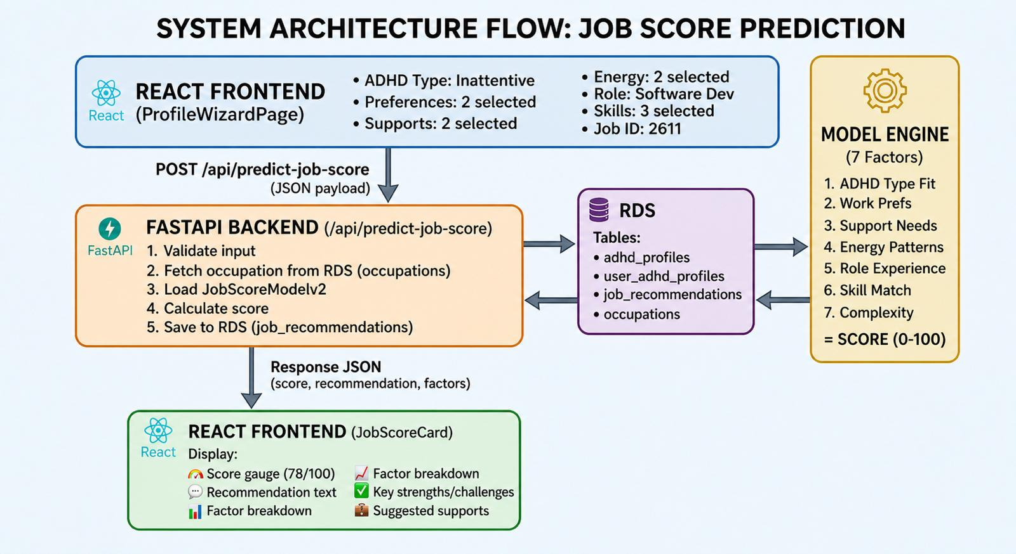
Figure 2 - Job Score Model Flow Diagram

Model Selection and Training
Two models were trained and compared:
- Logistic Regression - used as a baseline classifier. Learn a linear formula: Probability = sigmoid(0.8 × Focus_Score − 0.5 × Difficulty_Organizing + 0.3 × Job_Interruptions − 0.2 × Task_Complexity + …). Interpretable and fast to train.
- Random Forest (200 trees, max_depth=12) - selected as the production model because it captures non-linear interactions (e.g. 'Low focus + Low interruptions = might work', 'Low focus + High interruptions = never works') that Logistic Regression cannot model linearly.

Training Round | Model / Change | RMSE on Test Set | Conclusion
Round 1 - Baseline | Logistic Regression | 0.058 | Acceptable baseline; room to improve
Round 2 - Feature Expansion | Logistic Regression + energy_level, time_since_last_break, anxiety_score | 0.042 | Anxiety level improves prediction
Round 3 - Model Switch | Random Forest (100 trees, max_depth=10) | 0.035 | Non-linear patterns captured
Round 4 - Hyperparameter Tuning | Random Forest (200 trees, max_depth=12) | 0.032 - Best | Final model selected
Round 5 - Over-fit check | Random Forest (300 trees, max_depth=15) | 0.033 | Slightly worse - overfitting; Round 4 model retained

Model training loop - LogisticRegression and RandomForestClassifier fit calls, train/test split (70/30)]

Model Evaluation Metrics
Metric | Value | Interpretation
RMSE (Root Mean Square Error) | 0.05 | On average, predictions are off by ±5.2 percentage points. A predicted score of 75% may be 65–78% in reality.
F1-Score | 0.80 | Balanced between precision and recall - good overall discriminative performance.

Technique 7: Score Blending and Nonlinear Spread (Iteration 2)
The ML prediction is combined with a rule-based scoring layer to produce the final compatibility score. This blend is documented here as a modelling decision.

Rule layer (60% weight):
- Skills alignment - weighted overlap between user skills and job's skill list (50% of rule score).
- Work style fit - match between user work preferences/energy patterns and job environment (25% of rule score).
- Soft skills alignment - Gemini-derived job soft skill demands vs user inferred profile, optionally overridden by drag/drop (25% of rule score).
- Hard cap: if skills alignment is very low (below threshold), the final score is capped low so wrong-domain roles cannot float up on preferences alone.

ML layer (40% weight):
- The Random Forest model produces Task_Completion_Probability (0.0–1.0), scaled to ml_score_0_100 (0–100).

Blend formula (simplified):
blended ≈ 0.40 × ml_score_0_100 + 0.60 × rule_tilt
A nonlinear spread function (_spread_score_distribution) then reshapes the blended value to widen the midrange relative to extremes, before clamping to 0–100 for display.

7. Ethical, Legal and Privacy Issues

7.1 Data Ethics and AI Considerations

Population-Level Data Only (Iteration 1)
The Jobs and Skills Australia workbook contains aggregate occupation statistics - no individual-level employment or health data. This substantially reduces direct privacy risk for the taxonomy pipeline.

ADHD Dataset Ethics (Iteration 2)
- The ADHD_4Class dataset contains individual-level clinical profiles. Although sourced as open-access from Kaggle under a CC0 licence, the team acknowledges that ADHD is a protected health attribute. No individual records are surfaced in the application - the dataset is used solely for offline model training.
- The ADHD_Productivity dataset is entirely synthetic. Using synthetic data avoids privacy risks associated with real task logs while still capturing realistic ADHD work pattern distributions.
- Global population bias: Both datasets represent a global population rather than specifically Australian users. The team acknowledges that ADHD presentation, diagnosis practices, and work norms differ across countries. Suitability scores should be interpreted as indicative rather than clinically precise.
- Diagnostic label limitations: The four ADHD subtypes used in training (Inattentive, Hyperactive-Impulsive, Combined, Unspecified) are clinical classifications. Users may not know their formal diagnosis; the platform asks for self-reported ADHD type and does not require clinical verification.

AI Ethics - Gemini API (Iterations 1 and 2)
- Accuracy and fidelity: A simplified job description that misrepresents a genuine requirement could cause a user to apply for a role they are unqualified for. The Quick Snapshot is explicitly labelled in the UI as AI-generated and assistive - not a legally accurate reproduction of the original posting.
- Compatibility score limitations: The 0–100 compatibility score is a probabilistic estimate, not a guarantee of job success. The UI displays a plain-language explanation alongside the score. The ml_layer debug trace is available in the API response for transparency.
- Over-confidence in AI output: ADHD users may be more likely to accept AI outputs at face value. The application displays a clear disclaimer and retains a link to the original job description at all times.
- Bias in simplification: LLMs can encode societal biases in how they frame roles. Iterative prompt refinement based on real user submissions is planned.

Potential Algorithmic Biases
- The occupation corpus may under-represent certain sectors (care economy, creative industries, informal or gig work).
- The ML model is trained on a relatively small synthesised training set. Predictions for unusual ADHD-type × environment combinations may be less reliable.
- The 80/20 rule-vs-ML blend was set by the team based on testing; it may need recalibration with real-world user data in future iterations.

Transparency and User Autonomy
The application communicates clearly that all AI and ML outputs are guidance, not determinations. Users are not prevented from accessing original job descriptions. All personalisation is user-initiated and user-controlled - the system makes no unsolicited inferences about a user's disability status.

7.2 Legal and Licensing
- Jobs and Skills Australia dataset: used per publication terms; attribution maintained in product documentation and in this DMP. No endorsement by JSA is implied.
- Google Gemini API: used per Google's Generative AI API Terms of Service. The team has reviewed the terms regarding data handling for API inputs; job description text submitted via the API is subject to Google's data processing terms. Users are notified that submitted text is sent to a third-party API.
- PDFKit / pdfmake: open-source libraries (MIT / Apache 2.0 licensed); usage is unrestricted for this application.
- ADHD datasets (Kaggle - planned for Iteration 2): open access under CC0 or similar; licensing will be confirmed and documented before integration.

7.3 Privacy
- Iteration 1 does not send user profile data (skills selections, ADHD preferences) to any backend server. All profile data remains in the user's browser session storage.
- Job description text entered by the user is sent to the Gemini API (Google servers). Users are advised in the UI not to include personal identifying information in submitted job descriptions - e.g. their own name, address, or contact details.
- No personally identifiable information (PII) is collected or persisted by the application in Iteration 1.
- The Gemini API key is stored as a server-side environment variable (.env); it is never exposed in client-side JavaScript bundles or committed to the repository.
- Iteration 2+ plans - résumé uploads, persistent profiles, suitability scores - will require encryption in transit (HTTPS + TLS 1.3), access controls on AWS S3 buckets (Block Public Access enabled), JWT authentication between React and FastAPI, explicit data retention policies, and a Data Privacy Impact Assessment (DPIA) before deployment.

[Iteration 2 - DPIA outline; API data-handling confirmation from Google; S3 bucket policy screenshot]

8. Alignment with Problem Domain and User Needs

Research shows that approximately 19% of young adults with ADHD experience long-term unemployment compared to 13% of the general population (Helgesson et al., 2021). A key barrier is the mismatch between standard recruitment processes - which assume strong executive function (sustained attention, information filtering, structured self-expression) - and the cognitive styles of neurodivergent job seekers.

The data design in Iteration 1 directly addresses this gap:

Problem Identified | Data / Feature Response | User Persona Served
Open-ended skill articulation causes blank-page anxiety | au-skills-taxonomy.json supplies a constrained, searchable chip library derived from real Australian task data | Emily - inattentive ADHD, early career
Long job descriptions cause cognitive overload before a user can decide whether to apply | Gemini API extracts a Quick Snapshot of exactly 3 requirements and 3 responsibilities - displayed before any full detail | Emily - overwhelmed by unstructured text
Repeated job mismatch and burnout from applying to unsuitable roles | ML compatibility score (Iteration 2) predicts environment suitability from ADHD type × work environment; score breakdown shows which dimensions matched and which did not | Jake - combined ADHD, experienced worker
Interview anxiety and difficulty structuring responses | Gemini-powered interview preparation (Iteration 2) provides ADHD-type-specific communication strategies and self-advocacy talking points | Both personas

Future Challenges

- Licence compatibility: the JSA workbook terms must be re-validated on each new edition before use.
- Prompt drift: Gemini model updates may change how the simplification prompt is interpreted. A regression test suite over a sample of representative job descriptions is needed before accepting any model upgrade.
- Dataset bias: ADHD productivity and 4-class datasets (Iteration 2) are primarily sourced from global research - suitability for Australian users and for all ADHD presentations must be critically assessed before the recommendations engine goes live.
- Balancing personalisation accuracy with cognitive simplicity: a suitability score that is difficult to interpret may increase, rather than reduce, anxiety for ADHD users. Plain-language score explanations must be co-designed with neurodivergent users.
- Model retraining cadence: as more users interact with the platform, real-world task completion patterns (if collected under explicit consent) could improve model accuracy. A data collection and retraining governance process should be established before Iteration 3.

9. Summary

Area | Summary
Data Sources | Iteration 1: Jobs and Skills Australia occupation profiles workbook; derived au-role-taxonomy.json and au-skills-taxonomy.json; Google Gemini API; PDFKit/pdfmake. Iteration 2 additions: ADHD_4Class dataset (6,500 records); ADHD_Productivity synthetic dataset (10,000 task records); internal occupation catalogue (server-side DB). All sources documented with licensing and attribution details.
Processes | Three pipelines: (A) offline Python ETL using openpyxl - regex cleaning, Counter-based frequency thresholding, controlled vocabulary mapping, deduplication, JSON serialisation; (B) live Gemini API call - structured JSON prompt for simplification and (Iteration 2) job_fit_features extraction; (C) Iteration 2 ML pipeline - ADHD dataset merging via environment-type mapping, Random Forest training, score blending (20% ML + 80% rule), nonlinear score spread.
Modelling | Iteration 1: rule-based categorical mapping, structured NLP prompt engineering. Iteration 2: supervised ML (Logistic Regression baseline → Random Forest, final RMSE = 0.032); blended scoring engine combining ML task-completion probability with rule-based skills, work-style, and soft-skills components.
Governance | Git history for all source and derived artefacts. Gemini API key in server environment only. Trained model artefact versioned in Git. No persistent user data in Iterations 1–2; browser localStorage only.
Ethics and Privacy | AI and ML outputs labelled as assistive - not clinical determinations. No PII collected or persisted. ADHD datasets used for offline training only; no individual records surfaced in the application. Global population bias in datasets acknowledged. Score transparency via ml_layer debug trace.
Live Document | This DMP will be updated each iteration to reflect new data sources, modelling additions, prompt engineering changes, and Monash teaching staff feedback. Maintained in the Data Governance folder in the Project Governance Portfolio.

