ANNE Frank : Base vs fine tuned

DISTILBERT

BASE:  
{'0': {'precision': 0.2972972972972973,

'recall': 1.0,

'f1-score': 0.4583333333333333,

'support': 11},

'2': {'precision': 0.0, 'recall': 0.0, 'f1-score': 0.0, 'support': 26},

'accuracy': 0.2972972972972973,

'macro avg': {'precision': 0.14864864864864866,

'recall': 0.5,

'f1-score': 0.22916666666666666,

'support': 37},

'weighted avg': {'precision': 0.08838568298027759,

'recall': 0.2972972972972973,

'f1-score': 0.13626126126126126,

'support': 37}}

Accuracy: 0.2972972972972973

Precision: 0.08838568298027759

Recall: 0.2972972972972973

F1 Score: 0.13626126126126126

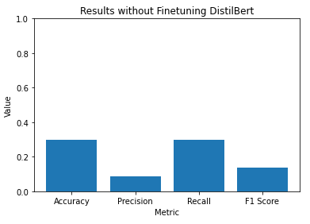

Fine-Tuned

{'0': {'precision': 0.6935483870967742,

'recall': 0.8269230769230769,

'f1-score': 0.7543859649122807,

'support': 52},

'1': {'precision': 0.0, 'recall': 0.0, 'f1-score': 0.0, 'support': 3},

'2': {'precision': 0.9166666666666666,

'recall': 0.8661417322834646,

'f1-score': 0.8906882591093117,

'support': 127},

'accuracy': 0.8406593406593407,

'macro avg': {'precision': 0.5367383512544803,

'recall': 0.5643549364021805,

'f1-score': 0.5483580746738642,

'support': 182},

'weighted avg': {'precision': 0.8378086966796644,

'recall': 0.8406593406593407,

'f1-score': 0.8370630718808857,

'support': 182}}

Accuracy: 0.8406593406593407

Precision: 0.8378086966796644

Recall: 0.8406593406593407

F1 Score: 0.8370630718808857

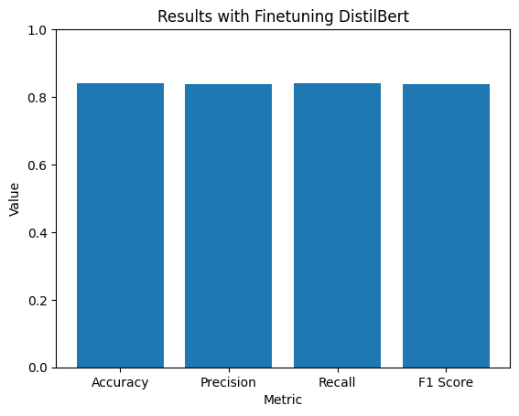

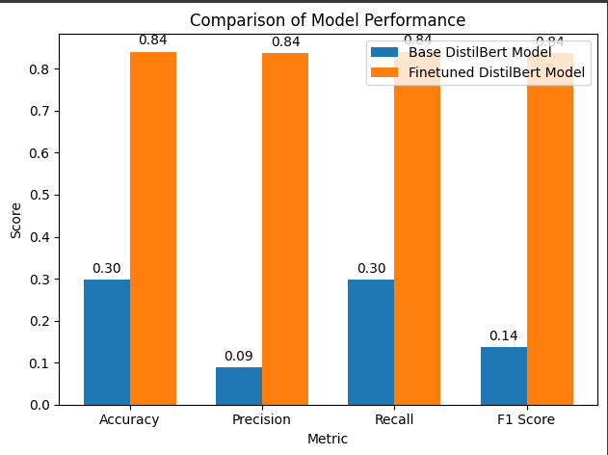

BERT

BASE:

{'0': {'precision': 0.25,

'recall': 0.18181818181818182,

'f1-score': 0.2105263157894737,

'support': 11},

'1': {'precision': 0.0, 'recall': 0.0, 'f1-score': 0.0, 'support': 0},

'2': {'precision': 0.6785714285714286,

'recall': 0.7307692307692307,

'f1-score': 0.7037037037037038,

'support': 26},

'accuracy': 0.5675675675675675,

'macro avg': {'precision': 0.30952380952380953,

'recall': 0.30419580419580416,

'f1-score': 0.30474333983105917,

'support': 37},

'weighted avg': {'precision': 0.5511583011583011,

'recall': 0.5675675675675675,

'f1-score': 0.5570833991886625,

'support': 37}}

Accuracy: 0.5675675675675675

Precision: 0.5511583011583011

Recall: 0.5675675675675675

F1 Score: 0.5570833991886625

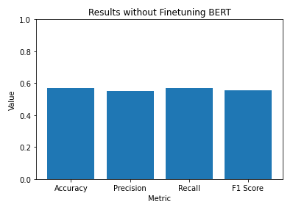

Fine-Tuned

Accuracy: 0.841

Precision: 0.835

Recall: 0.842

F1 Score: 0.836

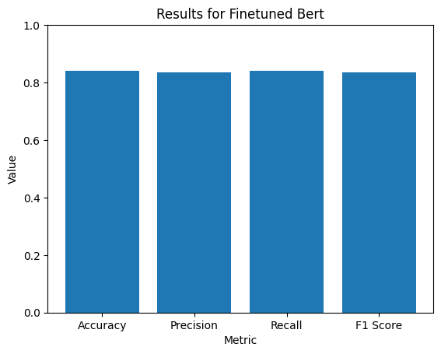

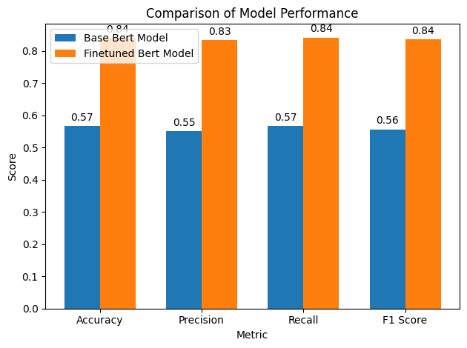

Roberta

Base

Accuracy: 0.7027027027027027

Precision: 0.493791088385683

Recall: 0.7027027027027027

F1 Score: 0.58000858000858

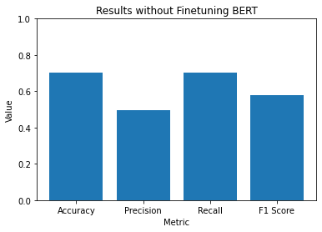

Fine tuned

Accuracy: 0.839

Precision: 0.840

Recall: 0.838

F1 Score: 0.836

