Module 2: Classifying Data to Convey Meaning

Dr. P.K. Viswanathan, Professor, Great Lakes Institute of Management

Introduction

When managers are bewildered by plethora of data, which do not convey any sense on the surface of it, they are looking for methods to classify the data (data reduction) to convey meaning which will help them draw the right conclusion. This module provides the nitty-gritty of arranging data into information.

2.1 Meaning and Examples of Raw Data

Raw data represent numbers and facts in the original format in which data have been collected. You need to convert the raw data into information for managerial decision-making.

Example of Raw Data

Assume that you know the weekly sales of a product in a region over the past year are:
(Figures in '000' units)
52 61 59 55 63 70 59 77 81 83 69 91 73
83 90 81 77 77 74 65 56 77 64 49 60 52
50 45 42 46 39 29 38 41 43 23 26 27 22
29 31 29 31 30 30 29 40 44 45 46 52 53

Suppose you present this set of data as it is to the General Manager (Sales). At best it will be boring to him.

Another example of raw data in a manufacturing could be 200 sample measurements taken on the diameter of a shaft in the context of controlling variation. These 200 measurements if you present as they are to the quality assurance manager, he can draw no meaningful conclusion.

Of course, without raw data you cannot get information. Raw data are the raw materials, which you will process appropriately to get the finished product- information.

Large and massive raw data tend to bewilder you so much that the overall patterns are obscured. You cannot see the wood for the trees. This implies that the raw data must be processed to give you useful information.

Raw Data

Information
PROCESS

2.2 Frequency Distribution

Frequency distribution focuses on classifying raw data into information. It is the most widely used data reduction technique in descriptive statistics. When you are looking for pattern that would help you understand the characteristic you measure in a problem situation, frequency distribution is the appropriate tool to use.

In simple terms, frequency distribution is a summarized table in which raw data are arranged into classes and frequencies. Classes represent categories or groupings, which contain a lower limit and an upper limit. Classes are formed conveniently following certain guidelines. Against each class, you count and then place the number of observations that fall into it. When you do it for all classes in a given data analysis problem, it becomes a frequency distribution.

Guidelines for Constructing a Frequency Distribution Table

- Identify the Minimum Value (Min) and Maximum Value (Max) in the given Data Set. Calculate Range = Max-Min

- Decide on the Number of Classes you would like to have. The number of classes can be determined as the square root of the number of observations in the data set. For example, if you have 100 observations, the number of classes can be 10. When perfect square root is not possible, you round off the square root to the nearest whole number. Also for any problem it is recommended that you have not less than 5 classes and not more than 15 classes.

- Determine the Width of the Class Interval as = Range / Number of Classes

- Formulate the Boundaries of the Classes in such a manner that it will include all the observations in the data set. Avoid overlapping of classes. Once class boundary for each class is ready, all you need to do is to tally the number of observations in each class.

Construction of a Frequency distribution-An Example

You take the example given in the beginning that contains weekly sales of a product in '000' units for the past year in a region. Going by the guidelines given above, you can have 7 classes (Square root of the number of observations, which is 52, is between 7 and 8. You round it off to 7). The range is 69(Max =91, Min=22). The width of the class = range divided by number of classes which is =69/7 = 10 approximately. The frequency distribution, which includes all observations, is given below:

Class | Frequency
22-32 | 12
32-42 | 5
42-52 | 11
52-62 | 7
62-72 | 5
72-82 | 8
82-92 | 4
Total | 52

*You will note that in this formation, the classes are not overlapping. 22-32 means 22 and more but less than 32. This continuous way of forming the class interval is key to constructing histogram

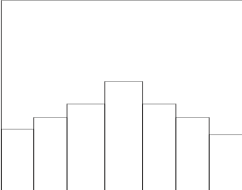
2.3 Histogram

Histogram (also known as frequency histogram) is a snap shot of the frequency distribution. Histogram is a graphical representation of the frequency distribution in which the X-axis represents the classes and the Y-axis represents the frequencies. Rectangular bars are constructed at the boundaries of each class with heights proportional to the frequency. | Histogram like frequency distribution depicts the pattern of the distribution emerging from the characteristic being measured. If the pattern is symmetrical and bell shaped, then it reflects the normal distribution curve. We will explain the normal distribution later under probability distributions.

Construction of Histogram-An Illustration

The inspection records of a hose assembly operation indicated a high rate of rejection. An analysis of the records showed that the "leaks" were a major cause of concern. It was decided to investigate the hose clamping operation. The hose clamping force (torque) was measured on twenty five assemblies. (Figures in foot-pounds). The data are given below: Draw the frequency histogram and comment.

8 | 13 | 15 | 10 | 16
11 | 14 | 11 | 14 | 20
15 | 16 | 12 | 15 | 13
12 | 13 | 16 | 17 | 17
14 | 14 | 14 | 18 | 15

Applying the guidelines discussed earlier for constructing histogram, you will notice that the range is 20-8 =12. You take the number of classes as 5(Note that the square root of the number of observations is √25 = 5). The width of the class is range/number of classes = 12/5 =2.4. Round it to 3. You can now form the boundaries of the classes starting with 8 and then incrementing by 3 successively the lower limit of each class until all the classes are formed. Tally the number of observations under each class. This would give you the following table of frequency distribution.

Class | Frequency
8-11 | 2
11-14 | 7
14-17 | 12
17-20 | 3
20-23 | 1

If you graphically depict this frequency distribution by taking classes on the X-axis and frequencies on the Y-axis, you get the following histogram.

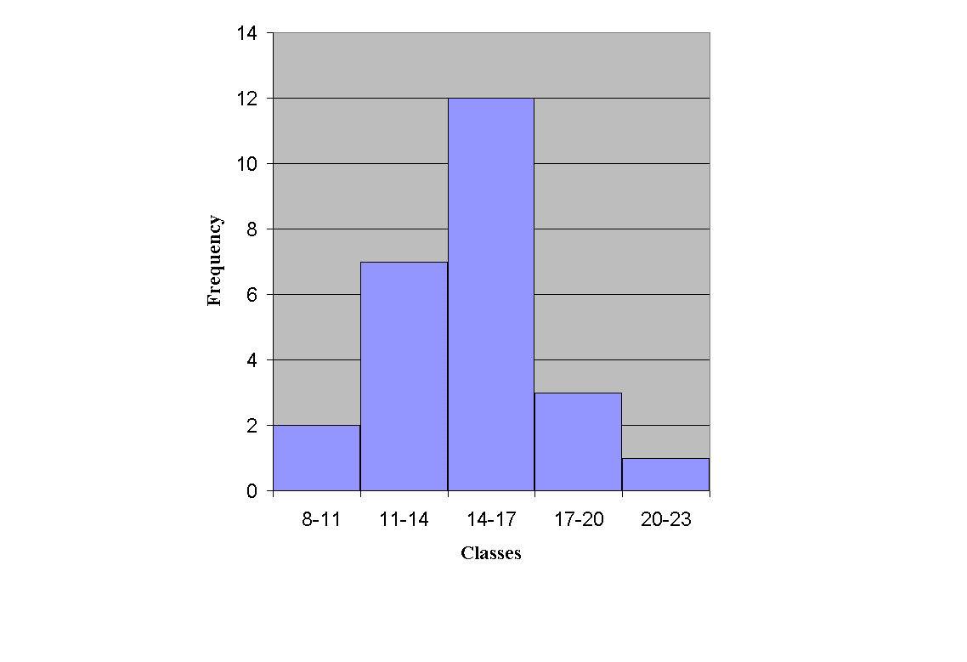
Histogram for the example
Looking at the histogram, it is easy for you to see that the pattern does not show a bell shape curve. Some distortion to normality is caused by the bars adjacent to the class 14-17. It is also evident that the average is in the range 14 to 17. Corrective action is needed. However, before taking any action, you must be cautious about the fact that the sample size here is only 25 observations. Take more measurements and draw the histogram again before taking corrective steps.
Computer and Histogram

Construction of Histogram - An Illustration

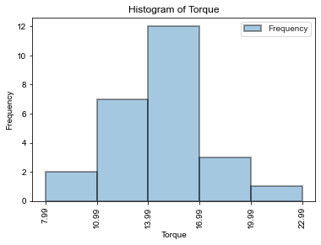

We shall use Jupyter Notebook to demonstrate how to code the above in Python.

https://github.com/ScryEngineering/Jupyter_examples/blob/master/CellInputsAndOutputs.ipynb

Jupyter Notebook has two types of modes: Markdown and Code modes. We use Markdown cell for documentation purpose and Code cell for typing the code to be executed.

Jupyter Notebook offers numbered prompts (In / Out) with input and output history. Code mode is indicated by a green cell border and a prompt appearing in the edit area. After typing the code in the cell, press Enter to execute the code.

Import statements are used to load the modules into the memory.

For more details, refer:
https://docs.python.org/2.0/ref/import.html
https://matplotlib.org/3.1.1/api/index.html

The package, seaborn is imported and given the alias name sns by typing "import seaborn as sns". The package, matplotlib.pyplot is imported and given the alias name, plt by typing "import matplotlib.pyplot as plt" in the first cell in the Input Area with prompt number,1.

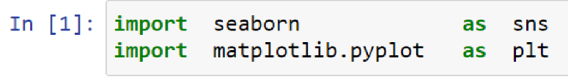

We now can refer to seaborn module by using the alias name, 'sns'. Similarly, we can refer to the matplotlib.pyplot, a collection of functions for generating plots that work like MATLAB by the alias name, plt.

A list ordered collection of objects and mutable (changeable). Lists are created with [] (square brackets) in Python.

Create a list, x to hold the values of hose clamping force (torque) for twenty-five assemblies.
Similarly, create a list, bins to hold the lower-boundary values of torque.

The seaborn package lets you create a variate of charts for numerical as well as categorical data. The histogram pictured above is an output from the histogram created by using function, distplot() of seaborn package in Python.

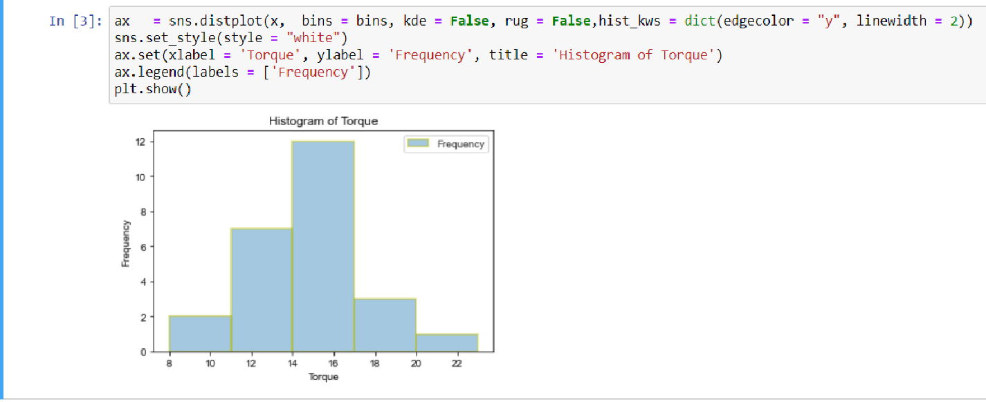

Parameters for distplot():
- a = the observed data, x
- bins = specification of hist bins, bins
- kde = whether to plot a gaussian kernel density estimate, False
- rug = whether to draw a rugplot on the support axis, False
- hist_kws = key word arguments for matplotlib.axes.Axes.hist(), dict(edgecolor = "k", linewidth = 2)

Note: The argument, edgecolor represents one of base colors {'b','g','r','c','m','y','k','w'}
'b' = Blue; 'g' = Green; 'r' = 'Red'; 'c' = 'Cyan'; 'm' = 'Magneta'; 'y' = 'Yellow'; 'k' = 'Black'; 'w' = 'White'. The argument, linewidth represents line width in points

The sns.distplot() returns an Axes object,ax with the plot for further tweaking.

A Rug Plot is a plot of data for a single quantitative variable, displayed as marks along an axis to give a visual distribution of the data. For more details, refer to https://en.wikipedia.org/wiki/Rug_plot

set_style() sets the asthetic style of the plots.

Parameters:

style: One of the five preset seaborn themes: darkgrid, whitegrid, dark, white, ticks. Default is darkgrid.

Use ax.set() to set the x axis label, y axis label and title for the graph.

For adding legends, use ax.legend() is used for creating the legend. Plot legend helps the analyst to understand the data better by visualization by assigning meaning to the various plot elements with different colors and shapes.

The function, plt.show() is used to display the graph.

2.4 Cumulative Frequency Distribution and Ogive Curve

Another extremely useful method of getting the essence of distribution is the cumulative distribution. This can be formed from the frequency distribution table. To explain the nuances of frequency distribution along with related terms used, consider the previous example of clamping pressure(torque).

Summary table for the clamping pressure(torque) example.
Class | Frequency | Relative Frequency as proportion | Relative Frequency as % | Cumulative Frequency in numbers | Cumulative Frequency in percent
8-11 | 2 | 0.08 | 8.00 | 2 | 8.00
11-14 | 7 | 0.28 | 28.00 | 9 | 36.00
14-17 | 12 | 0.48 | 48.00 | 21 | 84.00
17-20 | 3 | 0.12 | 12.00 | 24 | 96.00
20-23 | 1 | 0.04 | 4.00 | 25 | 100.00
23-26 | 0 | 0.00 | 0.00 | 25 | 100.00
Total | 25 | 1.00 | 100.00

Relative Frequency as Proportion

The relative frequency distribution represents the frequency in each class divided by the total frequency (total number of observations). In our illustration, the relative frequency corresponding to the class 8-11 is 2 divided by 25 and = 0.08. Likewise, you can calculate for the other classes the relative frequencies. Relative frequency is a proportion. Relative frequency of any class must be always between 0 and 1 when expressed as a proportion. The relative frequency corresponding to the class 8-11 is .08. This implies that the probability that an observation will fall in this interval is 8%.

Relative Frequency as Percentage

If you multiply the relative frequency in proportions by 100, you get the relative frequency in percentages. In most business applications, percentages and proportions are more useful than mere numbers because they facilitate comparison across groups. For example, if you are interested in comparing the sales performance of different regions with the targets that are set, relative frequency in proportions or percentages are more meaningful than mere numbers because the sales potential in all regions will not be identical.

Cumulative Frequency Distribution in Numbers

For this problem, take the first class 8-11. Now find out the number of observations that are less than 11. It is 8. Take the next class 11-14. How many observations are in this class? It is 7. The number of observations cumulated at this stage will be = 2+7 =9. That is 9 observations are less than 14. Similarly, the cumulative frequency up to 17 = 2+7+12 = 21. Likewise all entries are worked out and filled in the table that deals with the clamping pressure given in the beginning.

Cumulative Frequency Distribution in Percentages

Instead of the actual frequency in each class, if you take the percentage (relative frequency) and keep on cumulating exactly in the same manner as you have done while calculating cumulative frequency in numbers, you get the Cumulative Frequency Distribution in percentages. These are computed in the table for the clamping pressure example.

The Ogive Curve

The Ogive curve is a graphical representation of the cumulative frequency distribution using numbers or percentages. In this pictorial representation, less than upper boundaries of the classes are in the X-axis and cumulative frequency in numbers or percentages are in the Y-axis. A line graph in the form of a curve is plotted connecting the cumulative frequencies corresponding to the upper boundaries of the classes.

Today, this ogive graph is elegantly and efficiently obtained as output from plot command from matplotlib.pyplot package in Python. The ogive graphs for the percent torque example both for numbers and percentages obtained from matplotlib.pyplot package in python are given below:

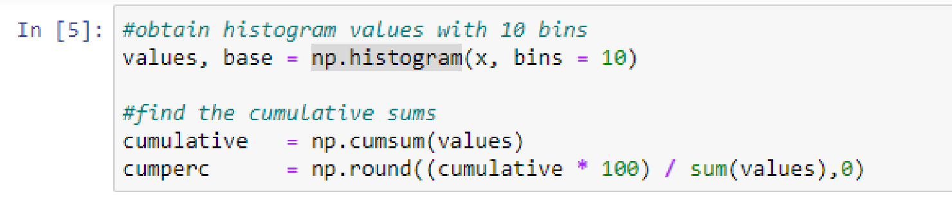

np.histogram(a, bins) is used to compute the histogram of a set of data.
Input parameters for this function:
a = Input data
base = Bin edges. Bins are the intervals obtained by dividing the entire range of values in the input data

This function, np.histogram() returns
hist : the values of the histogram
bin_edges : the bin edges

We find the cumulative values of the data using the np.cumsum() function giving values as the input and the cumulative percentage values by multiplying the cumulative values by 100 and then dividing by 100 before rounding off to the nearest integer.

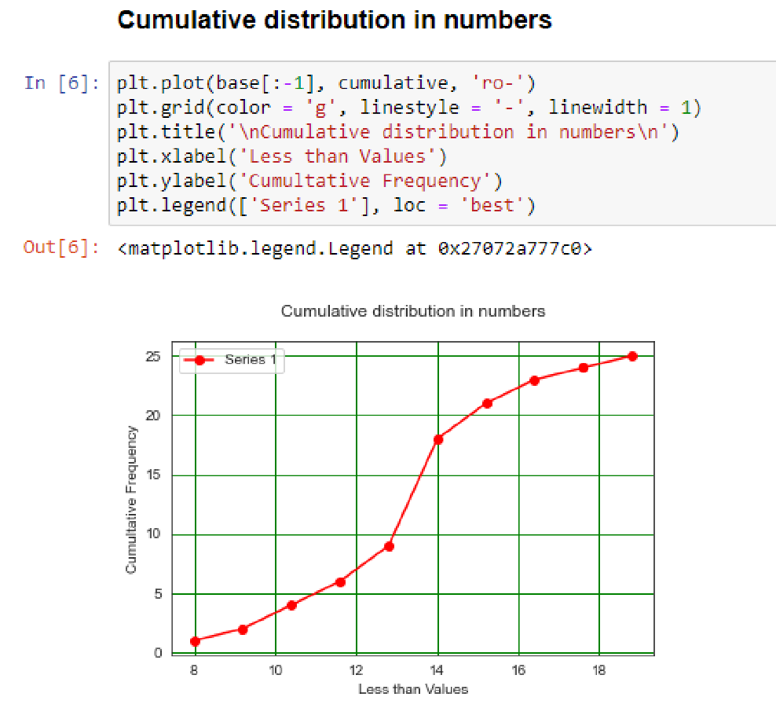
A line graph is plotted using the plot() function in matplotlib.pyplot by connecting the cumulative frequencies corresponding to the bin edges (upper boundaries of the classes). The function pyplot.grid() is used to configure the grid lines. The parameters, color = 'g' indicates "Green color", linestyle = '-' indicates solid line.

The argument, linewidth is used to adjust the width of the line. To make the line width thicker such as 1.5, 2 or 2.5 etc. Title for the graph is specified using the function pyplot.title(). Axis labels are specified using the functions, xlabel() / ylabel(). A list of labels to be shown in the legend along with the location of the legend can be specified using the function pyplot.legend().

Note: Since we had set the alias name for matplotlib.pyplot as plt, we are using plt in place of fuller path, matplotlib.pyplot.

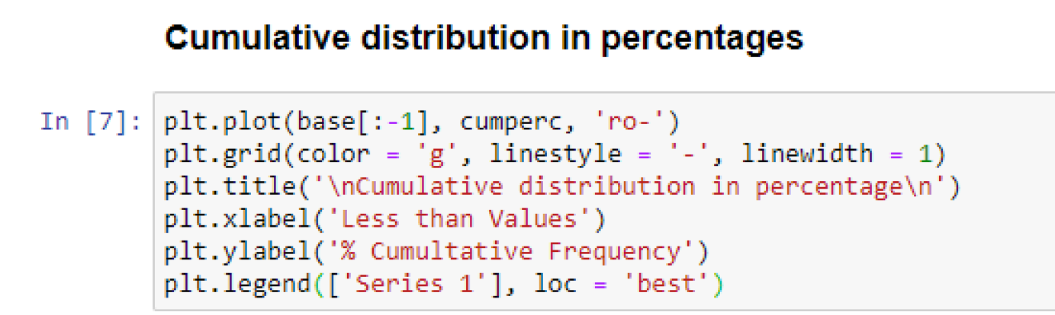
In the above code, instead of cumulative count, we have used cumulative percentage values.

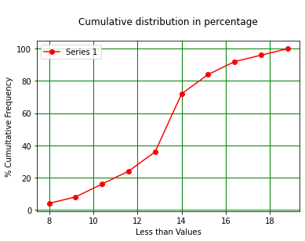

2.5 Module Summary

This module has given you a conceptual and practical framework of classifying data into information which is key to decision making. In particular, the module focused on:

Explaining the meaning of raw data with examples as well as its inadequacy in the context of decision making.

Frequency distribution as a data reduction technique for conveying meaning and recognizing patterns that are essential in analyzing data into information.

Meaning of histogram and construction of histogram for a better and sharper pattern identification as well as understanding the shape of the distribution (Normal or not).

The features and uses cumulative frequency distribution along with the related items-relative frequency and ogive curve.

Glossary:

Class: A Class represents a category or a group that contains a lower limit and an upper limit.

Cumulative Frequency Distribution: A type of frequency distribution that shows how many observations are above or below the lower boundaries of the classes.

Data Reduction: Data reduction involves methods to classify data to convey meaning when mangers are bewildered by plethora of data.

Frequency Distribution: Frequency distribution is a summarized table in which raw data are arranged into classes and frequencies. Frequencies represent the number of observations that fall into a set of classes.

Histogram: Histogram (also known as frequency histogram) is a snap shot photograph of the frequency distribution. Histogram is a graphical representation of the frequency distribution in which the X-axis represents the classes and the Y-axis represents the frequencies. Rectangular bars are constructed at the boundaries of each class with heights proportional to the frequency.

Information: When raw data are processed into suitable formats that convey meaning, they become information.

Ogive: Ogive is a graphical representation of the cumulative frequency distribution using numbers or percentages. In this pictorial representation, lower boundaries of the classes are in the X-axis and cumulative frequency in numbers or percentages are in the Y-axis. A curve is drawn connecting the cumulative frequencies that correspond to the lower boundaries of the classes.

Raw Data: Raw Data represent numbers and facts in the original format in which the
data have been Collected.

Relative Frequency: Relative frequency distribution represents the frequency in each class divided by the total frequency (total number of observations). It is expressed as percentage or proportion.

