Module 4: Probability- A Conceptual Framework

Dr. P.K. Viswanathan, Professor, Great Lakes Institute of Management

Introduction

Managers need to cope with uncertainty in many decision situations. For example, you as a manager may assume that the volume of sales in the next year is known to you exactly. This is not true because you know roughly what the next year sales will be, but you cannot give the exact number. There is some uncertainty. Concepts of probability will help you measure uncertainty and perform associated analyses. This module provides the conceptual framework of probability and the various probability rules that are essential in business decisions.

4.1 Meaning and Concepts of Probability

- In simple terms, probability refers to chance or likelihood of a particular event-taking place. For example, you may like to ask " what is the chance that the company will achieve a sale of more than Rs. 50 lakhs in the coming quarter?"

- An event is an outcome of an experiment.

- An experiment is a process that is performed to understand and observe possible outcomes. Examples include tossing a coin, drawing a card from a well-shuffled pack of cards, or rolling a pair of dice.

- Set of all outcomes of an experiment is called the sample space.

An Example:

In a manufacturing unit three parts from the assembly are selected. You observe whether they are defective or non-defective. Determine

a) The sample space.
b) The event of getting at least two defective parts.

Solution:

Let defective be designated as D and Non-defective be designated G.

a) Let S = Sample Space. It is pictured as under:
GGG GGD GDG DGG

GDD DGD DDG DDD

In symbols, this is given by the following set

S= {GGG, GGD, GDG, DGG, GDD, DGD, DDG, DDD}
Here the sample space is the set of all outcomes of the experiment of observing all the three parts for defective or non-defective. GGG represents all the three are non-defective, GGD represents first is non-defective, second is non-defective, and third is defective, and so on. Thus there are eight possibilities.

b) Let E denote the event of getting at least two defective parts. This implies that E will contain two defectives, and three defectives. Looking at the sample space diagram above,
E ={GDD, DGD, DDG, DDD}. It is easy to see that E is a part of S and commonly called as a subset of S. Hence an event is always a subset of the sample space.

Inline Question 1:

What is the sample space when you toss the coin twice? Use the symbol T =Tail and
H = Head
- S = {TH}
- S = {HH}
- S = {TT}
- S = {HT, HH, TH, TT}

You try to do it first and then check with the correct answer.

The correct answer is d). There are four possibilities in this experiment of tossing the coin twice. It would be head and tail, head and head, tail and head, tail and tail. This is shown in choice d). Choice a), choice b) and choice c) are only partially correct and hence rejected.

Definition of Probability

Probability of an event A is defined as the ratio between two numbers m and n. In symbols
P (A) = 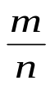where m= number of ways that are favorable to the occurrence of A and
n= the total number of outcomes of the experiment (all possible outcomes)
Please note that P (A) is always > = 0 and always < = 1. P (A) is a pure number.

The range within which probability of an event lies can be best understood by the following diagram. The glass shows three stages (for the purpose of illustration)-Empty, half-full, and full to explain the properties of probability.

(100 % Chance) Certainty 1  (50% Chance) Equally Likely 0.5  (0% Chance) Impossibility 0 | 

Man giving birth to a child is impossibility. Sun rises in the east is a certainty. Getting a head in one toss of a coin is 50%. Likewise getting tail in one toss of a coin is 50%.
Of course, probability of an event can take any value between 0 and 1. The above picture shows three typical and distinct values of probability of an event.

Example: From a well-shuffled pack of cards, if you pick up one card at random, what is the probability that the selected card is a King?

Let K = Getting a King
m= number of ways in which King can occur = 4(There 4 Kings in a pack of cards)
n= Total number Possibilities (Sample Space) = 52(There are 52 cards)

P (K) =4/52 =1/13.

Random means that every unit in the population has a known nonzero chance of being selected. Here, it implies that while picking up a card, every one of the 52 cards in the pack has the same probability of being selected. Another term that is used in this context is "equally likely".

Inline Question 2: A quality assurance manager says” I am 200 percent certain that our product will meet the specification of the customer”. Is this statement true or false?

Answer

The statement is false because probability cannot be more than 100 percent. When the event is a certainty, probability equals 1(100%). Probability is always between 0 and 1.

4.2 Types of Probability

There are three types of probability, which you should be aware of. They are:

1) Classical Probability
2) Relative Frequency
Probability

3) Subjective Probability

1) Classical Probability is same as the one we have used while defining probability in the beginning. This is called a priori probability because you can compute the answer in advance without actually having to perform any experiment. Consider for example probability of getting a King from a pack of cards. You can compute the answer in advance as 4/52. Even though classical probability comprehensively defines probability, its use in business analysis for assessing uncertainty is seriously handicapped because you cannot compute probability in advance without performing trials (experiments), or observing the behavior of the random variable. Here, random variable means a variable that takes many values with corresponding probabilities.

2) Relative Frequency Probability

"What is the chance that our company will achieve a sale of more than 15000 tons of specialty paper?" "What is the probability that you will get a score of at least 75% in the course Quantitative Methods in your MBA program?" "What is the chance that there will be no stock out problem this year?" The answers to these questions cannot be obtained in advance with out performing experiments or using the past data. The tool organization deploys is a typical frequency distribution of past data expressed as a relative frequency that was discussed in Module 2. For example, your company can use the past data on sales for assessing the probability of achieving a particular target. All you need to do is to convert the past sales figures into a well-structured frequency distribution containing target range in every class and the number of times that was achieved in every class. If you now express relative frequency either in proportion or in percentages to the total frequency, you can easily compute the probability of achieving particular target sales.

Please note that relative frequency is a pragmatic way of assessing probability in real life business situations.

3) Subjective Probability

When you cannot get probability worked out either based on classical approach or based on relative frequency of past data, the only option available to you is to use subjective probability. Assigning subjective probabilities to various events is based on some past experience, personal opinion, and an analysis of the business situation. Survey of Experts' Opinion for knowing the chances of certain key events affecting business is an example of subjective probability.

The major drawback of the subjective probability is that it can be tremendously influenced by personal prejudices, likes, and dislikes.

4.3 Mutually Exclusive Events

Two events A and B are said to be mutually exclusive if the occurrence of A precludes the occurrence of B. For example, from a well shuffled pack of cards, if you pick up one card at random and would like to know whether it is a King or a Queen. The selected card will be either a King or a Queen. It cannot be both a King and a Queen. If King occurs, Queen will not occur and Queen occurs, King will not occur. This is shown in the following diagram known by the name Venn diagram. You will appreciate that there are no common elements shared between the events King and Queen.

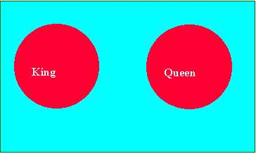

The principle of mutually exclusive can be extended to more than two events. The occurrence of one event precludes the occurrence of the remaining events.

4.4 Independent Events

Two events A and B are said to be independent if the occurrence of A is in no way influenced by the occurrence of B. Likewise occurrence of B is in no way influenced by the occurrence of A.

For example, when you toss a coin twice, getting head in the second trial is in no way influenced by what happened in the first toss. In the first toss you might have got a head
or a tail. In other words, the outcome of the second toss has nothing to do with what happened in the first toss.

The concept of independence can be extended to more than two events. In such situations, the occurrence of a particular event is no way influenced by the occurrence of the remaining events.

Inline Question 3: In a market survey, the respondents were asked, “Do you live in a flat or in an independent house? This is an example of mutually exclusive events. Is it True or False?

Answer: True because the occurrence of one event precludes the occurrence of the other. The respondent can either live in a flat or in a house. You cannot live at the same time in both the places.

4.5 Rules for Calculating Probability

1) Addition Rule -Mutually Exclusive Events

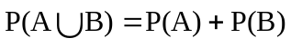
This rule says that the probability of the union of A and B is determined by adding the probability of the events A and B.

Here the symbol  is called A union B meaning A occurs, or B occurs or both A and B simultaneously occur. When A and B are mutually exclusive, A and B cannot simultaneously occur. There are no common elements for A and B when they are mutually exclusive.

2) Addition Rule - Events are not Mutually Exclusive

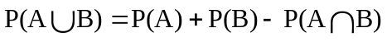
Here the symbol is called A union B meaning A occurs, or B occurs or both A and B simultaneously occur. 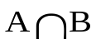is called A intersection B meaning both A and B simultaneously occur.

The above addition rule says the probability of the union of A and B is determined by adding the probability of the events A and B and then subtracting the probability of the intersection of the events A and B. The Venn diagram depicting  is given below:
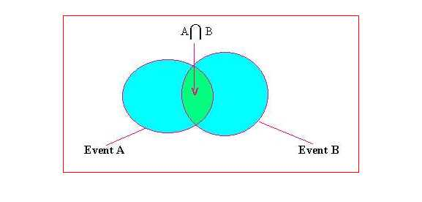

You will appreciate from the diagram that there are common elements between A and B designated as 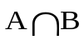. The subtraction of the term is because of double counting. This is included in event A as well as in event B.

Example Problems for Addition Rule:

From a pack of well-shuffled cards, a card is picked up at random. 1) What is the probability that the selected card is a King or a Queen? 2) What is the probability that the selected card is a King or a Diamond?

Solution to 1)

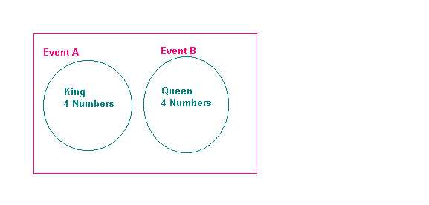

Let A = getting a King
Let B = getting a Queen

There are 4 kings and there are 4 Queens. The events are clearly mutually exclusive.

Applying the formula = 4/52 +4/52 = 8/52 =2/13
Hence the answer is 2/13

Solution to 2) There are totally 52 cards in a pack out of which 4 are Kings and 13 are Diamonds. Let A= getting a King and B= getting a Diamond. The two events here are not mutually exclusive because you can have a card, which is both a King and a Diamond called King Diamond. Please see diagram below: Applying the formula for non-mutually exclusive case namely, we have 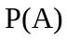=4/52, 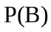=13/52, and 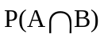=1/52(chance of getting both a King and a Diamond). Substituting and simplifying, we have
=4/52+13/52-1/52= 16/52=4/13
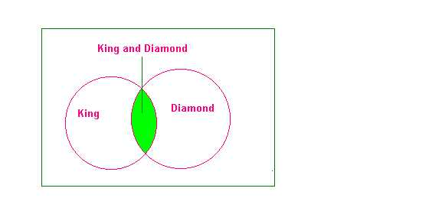
3) Multiplication Rule –Independent Events

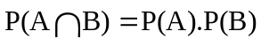
This rule says when the two events A and B are independent, the probability of the simultaneous occurrence of A and B (also known as probability of intersection of A and B) equals the product of the probability of A and the probability of B. Of course this rule can be extended to more than two events.

Example:
The probability that you will get an A grade in Quantitative Methods is 0.7. The probability that you will get an A grade in Marketing is 0.5. Assuming these two courses are independent, compute the probability that you will get an A grade in both these subjects.

Solution:
Let A = getting A grade in Quantitative Methods
Let B =getting A grade in Marketing
It is given that A and B are independent.
Applying the formula , we get
= 0.7.0.5 =0.35. This is the answer to the problem
4) Multiplication Rule- Events are not independent

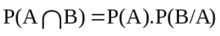
This rule says that the probability of the intersection of the events A and B equals the product of the probability of A and the probability of B given that A has happened or known to you. This is symbolized in the second term of the above expression as P (B/A).
P(B/A) is called the conditional probability of B given the fact that A has happened.
We can also write 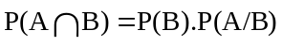if B has already happened.

From the formula, you can have a separate expression for calculating the conditional probability of A given B as follows:

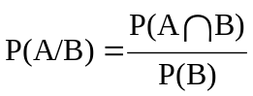
Likewise, conditional probability of B given A is given by
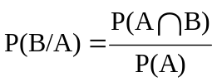

Example for Multiplication Rule-Events are not Independent

From a pack of cards, 2 cards are drawn in succession one after the other. After every draw, the selected card is not replaced. What is the probability that in both the draws you will get Spades?

Solution:
Let A = getting Spade in the first draw
Let B = getting spade in the second draw.
The cards are not replaced.

This situation requires the use of conditional probability.

P(A) = 13/52 (There are 13 Spades and 52 cards in a pack)
P(B/A)=12/51(There are 12 Spades and 51 cards because the first card selected is not replaced after the first draw)

Applying the formula
we have = (13/52).(12/51)=156/2652= 1/17.This is the answer to the problem.

Inline Question 4: There is a 30% chance that you catch the 9:00 A.M. bus. If you could catch the bus, you will be on time. Suppose you miss the bus, there is a 60% chance that you will be late. What is the probability that you will be late? Is it?

- 70%
- 60%
- 42%

Answer: The correct choice is c). Let us see how this is the right choice. This problem involves application of conditional probability because late and missing the bus are not independent.
Let A = Miss the bus P(A) = 1- probability of catching the bus = 1-0.30=0.70
Let B = Late P(B/A) =0.60 (60% chance of being late/miss the bus)

Probability that you will be late = 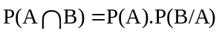=0.70.0.60=0.42 =42%

Choice a) is wrong because it only shows that there is 70% that you will miss the bus. Choice b) is wrong because it only shows that there is a 60% chance of being late given the fact that you miss the bus. Hence c) alone is the correct answer.

5) Marginal, Joint and Conditional Probability using a Contingency Table

Contingency table consists of rows and columns of two attributes at different levels with frequencies or numbers in each of the cells. It is a matrix of frequencies assigned to rows and columns.

The term marginal is used to indicate that the probabilities are calculated using a contingency table (also called joint probability table). Marginal probability means the probability of a simple event like P (A) or P(B).

Joint probability is the simultaneous occurrence of events. Probability that both A and B occur () is an example of joint probability.

Conditional probability like P(A/B) and P(B/A) have already been covered..

Example: A survey involving 200 families was conducted. Information regarding family income and whether the family buys a car are given in the following table.

Family | Income below Rs 4 lakhs/year | Income of Rs. 4 lakhs and above | Total
Buyer of Car | 38 | 42 | 80
Non-Buyer | 82 | 38 | 120
Total | 120 | 80 | 200

- What is the probability that a randomly selected family is a buyer of the car?
- What is the probability that a randomly selected family is both a buyer of car and belonging to income of Rs. 4 lakhs and above?
- A family selected at random is found to be belonging to income of Rs 4 lakhs and above. What is the probability that this family is buyer of car?

Solution to the Problem

Family | Income below Rs 4 lakhs/year | Income Rs. 4 lakhs and above | Total
Buyer of Car | 38 | 42 | 80
Non-Buyer of Car | 82 | 38 | 120
Total | 120 | 80 | 200

- What is the probability that a randomly selected family is a buyer of the Car?

Look at the contingency table above. There are 80 families in total are buyers of a car. There are 200 families in the survey. Hence the probability that a randomly chosen family is a buyer of the car =80/200 =0.40. Note this is a case of marginal probability of a family buying a car.

- What is the probability that a randomly selected family is both a buyer of car and belonging to income of Rs. 4 lakhs and above?

Again look at the table above. Both a buyer of car and an income of Rs 4 lakhs and above = 42 families. Total families in the survey =200. Hence the probability that a randomly selected family is both a buyer of car and belonging to income of Rs. 4 lakhs and above =42/200 =0.21. Note this is a case of joint probability (buyer and Rs. 4 lakhs and above)

- A family selected at random is found to be belonging to income of Rs 4 lakhs and above. What is the probability that this family is buyer of car?

A family is selected and found to be having an income of Rs 4 lakhs and above. In this category there are totally 80 families out of which 42 are buyers. Hence the probability =42/80 =0.525. Note this is a case of conditional probability of buyer given income is Rs. 4 lakhs and above.

4.6 Use of Probability Tree

Probability concepts are more effectively understood using a probability tree as the basis. The branches of the trees represent the probabilities of associated events. The tree can solve intriguing problems including Bayes’ Theorem of posterior analysis. Posterior analysis is a process by which the probabilities are revised based on new or additional information. Bayes’ Theorem is essentially a case of conditional probability. Let us look at an example to comprehend the power of the probability tree including Bayes’ Method.

There are three Machines designated as A, B, and C producing the same item. The output of A, B, and C are 40%, 35% , and 25% respectively. A produces 5 % defectives, B produces 10% defectives and C produces 12% defectives. Draw the probability tree and then answer the following;

- If an item is selected from the total output at random, what is the probability that it is defective?

- If an item is selected from the total output at random, what is the probability that it is non-defective (good piece)?

- An item is selected and found to be defective. What is the chance that it is produced from A? Produced from B? Produced from C?

Solution to the Problem: Let D = Defective. Let G= Non-Defective (Good)

The following tree is drawn. In the last part towards the end of the tree, each branch indicates the joint probability. For example, 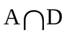means Machine A and Defective and the probability of this happening = 0.02(0.4 multiplied by 0.05 =0.02). Likewise, all probabilities are computed for all branches.
Joint Probability
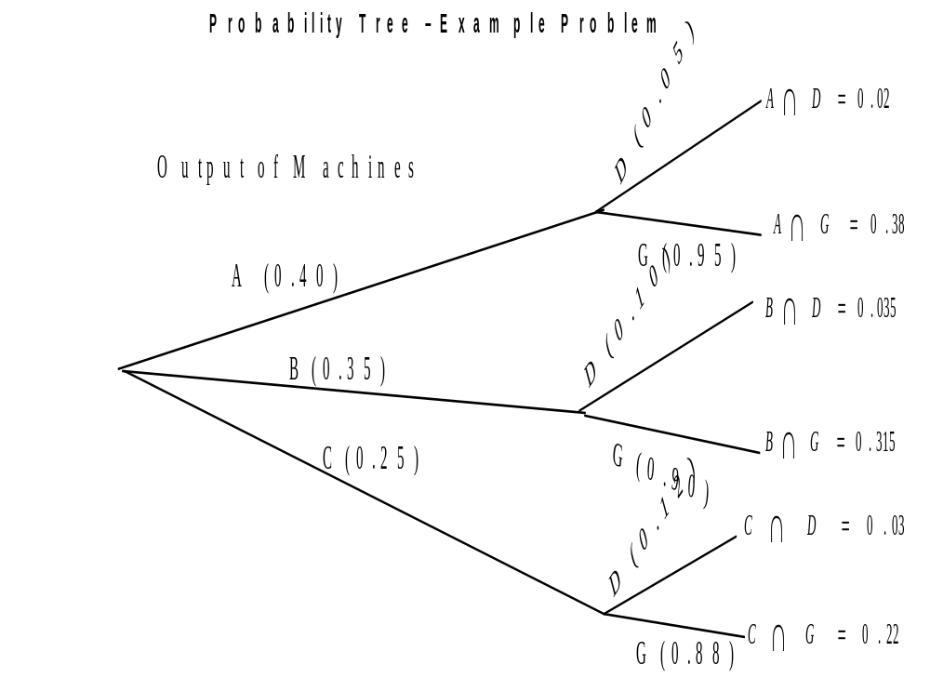

Solution Details Joint Probability
- If an item is selected from the total output at random, what is the probability that it is defective?

Look at the tree. Defective occurs in three places. A and Defective, B and Defective, C and Defective. Adding these three joint probabilities, namely 0.02+0.035+0.03 you get the answer. The answer is 0.085 or 8.5%. That is P(D) =0.085(Marginal Probability of D)

- If an item is selected from the total output at random, what is the probability that it is non-defective (good piece)?

Again look at the tree. There are three branches in which you find good pieces. A and Good, B and Good, C and Good. Adding these three joint probabilities, you get the answer. That is adding 0.38+0.315+0.22=0.915 or 91.5%. This is the answer.(Note: P(G) = 0.915 is the marginal probability of G)

- An item is selected and found to be defective. What is the chance that it is produced from A? Produced from B? Produced from C?

This part involves the application of Bayes’ Theorem of computing conditional probability. From the tree, computing these probabilities is very simple.
Let us first take Machine A. You want P(A/D) =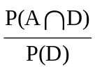 = 0.02/0.085 =0.23529. Likewise for Machine B, P(B/D) =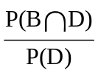=0.035/0.085 =0.41177
For Machine C, P(C/D) = 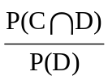= 0.03/0.085=0.35294
Assignment:

There are 6 batteries in an equipment. Two of them are defectives but you do not know which of the two are defectives. The only way to know is to remove the batteries and test them one by one using a testing device. Assume that after each battery is tested, it is not replaced. Draw the probability tree and then answer the following:

- What is the probability that one battery is defective?
- What is the probability that at least one battery is defective?
- Suppose the first battery selected is defective. What is the probability that the second battery is defective?

Discussion:

A company is currently interested in launching a new product. This product if introduced is first of its kind in the marketplace. The problem facing the company is a reasonable assessment of the demand potential for this item. This is really a challenging problem to the company in view of the fact that no past data are available. The company is interested in estimating the probability associated with various demand levels. Discuss how would you proceed with this task. Make sure you highlight the strengths and limitations of the methods you propose.

4.7 Module Summary

This module provided a conceptual framework on probability concepts with examples. Specifically this module focused on:

- The meaning and definition of the term Probability interwoven with other associated terms-Event, Experiment, and Sample Space.

- The three types of Probability – Classical Probability (A Priori Probability), Relative Frequency Probability, and Subjective Probability

- The concept of Mutually Exclusive Events and Independent Events

- The Rules for Calculating Probability which include Addition Rule for Mutually Exclusive Events and Non-Mutually Exclusive Events, Multiplication Rule for Independent Events and Non-Independent (Dependent) Events, and Conditional Probability

- Contingency Table to explain and calculate Marginal Probability, Joint Probability, and Conditional Probability

- The use of Probability Tree to solve intriguing problems including the application of Bayes’ Theorem in a pragmatic manner

Glossary:

A Priori Probability: This is a probability that you can compute in advance without actually having to perform any experiment.

Bayes’ Theorem: Bayes’ Theorem is essentially a case of conditional probability when the events are dependent.

Classical Probability: The number of cases that are favorable to the occurrence of an event divided by the total number of cases in an experiment.

Conditional Probability: It is the probability of an event occurring given the fact that another event has taken place.

Contingency Table: Contingency table consists of rows and columns of two attributes at different levels with frequencies or numbers in each of the cells. It is a matrix of frequencies assigned to rows and columns.

Equally Likely: Equally likely means every event in an experiment has the same chance of being selected

Experiment: An experiment is a process that is performed to understand and observe possible outcomes.

Independent Events: Two events are said to be independent if the occurrence of one event is in no way influenced by the occurrence of another event.

Joint Probability: Joint probability is the simultaneous occurrence of events. Probability of two events taking place in succession is an example of joint probability.

Marginal Probability: Marginal probability is the probability of a simple event. That is, it represents the probability of a single event.

Mutually Exclusive Events: The occurrence of one event precludes the occurrence of another event.

Posterior Probability: Posterior probability is the probability that is revised based on new or additional information.

Probability: Probability refers to chance or likelihood of a particular event-taking place.

Probability Tree: A visual display of events shown as a tree. The branches of the tree represent the probabilities of associated events.

Relative Frequency Probability: Relative frequency when expressed either in proportion or in percentages to the total frequency, it becomes relative frequency probability.

Random Variable: A variable that takes many values with corresponding probabilities.

Sample Space: Set of all outcomes of an experiment is called the sample space.

Subjective Probability: Subjective probability is based on some past experience, personal opinion, and an analysis of the business situation as perceived by a person. who is assessing the probability.

Venn Diagram: A visual display in which the sample space is represented by a rectangle and the events in the sample space represented by circles. Its purpose is to facilitate understanding of probability in intriguing problems.

