Module 5: Decision Analysis –A Conceptual Framework

Dr. P.K.Viswanathan, Professor, Great Lakes Institute of Management

Introduction:

Managers must be capable of making decisions under conditions of uncertainty. They must also be capable of using information, which may be inadequate for decision-making. The question that must be asked before making the final decision is, "is it worth gathering additional information?" This module provides a framework for decision making with minimum risk under uncertain environment.

5.1. How to Structure a Decision Problem?

You have to establish a criterion or a set of criteria for evaluating the alternatives. You have to then evaluate alternatives using criterion/criteria defined. The best decision corresponds to the best alternative chosen. In this module on decision analysis, the alternatives are evaluated using monetary value as the criterion. Monetary value for each alternative depends on the “states of nature”(uncertain events). The consequence that result from each alternative and for each state of nature in monetary value is called a payoff matrix. The following visual succinctly portrays how to structure a decision problem.

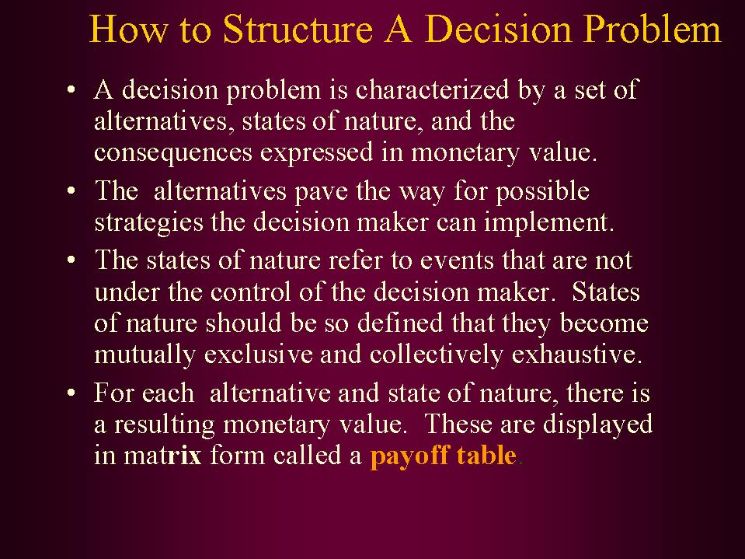
We will discuss the structure of decision problem with an example. The example picked up for discussion is a very simple one. Problems in real life situations could be very complex. However, for the purpose of clarity in thinking and understanding, this example will be very useful and it will lay the foundation for solving more challenging problems.

Example:

A small fruit merchant has got a problem on hand. He has to decide how many dozens of a particular type of fruit to stock on a given day. Total demand per day is uncertain. He has analyzed the past data and found the following pattern of demand distribution based on 360 days.

Total demand per day  (In dozens) | Number of days each demand level was recorded | Probability of demand (based on relative frequency)
25 | 72 | 0.20
30 | 90 | 0.25
35 | 108 | 0.30
40 | 90 | 0.25

Fruits not sold on any day perish and have to be thrown out. Selling price of the fruit per dozen is $ 30. Cost of procurement and other incidentals add to $ 20 per dozen. How many dozens per day should the merchant stock?

Solution:

In this decision problem, states of nature refer to uncertain demand patterns that could take values 25, 30, 35, or 40 with associated probabilities 0.20, 0.25,0. 30, or 0.25. Please note that the states of nature are mutually exclusive and collectively exhaustive. The total probability adds to one.

The alternatives are whether to stock 25, 30, 35, or 40. For each alternative, demand could be 25, or 30, or 35, or 40. Can you work out the pay off matrix? Try your best. Otherwise see the workings below.

Pay off Matrix for the Example:
(Figures in $)
Demand  (States of Nature) | If you decide to stock  (Decision alternatives)
Demand  (States of Nature) | 25 | 30 | 35 | 40
25(0.20) | 250 | 150 | 50 | -50
30(0.25) | 250 | 300 | 200 | 100
35(0.30) | 250 | 300 | 350 | 250
40(0.25) | 250 | 300 | 350 | 400

Let us explain how the pay off matrix is worked out. Profit per dozen = Selling price-Cost = 30-10 =$20. Fruits not sold on the same day will have loss of $20 per dozen. If you stock 25 and the demand is also 25, the profit will be (25)(10) =$250. If the demand is more than 25, even then the profit will be $250 because you have stocked only 25. Of course, you have lost the opportunity of making a profit of more than $250. You are wiser after the event. So you see under column 25 dozens, the pay offs are 250 all through. Let us come to the next column that has a decision of stocking 30 dozens. If you stock 30 and the demand is 25, you can sell only 25. The profit in this transaction is $ 250. There is excess stock of 5 dozens for which you will incur a loss of (5)(20) = $ 100. This will have to be subtracted from 250 resulting in net profit of $ 150. For the remaining elements in this column, you will have a profit of $ 300 all through because either demand equals 30 or exceeds 30. Extending this logic, you can fill up the other elements in the pay off matrix.

From the pay off matrix, can you say what is the optimal decision? That is, how many dozens should you stock? This can be answered by using the criterion called Expected Monetary Value (EMV). This is explained as under.

5.2 Expected Monetary Value (EMV)

The following visual explains the importance and method of computing EMV.

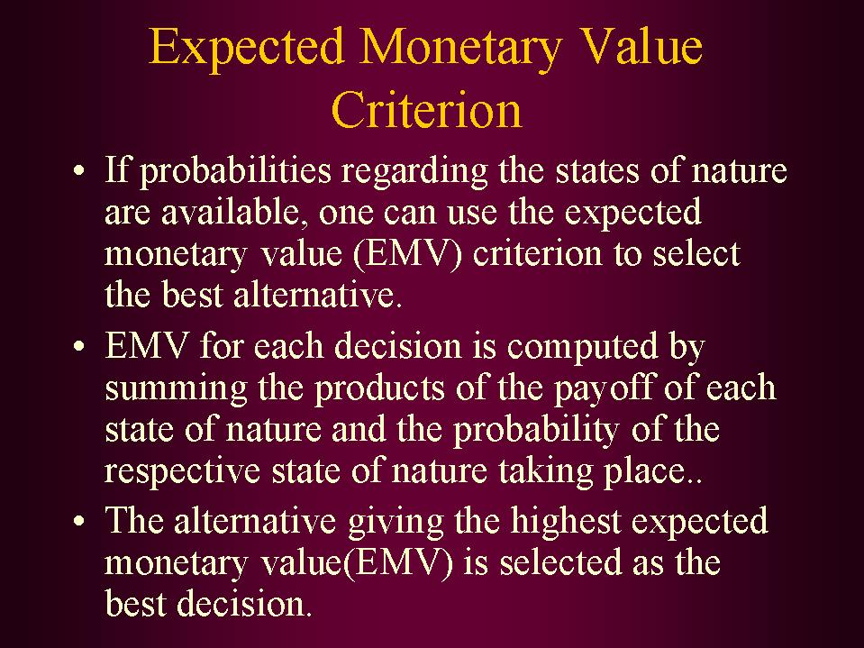

Activity 1: Work out EMV for each decision alternative.

Solution – EMV for the illustration

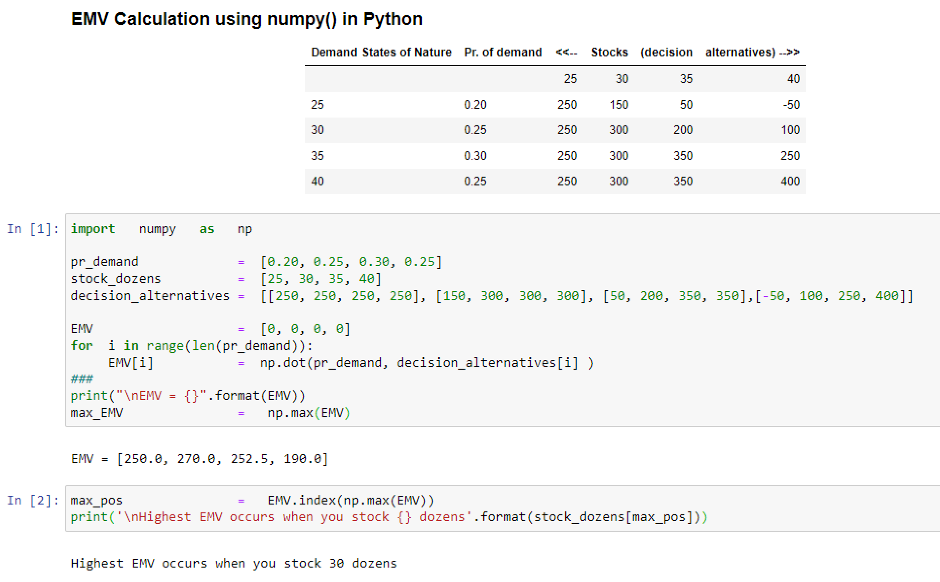

Let us show the calculation of EMV for one decision alternative. Take the case of stocking 30 dozens. The above table displays the pay offs under the option of 30 dozens. Multiply these pay offs by probabilities of states of nature (probabilities of demand occurring) and then add them to get EMV. EMV corresponding to a stock of 30 dozens = (150)(0.20)+(300)(0.25)+(300)(0.30)+300(0.25) =30+75+90+75 = $270. Like wise all EMVs are computed above by using Python code.

As you can see the highest EMV occurs when you stock 30 dozens. Hence the fruit merchant should stock 30 dozens and EMV = $270. Call this EMV as EMV optimum. Please note that EMV is a weighed average of monetary consequences using probability of each state of nature as weight.

In input area 1, we have imported the required package, numpy with alias as np for easy reference.

The list, pr_demand is created to hold the values of Probability of demand.
The list, stock_dozens is created to hold the values of demand -- stock in dozens.
The list, decision_alternatives, is created to hold the values of decision alternatives.

EMV, a list is initialized with value 0.

For each demand, probability of demand is multiplied with payoffs (decision alternatives) by using the dot() function available in numpy package. This dot() function performs the dot product of two arrays,

In input area 2, we extract the index position of the maximum EMV value in the list, EMV. The index() function of a list returns of the specified element in the list.

The max() function of the numpy package returns the macimum element of an array.

Expected Value of Perfect Information (EVPI)

Very often in a decision problem, manager of an enterprise has to answer the question “whether to take action now, or gather additional information and act later. Is the cost of additional information justified in terms of the additional profit you may get? This issue can be resolved using EVPI. EVPI is calculated as the difference between two factors-EPPI and EMV optimum.

Symbolically EVPI = EPPI-EMV optimum. We know already what is EMV optimum. To repeat again, EMV optimum is the highest EMV that you get among many decision alternatives. EPPI stands for expected profit with perfect information. To appreciate and calculate EPPI, let us go back to our example of fruit merchant problem. The pay off matrix is again displayed for clarity.

Pay off Matrix(Figures in $)
Demand  (States of Nature) | If you decide to stock  (Decision alternatives)
Demand  (States of Nature) | 25 | 30 | 35 | 40
25(0.20) | 250 | 150 | 50 | -50
30(0.25) | 250 | 300 | 200 | 100
35(0.30) | 250 | 300 | 350 | 250
40(0.25) | 250 | 300 | 350 | 400

If you know demand is 25, then the best decision is to stock 25 because this gives the highest pay off of $ 250(maximum of 250, 150, 50, -50). Like wise, if demand is 30
The best deision is to stock 30. Proceeding in this manner, we can complete the pay off matrix for best decision when demand is known in advance. The following table emerges.

Pay off Matrix (Figures in $) with perfect information
Demand  (States of Nature) | (Best Decision alternatives)  Stock
Demand  (States of Nature) | 25 | 30 | 35 | 40
25(0.20) | 250
30(0.25) |  | 300
35(0.30) |  |  | 350
40(0.25) |  |  |  | 400

Now use probabilities of state of nature as weights and compute the expected value as before. You get EPPI.

EPPI =(250)(0.20)+(300)(0.25)+(350)(0.30)+(400)(0.25) =330.
Hence EVPI = EPPI-EMV optimum = 330-270 = $60. EVPI acts as an upper bound measuring worth of gathering additional information.

In input area 3, the list, demand_states is created to hold the values of demand (States of Nature). The list, Payoff is created to hold the values of payoff values for each of the demand. The list Payoff_Matrix_Diag is created by taking the maximum of payoff corresponding to each demand.

In input area 4, we convert the payoff values into strings and in input area 5, we print the payoff matrix.

In input area 5, we create the list, state_Nature_demand hold the values of demand (States of Nature). We compute the list, EPPI by multiplying payoff value with the corresponding probability of state of nature by using the dot() function available in numpy. We compute EVPI by subtracting the max_EMV (maximum of EMV) from EPPI.

We print both EPPI and EVPI. We observe that EPPI = 330 and EVPI = $60 which tally with our manual calculation.

Opportunity Loss Table:

If the pay off matrix is expressed in terms of opportunity loss for every consequence, it is called a loss table. Opportunity loss is based on the concept of opportunity cost that measures the cost of sacrificing one alternative against another. For illustration sake, let us take the decision alternative of 30 dozens to stock. If the demand is 25 dozens, there is excess stock of 5 dozens for which you incur a loss of (5)(20) =$100. If the demand is 30 dozens, you can sell all 30 dozens and the opportunity loss is $0. If the demand is 35 dozens, then you have lost an opportunity of making an additional profit of (5)(10) =$50 had you stocked 35 dozens. If the demand is 40 dozens, you have lost an opportunity of making an additional profit of (10)(10) =$100 had you stocked 40 dozens. Using this logic the following opportunity loss table is constructed. The optimal decision is one that corresponds to the minimum expected opportunity loss(EOL). This will of course tally with the optimum decision based on the one that corresponds to maximum EMV.

Opportunity Loss Table ($)

Demand  (States of Nature) | If you decide to stock  (Decision alternatives)
Demand  (States of Nature) | 25 | 30 | 35 | 40
25(0.20) | 0 | 100 | 200 | 300
30(0.25) | 50 | 0 | 100 | 200
35(0.30) | 100 | 50 | 0 | 100
40(0.25) | 150 | 100 | 50 | 0
EOL | $80 | $60 | $77.5 | $140

Computing EOL is identical to computing EMV. Opportunity losses in each column in the above table is multiplied by the corresponding probabilities of demand and then added to get EOL. Please note that the optimal decision is to stock 30 dozens because EOL for this decision is $60, which is the least. Thus, minimum EOL decision tallies with maximum EMV decision.

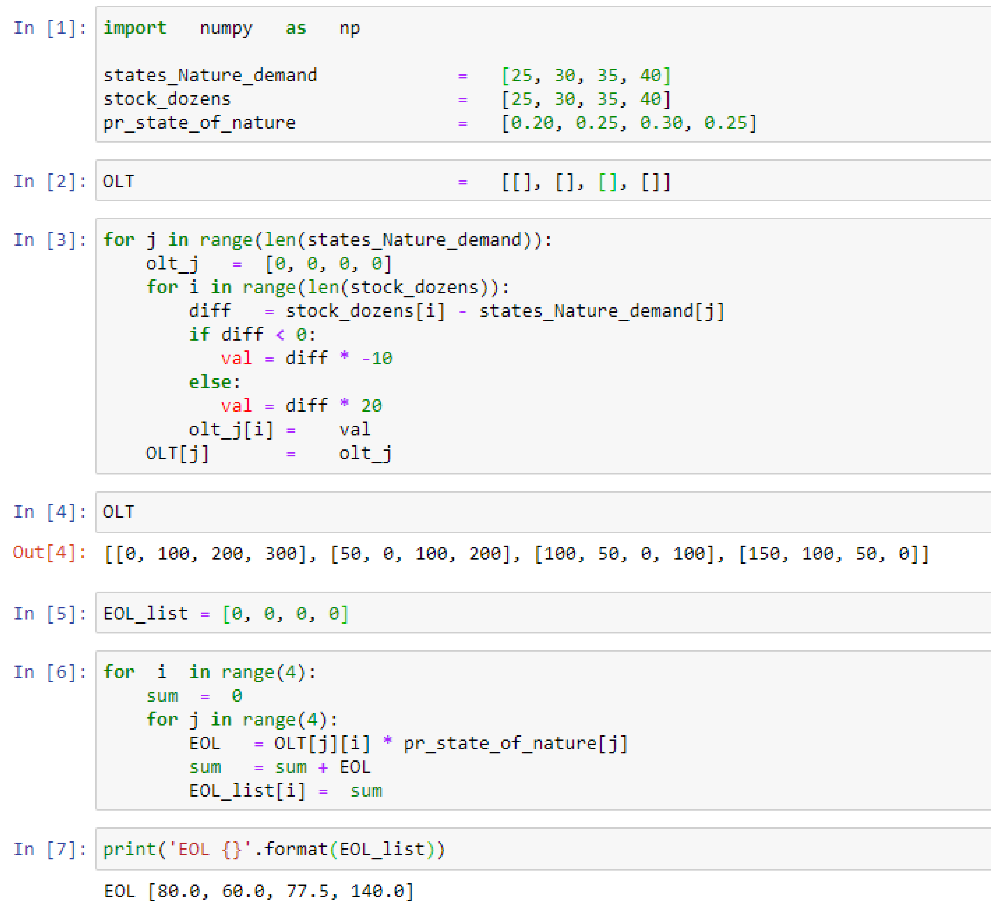
In input area 1, we have imported the required package, numpy with alias as np for easy reference.

The list, state_Nature_demand created to hold the values of demand (States of Nature).
The list, stock_dozens is created to hold the values of demand -- stock in dozens.
The list, pr_state_of_nature is created to hold the values of probability of demand.

In input area 2, OLT, a list is initialized with an empty list.

In input area 3, for each demand, we find diff, the difference between the stock and demand. If the stock is less than demand, i.e. if diff < o, it implies that there is a deficit stock and for which we incur a loss at the rate of $10 per unit; otherwise, there is an excess stock for which we incur a loss at the rate of $20 per unit.

In input area 5, we initialize the list, EOL_list.

In input area 6, we compute EMV by multiplying opportunity losses in each column of the list, OLT by the corresponding probabilities of the demand and then added to get EOL.

In input area 7, the list, EOL_list is printed, and we observe that the minimum EOL value is $60 corresponding to stock position at 30.

Activity 2: For each decision alternative, if you multiply the probabilities of states of nature with the corresponding pay offs, you get

- Expected profit with perfect information(EPPI)
- Expected value of perfected information(EVPI)
- Expected monetary value(EMV)

Solution: Correct choice is 3). This is the very definition of EMV. EMV is a weighted average of monetary value in which probabilities of states of nature are used as weights. They are multiplied with pay off of corresponding states of nature and summed to get EMV.

Activity 3: EVPI = ----------------------

Solution: EVPI = EPPI-EMV optimum.

Activity 4: EMV optimum gives the lowest monetary value. True or False

The statement is false because EMV optimum gives the highest monetary value.

Discussion:

Analyze, criticize, and explain the following statement.

‘Decision-making using EMV criterion is possible only on paper because probabilities of states of nature in real business problems cannot be obtained”.

5.3. Decision Tree

Decision tree is a very useful graphical tool for structuring and solving decision problems. The following visual succinctly portrays a decision tree.

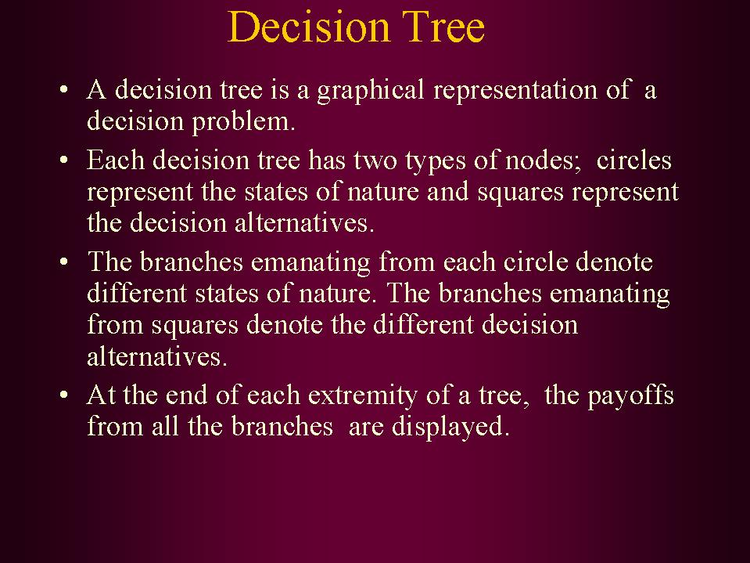

Example: For drawing the decision tree, let us take the same example of fruit merchant. For ready reference, the problem is stated below:

A small fruit merchant has got a problem on hand. He has to decide how many dozens of a particular type of fruit to stock on a given day. Total demand per day is uncertain. He has analyzed the past data and found the following pattern of demand distribution based on 360 days.

Total demand per day  (In dozens) | Number of days each demand level was recorded | Probability of demand (based on relative frequency)
25 | 72 | 0.20
30 | 90 | 0.25
35 | 108 | 0.30
40 | 90 | 0.25

Fruits not sold on any day perish and have to be thrown out. Selling price of the fruit per dozen is $ 30. Cost of procurement and other incidentals add to $ 20 per dozen. Draw the decision tree and answer how many dozens per day should the merchant stock?

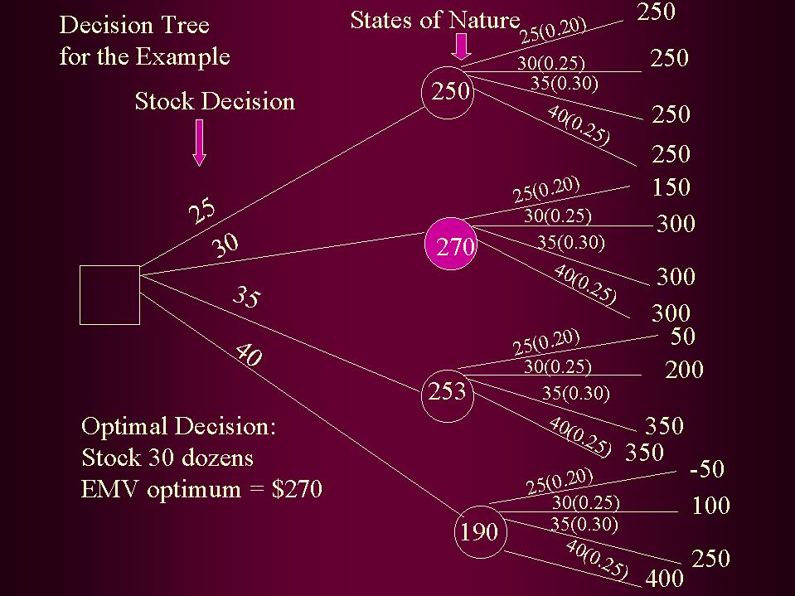

Explanation on the decision tree for the example:

- Branches emanating from the square represent decision alternatives of stocking 25, 30, 35, and 40 dozens.

- For each decision alternative, there are four states of nature (demand pattern) with associated probabilities.

- The branches that emanate from the circle represent the states of nature of the uncertain demand that could be 25, 30, 35, or 40 dozens. The figures with in brackets for each demand represent the probability of demand occurring.

- The pay offs for each decision alternative is given at the extremity of the tree, for every branch of states of nature.

- For every decision option, working backwards, expected monetary value (EMV) is calculated as the sum product of two terms namely state of nature (demand) and probability of state of nature (demand). The optimal decision is obtained by folding back the tree. All EMV values obtained by folding back the tree are displayed in each circle. EMV optimum is one that gives the highest monetary value. This is highlighted in the tree diagram in the beginning decision node. The other decision alternatives are therefore discarded. The principle of folding back is elegant and convenient especially in complex problems including sequential decisions.

- EMV optimum =$270. So stock 30 dozens is the optimal solution to the problem.

Solution using decision tree approach tallies with what you have got earlier. The advantage of decision tree approach is that it is very versatile when you have complicated problems including sequential decisions. You will appreciate the utility of a decision tree in assessing value of sample information.

5.4 Value of Sample Information

Expected value of perfect information (EVPI) discussed earlier in this module just gives an upper bound on the value of gathering additional information in a decision problem. Suppose we propose to conduct a sample survey to obtain additional information. You must ask the question “is it worth doing this?” The answer to this depends on the value of information we gather. This is calculated using expected value of sample information (EVSI). EVSI intuitively and logically must be = Expected profit with sample information (EPSI)- EMV optimum. In order to get EPSI, we have to revise the probabilities of the states of nature. The probabilities that are associated with the states of nature when you begin the exercise are called prior probabilities. For example, probabilities of the demand distribution in the fruit merchant problem are prior probabilities. Once sample information is used to revise these probabilities, they become posterior probabilities. Posterior probabilities are used to rework expected monetary values. The highest monetary value among the revised EMVs will give EPSI. From this if you subtract EMV optimum, you get EVSI. An example will clarify concepts.

Example: Marketing manager of a company producing consumer durable wants to decide whether to launch a new product or not. The sales quantity of the new product has two states of nature namely high sales or low sales. The pay off table is as follows.

Pay Off Table(Figures in $ million)

States of Nature | Probability | Launch | Do not launch
High sales | 0.4 | 5 | 0
Low sales | 0.6 | -4 | 0

Activity 5: Should the product be launched based on EMV criterion?

Answer: The product should not be launched. EMV for launching = (5)(0.4)+(-4)(0.6) = $-0.4ml. Since this is less than $ 0(EMV optimum) that you get if product is not launched, the product should not be launched.

Marketing manager does not want to decide just on the basis of EMV and would like to gather additional information before taking the final decision. A market research agency is willing to do a study that will cost $0.3million. There are two possibilities from the agency. It may predict high sales for the new product or it may predict low sales for the new product. Past record of the agency in terms of predicting ability is tabulated below:

States of Nature | Prior Probability | Agency predicts High Sales given States of Nature | Agency predicts Low Sales given States of Nature
High Sales | 0.4 | 0.6 | 0.4
Low Sales | 0.6 | 0.3 | 0.7

Should the marketing manager take the help of the agency or not?

Solution: In order to solve this problem, we need to work out the revised probabilities of the states of nature from prior probabilities of the states nature. This means we want to obtain posterior probabilities of high sales and low sales given agency prediction. This statisticians call as inverse probability approach based on Bayes theorem. You can easily get this by constructing joint probability table given below:

States of Nature | Agency Predicts High Sales | Agency Predicts Low Sales | Marginal Probability of States of Nature
High Sales | 0.24 | 0.16 | 0.40
Low Sales | 0.18 | 0.42 | 0.60
Marginal Probability of Agency Prediction | 0.42 | 0.58 | 1.00

Please note that the joint probability table is obtained by multiplying the probabilities of agency prediction given states of nature and prior probabilities. For example, take the first cell in the matrix above. It is equal to probability agency predicts high sales given state of nature is high sales multiplied by probability of high sales. This is = (0.6)(0.4) =0.24. Like wise all entries are computed.

Now the calculation of revised probabilities is very simple. Probability of high sales given agency predicts high sales = 0.24/0.42 = 0.57. Probability of low sales given agency predicts high sales =0.18/0.42 =0.43. The following table represents posterior probabilities given agency prediction.

Revised Posterior probability table
 | Given Agency Predicts
Posterior Probability of | High Sales | Low Sales
High Sales | 0.57 | 0.28
Low Sales | 0.43 | 0.72

A completed tree for solving this problem is given in next.

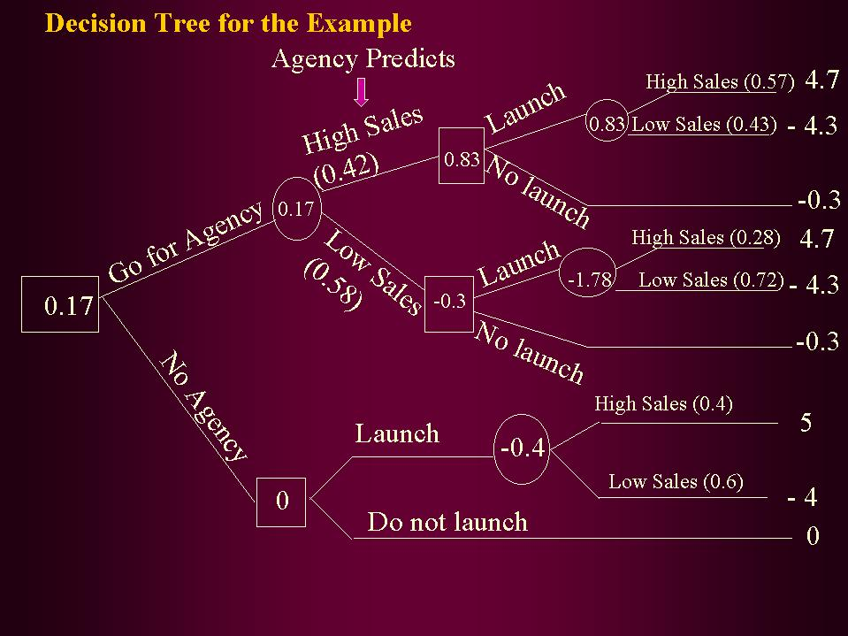

Explanation on the tree above:

- The manager has two options in the first stage of decision namely “go for agency” or “no agency”. This appears in the first square node.

- If you don’t go for agency, then you have two decision options-Launch the new product or do not launch the new product. These two options are shown in the next square node. If you launch, states of nature (demand) may be high sales or low sales with prior probabilities 0.4 and 0.6 respectively. Monetary values corresponding to these two states of nature are given as 5 and –4 at the extreme end of the branch. These are in $million. If you don’t launch, you get $0 million. EMV is calculated in the usual way for these two options. They are –0.4 and 0 respectively. So, EMV optimum =0. This appears in the square node corresponding to no agency.

- If you decide to go for agency, there are two states of nature. Agency predicts high sales with a probability of 0.42 and low sales with a probability of 0.58. These probabilities are from the revised posterior probability table.

- If agency predicts high sales, you have again got two-decision options-launch or no launch. Under each of these options, the states of nature could be high sales or low sales. However, the probabilities of these states of nature are posterior probabilities. These are given in brackets. Please refer again revised posterior probability.

- EMV values are worked out as before by multiplying probabilities of states of nature with corresponding pay offs and then summing them.. EMVs are displayed in circle and square nodes in the diagram.

- Please also note that while working out EMV values, cost of doing the study by agency ($0.3million) is taken out to represent the correct net monetary value. Under the scenario of taking agency help, if you choose not to launch, you still incur cost of $0.3million(-0.3 EMV)

- When you finally fold back the tree, you find going for agency produces a positive EMV of $0.17 million. This is better than getting $0 million of no agency. Hence go for agency.

Obviously EVSI = EPPI-EMV optimum = 0.17-0 =$0.17 million. This is the gain you have got by using sample information.

Looking at the decision tree, you can conclude the following:
- Take the decision of going to the agency.
- If agency predicts high sales, then launch the new product (EMV $0.83 million)
- If agency predicts low sales, then do not launch the new product (EMV $-0.3 million)
- Expected value of sample information (EVSI) is $0.17 million.

Please appreciate the profundity of posterior analysis. If you have gone entirely by EMV criterion without gathering additional information, you would not have introduced the new product and you would have missed an opportunity. The moral of the story is that it is better to gather additional information through sample survey before making the final decision. This is particularly important in crucial decision problems.

5.5. Module Summary

In this module, you have been introduced to a comprehensive framework on decision-making under conditions of uncertainty using decision analysis tools. Specifically, this module focused on:

- How to structure a decision problem in a systematic fashion

- Pay off matrix and its use

- Expected monetary value (EMV) as a major criterion in selecting the best decision

- Expected value of perfect information (EVPI) in assessing value of information

- Construction and use of decision tree in solving simple as well as complex problems

- Revising probabilities through posterior analysis to improve the power of decision making

- Expected value of sample information (EVSI), an important technique that comes handy before taking a final decision particularly in the context of introducing a new product into the market.

Glossary:

Decision Alternatives: It is a list of all possible choices available to the decision maker.

Decision Tree: It is a graphical representation of a decision problem. It has two types of nodes-square and circle. Branches emanating from the square nodes are the decision alternatives. Branches emanating from the circle nodes represent the possible states of nature. The payoffs of all the branches are displayed at the end of each extremity of the tree.

Expected Monetary Value (EMV): It is a weighted average of monetary value in which probabilities of states of nature are used as weights. They are multiplied with pay off of corresponding states of nature and summed to get EMV.

Expected Opportunity Loss (EOL): It is a weighted average of opportunity loss in which probabilities of states of nature are used as weights. They are multiplied with opportunity losses of corresponding states of nature and summed to get EOL.

Expected Value of Perfect Information (EVPI): It is the difference between two factors-Expected profit with perfect information(EPPI) and EMVoptimum (EMV for the best decision alternative). EVPI acts as an upper bound measuring worth of gathering additional information.

Expected Value of Sample Information: It is the difference between Expected profit with sample information (EPSI) and EMV optimum. It measures the gain form sampling.

Opportunity Loss: It is the opportunity cost of sacrificing one alternative against another.

Payoff Matrix: This is also called a payoff table that gives the consequence that result from each alternative for each state of nature in monetary value.

Posterior Probabilities: These are conditional probabilities that are obtained using Bayes theorem to revise prior probabilities in the light of additional information.

Prior probabilities: These are the probabilities of the states of nature that are known to us in the beginning.

States of Nature: These are events that are not under the control of the decision maker.

