Module 10: Chi-Square Test and Analysis of Variance (ANOVA)

Dr. P.K.Viswanathan, Professor, Great Lakes Institute of Management

Introduction:

In the previous module, we have made inferences about difference between two population means based on the corresponding sample means. Suppose we are interested in testing the equality of means involving more than two populations, we have an elegant technique known as ANOVA developed by Ronald Fisher, the father of statistics in the year 1920. The specialty of ANOVA is that it is part of the domain called "Experimental Design" which deals with cause-effect relationship in an effective manner. Cause-effect relationship is also reflected in association of attributes. Association of attributes is effectively answered by the chi-square test. This module covers the basic models of chi-square test and ANOVA.

10.1 Chi-square Analysis-Basics

Chi-square analysis is widely used in research studies for testing hypothesis involving nominal data. Nominal data are also known by two names-categorical data and attribute data. The symbol χ² statistic is used to designate the chi-square distribution whose value depends on the number of degrees of freedom (d.f.). A chi-square distribution is a skewed distribution particularly with smaller d.f. As the sample size and therefore the d.f. increases, the χ² distribution becomes a symmetrical distribution approaching normality. The general shape of the χ² distribution for smaller d.f. is given below:

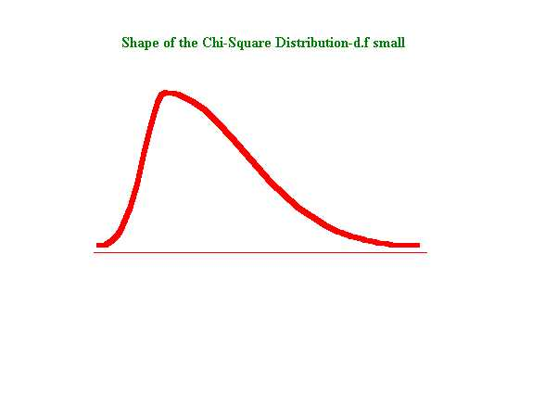
The χ² test is a nonparametric test. Nonparametric means the original distribution from
which the samples are drawn need not be normal. It is a classic nonparametric test
involving data measurement in nominal scale. Please note that all parametric tests make
the assumption that the samples are drawn from a normal population or at least a known probability distribution.. Nonparametric methods are also called ‘distribution free’ methods.

Conditions for using the χ² Test

- The sample observations drawn from a population must be independent and random

- The data must be in frequency (counting) form. If the original data are in percentages, they must be converted into frequency.

- No frequency in any cell/category must be less than 5. If the frequency is less than 5 for a category, you have to do some regrouping

When the degrees of freedom is greater than or equal to 30, the χ² distribution approaches the normal distribution.

10.2 Chi-Square Test-Goodness of Fit

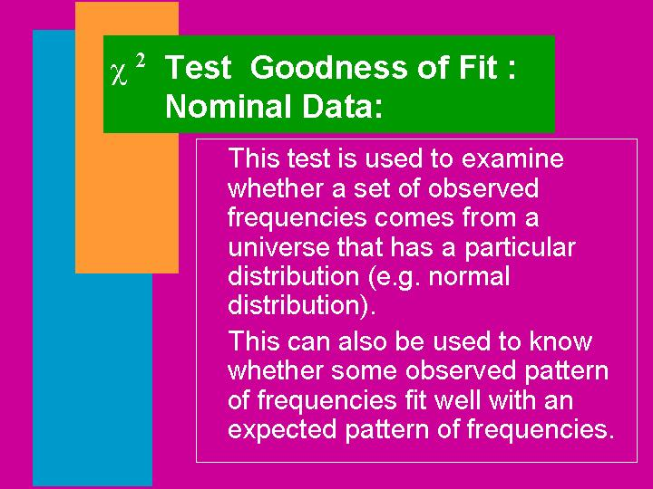

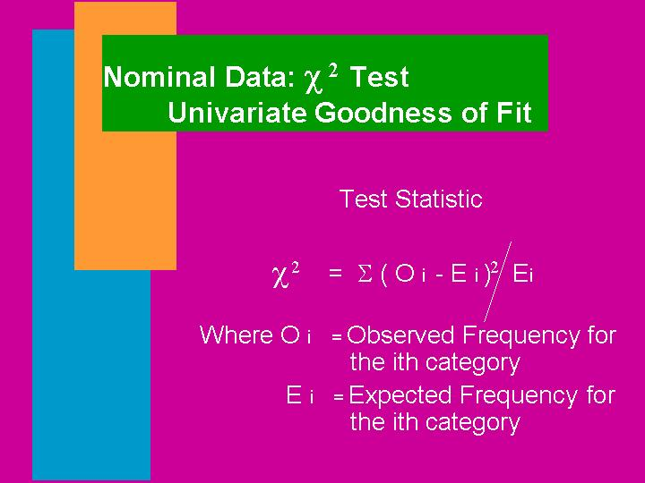

Hypothesis testing procedure is exactly the same as what you have seen in module 9. For a level of significance, the critical χ² will be always the upper χ² value from the standard table. Of course, our table and bible is Microsoft Excel. Please note that χ² value is always positive. You will understand the use of χ² test-goodness of fit by going through the example discussed next.

Example: In consumer marketing, a common problem the marketing manager encounters is the selection of the appropriate package design. Assume that a marketer wishes to compare five different package designs. He is interested in knowing which is the most preferred one so that the same can be introduced in the market. A random sample of 200 consumers gives the following picture:

Package Design | Preference by consumers
A | 36
B | 52
C | 40
D | 35
E | 37
Total | 200

Are the consumer preferences for the designs show any significant differences?

Solution: If you look at the table, you may be tempted to feel that B is the most preferred design. Statistically, you have to find out whether this preference could have arisen due to chance. The appropriate test statistic is the χ² test of goodness of fit.

Null Hypothesis: All package designs are equally preferred

Alternative Hypothesis: No, they are not equally preferred

Package Design | Observed(O) | Expected(E) | 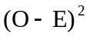 | 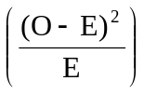
A | 36 | 40 | 16 | 0.400
B | 52 | 40 | 144 | 3.600
C | 40 | 40 | 0 | 0.000
D | 35 | 40 | 25 | 0.625
E | 37 | 40 | 9 | 0.225
Total | 200 | 200 |  | 4.850

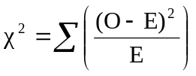= 4.850
The critical value of 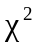 at 5% level of significance from Excel is obtained as follows:

Click paste function, click Statistical, and then click CHIINV
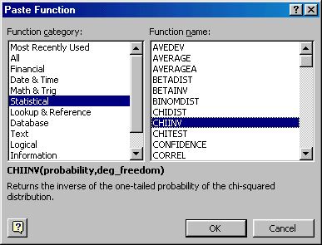

Click ok. Then enter the values in the probability cell and d.f, you get
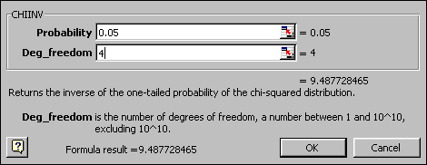

The critical for 4 d.f at 5% level of significance is 9.49(see above). Since the calculated value of is less than critical at 5% level, accept the null hypothesis of equal preference. The conclusion is that all packages are equally preferred and difference in preference in the sample survey may have arisen due to chance.

Inline Question: Chi-Square Test of goodness of fit is the appropriate test to use when the data measurements are ordinal. True or False

Answer: the statement is false. This is because Chi-Square test is possible only when the data measurements are nominal (categorical).

10.3 Chi-Square Test of Independence

The goodness-of-fit test explained above is suitable for situations involving one categorical variable (e.g. package design). If there are two categorical variables, and our interest is to find out whether these two variables are associated with each other, the test of independence is the appropriate technique to use. This test is very popular for analyzing cross-tabulations in which an investigator is keen to find out whether the two categorical variables are having any relationship with each other.

The cross-tabulation is called a contingency table containing frequency data corresponding to the categorical variable in the row and the column. The marginal totals of the rows and columns are used to calculate the expected frequencies that will be part of the computation of the statistic. Have you heard this term “contingency table” earlier? You must say ‘yes’! Please review module 4 on probability where the contingency table is used in the context of computing joint and marginal probability.

A marketing manager may be curious to find out whether consumers in different income strata prefer different brands. Is there any association between the brand preferred and the income strata? The null hypothesis is that there is no association between brand and income; they are independent. test of independence in a contingency table is used here. The procedure for the hypothesis testing is same as the one variable case except the calculation of expected frequencies and the degrees of freedom.

Example:

In a market survey conducted to examine whether the choice of a brand is related to the income strata of the consumers, a random sample of 600 consumers reveal the following:

Observed frequencies (O_{i})
Income Strata  (Income Per month) | Brand1 | Brand2 | Brand3 | Total
Less thanRs.10000 | 132 | 128 | 50 | 310
Rs10000-15000 | 62 | 60 | 28 | 150
Rs15000-20000 | 30 | 30 | 26 | 86
Above Rs 20000 | 16 | 22 | 16 | 54
Total | 240 | 240 | 120 | 600

The manger who conducted this survey wants to know whether the brand preference is associated with the income strata. If so, he has to evolve a creative advertising strategy.

Solution:

The null hypothesis is that there is no association between the brand preference and the income level (These two are independent). The alternative hypothesis is that the brand and income level are associated (dependent).

Let us take a level of significance of 5%.

In order to calculate the value, you need to work out the expected frequency in each cell in the contingency table. In our example, there are 4 rows and 3 columns amounting to 12 elements. There will be 12 expected frequencies.

Observed frequencies (O_{i})
Income Strata  (Income Per month) | Brand1 | Brand2 | Brand3 | Total
Less thanRs.10000 | 132 | 128 | 50 | 310
Rs10000-15000 | 62 | 60 | 28 | 150
Rs15000-20000 | 30 | 30 | 26 | 86
Above Rs 20000 | 16 | 22 | 16 | 54
Total | 240 | 240 | 120 | 600

The expected frequency corresponding to row1 and column 1 is computed as follows:
Marginal total of row1 multiplied by marginal total of column1 divided by grand total =(310)(240)/600 =124. The expected frequency corresponding to a particular row and column =marginal total of that row multiplied by marginal total of that column divided by the grand total. For example, the expected frequency for row 4 and column 3 = (54)(120)/600 =10.8. In this manner all the expected frequencies are computed.

Observed Frequency (O) Expected Frequency (E)
Income Strata | Brand1 | Brand2 | Brand3
Less than 10000 | 132 | 128 | 50
10000 to 15000 | 62 | 60 | 28
15000 to 20000 | 30 | 30 | 26
Above 20000 | 16 | 22 | 16

Income Strata | Brand1 | Brand2 | Brand3
Less than 10000 | 124 | 124 | 62
10000 to 15000 | 60 | 60 | 30
15000 to 20000 | 34.4 | 34.4 | 17.2
Above 20000 | 21.6 | 21.6 | 10.8
Note: The fractional expected frequencies are retained for accuracy purpose. Do not round them.

Compute . There are 12 observed frequencies (O) and 12 expected frequencies (E). As in the case of the goodness of fit, calculate this value. In our case, the computed =12.76.

The critical value of depends on the degrees of freedom. The degrees of freedom = (the number of rows-1) multiplied by (the number of colums-1). In our case, there are
4 rows and 3 columns. So the degrees of freedom =(4-1). (3-1) =6.

Using Excel, you can get the upper value at 5% level for 6 d.f. This value=12.59. See paste function below:

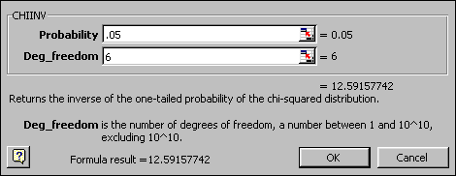

Since the calculated value of is greater than the critical value of , reject the null hypothesis and accept the alternative hypothesis. The conclusion is that the brand preference and income level are associated. A creative advertising strategy will have to be worked out to take care of this relationship.

Inline Question: Which of the following are true about the test.

- The sample observations drawn must be independent and random
- The samples drawn must be from a normal population
- The data measurements must be categorical
- The data must be expressed in percentage form

Answer: a) and c) are true because they are part of the conditions for applying the test. b) is wrong because is a nonparametric test and as such does not require the assumption of the samples drawn from a normal distribution. d) is wrong because the data must be expressed in frequency form.

Inline Question: For the following diagram on distribution with 10 d.f, what is the upper critical value? Is it?
a) 8.31
b) 19.30
c) 18.31

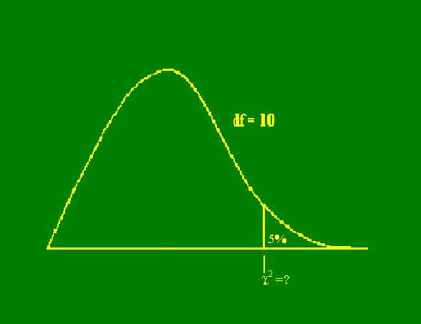

Solution: the right choice is c). Using the Microsoft Excel paste function critical value of for 10 d.f at 5% =18.31.
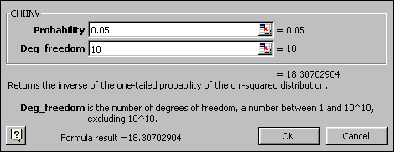

10.4 ANOVA-Basics

- Very often an investigator would like to compare more than two population means in a problem situation. For example, a human resource manager may be interested in the aptitude test scores from a standard test for executives having four types of background. Such comparisons could be accomplished using the t distribution by looking at samples two at a time and then comparing the means. Although this method is feasible, it is an inefficient method of doing the comparison for more than two population means.

- The first reason for its inefficiency is that the standard deviation for the differences between the two sample means is not computed based on observations from all the samples but instead utilizes samples only from the two populations that are under immediate consideration. The second reason is that intuitively we will almost always find a significant difference that exists between at least one pair of means when there are enough identical populations. This implies that we cannot trust our level of significance. That is, there is every possibility that the type I error will get inflated in the process.

- We need a technique that will enable us to test the hypothesis of equality of more than two population means that will overcome the deficiencies of the t test. It is in this context that the role of analysis variance popularly called ANOVA looms large. Ronald Fisher considered the father of statistics was the architect of a fascinating discipline called the “experimental design”. Fisher’s objective was to establish the cause and effect relationship between variables. By performing experiments in his agricultural field, Fisher could test the hypothesis involving more than two population means and the fundamental technique that he used was the analysis of variance. Thus analysis of variance is part of this great domain of experimental design.

- The beauty of ANOVA is that it performs the test of equality of more than two population means by actually analyzing the variance. In simple terms, ANOVA decomposes the total variation into components of variation. That is, explaining the changes in the response variable caused by these components. To put it succinctly, the total sum of squares is equal to the sum of squares due to causes. In the next screen, we will explain how ANOVA works in practice by first focusing on the one-way classification.

10.5 ANOVA-One-Way Classification

The best way to understand the one-way classification is through an illustration. A consumer marketing group desired to examine whether supermarket chains operating in a city differed in their “out of stock” levels for advertised specials. The group identified the relevant response variable as the percentage of the items advertised not in stock. The following table provides the data collected from three supermarket chains in the city.

Percentage of the items “Out of Stock” on Advertised Specials
Chain1 | Chain2 | Chain3
15 | 10 | 17
14 | 14 | 12
20 | 9 | 14
15 | 10 | 15
16 | 11 | 12

The marketing group would like to know whether there are significant differences among the three chains with regard to mean percentage out of stock on advertised specials. How would you analyze this situation?

Solution: Step1- Enter the data in the Microsoft Excel, then click Tools, click Data Analysis, and click Anova: Single Factor. You will get the following:
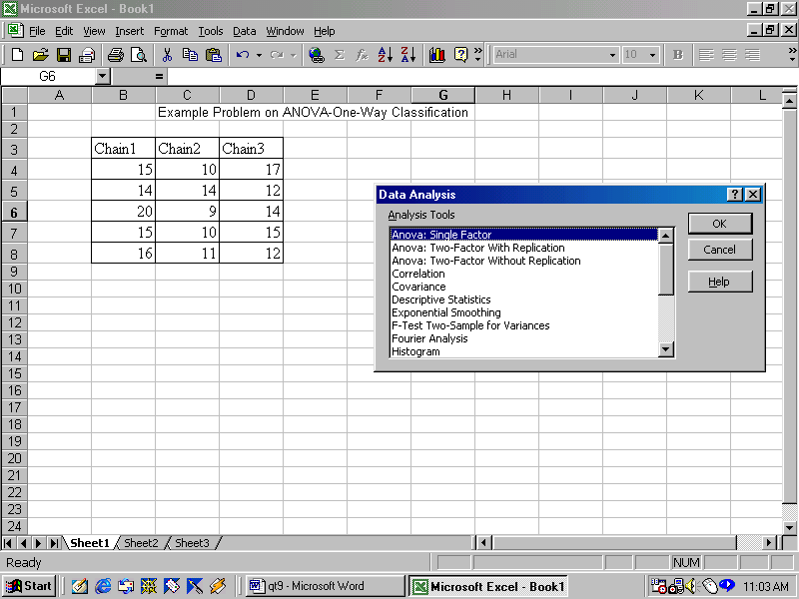
Click ok and you will get

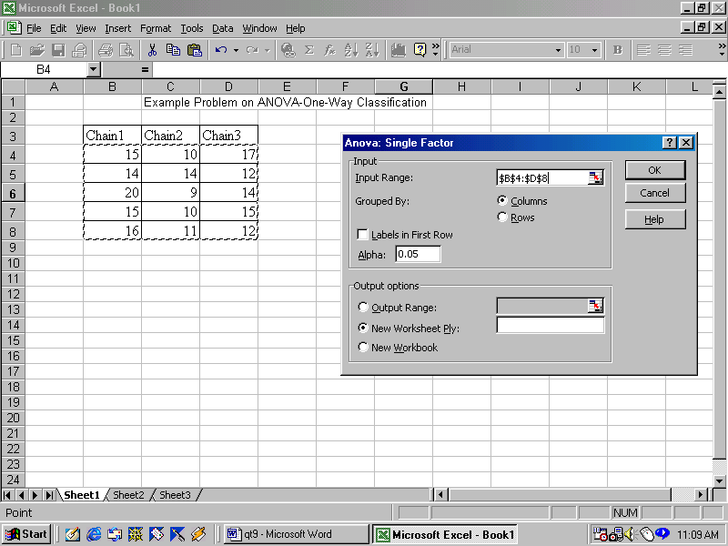

By default, the level of significance is taken as 5% and the grouping is done column-wise. You can of course do it row wise. Please see the screen above. In our problem, the chains are the columns. Click ok and you get the ANOVA table output as follows:
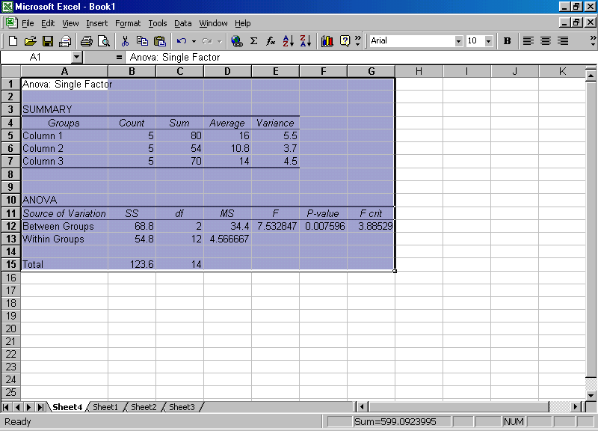

Explanation of the ANOVA output

- The summary table provides the group means and variances corresponding to each column along with group total, and count (no of observations). In our case, the columns represent the chains and the averages are for the percentage out of stock position.

- The next one in the output is the ANOVA table that is extremely important for us to interpret. The first column is labeled as “source of variation”. This tells us the factors responsible for causing variation. You see underneath “between groups” and “within groups”. The between groups variation represent the variation caused by the chains with regard to the out of stock situation. The within group variation represent the error variation (residual). It is a general practice to use the term treatment for the different chains. Treatment is a generic term that could represent the row or column variation. Treatments could be different methods, different machines, different markets, and the like.

- The second column is labeled as SS meaning sum of squares. The sum of squares is worked out corresponding to each source of variation. Please note that total sum of square is the addition of between group sum of square and the within group sum of square.

- The third column is labeled as df denoting the degrees of freedom for each factor. The easy way to understand is that there are 3 chains and so the chain factor has two degrees of freedom (always the original number-1 that are free to move). The total number of observations = 15 and so the total has 14 d.f. The within group d.f (for error factor) has been obtained by subtraction 14-2 =12 d.f( d.f for error =d.f for total-d.f for treatment). You don’t really have to worry as to how to get the degrees of freedom. Excel will do it for you. Just for an appreciation, the way the computer has worked out the degrees of freedom has been explained.

- The fourth column is labeled as MS meaning the Mean Square. You will notice that there are two mean squares. One is for the treatment (between groups) and another for the error(within Groups). Each mean square is obtained by dividing the sum of squares by the corresponding d.f. Please note that the mean squares are not additive. That is adding the mean squares of treatment and error will not be equal to total mean square.

- The fifth column is labeled as F meaning the F statistic that we will use for interpretation of result. This is the computed F. Statistically speaking the F distribution is a ratio of two independent Chi-Square and so it has a pair of degrees of freedom one for the numerator and another for the denominator. Please note that in our computation of F, we have divided the between group mean square (treatment mean square) by the within group mean square(error mean square) to get the value of F. Both these mean squares follow a chi-square distribution. The computed F has (2, 12) df meaning that the numerator has 2 df and the denominator has 12 df. In short form it is written as F(2,12).

- The sixth column is labeled as P-value that we know.

- The seventh column is labeled as F critical meaning the critical F value for ( 2, 12) df for a given level of significance (0.05 in our problem).

Formulation of the Null and Alternative hypothesis

H₀: The population means of percentage stock out position for all the three chains are equal

H₁: The population means of percentage stock out position for at least one pair of chains are not equal

Decision Rule: If the computed F is greater than the critical F, reject the null hypothesis H0 and accept the alternative H1.

At 5% level from the ANOVA output of Excel, we have the computed F = 7.53 and the critical F(2,12) =3.89. So, reject the null hypothesis and accept the alternative. The inference is that the population means of percentage stock out are not the same for all the three chains. So, what do you do? Now, look at the point estimates from the summary table. Chain 1 has a mean stock out of 16%, chain 2 has a mean stock out of 10.8% and chain 3 has a mean stock out of 14%. Chain 2 has the least stock out percentage followed by chain 3 and then chain 1.

Assumptions involved in using ANOVA

- The samples drawn from different populations are independent and random. In our case the samples are independently and randomly drawn from the three supermarket chains.

- The response variables of all the populations are normally distributed. In our example, the response variable namely the percentage stock out is normally distributed.

- The variances of all the populations are equal. In our example, the variances of the three chains are equal.

Discussion:
Analyze, criticize, and explain the following statement:

“The pattern of differences revealed by ANOVA must be carefully examined in order for a decision maker to decide whether the results are really helpful or only academic in nature”.

10.6 ANOVA-Two -Way Classification

The two-way classification is a mere extension of the one-way ANOVA. You will have two factors for which the population means will have to be compared. Microsoft Excel has the necessary model to tackle the two-way ANOVA. The testing procedure is exactly the same except for the fact that you will be testing the population means for two factors. Excel does this ANOVA as a row and column comparison. Let us look at an example.

Example:
A supermarket that has a chain of stores is concerned about its service quality reputation perceived by its customers. The Table below shows the perceived service quality with regard to politeness of the staff. The number in each cell of the table is the percentage of people who have said that the staff is polite. Perform the two-way ANOVA and draw your inferences about the population means of politeness corresponding to the days as well as the stores.

Day Store | A | B | C | D | E
Monday | 79 | 81 | 74 | 77 | 66
Tuesday | 78 | 86 | 89 | 97 | 86
Wednesday | 81 | 87 | 84 | 94 | 82
Thursday | 80 | 83 | 81 | 88 | 83
Friday | 70 | 74 | 77 | 89 | 68
Enter the data in Microsoft Excel, click Tools, click Data Analysis and click Anova: Two factors with out replication, you get
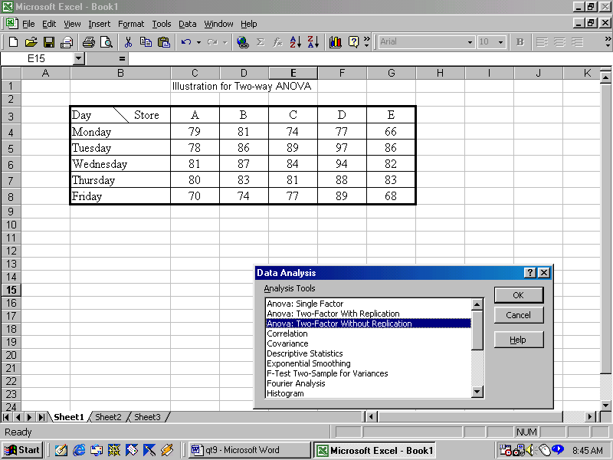

Please note that Excel can do ANOVA with unequal sample sizes in rows or columns as well as with and without replication. Here we have taken without replication meaning that each cell has only one observation. The program will ask input range. You highlight the entire matrix. You now get the following:

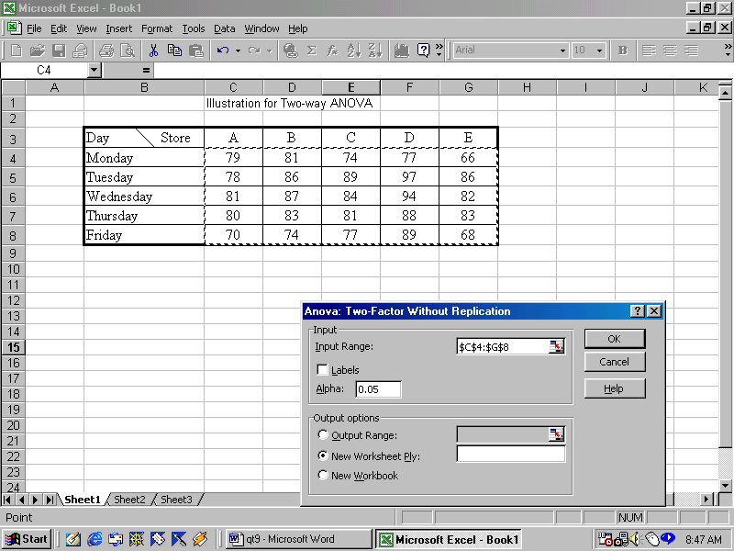

You click ok and you get the ANOVA output. The interpretation of this output is given below:

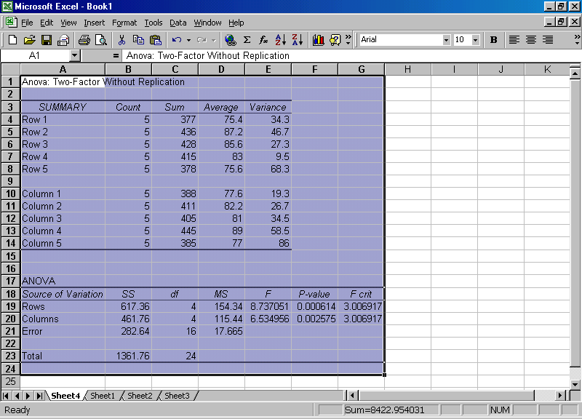

Interpretations:

Rows are the days and columns are the stores. The F value computed in both cases is greater than the critical F. So reject the null hypothesis of equality of means in both the cases. The conclusion is that the stores(columns) as well as the days(rows) reveal different patterns in politeness level. The highest politeness level is witnessed on Tuesday and Store D extends the maximum politeness level.

Inline Question: In the output above, what are the degrees of freedom for the computed F corresponding to stores and Days?

Answer: Degrees of freedom for the F corresponding to stores =F(4,16). Degrees of freedom for the F corresponding to days is also =F(4,16)

10.7 Module Summary

This module has introduced you to the basic models of the chi-square tests and ANOVA. The cause-effect relationship has been brought to your attention along with the role of Chi-square and ANOVA. In particular, this module focused on:

- Conceptual framework of the chi-square analysis

- Basic models of chi-square namely the goodness of fit and test of association in a contingency table through examples

- Basics of ANOVA

- One-way and Two-way classifications of ANOVA with interpretations in practical problems

- Applying Microsoft Excel to work out the critical value of chi-square

- Applying Microsoft Excel to perform one-way and Two-way ANOVA

Glossary:

Analysis of Variance (ANOVA): It is a technique that is used to test the hypothesis of equality of more than two population means.

Chi-Square Distribution: It is a probability distribution that is widely used in research studies for testing hypothesis involving nominal data. The value of chi-square distribution depends on the number of degrees of freedom (d.f.).

Contingency Table: It is a cross-tabulation table containing frequency data corresponding to the categorical variable in the row and the column.
Expected frequencies: These are frequencies that are computed assuming the null hypothesis is true. Thus we expect these frequencies to take place in a contingency table when the null hypothesis is true.

F Distribution: Statistically speaking the F distribution is a ratio of two independent Chi-Squares and so it has a pair of degrees of freedom one for the numerator and another for the denominator. This is used in ANOVA for testing the equality of more than two population means.

Goodness of Fit: It is a test using Chi- Square distribution to determine whether there are significant differences between the observed frequencies and expected frequencies involving categorical data.

Observed Frequencies: Frequencies that are actually observed in survey research both for one way table as well as for contingency table involving nominal (categorical data).

Test of Independence: This is a test that is used for analyzing cross-tabulation data in a contingency table in which an investigator is keen to find out whether the two categorical variables are independent of each other.

Treatment: Treatment is a generic term that could represent a row or a column in an ANOVA table. Treatments could be different methods, different machines, different markets, and the like.

