Module: 11 Correlation and Regression

Dr. P.K.Viswanathan, Professor, Great Lakes Institute of Management

Introduction:

Managers very often have to assess the nature and degree of relationship between variables. For example, a marketing manager would like to know the degree of relationship between advertising expenditure and the sales volume. Normally, you expect a positive relationship between sales and advertising expenditure. The manager would like to know whether money spent on advertising is justified in terms of sales generated; flat 10 percent increase in advertisement expenditure will result in how much extra sales volume? This type of question could be answered by Correlation and Regression. This module covers the nitty-gritty of correlation and regression.

11.1 What is Correlation?

The manager of the business environment of today is very often interested in finding out whether there is any association between two or more variables and if it is true, he would like to know the strength of relationship between the variables. The strength of relationship is also known as the degree of relationship. In the previous module, we have provided a conceptual framework of the Chi Square distribution that does try to provide some answer to the question of finding out whether the two attributes in a contingency table or associated or not. The degree of relationship between two variables can be elegantly worked out by correlation coefficient when the variables are intervally scaled.

What is the correlation between demand and price of a product? For all normal commodities we know that when price increases, the demand decreases and when price decreases, the demand increases. Economists call this inverse relationship between demand and price as the price elasticity of demand. So, logically speaking the correlation coefficient between demand and price must be negative.

Let’s see another example. As a manager of marketing if you are interested in finding out the degree of relationship between the advertising budget and the sales generated, the correlation coefficient can help you very much. You expect that the correlation coefficient between the sales and the advertising budget will be positive.

In a number of situations where managers are interested in establishing the strength of relationship between variables, correlation coefficient can help them a great deal. Examples include the correlation between motivation of workers and productivity, customer satisfaction and profitability, percentage defectives and cost, and preventive maintenance vs. machine breakdowns.

11.2 Insights into Correlation

Scatter diagram: In order to understand the nature of correlation, scatter diagram is the appropriate tool to use. Scatter diagram enables the investigator to know whether there is positive correlation, negative correlation or no correlation in a problem situation. In simple terms, scatter diagram depicts in graphical manner any two variables plotted in the X-Y plane. The following visual outlines the purpose of scatter diagram.

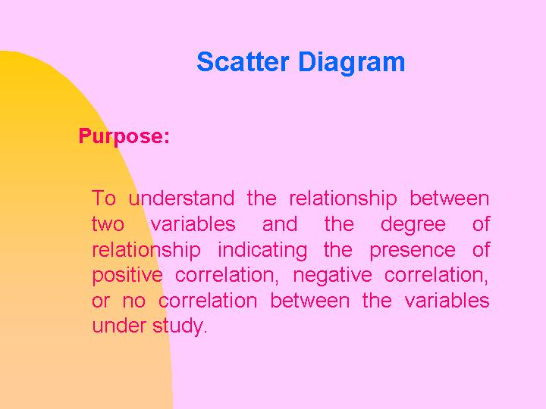

Positive Correlation: As the value of one variable increases, the value of the other variable also increases. (Example: Sales versus Advertising) See the following visual.

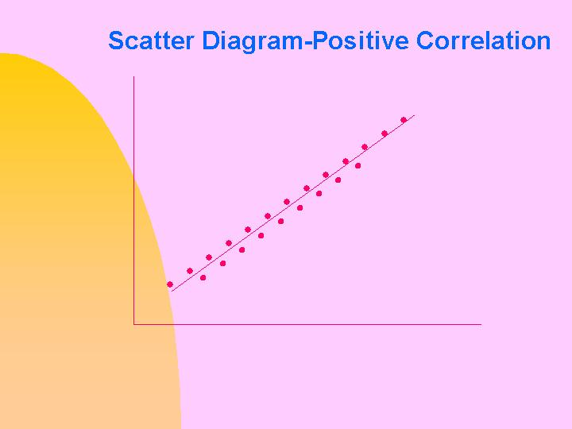

Negative Correlation: As the value of one variable increases, the value of the other variable decreases. (Example: Demand for a product versus its price). See visual below:

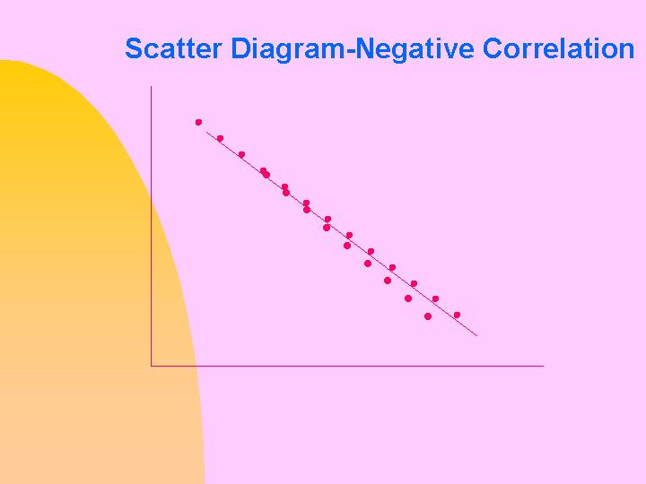

No Correlation: At times, we may not be able to find any correlation pattern. It may be a case of absence of correlation. We say that no linear correlation is observed. This is because the correlation coefficient that we apply in practice is based on a linear relationship. The linear correlation coefficient was developed by Karl Pearson. See visual below: As you can see, no useful relationship can be established and it points to the fact that no correlation in the linear sense exists.

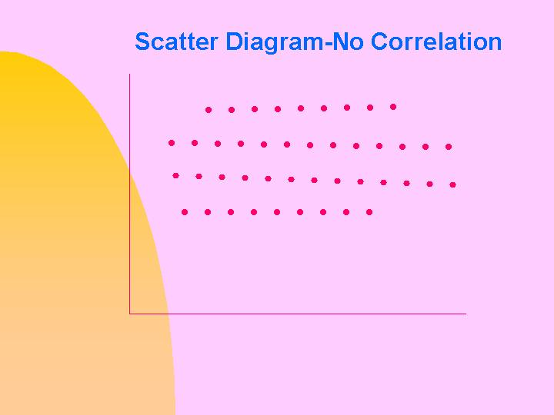

Pearson’s Correlation Coefficient

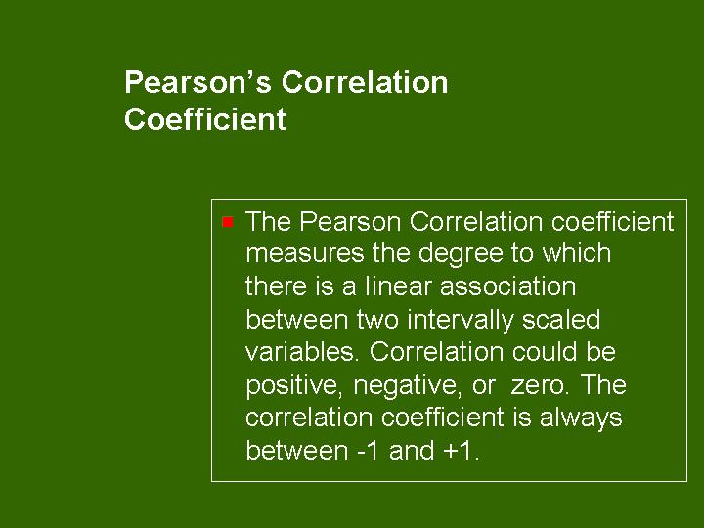

For a sample of n observations selected on two variables X and Y, the sample correlation coefficient of Karl Pearson is defined as follows:

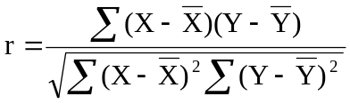. This is also known as Product Moment Correlation:

Here r represents the sample correlation coefficient.

Properties of Correlation Coefficient

- The correlation coefficient is a pure number independent of unit of measurement and scale. The value of r will not change if X and Y are converted into U and V by transformation of scale.

- The correlation coefficient always lies between –1 and +1

- The three extreme positional values of r are shown below:

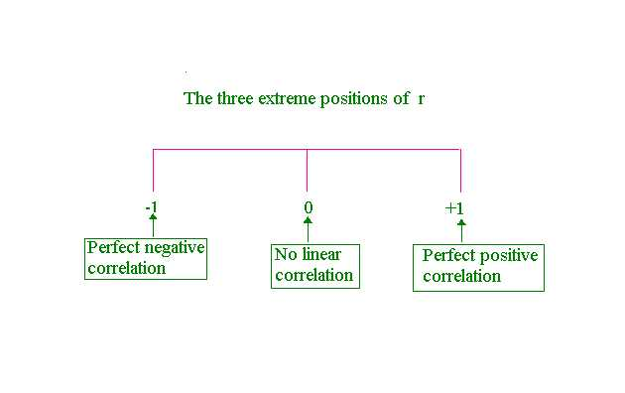
Example: The following data refer to two variables-promotional expenses(Rs. Lakhs) and sales(1000 units) collected in the context of a promotional study. Calculate the correlation coefficient and comment.

Promotional Expenses | Sales
7 | 12
10 | 14
9 | 13
4 | 5
11 | 15
5 | 7
3 | 4

We will show how easy it is to do this exercise on Microsoft Excel. No hassle involving complex formulas and memorizing expressions. Even the formula given for the correlation coefficient r is not required. Just follow the step by step procedure given.

Step1: Enter the data in the spreadsheet. Then click Paste Function, click Statistical, and click CORREL. The following will appear:
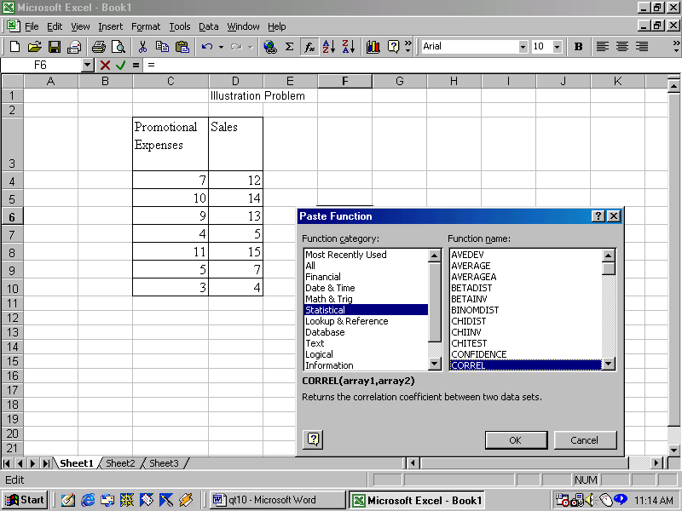

Step 2: Click Ok. Highlight the data for array1 and array 2. Then click Ok. You get the answer.
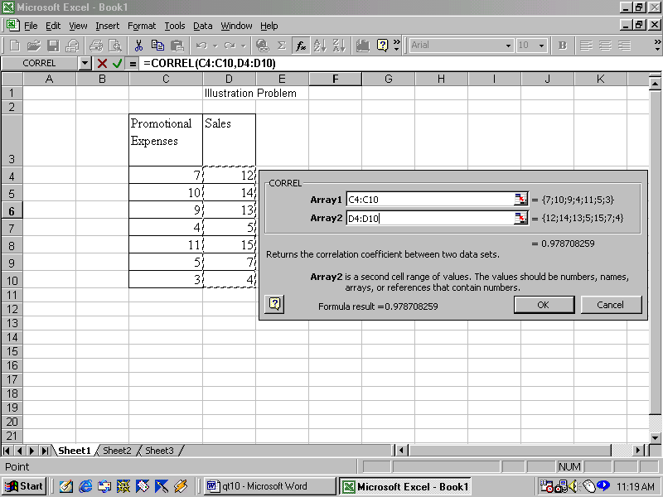

Comments: The correlation coefficient is 0.9787(see Excel output above). The promotional expense is strongly associated with sales and the correlation is very close to1.

Inline Question: In a market research study, the correlation coefficient between income and consumption is 2.8. Interpret the result.

Answer: The correlation coefficient cannot be greater than1. How can it be 2.8? Something must have gone wrong while computing r. The analyst must find out what went wrong in the calculation.

Inline Question: Product moment correlation and Pearson’s correlation coefficient are the same. True or False.

Answer: The statement is True. This is another way of expressing the Pearson Correlation.

Inline Question: Draw the scatter diagram; calculate the correlation coefficient using the formula for the illustration discussed previously.

Solution: We can use Microsoft Excel to draw the scatter diagram and also calculate r in a traditional way. The output below gives the value of r =0.9787 that tallies with what has been achieved by direct paste function. Now, you will agree with me that the direct method is the easiest

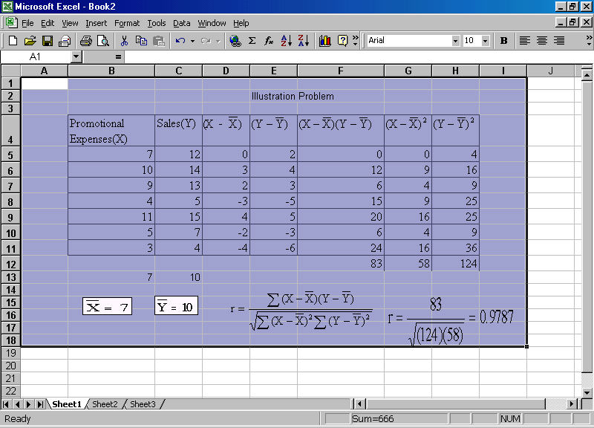

Scatter diagram: Output from Excel

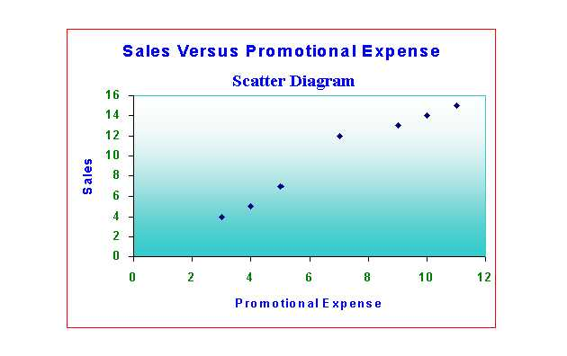

The scatter diagram clearly brings into sharp focus the high degree of positive correlation between promotional expense and sales. The pattern shows a linear correlation of a very high magnitude. The computed value of r =0.9787

11.3 Basics of Regression

- Need for Regression: The Pearson’s correlation coefficient gives you just the degree of relationship or association. It cannot help you estimate or predict the response variable for a given independent variable. The response variable is called the dependent variable. In the example we have taken for the correlation coefficient, ‘promotional expense’ is the independent variable and ‘sales’ is the dependent variable. Sales depend on promotional expense. Using regression analysis, it is possible to predict sales for a given promotion expense. For business planning and forecasting, regression is much more useful than correlation.

Objectives of Regression Analysis:

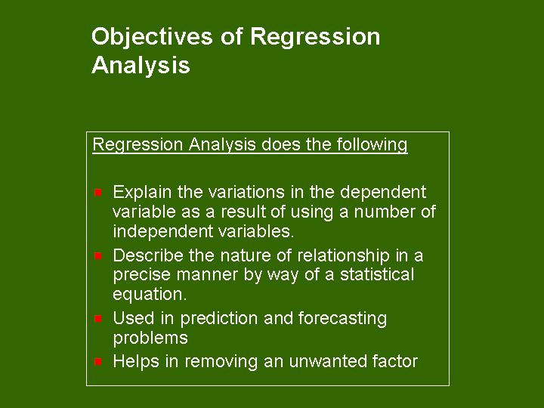

11.4 Regression Model

Simple Linear Regression: In this model, dependent variable is a linear function of one independent variable. For example, demand may be structured as a linear function of price. Based on sample data collected for the dependent and independent variable, a model is postulated connecting the dependent variable with the independent variable in a linear equation form. Symbolically, we write the sample regression line as follows:

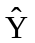 = a+bx
where
is the dependent variable estimated
X is the independent variable
a and b are constants.

a and b are determined by statistical least square method. b is called the regression coefficient(slope) and a is the constant term (intercept).

Historical Perspective: Just for knowledge sake, it is worth pointing out here that the estimates for a and b obtained by least square method are called ‘Best Linear Unbiased Estimates’ (BLUE) first pioneered by Gauss and Markoff in the context of General Linear Models that take care of Multiple Linear Regression as well.

Multiple Linear Regression: Whenever we are interested in the combined influence of several independent variables upon one dependent variable, our model is that of multiple regression. Demand for example, may be a function of price, income of the consumer, advertising expense, industrial growth, and competitor’s price. When all these independent variables change, what happens to the demand is a study of multiple linear regression.

We will first understand how to set up the simple linear regression model and interpret the results before moving on to multiple regression model. This is because simple linear regression lays the foundation for multiple regression analysis.

How does Simple Linear Regression work in practice?

Example: The following data refer to two variables-promotional expenses(Rs. Lakhs) and sales(1000 units) collected in the context of a promotional study. Set up the simple linear regression model and validate it statistically. Also predict sales when promotional expense is Rs.13 lakhs.

Promotional Expenses | Sales
7 | 12
10 | 14
9 | 13
4 | 5
11 | 15
5 | 7
3 | 4

Solution:
We are going to use Excel for solving this problem. We will avoid all derivations and mathematical expressions. When you have the software, why bother? Follow the steps meticulously.

Step1: Enter the given Data in the spreadsheet. Click Tools and then click Data Analysis.
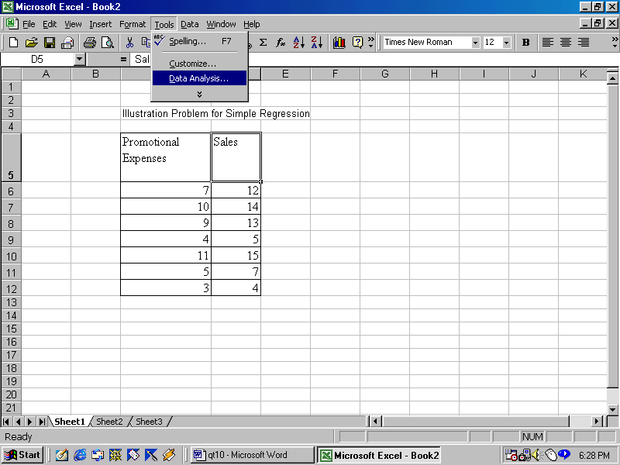
Step 2: In Data Analysis highlight Regression with mouse.
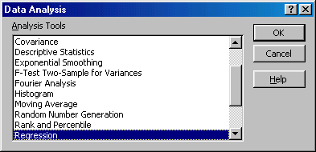

Step 3: Click Ok and then enter the input range for Y
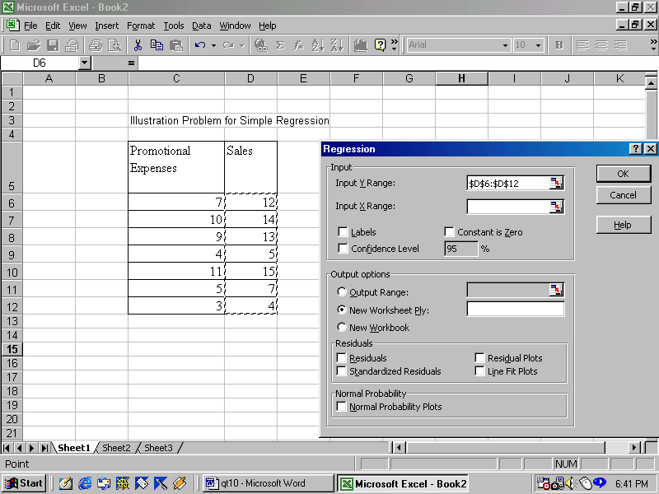
Step4: Enter the input range for X value exactly in the same way you have entered the input range for Y value, and then click Ok. You get the desired output.
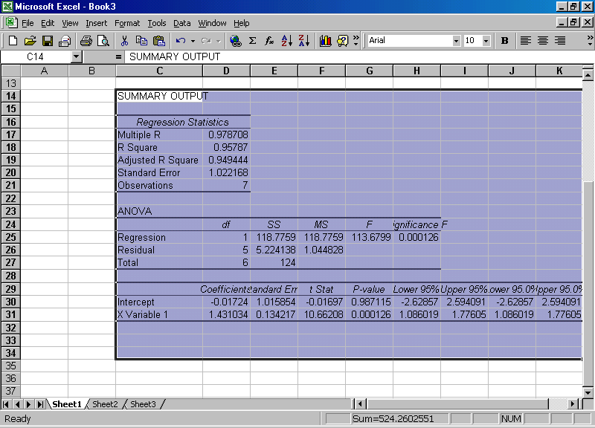
Explanation on the Output:

The output of Excel for the regression analysis is very detailed giving perhaps more than what we actually need. Let us focus on the important ones.

- Regression Equation:

= a+bX. Here is the estimated dependent variable (sales). a= the intercept value seen in the last part. Under column labeled coefficient, against the intercept value you can see
–0.01724. This is the value of a. Against X variable 1 you can see 1.43104. This is the value of b. b is also called the slope of the line of regression. Incidentally b is known as regression coefficient. X variable 1 denotes that there is only one independent variable.

Hence the fitted line is = -0.01724+1.43104X. This says that estimated sales =
-0.01724+1.43104 times promotional expense. Since it is a fitted line based on sample data, statisticians write the equation as = a+bX. When x =13, the value on simplification = 18.59. This is the estimated sales in 1000 units when the promotional expense is Rs 13 lakhs

- Statistical Validation: Look at the Regression Statistics output on top.

  - Multiple R denotes the correlation coefficient between the two variables namely promotional expense and sales. Please note that this tallies with the value of r we have done earlier. The value of R =0.9787(very strong positive correlation between sales and promotional expense).

  - R Square (R²) has a value 0.95787. R² is called the coefficient of determination. This gives the contribution made by regression in explaining the variations in the dependent variable. This is worked out as a ratio between the regression sum of square and the total sum of square. Closer the value of R² to 1, greater is the veracity of the model. In our case R² =0.95787. The interpretation is 95.787% of the variations in sales is explained by promotional expense and only about 4.22% is explained by the error or residual term. So, the model fitted is fairly accurate.

  - Adjusted R²: When more independent variables are added in the regression model, R² value will increase. It needs to be corrected to reflect the reality. This is achieved by Adjusted R². It is computed by the formula 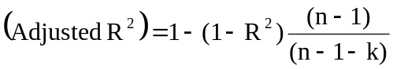. n is the number of observations.
n-1 is the degrees of freedom for Total and and k is degrees of freedom for the regression parameters estimated. If you substitute and simplify, you get the adjusted R² value =0.9494 that is given in the output. Excel will take care of this. Don’t worry.

  - Standard Error: The standard error of the sample dependent variable is given by the square root of the mean square corresponding to the Residual term in the ANOVA table that just follows the Regression Statistics.

ANOVA output:

- Total Sum of Squares = Regression Sum of Squares+ Error Sum of Squares (Residual Sum of Squares)
- Regression Sum of Squares = 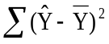 = 118.7759
- Error Sum of Squares = 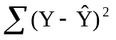= 5.2241
- Total Sum of Squares = 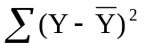=124.0000
- Mean Squares due to regression and error are worked out by dividing the sum of squares by the corresponding degrees of freedom. (See ANOVA output)

Null Hypothesis: There is no linear relationship between Y and X in the population regression line
Alternative Hypothesis: There is linear relationship between Y and X in the Population Regression Line

Look at the calculated F value. It is 113.61 and is greater than the critical F(6.61). Reject the null hypothesis. Please note that you can get the critical F using FINV function of Excel. Here significance F value (P-value) is given to be 0.000126 that is less than the level of significance 0.05. Reject the null hypothesis. The conclusion is that sales is a linearly related to promotion expense.

Inline Question: Calculate R² using the ANOVA table

Solution: R² = (Regression Sum of Squares)/Error sum of Square = (118.7759)/124 =0.95787

Inline Question: For testing the hypothesis of the linear relationship in the above problem, what are the degrees of freedom of the F statistic?

Solution: Look at the ANOVA output. The degrees of freedom for the regression is 1, and the error is 5. So the F ratio will have 1 degree of freedom for the numerator and 5 degrees of freedom for the denominator. The answer is F(1,5).

Inline Question: What is the standard error of the distribution of sample sales(Y)?

Solution: From the ANOVA, Residual Mean square(Error Mean Square) = 1.044828. Take the square root of this. That is the standard error required. The value is √(1.044828) =1.0222. Please note that this value tallies with the value of standard error under Regression Statistics of Excel in the summary output.

Things to do in a Simple Linear Regression Model

- Postulate the model =a+bX.
- Enter the sample data for X and Y in Microsoft Excel.
- Perform the Regression Analysis and get the summary output from Excel
- Write the Regression Equation using the intercept and coefficient of X from Excel summary output. Predict Y for a given X
- Validate the model statistically by looking at R² as well as F statistic in the ANOVA that tests the null hypothesis of no linear relationship.
- After statistical validation use the model for estimation and prediction

Assumptions involved in a Regression Model

- The sample observations drawn are independent and random
- For a given value of X, the conditional distribution of Y is normally distributed
- The population regression of Y on X is assumed to be linear.
- Errors are uncorrelated and follow identical normal distribution with mean 0 and standard deviation σ

Inline Question: What are the residual terms for the regression example discussed by us? Plot the residuals.

Promotional Expenses | Sales
7 | 12
10 | 14
9 | 13
4 | 5
11 | 15
5 | 7
3 | 4

Solution: In the options, click residuals, and residual plots after entering the input range for Y and X. You get

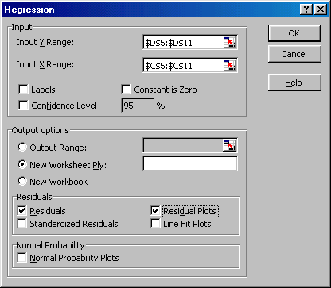

Click Ok and you get the residuals and the residuals plotted. Please note that residual = Y- (Actual Value-Estimated value)
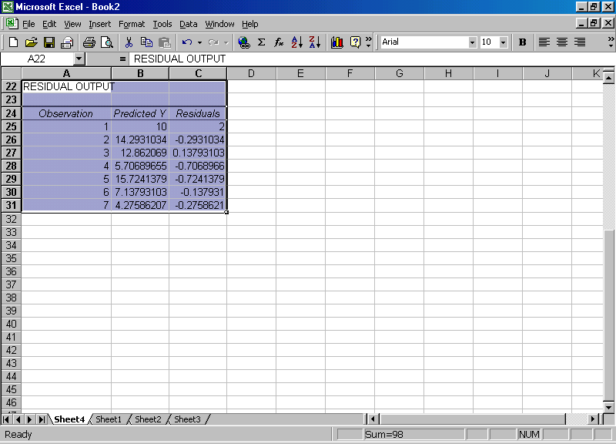
Solution continues:

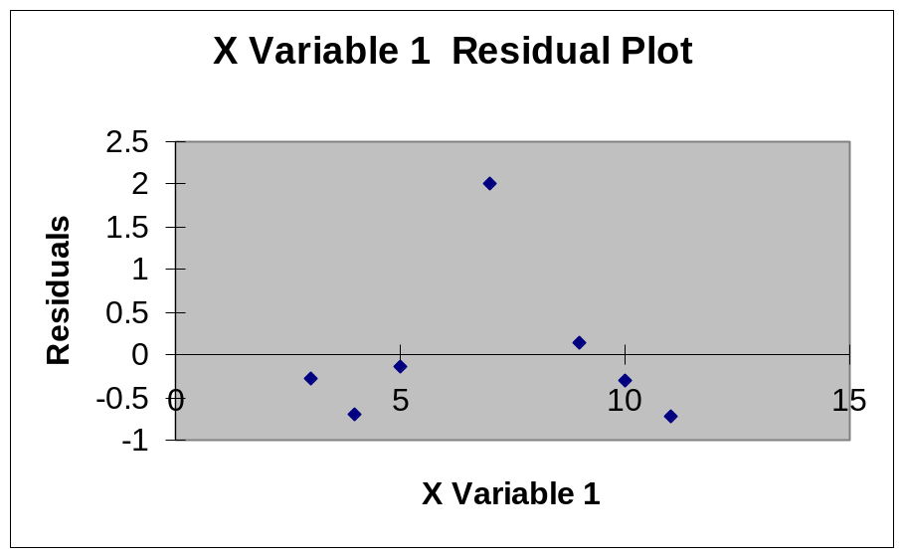

Multiple Linear Regression Model

Multiple linear regression is a logical extension of the simple linear regression. The number of independent variables will be more than one. The same procedure of setting up the model is followed as in the case of simple linear regression. When the number of independent variables increases, Microsoft Excel is the only way out. The best way to understand how multiple regression works in practice is through an example.

Example: Eight patients underwent an operation in a hospital. Measurements of weight(kg), duration of operation(minutes), and blood loss(ml) were taken. The hospital authorities would like to know whether the blood loss was related to weight and duration of operation. The data are as follows:
Weight(X1) | Duration of  Operation (X2) | Blood Loss(Y)
44 | 108 | 505
42 | 85 | 492
70 | 88 | 472
45 | 114 | 506
50 | 110 | 484
51 | 101 | 492
36 | 97 | 515
53 | 121 | 466
Questions:
- Write the regression equation of blood loss in terms of weight and duration of operation
- What is the R² value? Interpret
- Validate the model using ANOVA

Solution: Proceed exactly like the simple regression model in Microsoft Excel. Enter the Data, click Tools, click Data Analysis, click Regression. You get
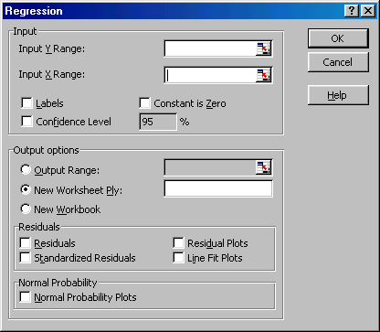

Enter the input range for Y exactly as before. For input range for X, you need to highlight the two columns containing X1 and X2. That is all. You get now the following. See the two columns of X1 and X2 are highlighted to convey to Excel that it is multiple regression model.

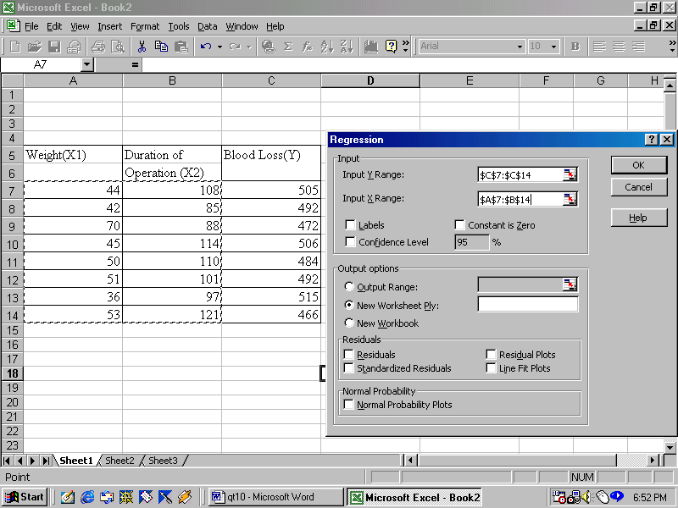

Now click Ok. You get the answer. The output appears as follows:

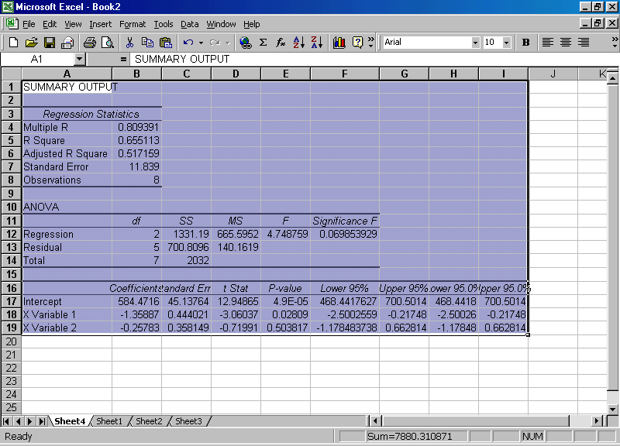

- Regression equation is Y = 584.4716-1.35887X1-0.25783X2

- From regression Statistics on top R² =0.6551. This means that 65.51% of variations in blood loss is explained by weight and duration. About 35.49% are accounted by error. The R2 value suggests that the model is not robust and more factors will have to be added. Let us see what ANOVA concludes.

- In ANOVA, calculated F value is 4.75 and F significance is 0.0699(P-value). Since the P value is less than the level of significance 0.05, accept the null hypothesis of no linear relationship between Blood loss and weight and duration. You get the same conclusion by working out F critical using the paste function. F critical for F(2,5) for 5% is = 5.79. Calculated F is less than critical F. So, accept the null hypothesis.

Limitations of Multiple Regression Model

- The most crucial assumption made is that the independent variables are not correlated with each other. If they are correlated, then the regression coefficients cannot be estimated. This problem is called multicollinearity. The procedure followed for resolving multicollinearity is to drop the independent variable that has the highest standard deviation and then rework the model again. The other way is to transform a set of correlated independent variables into an uncorrelated set of variables by the technique called principal component analysis. This is an advanced technique requiring the help of advanced statistical software like SPSS.

- When there are wild fluctuations in one or more of the independent variables, multiple regression model crumbles and will be highly unreliable.

- In order to use the multiple regression model for prediction, you have to first predict the values of the independent variables using some other prediction method.

- In forecasting problems, multiple regression at best can work for short and medium term only. It cannot be successfully used for long term forecasting.

Discussion:
Analyze, criticize, and explain the following statement
“Regression analysis is much more useful than correlation analysis in providing solution to business problems”.

Assignment: Using Microsoft Excel, draw the estimated regression line along with actual observations of Y for the following data.

Promotional Expenses(X) | Sales(Y)
7 | 12
10 | 14
9 | 13
4 | 5
11 | 15
5 | 7
3 | 4

11.5 Module Summary

This module has introduced you to the essentials of correlation and regression with their important features. Specifically, this module focused on:

- Meaning and role of correlation

- Understanding correlation through scatter diagram

- Definition and properties of Pearson’s correlation coefficient

- How to compute correlation coefficient

- Basics of regression analysis

- Simple linear regression model and statistical validation

- Multiple linear regression model and statistical validation

- Extensive use of Microsoft Excel to get solution for correlation and regression

Glossary:

Coefficient of Determination: This gives the contribution made by regression in explaining the variations in the dependent variable. Closer this value to 1, greater is the veracity of the linear model postulated.

Correlation: It is a study that focuses on the strength of association or relationship between variables.

Correlation Coefficient: It measures the degree to which two intervally-scaled variables are linearly associated. It is a pure number that lies in the interval –1 to +1. There could be zero correlation, positive correlation, or negative correlation.

Dependent Variable: It is the response variable that we are estimating or predicting in a regression model. It is a function of one or more independent variables.

Independent Variables: These are variables that are known and are found in the right side of the regression equation. The response variable is postulated as a function of these independent variables. In other words the behavior of the independent variables affect the value of the response (dependent) variable.

Least Square Method: This is used to determine the best linear unbiased estimates of the regression coefficients in a regression model.

Multiple Linear Regression: It is a study focusing on the combined influence of several independent variables upon one dependent variable using a linear model.

Regression Analysis: It is a process of predicting the value of the response variable (dependent variable) that depends on one or more number of independent variables. Prediction is achieved through a statistical equation based on the least-square method.

Residual: It is the difference between the actual value of the dependent variable minus the predicted value of the dependent variable obtained from regression equation. This measures the backtracking ability of the model to predict.

Scatter diagram: It is diagram that depicts in a graphical manner any two variables plotted in the X-Y plane. Scatter diagram enables the user understand the nature of correlation between two variables.

Simple Linear Regression: In this model, dependent variable is a linear function of one independent variable.

Slope: It is the value of the regression coefficient in the regression equation. It gives for every unit increase in its value, the resultant change in the dependent variable.

Y-Intercept: It is the constant term in the regression equation. It is obtained by letting the values of the independent variable equal to zero.

