Module: 12 Forecasting

Dr. P.K.Viswanathan, Professor, Great Lakes Institute of Management

Introduction:

Many crucial decisions made by management depend upon the assessment of the future-demand for products and services, sales growth, and cost trends. Management must forecast the future in order to make sound decisions today. So, managers need efficient and reliable forecasting methods for business planning. This module presents a few widely used forecasting techniques in practice.

12.1 Forecasting-Basics:

Why Forecasting?

- Demand or sales forecasting is the foundation stone upon which the entire business planning is built. An organization cannot predict its profitability without predicting sales revenue. Sales revenue cannot be predicted without forecasting sales in physical quantities. The entire production program and materials resource planning cannot be achieved without a realistic sales forecast of the various products the organization would like to market. Corporate plans, turnaround plans and competitive business strategies need the help of forecasting. In other words, not to forecast is to assume status quo and do nothing. This will never be acceptable to any manager in any organization.

- We must of course recognize the fact that future is uncertain and therefore no forecasting can be hundred percent accurate. This is a paradox in forecasting: on the one hand you need sales forecasts and on the other hand no forecast can be accurate.

- Managers in any business enterprise have no choice between forecasting and not forecasting because without a sound forecasting system, the risk of making a wrong decision increases. Managers however have choice amongst the methods of forecasting. In this module, we will dwell at length on the popular methods of forecasting in practice.

Forecasting Methods in Practice:

The following visual portrays the widely used forecasting techniques in practice.

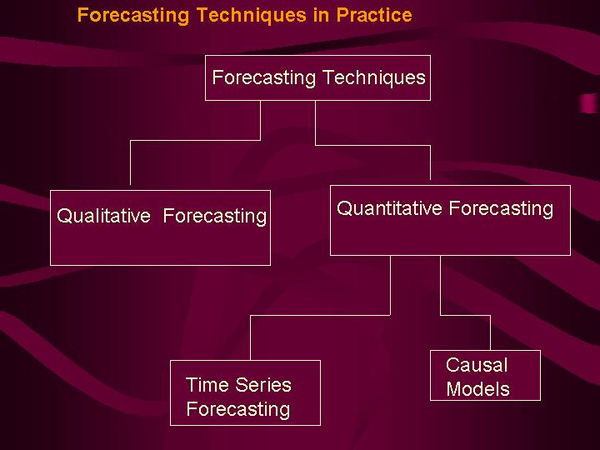

Selecting the Right Forecasting Technique-Guidelines

- Availability of data: If no appropriate historical data are available, quantitative techniques of forecasting are not possible. Only qualitative forecasting techniques are possible.

- Accuracy envisaged: Greater the accuracy needed, greater is the need for sophisticated techniques of forecasting.

- Urgency with which the forecast is sought: If forecasts are required urgently, only less sophisticated techniques are possible to use.

- Cost: This includes cost of forecasting exercise and what it costs the firm if a wrong forecast is made.
12.2 Qualitative Methods of Forecasting
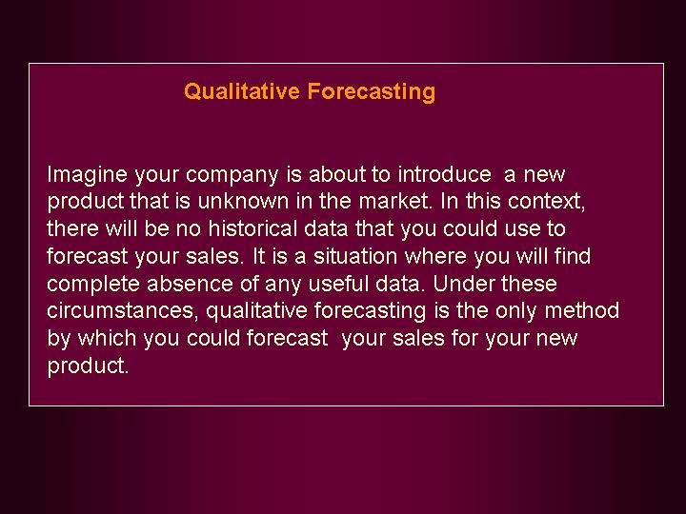

Methods of Qualitative Forecasting:

The following visual gives the popular methods of qualitative forecasting.
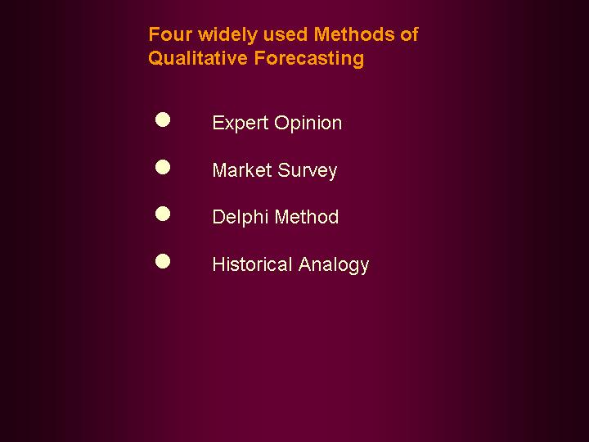

Inline Question: Qualitative forecasting is superior to quantitative forecasting because it emphasizes on quality. True or False.

The statement is false. These are the two broad types of forecasting methods. Qualitative is judgmental in nature whereas quantitative relies on hard data. By themselves, these two have nothing to do with the word quality. Quality of the forecast is an entirely different subject and depends on many factors.

Expert Opinion:

- In this method, a group of experts from diverse background such as marketing, sales, finance, operations, and purchasing are asked to make forecast for the product under consideration. A consensus is then reached on a forecast figure. Each expert brings with him/her a set of biases, and perspectives that might influence the forecast. Of course, their judgment would be substantiated by a wealth of information that include past data, industry growth rates, competitive strategies and reactions from customers and distributors.

- The advantages of this method: 1) It is fast and efficient. 2) It is timely and based on good information content. 3) It uses the collective knowledge of experts.

- The disadvantages of this method: 1) Experts can make mistakes. 2) Subjectivity and bias of experts can vitiate the forecast. 3) The group dynamics of the experts could be greatly influenced by the degree of dominance of a particular person. He who could shout loudest might get his way.

Market Survey:

In this method, you conduct a market survey of customers’ intentions to buy a product. A carefully designed questionnaire is administered to the selected target audience of customers. Customers are selected independently using a representative random sample. This method is very popular and if carefully implemented will give you good results.

- This is the apt technique to use, particularly if you want to forecast sales for a new product or new brand.

- This method of forecasting requires the active cooperation of the target audience.

- The sample size must be reasonably large. Larger the sample size, smaller will be the standard error and sampling error.

- Larger the sample size, the more time consuming and costly the survey will be. So, you have to strike a balance between sample size and cost.

Delphi Method:

- In the expert opinion method of forecasting, a consensus forecast is arrived at after eliciting the opinion and views of experts with diverse background. Certainly this method is subject to group dynamics (effects). At times, judgments may be highly influenced by persuasions of some group members who have strong likes and dislikes. Delphi method attempts to retain the wisdom and accumulated knowledge of a group while simultaneously attempting to reduce the group effects.

- In Delphi method, group members are asked to make individual assessment about a forecast. These assessments are compiled and then fed back to the members, so that they get the opportunity to compare their judgment with others. They are then given an option to revise their forecasts. After three or four replications, group members reach their final conclusion.

Historical Analogy:

This method is applied when a new product is about to be introduced by a company. Forecasting sales for new products are difficult in view of lack of proper historical data. Historical analogy method attempts to forecast sales for a new product based on the performance of related or similar products in the market place. The database of sales of these products forms the basis for forecasting.

The drawbacks of this method include:

- You cannot precisely say how your new product is similar or related to a particular product.

- Suppose you have a number of products that you feel are similar to yours. Which of these will you consider as most similar to yours?

- Products that are similar to yours could have failed in the past for a variety of reasons. Let us say a similar product failed in the past because whenever there was an advertisement about this product, it was not available on the shelf. So, the consumers developed a negative perception about this product and became skeptical about its availability. You may not know all these and simply conclude your product will also fail!

Inline Question: Which one of the following will not affect selecting a forecasting method

- Accuracy envisaged
- Professional style of the organization
- Data availability
- Cost

Answer: b) is the right choice. Selection of a forecasting method certainly will depend on a) Accuracy, c) Data availability d) Cost. Selection of a forecasting method will not depend on the professional style of the organization.

Inline Question: What are the four methods of qualitative forecasting?

Answer: 1) Expert Opinion 2) Market Survey 3) Delphi method 4) Historical Analogy

Inline Question:

What is the paradox in forecasting?

Answer: Because future is uncertain, no forecasting can be hundred percent accurate. This is a paradox in forecasting: on the one hand you need sales forecasts and on the other hand no forecast can be accurate.

Discussion:
Analyze, criticize, and explain the following statement:

“ If at all forecasting techniques would be useful, they would be only in predicting sales for products. They have insignificant role in sales of services”.

12.3 Quantitative Methods of Forecasting

Quantitative forecasting uses statistical analysis of data to forecast sales. Time series analysis and causal model fall under the purview of quantitative forecasting. In this module, we will discuss time series analysis (projective methods) of forecasting. Causal model uses regression analysis for forecasting. Please note that we have already covered regression analysis extensively in module 10. You are expected to go through module 10 and be ready for a mini case assignment on regression method of forecasting under test items.

Time Series Analysis:

What is meant by time series data? The following visual captures the essence of time series.
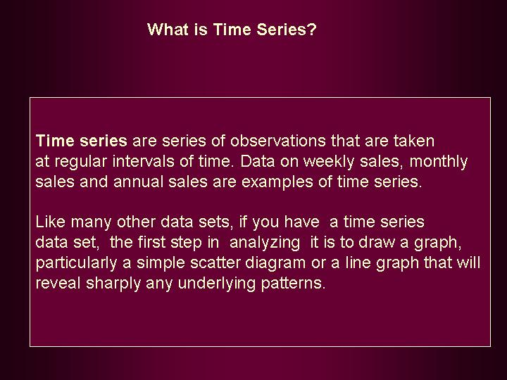
Time series is made up of four components:

- Trend (T) represents the long-term behavior of a time series. This would tell whether the time series data reveal a steady upward or downward movement.
- Seasonal Variation (S) represents variation caused by season. Typically this shows variation in demand during peak and lean season. For example, demand for snow tires will be at its peak during winter in USA.
- Cyclical Variation(C) represents the typical business cycles that occur sporadically in several years. For example, in stock market, you will witness cycle of buoyancy or boom and cycle of recession that occur once in a while between many years.
- Random Variation(R) represents irregular variations that occur by chance having no assignable cause. Random variation cannot be predicted.

Moving Average

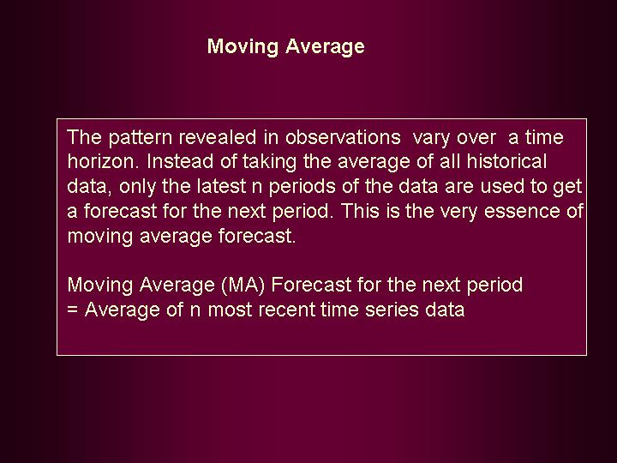

An illustration will help you understand how moving average (MA) works in practice.

Example: A company is interested in forecasting demand for one of its products. Past data on demand for the last 12 months are available and given below: Using a period of 3 months, make a moving average forecast for period 13(13th month).

Month | Sales (100 units)
1 | 15
2 | 9
3 | 16
4 | 17
5 | 11
6 | 20
7 | 10
8 | 17
9 | 12
10 | 9
11 | 18
12 | 20

Solution: We will work out the moving averages using Python.

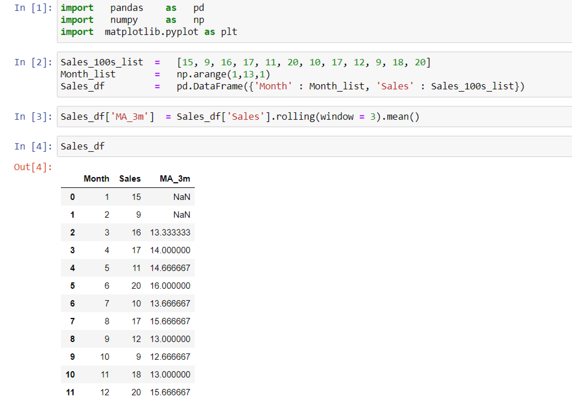
In input area 1, we import the required packages, pandas, numpy and matplotlib.pyplot.

In input area 2, we construct the lists, Sales_100s_list, Month_list. We construct a pandas data frame using these lists.

In input area 3, we create a new column, MA_3m after calculating the 3- months moving average by using the function, rolling() using the argument, window = 3 and obtaining the arithmetic mean of these values.

In input area 4, we print the data frame, Sales_df.

In the above table, 3 month moving averages are worked out. Moving averages for months 1 and 2 are obviously not possible. The first moving average is (15+9+14)/3 =13.33. The second moving average is (9+16+17)/3 =14.00 Likewise all entries are filled in by the Python program automatically.

As you will notice that the number of observations is only 10 in column MA_3m compared to the original number of observations of 12. So, by using moving average method, you have lost 2 observations. This is inevitable in moving average method of forecast. The forecast demand for month 13 =15.67(moving average corresponding to month 12). Please note that the forecast for the next period is always the most recent moving average.

The graph depicted below shows the actual Sales (100 units) and the Predicted 3-month Moving Average values. In input area 5, we plot the graph by using the function, plot() and giving the arguments as Sales_df[‘Sales’] (Actual Sales values) and Sales_df[‘MA_3m’] (three month moving averages).

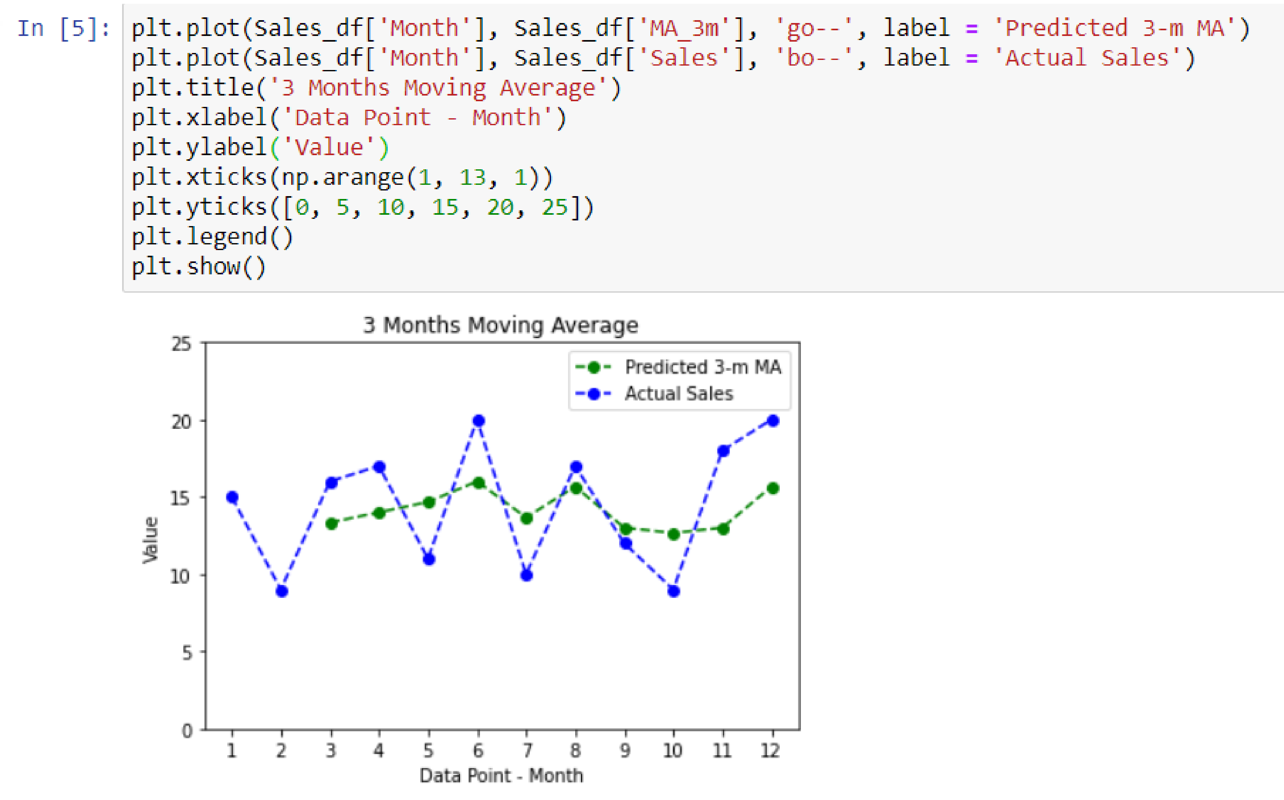

Inline Question: What is the moving average forecast demand for month 13 if you use a 4 monthly interval (period)?

Solution: Using Python, we have the following solution:

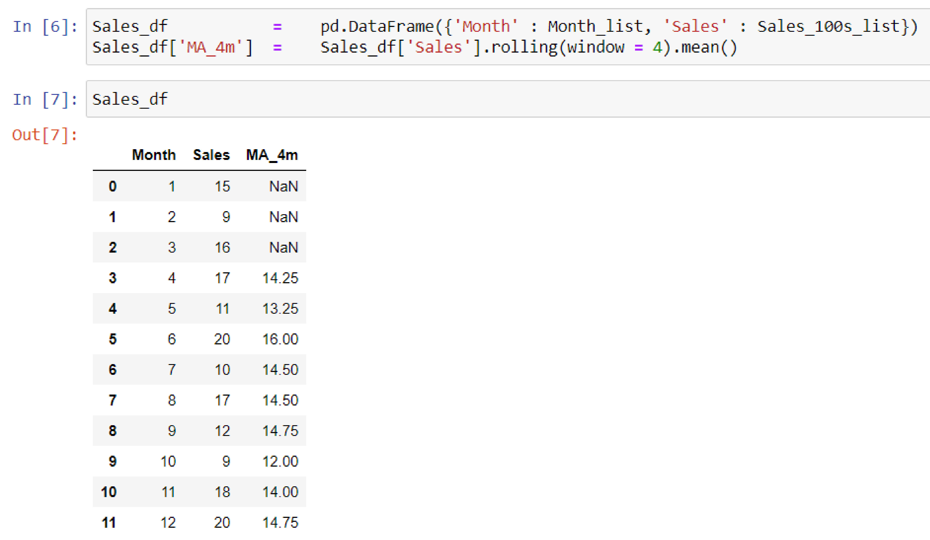
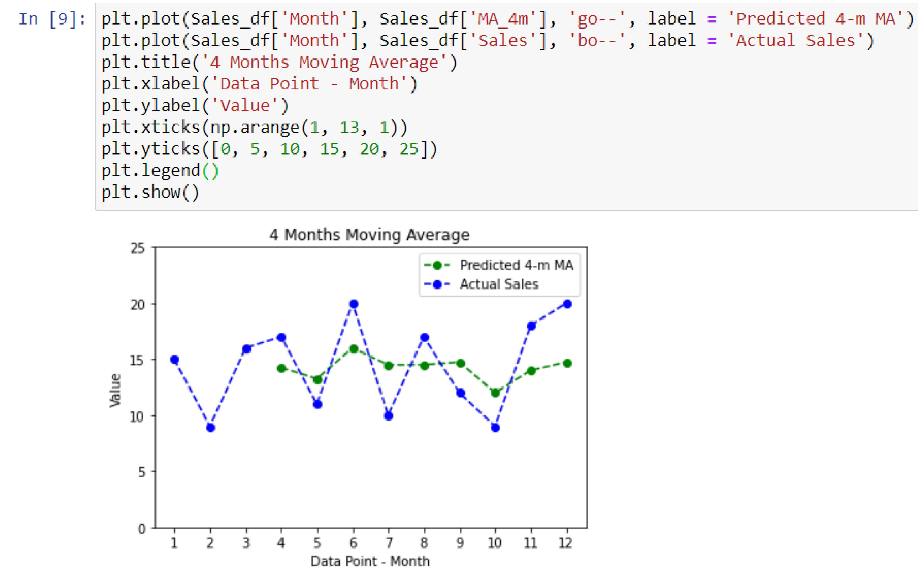
Forecast for month 13 is =14.75(Moving average corresponding to period 12 is 14.75).

Drawbacks of Moving Average Forecast:

Moving average forecast is quick, easy and fairly inexpensive to implement. It provides a reasonably good forecast for the immediate future (very short term). However, practicing managers must remember the following drawbacks given in the visual.

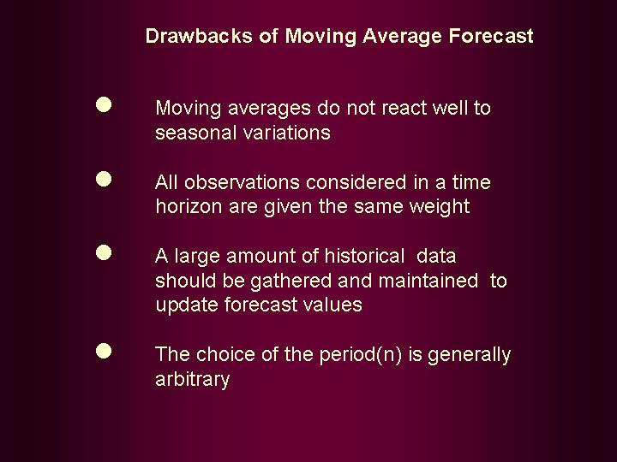

Exponential Smoothing

Exponential smoothing is a particular case of moving average in which there are three components - 1) the forecast for the most recent period, 2) the actual value for the period, and 3) a smoothing constant α. This smoothing constant αis a weighting factor that lies between 0 and 1. The selection of the right kind of α is matter of judgment by the experienced user. But it must be chosen very carefully.

Exponential smoothing is an excellent forecasting technique for short term forecasting. It is used not only in sales forecasting but also in forecasting input prices in materials procurement. The single biggest advantage is that this technique is extremely simple to use.

New Forecast = α(actual value) + (1-α) (last forecast). The meaning of this statement is explained with an example. Suppose the actual sale for month 2 is 50 units and your forecast for month 2 is 55 units. Let us take α = 0.3.

New Forecast = (0.3) (50) + (1-0.3)( 55) = 53.5.

Exponential smoothing is versatile technique of forecasting that allows the user a great deal of flexibility. You can choose the right α over a period of time using your experience. You can decide how much weight should you give to the recent actual value and how much to the forecast based on your experience of the recent past.

Example: A company is interested in forecasting demand for one of its products. Past data on demand for the last 12 months are available and given below: Using exponential smoothing technique, forecast demand for month 13. Take α = 0.2

Month | Sales (100 units)
1 | 15
2 | 14
3 | 16
4 | 17
5 | 15
6 | 18
7 | 20
8 | 22
9 | 23
10 | 21
11 | 24
12 | 26

Solution:

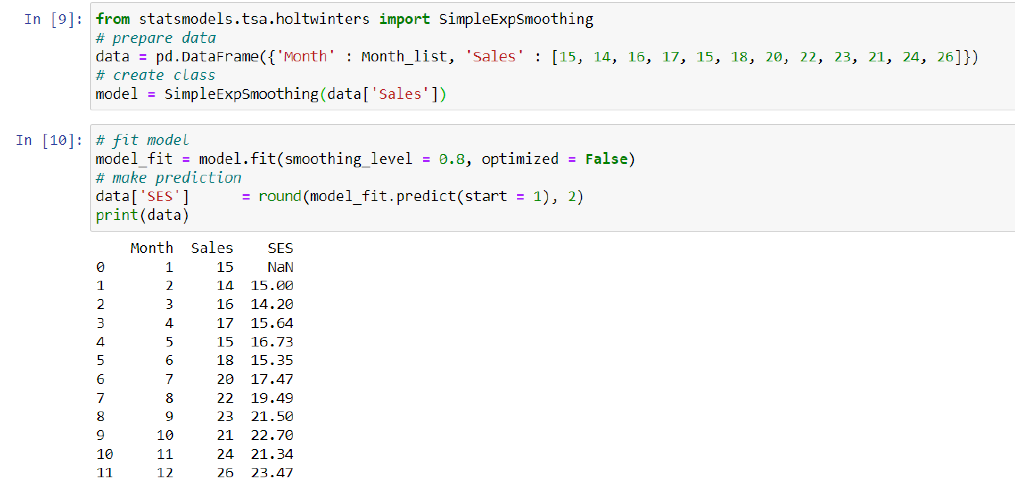
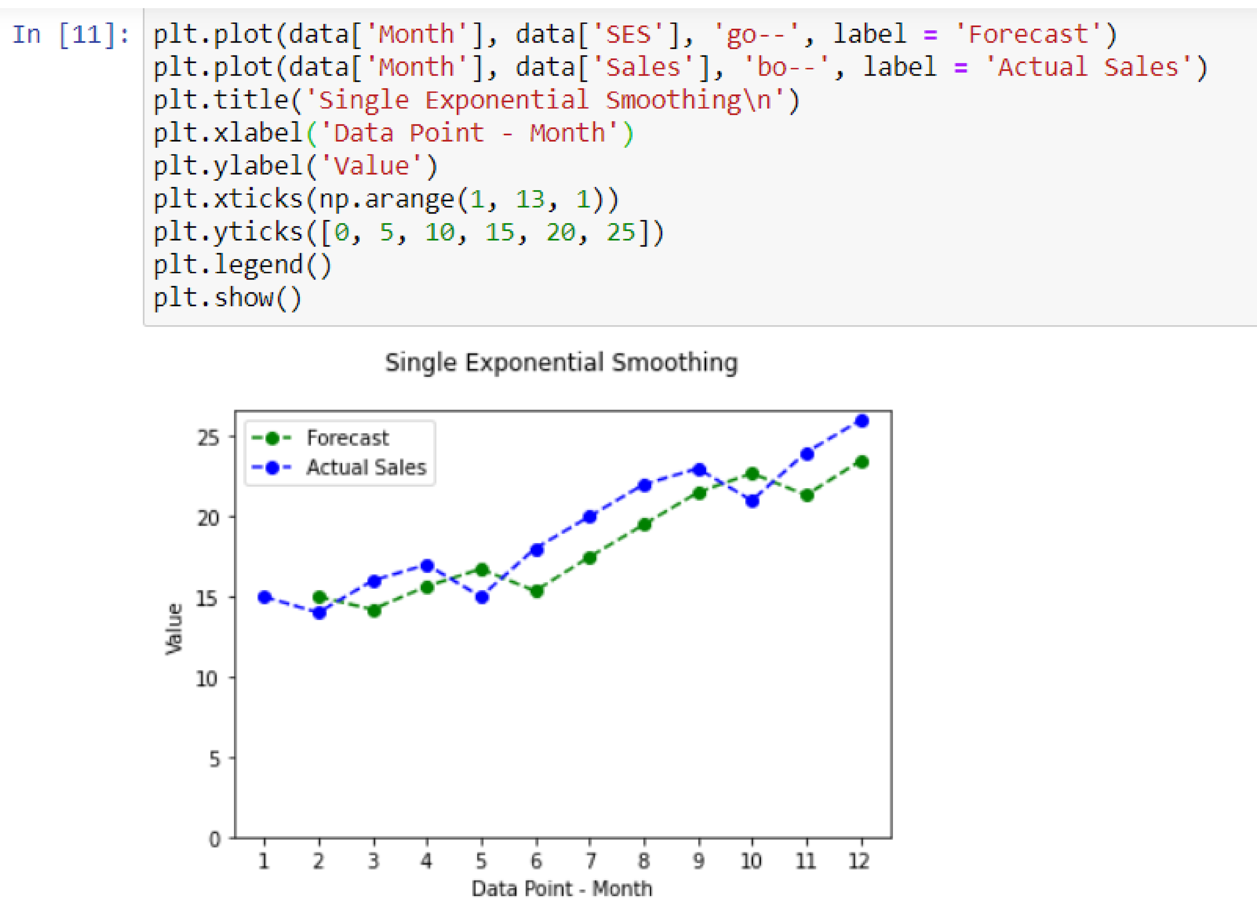
In input area 9, import the required package statsmodels.tsa.holtwinters. Construct the pandas data frame, data for Month and corresponding Sales. Apply SimpleExponentialSmoothing() function.

In input area 10, fit the model with smoothing level as 1 - alpha = 0.8 (given that alpha = 0.2) and setting the argument, optimized as False. Using this fitted model, predict Sales.

In input area 11, plot both the actual Sales and forecasted Sales values.

The question that is often raised in the usage of exponential smoothing is “is there a scientific way to fix the value of α? The answer is both yes and no. Yes, because you can get that value of α that gives the minimum mean square error. No, because mean square error is highly influenced by the square terms of individual errors. Judgment of α based on experience and tracking forecasting efficiency is the only way out. This is indeed a weakness of exponential smoothing method of forecasting.

Trend Projection:

In this method, we fit a trend line using the time series data. This trend line could be linear or nonlinear (quadratic trend, exponential trend, etc). We will discuss the linear trend that is popular and very much used in practice. The reason for its popularity emerges from the following rationale. Most of the nonlinear trend lines can be converted into linear lines by mathematical transformation. We will not dwell on the transformation method in this module. It is enough to say that linear trend is a reasonably good approximation of trend pattern that is revealed by time series data.

In simple terms, we fit an equation of the form Y =a+bt using the method of least square. Please note that least square method is used in regression analysis that was discussed in module10. In this equation Y is the dependent variable and t is the independent variable. In other words, you assume that forecast values of Y will be shaped by the past pattern only. The historical trend continues.

Example: A company is interested in forecasting demand for one of its products. Past data on demand for the last 12 months are available and given below: Using linear trend line, forecast demand for month 13.

Month | Sales (100 units)
1 | 15
2 | 14
3 | 16
4 | 17
5 | 15
6 | 18
7 | 20
8 | 22
9 | 23
10 | 21
11 | 24
12 | 26

Solution:

Use Python code given below to get the regression equation. You import the required modules, construct the pandas data frame, data, apply ols() function, fit the model to the data and finally print the summary.

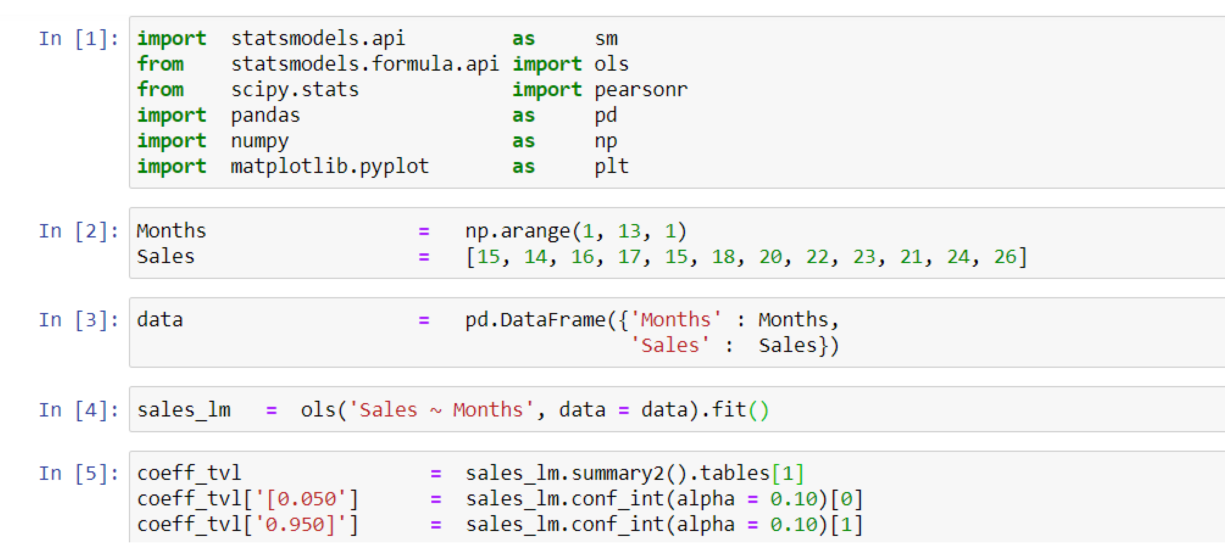
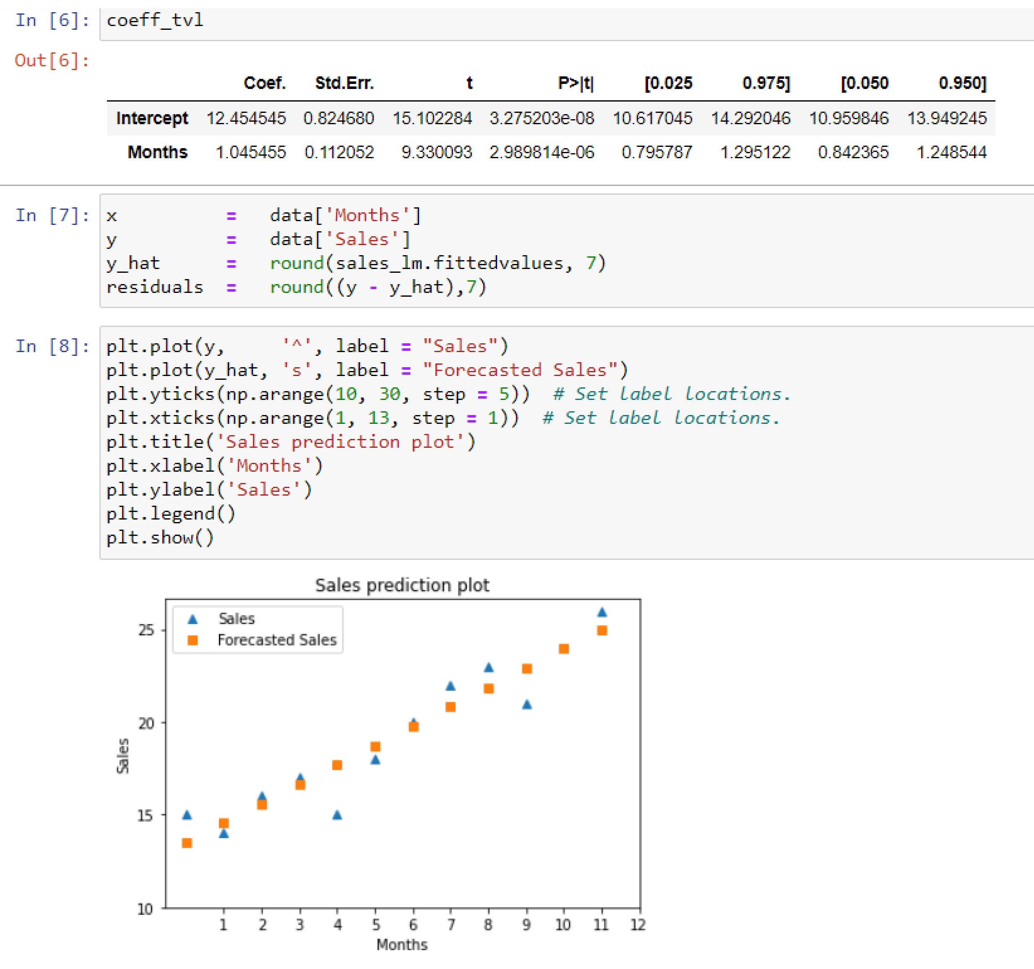

As you can see, intercept =12.45 and slope =1.046. So, the fitted line is given by
Y =12.45+1.045t

Forecast demand for month 13 = 12.45+(1.045)(13) =26.04

A Brief Note on Accuracy of Forecast

- We have discussed a number of forecasting techniques in this module. Needless to say, accuracy of forecast is paramount. Accuracy measures must reflect the closeness of predicted values with the actual values. Closer the predicted value to actual, greater is the accuracy. Backtracking ability of forecast is measured by the behavior of forecast values towards the actual. In all time series forecast methods that we discussed so far, we have provided graphical display of predicted versus actual values to understand the backtracking ability of forecast model under consideration.

- Another point to be noted is that suitable adjustments should be made in the forecast figures arrived at. This would include adjustments for seasonality, and cycles. For example, you have the trend projections based on least square line. You have made a projection for the coming period. This projection figure will have to be suitably modified if there is a strong seasonality. You can easily establish seasonal index for each calendar month. This is obtained by dividing the actual value by the corresponding trend value. If you continuously maintain a large database, seasonal indices could be updated in a dynamic manner. All you do is to first project the trend value for the forecast period by using least square method, or moving average. Multiply this trend value by the corresponding seasonal index; you get a forecast adjusted for seasonality.

- All these measures will improve your accuracy. There are two methods in practice that are used for understanding forecast error. 1) Average Absolute Error- this is obtained by computing the absolute difference between forecast value and actual value for every element in the time series data set and then taking the average of all these values. 2) Average Percentage Relative Error- in this method, you first compute the absolute difference between forecast value and actual value for every element in the data set and then divide each one of them by the corresponding actual value. Take the average of such values and multiply by 100. You get average percentage error. Which of these methods you choose is a matter of judgment.

- Intuitively and logically the graph of forecast values should be reasonably close to the actual values. If it is not, look for reasons and gather more data. Revise your model completely if needed.

- Accuracy can be greatly improved if you have a large amount of historical data. This will permit you to use advanced forecasting techniques like Box-Jenkin method, Adaptive Filtering, and Econometric models of forecasting. The discussion of these is beyond the scope of this module. Those interested can refer to Econometrics Methods by J. Johnston, McGraw Hill Book Company for treatment on these advanced topics.

12.4 Module Summary

This module has provided a conceptual framework on various forecasting techniques with their strengths and limitations. Specifically, this module focused on:

- The need for forecasting.

- Schematic diagram giving classification of forecasting techniques in practice.

- Guidelines for selecting a forecasting method.

- Qualitative or judgmental forecasting split into expert opinion, market survey, Delphi method, and historical analogy.
- Quantitative forecasting split into time series analysis and causal method. Full attention only on time series analysis as causal model involving regression has already been covered in module10.

- Time series models split into moving average, exponential smoothing, and trend projection using least square line.

- Forecasting accuracy and associated measures on forecast error.

- Use of Microsoft Excel to compute moving averages, exponential smoothing, and trend line based on least square method along with graphical display of forecast versus actual.

Glossary:

Average Absolute Error: This is obtained by computing the absolute difference between forecast value and actual value for every element in the time series data set and then taking the average of all these values.

Average Percentage Error: - In this method, we first compute the absolute difference between forecast value and actual value for every element in the data set and then divide each one of them by the corresponding actual value. We then take the average of such values and multiply by 100 to get average percentage error.

Causal Forecasting Model: It is a statistical model that establishes functional relationship between the dependent variable to be forecast and one or more independent variables.

Cyclical Variation: It is one of the components of a time series, which represents the typical business cycles that occur sporadically in several years.

Delphi Method: It is one of the qualitative forecasting techniques that solicits the opinion and accumulated knowledge of a group while simultaneously attempting to reduce the group dynamics.

Expert opinion Method: This is one of the qualitative methods of forecasting in which a group of experts from diverse background such as marketing, sales, finance, operations, and purchasing are asked to make forecast for the product under consideration. Then a consensus is reached on a forecast figure. Each expert brings with him/her a set of biases, and perspective that might influence the forecast. This technique gets affected by group dynamics.

Exponential Smoothing: It is a time series forecasting technique which can be considered as a particular case of moving average in which there are three components - 1) the forecast for the most recent period, 2) the actual value for the period, and 3) a smoothing constant α. This smoothing constant α is a weighting factor that lies between 0 and 1.

Forecast Error: It is the difference between the actual values and the predicted values in a forecasting problem.

Historical Analogy Method: This method is applied when a new product is about to be introduced by a company. Forecasting sales for new products are difficult in view of lack of proper historical data. Historical analogy method attempts to forecast sales for a new product based on the performance of related or similar products in the market place.

Market Survey Method: In this method, we conduct a market survey of customers’ intentions to buy a product. A carefully designed questionnaire is administered to the selected target audience of customers. Customers are selected independently using a representative random sample. This method is very popular and if carefully implemented will give you good results.

Mean Square Error: This is computed by the sum squares of deviations between the actual values and the predicted values divided by the number of observations.

Moving Average: It is a time series forecasting method in which the forecast for the next period is the average of the n most recent observations.

Qualitative Forecast: It is a subjective forecasting technique based on judgment, expert opinion, and experience.

Quantitative Forecast: This forecast is based on statistical analysis of data. Time series analysis and causal model fall under the purview of quantitative forecasting.

Random Variation: It represents irregular variation in a time series that occur by chance having no assignable cause. Random variation cannot be predicted.

Seasonal Variation: It represents variation caused by season. Typically this shows variation in demand during peak and lean season.

Time Series: These are series of observations taken at regular intervals of time.

Trend: It represents the long-term behavior of a time series. This would tell whether the time series data reveal a steady upward or downward movement.

Trend Projection: This is a time series forecasting method in which we fit a function using the method of least squares. In this function the response variable to be forecast is the dependent variable and time is the independent variable.

