Module 3: Descriptive Statistics

Dr. P.K.Viswanathan, Professor, Great Lakes Institute of Management

Introduction

Raw Data are the raw materials that will have to be converted into finished products (Information). From a voluminous database containing raw data, it is impossible to see any pattern unless they are converted into information by data reduction. The reduction can be achieved by summary measures, which are concise and yet give a reasonably accurate view of the original data. This module covers the important summary measures of central tendency and measures of dispersion (variation).

3.1 What is meant by Central Tendency?

Whenever you measure things of the same kind, a fairly large number of such measurements will tend to cluster around the middle value. The question that arises is
" is it possible to define one typical representative average in such a manner that the remaining items in the data set will cluster around this value?” This value is called a measure of " Central Tendency". Other synonymous terms include "Measures of Location", or "Statistical Averages".

3.2 Measures of Central Tendency- Mean, Median, Mode
Quantitative Specialists, Statisticians, and Information Analysts rely heavily on summary measures when a large mass of data will have to be analyzed to help decision-makers. You as a manager need these summary measures of central tendency to draw meaningful conclusions in your functional area of operation. The most widely used measures of central tendency are arithmetic mean, median, and mode.

Arithmetic Mean (called mean) is the most common measure of central tendency used by all managers in their sphere of activities. It is defined as the sum of all observations in a data set divided by the total number of observations. For example, consider a data set containing the following observations:

4, 3, 6, 5, 3, 3. The arithmetic mean = (4+3+6+5+3+3)/6 =4. In symbolic form the mean is given by

Mean is given by
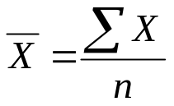
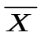 = Arithmetic Mean (Mean)
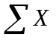 Indicates sum all X values in the data set
n = Total number of observations (Sample Size)

Arithmetic Mean Calculation for Raw Data- An Example

The inner diameter of a particular grade of tire based on 5 sample measurements are as follows: (figures in millimeters)

565, 570, 572, 568, 585

Applying the formula

We get mean = (565+570+572+568+585)/5 =572

Caution: Arithmetic Mean is affected by extreme values or fluctuations in sampling. It is not the best average to use when the data set contains extreme values (very high or very low values).

Median is the middle most observation when you arrange data in ascending or descending order of magnitude. That is, the data are ranked and the middle value is picked up. Median is such that 50% of the observations are above the median and 50% of the observations are below the median.

Median is a very useful measure for ranked data in the context of consumer preferences and rating. It is not affected by extreme values but is affected by the number of observations.

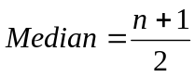th value of ranked data
n = Number of observations in the sample

Note: If the sample size is an odd number then median is (n+1)/2 in the ranked data. If the sample size is even, then median will be between two middle values. You take the average of these two middle values.

Median Calculation for Raw Data-An Example for Odd Size Sample

Marks obtained by 7 students in Computer Science Exam are given below:
Compute the median.

45 40 60 80 90 65 55

Arranging the data after ranking gives

90 80 65 60 55 45 40

Median = (n+1)/2 th value in this set = (7+1)/2 th observation= 4th observation=60
Hence Median = 60 for this problem.

Median Calculation for Raw Data -Even Sample Size

Diameter of a shaft in millimeters in a manufacturing unit is given below for 10 samples. Calculate the median value.

2.50 2.45 2.55 2.60 2.46 2.43 2.56 2.58 2.66 2.65

Arranging the data in the ascending order, you will get

2.43 2.45 2.46 2.50 2.55 2.56 2.58 2.60 2.65 2.66

The median falls between 5th and 6th observation. That is between 2.55 and 2.56.
Hence median = (2.55+2.56)/2 =2.555

Mode is that value which occurs most often. It has the maximum frequency of occurrence. Mode is not affected by extreme values.

Mode is a very useful measure when you want to keep in the inventory the most popular shirt in terms of collar size during festival season. Median and mean will not be helpful in this type of situation. Another example where mode is the only answer is in determining the most typical shoe size to be kept in stock in a shop selling shoes.

Caution: In a few problems in real life, there will be more than one mode such as bimodal and multi-modal values. In these cases mode cannot be uniquely determined.

Mode Calculation for Raw Data-An Example

The life in number of hours of 10 flashlight batteries are as follows: Find the mode.
340 350 340 340 320 340 330 330 340 350

340 occurs five times. Hence, mode=340.

Mean, Median, and Mode for Grouped Data (Frequency Distribution)

Information based decision making is the order of the day. When a large volume of raw data will have to be processed into information, you need the measures of central tendency- mean, median, and mode to be calculated based on the frequency distribution (also called grouped data). The formulas and calculations are explained one after the other in symbolic form.

Mean for Grouped Data

Formula for Mean is given by
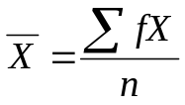
Where 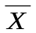 = Mean
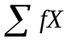 = Sum of cross products of frequency in each class with midpoint X of each class
n = Total number of observations (Total frequency)= 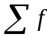

Example: Find the arithmetic mean for the following continuous frequency distribution:

Class 0-1 1-2 2-3 3-4 4-5 5-6
Frequency 1 4 8 6 3 1

Solution for mean

The midpoint of the first class is (0+1)/2 =0.5; the midpoint of the second class, _{is} (1+2)/2 = 1.50, and so on. Again these calculations can be done on a spreadsheet, as shown below:

 | A | B | C | D
1 | Class | X | f | fX
2 | 0-1 | 0.5 | 1 | 0.5
3 | 1-2 | 1.5 | 4 | 6.0
4 | 2-3 | 2.5 | 8 | 20.0
5 | 3-4 | 3.5 | 7 | 24.5
6 | 4-5 | 4.5 | 3 | 13.5
7 | 5-6 | 5.5 | 2 | 11.0
8 | Totals |  | 25 | 75.5
9 | Mean |  |  | 3.02

Mean = = 75.5/25=3.02
It is easy to see from the spreadsheet that 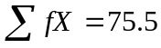 and 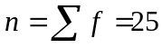.
Note: The mean calculated for grouped data is only an approximation because you assume in this formula that all the values in any class is equal to the mid point of that class. This assumption leads to the conclusion that the mean of 3.02 computed above is only a good approximation of the actual mean.

Median for Grouped Data

Formula for Median is given by

Median =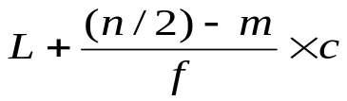
Where L =Lower limit of the median class
n = Total number of observations =
m= Cumulative frequency preceding the median class
f= Frequency of the median class
c= Class interval of the median class

Example: Find the median for the following continuous frequency distribution:

Class 0-1 1-2 2-3 3-4 4-5 5-6
Frequency 1 4 8 6 3 1

Solution for median

Class | Frequency | Cumulative Frequency
0-1 | 1 | 1
1-2 | 4 | 5
2-3 | 8 | 13
3-4 | 7 | 20
4-5 | 3 | 23
5-6 | 2 | 25

Note: As in the case of mean, median for grouped data is also an approximate value of the actual median.

Substituting in the formula the relevant values,
Median =

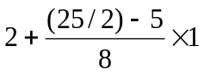 = 2.9375

Mode for Grouped Data
Mode = 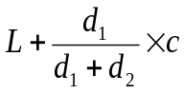
Where L =Lower limit of the modal class
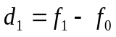
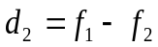

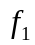 = Frequency of the modal class
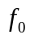= Frequency preceding the modal class
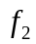 = Frequency succeeding the modal class
C = Class Interval of the modal class

Example: Find the mode for the following continuous frequency distribution:

Class 0-1 1-2 2-3 3-4 4-5 5-6
Frequency 1 4 8 6 3 1

Solution for mode

Class | Frequency
0-1 | 1
1-2 | 4
2-3 | 8
3-4 | 7
4-5 | 3
5-6 | 2

Note: Just like mean and median, for grouped data, mode is also an approximate value of the actual mode.

Substituting in the formula the values of the relevant terms,

Mode = 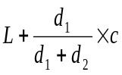

=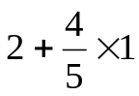 = 2.8
(Note: d₁ = f₁-f₀ =8-4 =4. d₂=f₁-f₂ =8-7 =1)

Comparative Picture of Mean, Median, Mode

Mean | Median | Mode
- Defined as the arithmetic average of all observations in the data set.  - Requires measurement on all observations.  - Uniquely and comprehensively defined.  - Affected by extreme values.  - Can be treated algebraically. That is, Means of several groups can be combined. | Defined as the middle value in the data set arranged in ascending or descending order.  Does not require measurement on all observations  Cannot be determined under all conditions.  Not affected by extreme values.  Cannot be treated algebraically. That is, Medians of several groups cannot be combined. | Defined as the most frequently occurring value in the distribution; it has the largest frequency.  Does not require measurement on all observations  Not uniquely defined for multi-modal situations.  Not affected by extreme values.  Cannot be treated algebraically. That is, Modes of several groups cannot be combined.

3.3 Measures of Dispersion (Variation), Range, Mean Absolute Deviation,
Standard Deviation, Coefficient of Variation

Measures of Central Tendency by themselves are not adequate in analyzing business data. Consider the following data of salaries paid to Executives of three departments with each having on its roaster 4 executives.

Figures: Salaries per month in Rs

Department A | Department B | Department C
25000 | 24000 | 18000
25000 | 26000 | 32000
25000 | 23000 | 15000
25000 | 27000 | 35000

If you carefully study the above table, you will notice that the average salary per executive is Rs.25000 for all the three departments. Department A has no variation and all are getting identical salaries. Department B shows some variation but not too bad. Department C shows a high level of dispersion and Scattering. Therefore, you have to study the spread or dispersion around the central tendency. In other words, statistical measures of central tendency and measures of dispersion (variation) will have to be studied together for drawing meaningful conclusions.

Measures of Dispersion (Spread)

In simple terms, measures of dispersion indicate how large the spread of the distribution is around the central tendency. It answers unambiguously the question " what is the magnitude of departure from the average value for different groups having identical averages?” It is important to study the central tendency along with dispersion to throw light on the shape of the curve; to gauge whether there is distortion to the bell shaped symmetrical normal distribution curve that forms the foundation stone upon which the entire statistical inference is built.

Consider the following pictures:

Inferences from the graphs above:

The first one represents two symmetrical bell shape distributions with different central tendency. The second one represents two symmetrical bell shape distributions with same mean but different spread or variation. The third one reveals the shape of the distribution. It is easy for you to see that the shape of the distribution is influenced both by the central tendency and the dispersion.

Range is the simplest of all measures of dispersion. It is calculated as the difference between maximum and minimum value in the data set.

Range = 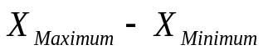

Example for Computing Range

The following data represent the percentage return on investment for 10 mutual funds per annum. Calculate Range.

12, 14, 11, 18, 10.5, 11.3, 12, 14, 11, 9

Range = = 18-9=9

Range is a good measure of spread in a distribution only when the data set shows a stable pattern of variation without extreme values. If one of the components of range, namely the maximum or minimum value becomes an extreme value, then range should not be used. The other weakness of range is that it is based only on two observations. Suppose you have 1000 observations measured on a particular characteristic, range will ignore 998 observations! Range is a popular measure of variation in quality control applications where you take samples of 4 or 5 observations at regular intervals of time.

Mean Absolute Deviation (MAD) is defined as the average based on the deviations measured from arithmetic mean in which all deviations are treated as positive, ignoring the actual sign. Unlike range, MAD is based on all observations. Hence it reflects the dispersion of every item in the distribution. In symbolic form it is defined by the following formula:
MAD = 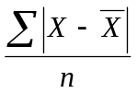
Where 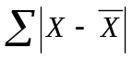 represents sum of all deviations from arithmetic mean after ignoring sign, 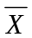= Arithmetic Mean
n = Number of observations in the sample(sample size)

Caution: Mean Absolute Deviation (MAD) has two weaknesses. 1) It cannot be combined for several groups. 2) Ignoring the sign has serious implications to a business manager attempting to measure the spread of the distribution in a scientific manner.

An Example for Calculating MAD

The following data represent the percentage return on investment for 10 mutual funds per annum. Calculate MAD (Please note that this is the same example used for computing Range)

12, 14, 11, 18, 10.5, 11.3, 12, 14, 11, 9

Solution:

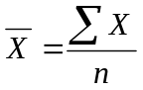= (12+14+11+18+10.5+11.3+12+14+11+9)/10 =12.28
= 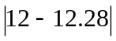+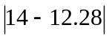+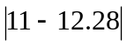+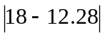+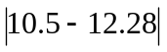+
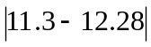++++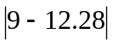=18.32
MAD == 18.32/10 =1.832

If you look at the deviations of each term from the mean (12.28), you will easily see how erroneous it is to ignore the signs. Take for example, the deviation 14-12.28 and compare it with 9-12.28. If you ignore the sign, the first one produces a deviation of 1.72 and the second of 3.28. Can you conclude that getting a return of 9% is better than getting a return of 14% because the deviation is favorable when measured from the average return of 12.28? The answer is a clear "NO".

Standard deviation forms the basis for the discussion on Inferential Statistics. It is a classic measure of dispersion. It has many advantages over the rest of the measures of variations. It is based on all observations. It is capable of being algebraically treated which implies that you can combine standard deviations of many groups. It plays a very vital role in testing hypotheses and forming confidence interval. You will appreciate the use of standard deviation in later modules that deal with statistical inference.

To define standard deviation, you need to define another term called variance. In simple terms, standard deviation is the square root of variance. In order to get a complete picture, look at the following table of terms and notations.

Important Terms with notations | Key Remarks
Sample Variance 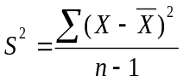  Sample Standard Deviation S=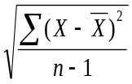  Population Variance 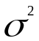=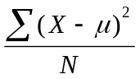  Population Standard Deviation 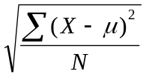  Where (Sample Mean) and 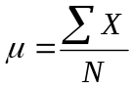(Population Mean)  n =Number of observations in the sample(Sample size)  N =Number of observations in the Population(Population Size) | - is an unbiased estimator of =  - is an unbiased estimator of  - The divisor n-1 is always used while calculating sample variance for ensuring property of being unbiased  - Standard deviation is always the square root of variance

An Example to Calculate Standard Deviation

The following data represent the percentage return on investment for 10 mutual funds per annum. Calculate the sample standard deviation (Please note that this is the same example used for computing Range and MAD).

12, 14, 11, 18, 10.5, 11.3, 12, 14, 11, 9

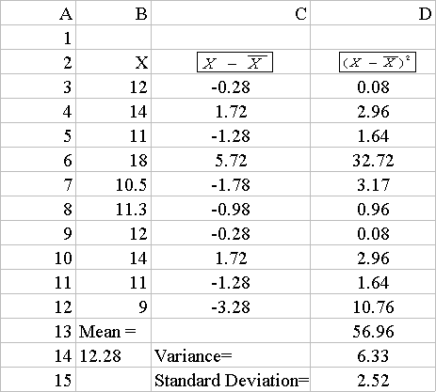
It is easy to compute the variance and standard deviation using Microsoft Excel spreadsheet. The Calculations are shown below:

From the spreadsheet of Microsoft Excel, it is easy to see that Mean = =12.28(In column A and row14, 12.28 is seen).
- Sample Variance ==6.33(In column D and row 14, 6.33 is seen)
- Sample Standard Deviation = S ==2.52(In column D and row 15, 2.52 is seen)

A comparative picture of the spread calculated by the three Measures of Dispersion
For this illustration:

Dispersion Used | Calculated Value | Remarks
Range  Mean Absolute Deviation (MAD)  Standard Deviation | 9  1.832  2.52 | Range is not reflecting the reality in this example. This is because one of its components bears the maximum value of 18 which is an extreme value.  Mean Absolute Deviation (MAD) seems better than Range but ignoring the sign of deviation has serious implications in this example as pointed out earlier.  Standard Deviations is an elegant measure here. It brings out profoundly the risk factor in the return on investment of the mutual funds as 2.52. This means that the departure from an average return of 12.28 could be 2.52 on either side(+2.52 or -2.52)

All factors considered, Standard Deviation is the Measure of Dispersion you will be using most often as a manager while analyzing the spread or Scattering around the central tendency in any business analysis and problem solving exercise.

Standard Deviation Calculation for Grouped Data (Frequency Distribution)

The standard deviation for sample data, based on frequency distribution is given by

S =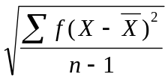 which is used to estimate the Population Standard Deviation .
Here , n is the Sample Size =, X =Mid Point of each class

An Example: Frequency Distribution of Return on Investment of Mutual Funds

 | Number of Mutual Funds
5-10  10-15  15-20  20-25  25-30  Total | 10  12  16  14  8  60

You can do this calculation of Sample Standard Deviation using the spreadsheet of Microsoft Excel.

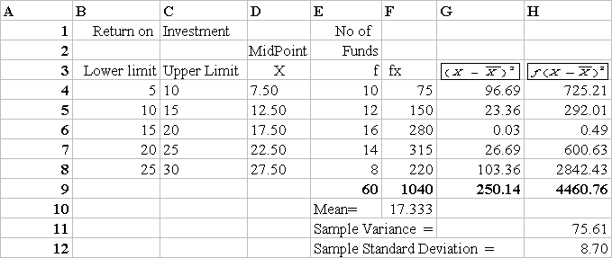
Note: Mean ==1040/60=17.333(cell F10),
Standard Deviation = S == 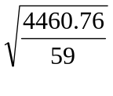=8.70(Cell H12)

Coefficient of Variation (CV) is defined as the ratio of Standard Deviation to Mean. In symbolic form CV= 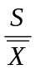 for sample data and 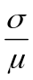 for the population data. CV is the measure to use when you want to see the relative spread across groups or segments. It also measures the extent of spread in a distribution as a percentage to the mean. Larger the CV, greater is the percentage spread. As a manager, you would like to have a small a CV so that your assessment in a situation is robust. The percentage risk is minimized.

An Example for CV

Consider two Sales Persons working in the same territory. The sales performance of these two in the context of selling PCs are given below. Comment on the results.

Sales Person 1 | Sales Person 2
Mean Sales (One year average) 50 units  Standard Deviation 5 units | Mean Sales (One year average)75 units  Standard Deviation 25 units

The CV is 5/50 =0.10 or 10% for Sales Person1 and 25/75=0.33 or 33% for Sales Person 2. It seems Sales Person1 performs better than Sales Person 2. Information based decision making is the order of the day. When a large volume of raw data will have to be processed into information, you need the measures of central tendency- mean, median, and mode to be calculated based on the frequency distribution. also called grouped data. The formulas and calculations are explained one after the other in symbolic form.
2 with less relative dispersion or scattering. Sales Person 2 has a very high departure or standard deviation from his average sales achievement. The moral of the story is "do not get carried away by absolute number". Look at the scatter. Even though, Sales Person 2 has achieved a higher average, his performance is erratic, not consistent.

3.4 Module Summary

In this module, you have been exposed to the concepts and applications of the summary measures of central tendency and measures of dispersion along with their strengths and limitations. To be specific, this module focused on the following:

- The meaning, definition, and role of the three measures of central tendency- arithmetic mean, median, and mode along with the calculations of these three for raw data and grouped data

- The meaning, definition, and role of the three measures of dispersion - range, mean absolute deviation(MAD), and standard deviation along with the calculation of standard deviation for raw data and grouped data

- The definition and use of coefficient of variation(CV) with an example
Glossary:

Central Tendency: Whenever we measure things of the same kind, a fairly large number of such measurements will tend to cluster around the middle value. This is known as central tendency.

Coefficient of Variation (Relative Dispersion): Coefficient of Variation (CV) is defined as the ratio of Standard Deviation to Mean. CV measures the relative spread across groups or segments.

Dispersion (Variation): Dispersion indicates how large the spread of the distribution is around the central tendency.

Mean (Arithmetic Mean): Mean (Arithmetic Mean) is the most common measure of central tendency used by all managers in their sphere of activities. It is defined as the sum of all observations in a data set divided by the total number of observations.

Mean Absolute Deviation: Mean Absolute Deviation (MAD) is a measure of dispersion that is computed as the average based on the deviations measured from arithmetic mean in which all deviations are treated as positive, ignoring the actual sign

Measure of Central Tendency: If one typical representative average is defined in such a manner that the remaining items in the data set will cluster around this value, such a value is called a measure of " Central Tendency".

Measure of Dispersion: A measure that assesses the magnitude of departure from the average value (central tendency) is called measure of dispersion.

Median: Median is the middle most observation when we arrange data in ascending or descending order of magnitude. Median is such that 50% of the observations are above the median and 50% of the observations are below the median.

Mode: Mode is that value which occurs most often. It has the maximum frequency of occurrence.

Range: It is calculated as the difference between maximum and minimum value in a data set.

Symmetrical: It is a property of a distribution in which the area covered in one half portion is the mirror image of the other half portion.

Standard Deviation: Standard deviation is the positive square root of variance. Its unit of measurement is same as that of the original data.

Variance: It is a measure of dispersion that is computed as the average sum of square of each item from the mean in a data set.

