Module 6: Probability Distributions:

Dr. P.K.Viswanathan, Professor, Great Lakes Institute of Management

Introduction

Very often we want to describe and analyze numbers in the form of a distribution. You have seen this sharply in module 2 and module 3. Distributions can be formed by two methods; 1) from data collected and 2) with the help of standard distributions that have stood the test of time. This module provides the conceptual framework and applications of the three widely used probability distributions namely The Binomial Distribution, The Poisson Distribution, and The Normal Distribution. While the first two are discrete in nature, the last one is a continuous distribution.

6.1 What is a Probability Distribution?

To grasp the essence of a Probability Distribution, let us look at an example. This example will bring into sharp focus the underlying concepts of a probability distribution.

Example:

You rotate a pair of dice and observe the sum by totaling the numbers that turn up in both the dice. Let us designate this sum by a random variable X. When the first die shows up number 1, the second die could be 1, 2, 3, 4,5,6. Likewise when the first die shows up number 2, the second die could be 1, 2, 3, 4, 5, 6. If you continue this experiment this way until all the possibilities are exhausted, the sample space will contain 36 elements. The distribution that can be observed by us will contain a sum =2, 3,4,5,6,7,8,9,10,11,12. Please note that the starting sum will be =2 because when both the dice show up number 1, the sum =1+1 =2. Likewise, the maximum sum in the distribution will be 12 when both the dice show up a number 6. If we write the values of the random variable (sum) with associated probabilities, it will become what is called a probability distribution.

Sample Space for the Example

(D1 D2) | (D1 D2) | (D1 D2 | (D1 D2) | (D1 D2) | (D1 D2)
(1 1) | (2 1) | (3 1) | (4 1) | (5 1) | (6 1)
(1 2) | (2 2) | (3 2) | (4 2) | (5 2) | (6 2)
(1 3) | (2 3) | (3 3) | (4 3) | (5 3) | (6 3)
(1 4) | (2 4) | (3 4) | (4 4) | (5 4) | (6 4)
(1 5) | (2 5) | (3 5) | (4 5) | (5 5) | (6 5)
(1 6) | (2 6) | (3 6) | (4 6) | (5 6) | (6 6)

Note: D1 represents Die1 and D2 represents Die2

For example you take the case of getting eight. Adding (2 6) = 8. Adding (3 5)=8. Adding (4 4)=8. Adding (5 3)=8. Adding (6 2)=8. You see, there are 5 possibilities in which the sum 8 can occur. If you exhaust all the values that the random variable sum can assume, there are 36 elements in the sample space. Hence, the probability of getting a sum of 8 =5/36. Likewise, the Probabilities are computed for all other values of the sums associated with this experiment.

Probability Distribution for this problem based on the above sample space

X=Sum | P(X)
2 | 1/36
3 | 2/36
4 | 3/36
5 | 4/36
6 | 5/36
7 | 6/36
8 | 5/36
9 | 4/36
10 | 3/36
11 | 2/36
12 | 1/36

Please note that the probability of the sample space =1. (Adding all the probabilities above you get 1)

In precise terms, a probability distribution is a total listing of the various values the random variable can take along with the corresponding probability of each value. A real life example would be the pattern of distribution of the machine breakdowns in a manufacturing unit. The random variable in this example would be the various values the machine breakdowns could assume. The probability corresponding to each value of the breakdown is the relative frequency of occurrence of the breakdown. The probability distribution for this example is constructed by the actual breakdown pattern observed over a period of time. Statisticians use the term “observed distribution” of breakdowns.

Inline Question 1: The relative frequency distribution is an example of a probability distribution. True or False.

Answer: True because relative frequency of each class is a proportion or percentage of the frequency of that class to the total frequency. This indicates therefore the probability of the particular class occurring.

Another Example for a Probability Distribution

A multinational bank is concerned about the waiting time of its customers before they could use the ATM for their transactions. A study of a random sample of 500 customers reveals the following probability distribution.

X ( Waiting Time per  Customer in Minutes) |  | P(X)
0 | 0.20
1 | 0.18
2 | 0.16
3 | 0.12
4 | 0.10
5 | 0.09
6 | 0.08
7 | 0.04
8 | 0.03
Total | 1.00

What is the probability that a customer will wait more than 5 minutes?
What is the probability that a customer need not wait?
What is the probability that a customer will wait less than 4 minutes?

Solution:
P (X > 5) = P(6)+P(7)+P(8) =0.08+0.04+0.03=0.15
P(X=0) = 0.20
P(X<4) = P(0)+P(1)+ P(2)+ P(3)=0.20+0.18+0.16+0.12=0.66

Please note that the example discussed above is known by the term “Observed Probability Distribution” because it is data driven.

Expected Value of a Random Variable is another fundamental term, which you must explain in the context of decision making under uncertainty. The expected value of a random variable is computed by multiplying each value that the random variable can assume by the corresponding probability of occurrence of that value and then take the summation of these cross product terms. The probabilities are the weights that are attached to each of the value the random variable can take. In other words, expected value of a random variable is a weighted average of the all the possible outcomes of an experiment.

To understand how the expected value is calculated, let us take the multinational bank
example discussed earlier.

X ( Waiting Time per  Customer in Minutes) |  | P(X) | 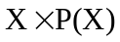
0 | 0.20 |  | 0.00
1 | 0.18 |  | 0.18
2 | 0.16 |  | 0.32
3 | 0.12 |  | 0.36
4 | 0.10 |  | 0.40
5 | 0.09 |  | 0.45
6 | 0.08 |  | 0.48
7 | 0.04 |  | 0.28
8 | 0.03 |  | 0.24
Total | 1.00 |  | 2.71

From the table in the last row in column 3 against Total you see the value 2.71. This is the
Expected value of X designated as E(X) and it is found to be equal to 2.71 Minutes. Thus the average waiting time of a customer before getting access to ATM is 2.71 minutes.

Discrete Probability Distribution
The two examples we have taken to explain the concept of a probability distribution are called discrete probability distributions. The probability distribution that uses a discrete random variable is called a discrete probability distribution. A discrete random variable implies that the random variable can assume only a restricted number of distinct values. The number of units demanded per day of a product is an example of a discrete random variable. The number of cars passing through a street per hour during peak traffic is an example of a discrete random variable. In this module, we will deal with two types of discrete probability distribution namely 1) The Binomial Distribution and 2) The Poisson Distribution.

Continuous Probability Distribution
The probability distribution that uses a continuous random variable is called a continuous probability distribution. A continuous random variable is a random variable, which can take any value within some interval of real numbers. Measurement of the height and weight of the respondents is an example of a continuous random variable. Similarly, voltage, pressure, and temperature, are examples of continuous random variables. In this module, we will deal with the important continuous distribution namely the Normal Distribution.

6.2 The Binomial Distribution

The Binomial Distribution is a widely used probability distribution of a discrete random variable. It plays a major role in quality control and quality assurance function. Manufacturing units do use the binomial distribution for defective analysis. An item is considered defective if it has one or more types of defects. Reducing the number of defectives using the proportion defective control chart (p chart) is an accepted practice in manufacturing organizations. Binomial distribution is also being used in service organizations like banks, and insurance corporations to get an idea of the proportion customers who are satisfied with the service quality.

The conditions for applying Binomial Distribution are enunciated in the Bernoulli Process. They are given below

- Trials are independent and random

- There are fixed number of trials (n trials)

- There are only two outcomes of the trial designated as success or failure.
(Success or failure are generic terms and may very well include terms like yes or no,
defective, or non-defective, good or bad, etc

- The probability of success is uniform through out the n trials

Binomial Probability Function

Under the conditions of a Bernoulli process,
The probability of getting x successes out of n trials is indeed the definition of a Binomial Distribution. The Binomial Probability Function is given by the following expression
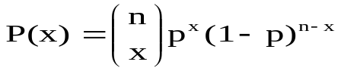
Where P(x) is the probability of getting x successes in n trials

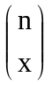 is the number of ways in which x successes can take place out of n trials =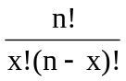

p is the probability of success, which is the same through out the n trials.
p is the parameter of the Binomial distribution

x can take values 0, 1, 2, ………., n

Note: In the usual notation 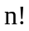 = 1.2.3.4…………n (It is the product of the first n terms). For example, 5! = 1.2.3.4.5 =120.

Example:

A bank issues credit cards to customers under the scheme of Master Card. Based on the past data, the bank has found out that 60% of all accounts pay on time following the bill. If a sample of 7 accounts is selected at random from the current database, construct the Binomial Probability Distribution of accounts paying on time.

Solution:

This problem can be structured as a Bernoulli Process where an account paying on time is taken as success and an account not paying on time is taken as failure. The random variable x represents here an account paying on time, which can take values 0,1,2,3,4,5,6,7. You need to prepare a table containing x and P(x) for all the values of x. Performing calculations using Binomial Probability Function for x= 0,1,2,3,4,5,6,7 is very tedious. One option available to you is to use the Binomial Probability Table that gives the probability value for a given value of n, p, and x.

The best option is to use the functions available in stats package in Python. The function, scipy.stats.binom.pmf gives the probability mass function for the binomial distribution and the output gives probability of binomial distribution function in terms of array. The function, scipy.stats.binom.cdf(k,n,p) gives cumulative binomial distribution and the output gives cumulative probability of binomial distribution function in terms of array.

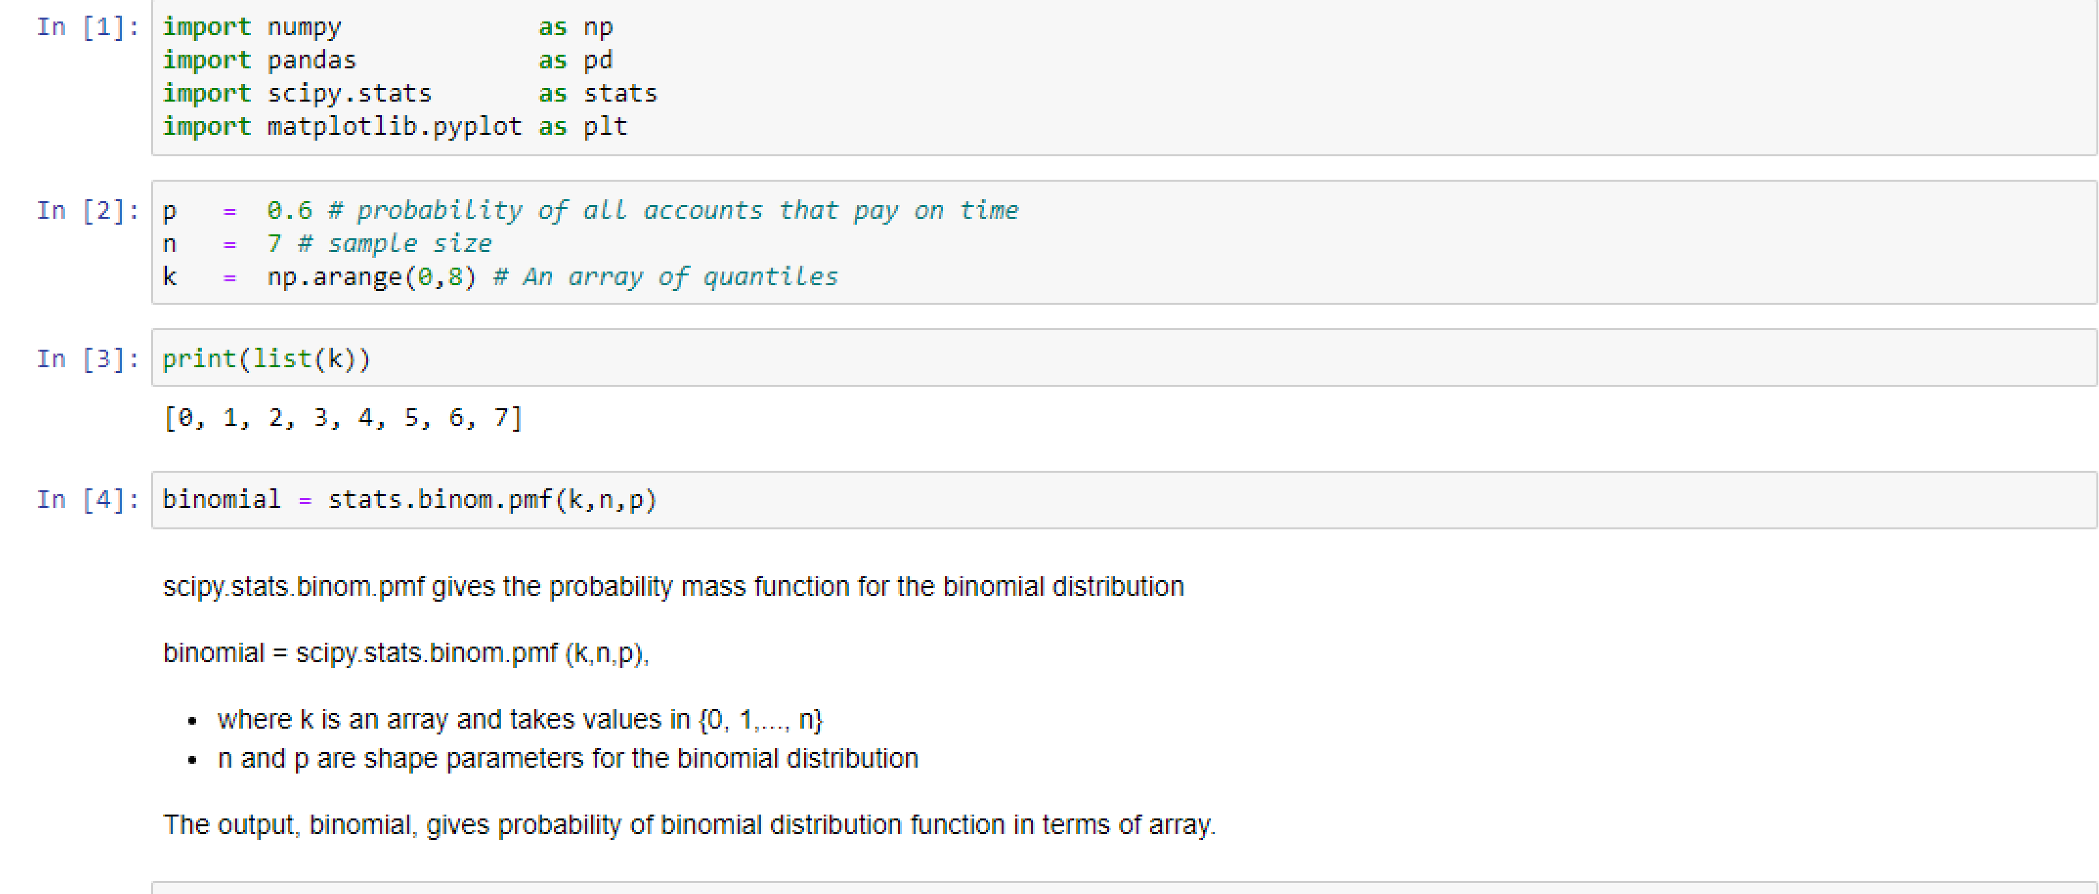
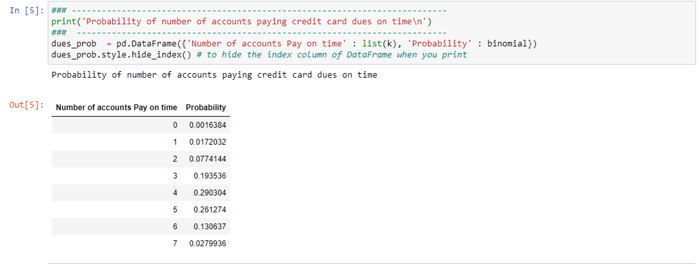
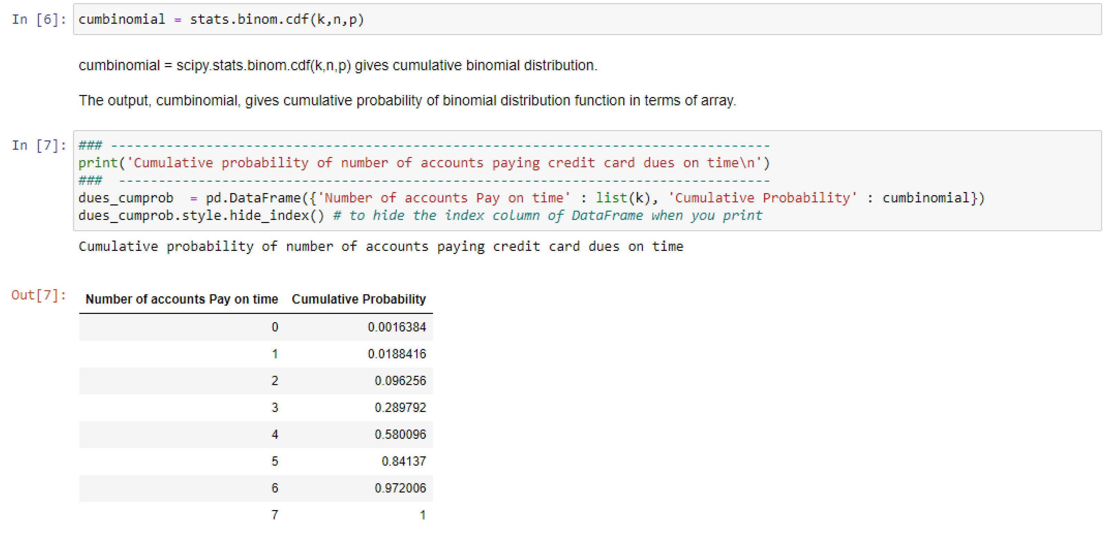
In Input area 1, we import the required packages and setting alias name for each of them. We import numpy package for performing numerical operations, pandas for data frame manipulations, scipy.stats module for performing statistical calculations such as Binomial probabilities etc. and matplotlib.pyplot for showing graphs.
In input area 2, we assign p, the probability of success for each trial; n , the number of trials and k an array of quantities ranging from 0 to 7.
In input area 3, we print the values of k.
In input area 4, we invoke the function, stats.binom.pmf with parameters (k,n,p) and store the output as an array binomial. This binomial array gives the probabilities for individual terms.
In input area 5, we store the binomial array and k, the array of quantities as a Pandas data frame and print the same and hide the index column of the data frame.
In input area 6, we invoke the function, stats.binom.cdf with parameters (k,n,p) and store the output as an array cumbinomial. This cumbinomial array gives the cumulative probabilities.
In input area 7, we store the cumbinomial array and k, the array of quantities as a Pandas data frame and print the same and hide the index column of the data frame.

Inline Questions:

From the Binomial Probability Distribution example discussed, answer the following fill in the blank questions.

- What is the probability of getting not more than 3 accounts paying on time?
The answer is -------------------

- What is the probability of at least 4 accounts paying on time?
The answer is -------------------

- What is the probability of no account paying on time?
The answer is --------------

Solution: Look at the below images given below again for answering the questions.

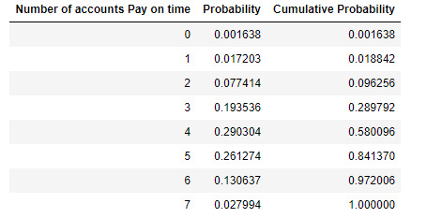

1) You want P (x < =3). The answer is 0.289792. Why? Can you justify? Column “Cumulative Probability” gives the cumulative probability corresponding to the x value. Look at Column “Nature of accounts Pay on time”, which gives the values that can be assumed by x. When x =3, the cumulative probability column says the required answer is 0.289792.

2) You want P(x > = 4)= P(4)+P(5)+p(6)+P(7)= 1-P(x< =3)= 1-0.289792 = 0.710208

3) You want P(x=0) = P(0) =.001638.

You will appreciate by now that you can tackle through Python functions intriguing and complicated problems on the Binomial Distribution.

The binomial density function plot for n = 8 trials; k represents the number of successes or event of interest (credit card payment on time). The binomial probability density function lets you to obtain the probability of observing exactly k successes in n trials, with the probability p of success on a single trial and q = 1 - p. We can plot the binomial density function using the matplotlib package as shown below:

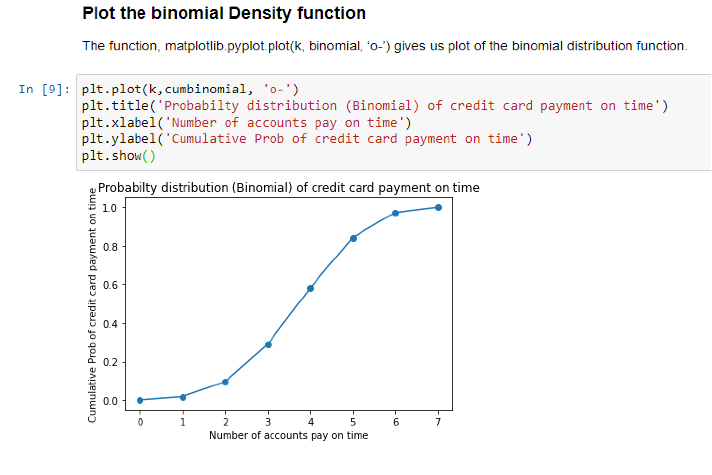
In the input area 9, we use the alias, plt for denoting matplotlib.pyplot. We plot the graph for probability distribution (Binomial) of credit card payment on time by using x axis for k, number of accounts pay on time and y axis for cumbinomial, cumulative probability of credit card payment on time.

The function plt.plot(k, cumbinomial, 'o-') plots cumbinomial (Cumulative probability) vs k (number of successes) as markers, '_' for denoting a hline marker and 'o' denoting a circle marker.

Functions plt.title(), plt.xlabel() and plt.ylabel() let you add title, x axis label and y axis label to the graph.

plt.show() will show the current figure.

The Mean and Standard Deviation of the Binomial Distribution

The mean μ of the Binomial Distribution is given by μ = E(x)= np
The Standard Deviation σ is given by σ = 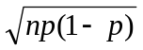
Mathematically, we can derive both these measures. The derivations are not really important for managers taking decisions that involve the use of the Binomial Distribution. We therefore omit the derivations here. Intuitively speaking, it makes sense that the mean =np. For example, in a production process, if the proportion defective (p) is 0.10 for a particular component, then over a period of time, it is reasonable to expect that the defective components in the output would be 0.10 times the total output. The standard deviation gives an idea about the spread and scattering about the mean and in this case, it measures the departure from the average defective output.

Example for Mean and Standard Deviation: A bank issues credit cards to customers under the scheme of Master Card. Based on the past data, it has found out that 60% of all accounts pay on time following the bill. If a sample of 7 accounts is selected at random from the current database, calculate the mean and standard deviation of the accounts paying on time?

This problem can be structured as a Bernoulli Process where an account paying on time is taken as success and an account not paying on time is taken as failure. The random variable x represents here an account paying on time, which can take values 0,1,2,3,4,5,6,7. Applying the formula for mean μ= np , you get mean = 7×0.6 =4.2. That is you can expect on an average 4.2 of the accounts will pay on time. Applying the formula for standard deviation σ = , you get standard deviation = 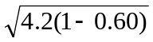= 1.30

6.3 The Poisson Distribution

Poisson Distribution is another discrete distribution which also plays a major role in quality control in the context of reducing the number of defects per standard unit such as number of defects per item, number of defects per transformer produced, number of defects per 100 m²
of cloth, etc. Other real life examples would include 1) The number of cars arriving at a highway check post per hour, 2) The number of customers visiting a bank per hour during peak business period among others.

Poisson Probability Distribution Function is worked out based the Poisson Process characterized by the following:

- The probability of getting exactly one success in a continuous interval such as length, area, time and the like is constant
- The probability of a success in any one interval is independent of the probability of success occurring in any other interval.
- The probability of getting more than one success in an interval is 0.

Poisson Distribution Formula

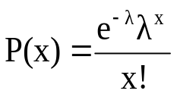
where
P(x) = Probability of x successes given an idea of
= Average number of successes
e = 2.71828(based on natural logarithm)
x = successes per unit which can take values 0, 1, 2, 3,…………..∞

is the Parameter of the Poisson Distribution.
Mean of the Poisson Distribution is =
Standard Deviation of the Poisson Distribution is = 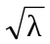

Example: If on an average, 6 customers arrive every two minutes at a bank during the busy hours of working, a) what is the probability that exactly four customers arrive in a given minute? b) What is the probability that more than three customers will arrive in a given minute?

Solution:

= 3 ( 6 customers every two minutes implies 3 customers per minute)

a) You are required to find out P(x =4). Substituting in the formula the value of x =4, you can get the answer after simplifying the expression .
In order to solve this problem, we use Python packages, numpy for performing numerical operations, pandas for performing operations on data frames and scipy.stats for performing statistical calculations such as getting Poisson probabilities.
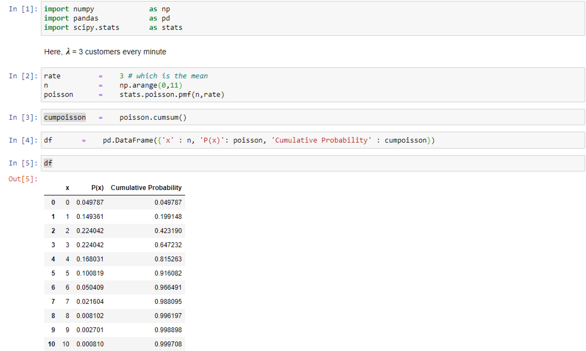

In input area 1, we import packages numpy, pandas and scipy.stats with alias names np, pd and stats respectively.

In input area 2, we set the variable, rate to hold the value 3, which represents 3 customers every minute.
n to hold the range of values from 0 to 11 and poisson to hold the output of probability mass function, pmf() given the rate and n.

In input area 3, we calculate cumpoisson, the cumulative probabilities using the cumsum() function.

In input area 4, we create a pandas data frame, df to hold the values of n, poisson and cumpoisson.

In input area 5, we display the values of the df, data frame.

Look at the table and you will find that corresponding to x =4 in column x, the probability P(x=4) is 0.168031 found in column P(x).

- You want P(x > 3) = 1- P(x < = 3) = 1-0.647232 = 0.352768 ( Please note that P(x< = 3) is found in Column ‘Cumulative Probability’ corresponding to the value of x =3 in column P(x). You could see 0.647232 in row 3 and column ‘Cumulative Probability’.

When can Poisson Distribution be used as an Approximation to the Binomial Distribution?

There is a general consensus among the statisticians that when n is greater than or equal to 20, and p is less than or equal to 0.05, the Poisson Approximation to the Binomial is a valid assumption. In this approximation, np = . Now, use the Poisson Probabilities as an approximation to the Binomial Probabilities by substituting np = in the expression . When you have the power of Microsoft Excel, this approximation loses its significance. At any rate conceptually, you should know as to when the Poisson Distribution can be used in the place of the Binomial Distribution.

Inline Question:

The number of arrivals of trucks per hour at a loading booth is an example of the

- Binomial distribution
- Normal distribution
- Poisson Distribution

Answer: The right choice is c) First Poisson distribution is a discrete distribution. Choice c is wrong because Normal distribution is a continuous distribution. Trucks arrival per hour time interval fits into the Poisson process. Number of arrivals per hour indicates the rate of arrival, (which we term as ) and hence Binomial distribution is not appropriate here.

Assignment:

An airlines in a large city, gets on an average 5 claims per day for missing baggage. Using Microsoft Excel, construct the Poisson probability distribution (both individual and cumulative) for this problem. Based on this output, answer the following:

- What is the probability that at least there are 7 claims for missing baggage?
- What is the probability of no claims for the missing baggage?
- What is the probability that there are exactly 4 claims for missing baggage?

6.4 The Normal Distribution

The Normal Distribution is the most widely used continuous distribution. It occupies a unique place in the field of statistics. In fact, the entire quality control function that employs the statistical techniques heavily will come to a grinding halt without the use of the normal distribution. The control charts for reducing and stabilizing variation relies on the normal distribution. Process capability studies to meet the customer specifications needs the normal distribution. The whole subject matter- inferential statistics is based on the normal distribution. In all management functions including the human side, the observed frequency distributions encountered are all fairly close to the normal distribution when the sample size is reasonably large.

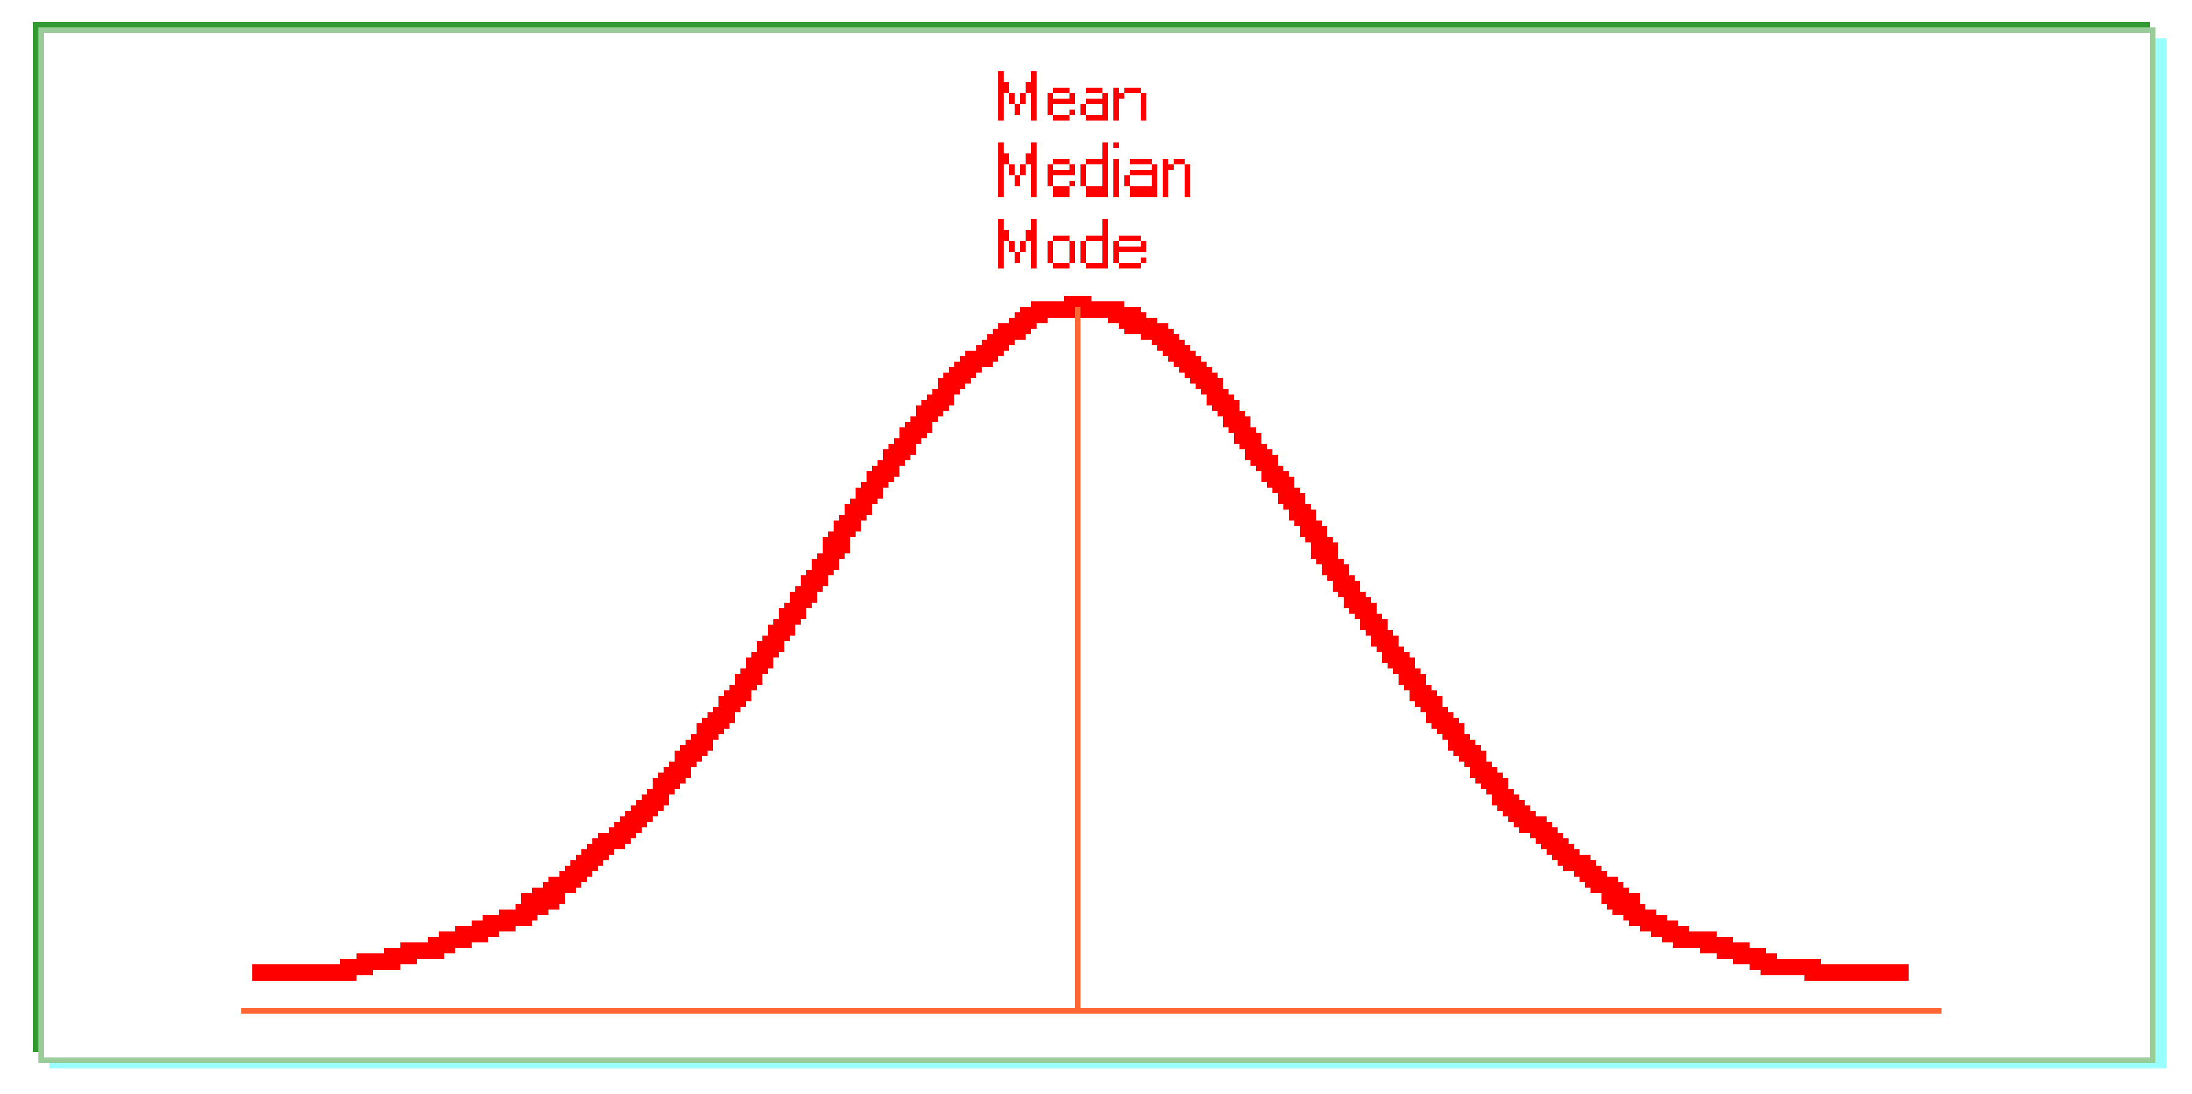
Properties of the Normal Distribution

- The normal distribution is a continuous distribution looking like a bell. Statisticians use
the expression “Bell Shaped Distribution”.

- It is a beautiful distribution in which the mean, the median, and the mode are all
equal to one another.

- It is symmetrical about its mean.

- If the tails of the normal distribution are extended, they will run parallel to the
horizontal axis without actually touching it. (asymptotic to the x-axis)

- The normal distribution has two parameters namely the mean μ and the standard deviation σ

Normal Probability Density Function

In the usual notation, the probability density function of the normal distribution is given below:
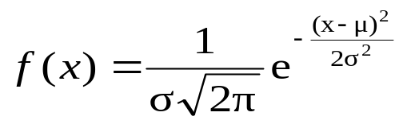
x is a continuous normal random variable with the property 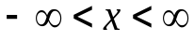 meaning x can
take all real numbers in the interval . You need not worry about this complicated
function because all calculations can be done without the help of this expression.

What is important is that you should understand the normal distribution and you should be
able to apply it to practical problems. For this purpose, the knowledge of the actual probability
density function is not required.

If x follows a normal distribution with mean μ and standard deviation σ, it is a
general practice among statisticians to symbolize this expression as x~ N (μ,σ ).

The Use of Symmetry Property of the Normal Distribution(Empirical Rule)

The symmetry property of the normal distributing is a beauty. The area under the normal curve has got three distinct positions. They are pictured as follows: Please also note that the values of the area covered under each picture are very close to the actual values that one could compute based on the probability density function of the normal distribution.

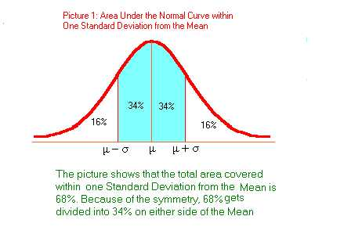
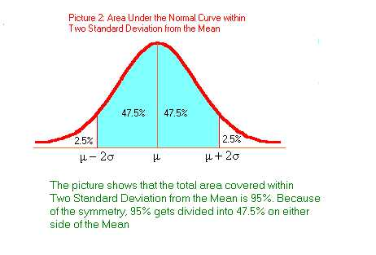
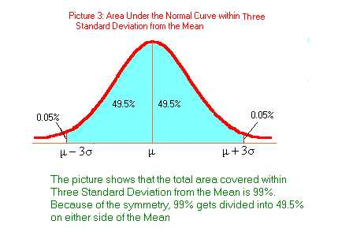

The Standard Normal Distribution

For practical problems, which require the help of the normal distribution for solutions, it is not possible to compute the probability in a straightforward manner because each of those normal variables may have different units of measurements. One problem may involve the unit meter, another may involve kilograms, and so on. Therefore you need a probability distribution that can tackle any unit of measurement. Fortunately, you have the Standard Normal Distribution defined as follows:

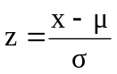. z is called the standard normal variable. Please note that z is a pure number independent of the unit of measurement. The random variable z follows a normal distribution with mean=0 and standard deviation =1. You first convert the original variable in a given problem into z. It is only a transformation of scale. The probability table for z is available for computing the necessary probabilities for a given situation. The elegant way of getting the probability value based on z is to take advantage of the Microsoft Excel.

Example Problem for the Normal Distribution

The mean weight of a morning breakfast cereal pack is 0.295 kg with a standard deviation of 0.025 kg. The random variable weight of the pack follows a normal distribution.

  - What is the probability that the pack weighs less than 0.280 kg?
  - What is the probability that the pack weighs more than 0.350 kg?
  - What is the probability that the pack weighs between 0.260 kg to 0.340 kg?

Solution: Draw the correct diagram to the original problem. This step is crucial for getting the answer. Let us draw the diagram for each part and then provide the solution using Microsoft Excel.
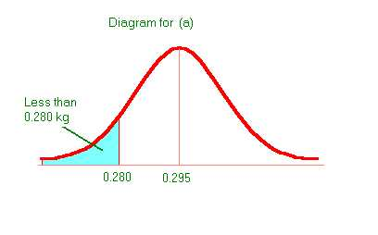
- See diagram above in which the probability of the shaded area is wanted.

= (0.280-0.295)/0.025 = -0.6.

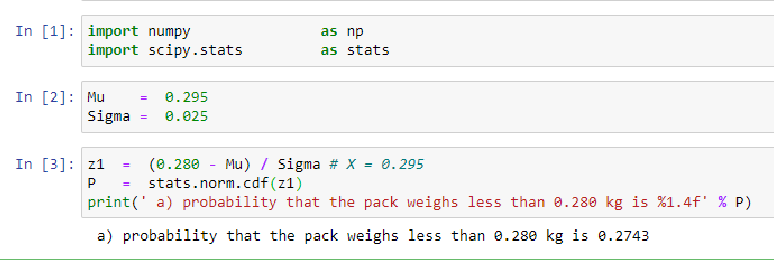

In input area 1, you import the required packages numpy and scipy.stats with aliases np and stats respecively.

In input area 2, you assign the value of 0.295 kg, the mean pack weight to the variable, Mu and the value, 0.025 kg for the standard deviation to the variable, Sigma.

In input area 3, we compute z1, by subtracting the mean from x, which is 0.280 and then divide by the standard deviation, Sigma.

Then we calculate the desired probability by using the function, norm.cdf() by giving the argument, z1 and print it to get the answer. The function, norm.cdf() calculates the Cumulative Distribution Function of a normal continuous random variable.

The answer for part a) of the question = 0.2743. This says that 27.43 % of the packs weigh less than 0.280 kg.

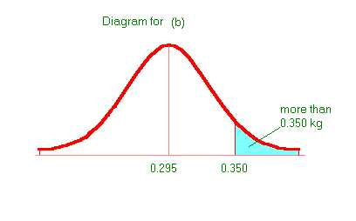

b) = (0.350-0.295)/0.025 =2.2.

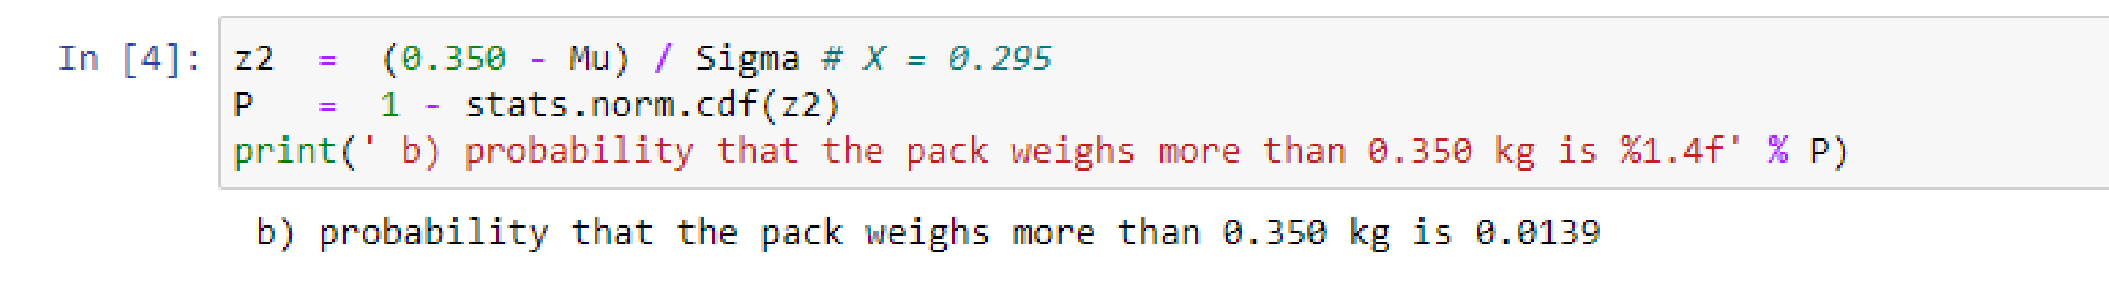
In input area 4, we have subtracted the probability obtained from the function, stats.norm.cdf() from 1 since the function returned the cumulative value of weight up to 0.350 kg. The answer to part b) of the question is 0.0139. This means that 1.39% of the packs weigh more than 0.350 kg.

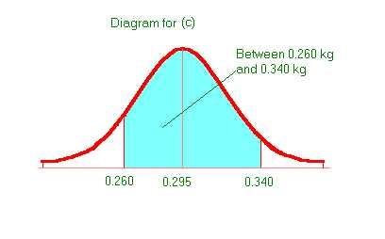

- For this part, you have to first get the cumulative probability up to 0.340 kg and then subtract the cumulative probability up to 0.260. = (0.340-0.295)/0.025 =1.8(up to 0.340). = (0.260-0.295)/0.025 = -1.4(up to 0.260).

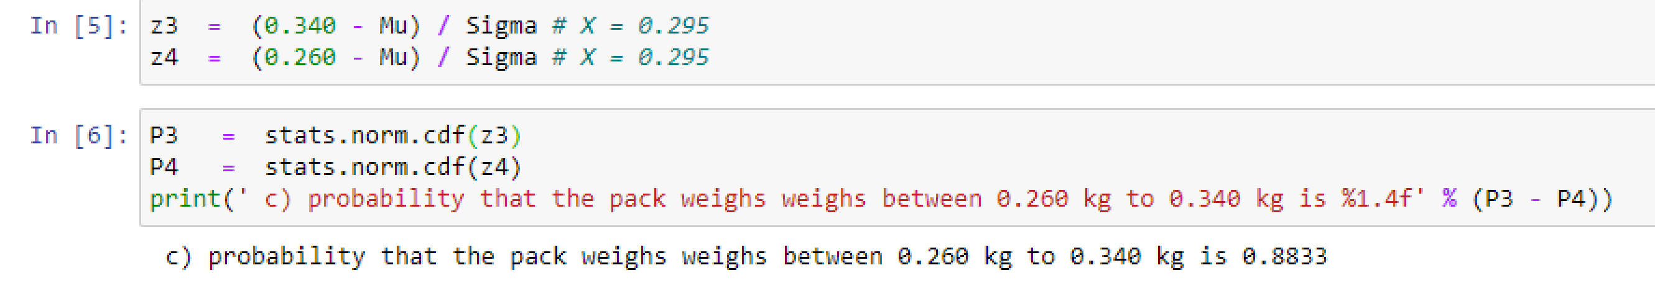

In input area 5, we calculate Z values corresponding to the weights 0.340 kg and 0,260 kg and assign the variables z3 and z4 respectively.

We have obtained the probabilities, P3 & P4 for the weights upto 0,340 kg and 0,260 kg respectively by using the function, stats.norm.cdf(). The difference, P3- P4 gives us the required answer, 0.8833. This means that 88.33% of the packs weigh between 0.260 kg and 0.340 kg.

Critical Thinking Skills:
There is another fantastic feature in Microsoft Excel by which you can get the cumulative probabilities for any normal distribution problem directly. You need not use the z distribution. Find out how is this possible from the paste function. Have a detailed discussion on this feature

Inline Question:

A large number of line voltage tests of residences reveal a mean voltage of 200 V and a standard deviation of 30 V. The distribution pattern in this case is found to be normal. Determine the percentage of voltage data between 180 V and 210 V.

Solution: First draw the appropriate diagram. In this case it is
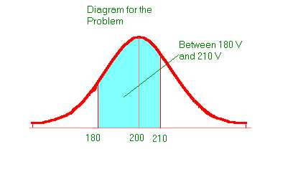
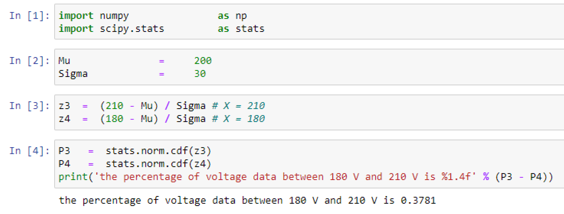

In input area 3, we calculate Z values corresponding to the weights 210 V and 180 V and assign the variables z3 and z4 respectively.

In input area 4, we calculate the cumulative probability up to 210 V as P3 and the cumulative probability up to 180 V as P4. Hence the answer is P3 – P4 = 0.3781.

That is about 37.81% of the voltage data fall in the range of 180 V to 210 V.

Inline Question: The probability that the line voltage is more than 210 V is 36.94 %. True or False.

Answer: True because the cumulative probability up to 210 V is 0.6306.

Hence the probability that the line voltage is more than 210 V = 1- 0.6306 = .3694 = 36.94%

The Normal Approximation to the Binomial Distribution

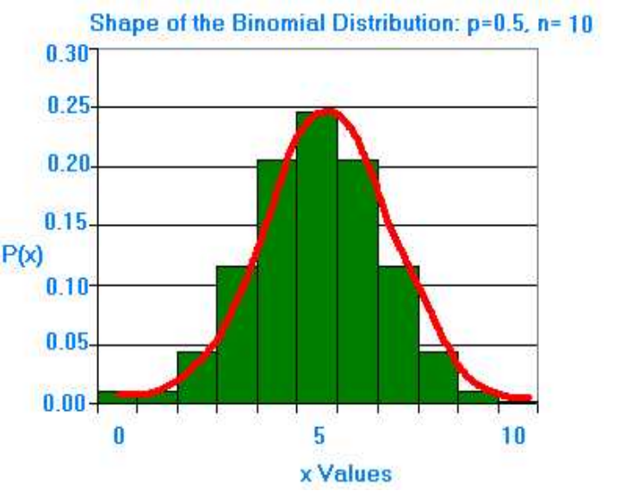 | The diagram on the left hand side shows a pattern of a symmetrical bell shaped normal distribution. In the binomial distribution by taking n=10, and p= 0.5, a histogram was first drawn in which the horizontal axis represent the success (x) and the vertical axis represents the probability of success P(x). A normal distribution is superimposed on the histogram. The shape of the histogram coincides with the normal curve almost perfectly. Hence it is agreed by many practitioners that the Normal approximation for the Binomial holds true when the value of np is at least =5.

6.5 Module Summary

This module is extremely important from the point of view of many fascinating aspects of statistical inference that would follow in the subsequent modules. Certainly it is expected from you that you better master the nitty-gritty of this module. This module specifically focused on:

- The definition, meaning, and concepts of a probability distribution.
- The related terms–discrete random variable, continuous random variable, and observed distribution
- Discrete probability distribution, and continuous probability distribution
- The Bernoulli process with its elements
- The Binomial distribution and its role in business problems
- The Poisson process
- The Poisson distribution and its uses
- The Poisson approximation to the Binomial distribution
- The Normal distribution and its role in statistical inference
- The concept of the Standard Normal Distribution and its role
- The Normal approximation to the Binomial distribution
- All through this module the pivotal role of the Microsoft Excel for probability calculations for all the distributions.

Glossary:

Bernoulli Process: It is a process in which trials are independent and random, there are fixed number of trials (n trials), there are only two outcomes of the trial usually designated as success or failure, and the probability of success is uniform through out the n trials.

Binomial Distribution: It is a probability distribution of a discrete random variable under the conditions of Bernoulli process.

Continuous Probability Distribution: It is a probability distribution that uses a continuous random variable.

Continuous Random Variable: A continuous random variable is a random variable, which can take any value within some interval of real numbers.

Discrete Probability Distribution: It is a probability distribution that uses a discrete random variable.

Discrete Random Variable: A discrete random variable is a random variable that can assume only a restricted number of distinct values.

Expected Value of a Random Variable: Expected value of a random variable is a weighted average of the all the possible outcomes of an experiment with probabilities of outcomes as weights.

Normal Distribution: It is a continuous probability distribution looking like a bell. Statisticians use the expression “Bell Shaped Distribution”. It is a beautiful distribution in which the mean, the median, and the mode are all equal to one another. It is symmetrical about its mean. If the tails of the normal distribution are extended, they will run parallel to the horizontal axis without actually touching it (Asymptotic to the x-axis). The normal distribution has two parameters-mean, and standard deviation.

Poisson Distribution: Poisson distribution is probability distribution of a discrete random variable based on the Poisson Process.

Poisson Process: It is a process characterized by the following:
The probability of getting exactly one success in a continuous interval such as length, area, time and the like is constant. The probability of a success in any one interval is independent of the probability of success occurring in any other interval. The probability of getting more than one success in an interval is 0.

Probability Distribution: A probability distribution is a total listing of the various values the random variable can take along with the corresponding probability of each value.

Standard normal Distribution: It is normal distribution with mean = 0 and standard deviation =1

