Module 8: Statistical Estimation-Concepts and Applications

Dr. P.K.Viswanathan, Professor, Great Lakes Institute of Management

Introduction

Marketing Manager in an organization needs to estimate the likely market share his company can achieve in the market place. A production manager may be interested in estimating the proportion defective of the finished product before shipment to the customer. An account manager needs to estimate the average collection period for collecting dues from the customers. How confident are they in their estimates? This module provides some insights into point estimation and interval estimation that are essential in business planning. Please remember that the three components-point estimation, interval estimation, and hypothesis testing together constitute the all-important inferential statistics.

8.1 Point Estimation

A manager of an enterprise is interested in the population (universe) value, not in a sample value! A sample is of interest as long as it throws light on the population.
Point Estimation deals with the task of selecting a specific sample value as an estimate for a population parameter.

Average Income of Purchasers of Brand X Car based on a random sample of 150 purchasers is $50000 per Annum. This is an Example of a Point Estimate.
The percentage of housewives who prefer model X refrigerator in a random sample of 250 housewives is another example of a point estimate.

A point estimate is a specific value of a sample statistic that is used to estimate a population parameter. .

Point Estimation – Population Mean

Recapitulate the contents of the previous module. The sample mean 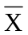is an unbiased estimator of the population mean . You will also recall that an unbiased estimator is one whose expected value is equal to the population parameter. That is, 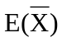 is equal to .
Of course the samples must be independent random samples from the population of interest. For a better clarity, read the following example.

Example: The marketing manager of a company selling carpet cleaners is interested in estimating the average value (in $) of sales per call. The marketing manager is interested in this estimate for the future and not for the past. The company follows a policy of feeding its sales persons with leads obtained from enquiries and referrals. The results of calls made from these leads are maintained in a comprehensive customer database. The marketing manager takes a simple random sample of size 40 from these records. The arithmetic mean sale per call is equal to $ 59.50. What is the best point estimate for the corresponding population mean? It is $ 59.50. Why? Because the sample mean is an unbiased estimator of the population mean. The criterion for the ”best” is based on the property of unbiasedness. Here =59.50 and we say that it is an unbiased estimator of the population mean . The meaning in this context is that the arithmetic mean sales value per call based on the sample salespersons is a true reflection of the population average sales value per call based on the total calls made by all the salesperson in the company.

Point Estimation-Population Proportion

First try to explain as to what do you mean by the word proportion? A proportion is a special type of arithmetic mean, special in the sense that the individual elements can take the value either 0 or 1. In a survey if you select a random sample of respondents and ask them whether they have a deluxe car, you may get a reply- yes or no. You will assign “1” to each person who says yes and “0” to each person who says no. The values are summed and the sum is divided by the total number of respondents. The interpretation of a proportion then becomes similar to the interpretation of an arithmetic mean. In other words proportion is a particular case of arithmetic mean. Let us designate the population proportion as P and sample proportion as p. Sample proportion is an unbiased estimator of the population proportion. That is p is an unbiased estimator of P. So E(p) = P.
A particular value of p based on a sample survey becomes a point estimate.

In symbols p =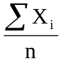 where 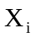 =1 if the ith unit in the sample possesses an attribute of interest such as having a deluxe car.= 0 if the ith unit in the sample does not possess the attribute.

Applying the central limit theorem, if the sample size is large, regardless of the shape of the population distribution, the distribution of the sample proportion follows a normal distribution with mean = P and standard deviation = 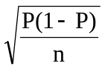. The standard error of the proportion 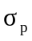= . We avoid the derivations here because they are not necessary.

Suppose the marketing manager in the previous example is also interested in estimating the percentage of calls resulting in sales. A random sample of 150 records from the customer database reveals that 20% of the leads results in sales. The sample proportion of leads resulting in sales (p) is an unbiased estimator of the population proportion of leads resulting in sales. The practical implication is that in the population of leads, 20% will result in sales. Suppose the total leads in the population are 1500, 20% of these leads will result in sales. That is 300 out of 1500 leads will result in sales.

These two statistic(s) namely the sample mean and the sample proportion are encountered very frequently in marketing research studies. What percentage of last month’s buyers were first time buyers? What is the per capita household consumption of gas in a middle class family? How much time a week does the average youth watch TV? What proportion of major consumer durable purchases are joint decisions by husband and wife? All these examples refer to a proportion or a mean. In each case the sample statistic is an unbiased estimator of the true population parameter, provided random sampling procedure is employed.

Inline Questions:

A supermarket is concerned about the presence of bacterial infection in a food package. A random sample of 64 packages is selected and sent to a laboratory for test. A score between 0 and 100 is possible in the test result. 0 means totally free from infection and 100 means very highly infected. Tests on the sample of 64 result in a mean score of 20. It is known from pilot studies conducted on such food products that the infection score is normally distributed with a standard deviation of 4.

1) What is the point estimate for the population mean score? (The mean score of all the
food packages in the supermarket)
- 10
- 18
- 20
- 8

Answer: The right choice is c). The sample mean is an unbiased estimator of the population mean. The sample mean based on a random sample of 64 is a score of 20. Hence, the point estimate here is 20.

2) The standard error of the sample mean is -----------------

Answer: The standard error of the sample mean is 0.5.
The standard error of the sample mean = 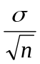 = 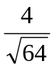 =4/8 = 0.5

8.2 Interval Estimation

A point estimate cannot be expected to coincide exactly with the population parameter. Suppose in a survey you find that the average income of a household is Rs. 300000 per year. Is it that the income of every household is Rs.300000 per year? Certainly not. Some households may have more than Rs. 300000 and some may have less than this amount. In other words point estimate will not coincide with the population parameter. How to cope with this problem? Interval Estimation comes to our help in this regard. Interval Estimation establishes an interval consisting of a lower limit and an upper limit in which the true value of the population parameter is expected to fall. This interval is called “Confidence Interval” in the parlance of inferential statistics. The meaning of the expression confidence interval is that if you keep on taking repeated samples, the probability that the true value of the population parameter will fall in this interval is a certain percentage. The convention is to use a 95 % confidence level and some times 99% confidence level. Suppose you choose 95% as the confidence level. Let us interpret the meaning once more. If you keep on taking repeated samples, the probability that the true value will fall in this interval is 95%. In other words, you are 95% confident that the true value of the population parameter will fall in this interval. The actual establishment of the confidence interval is built on the sampling distribution principle. The following diagram captures the meaning of interval estimation.

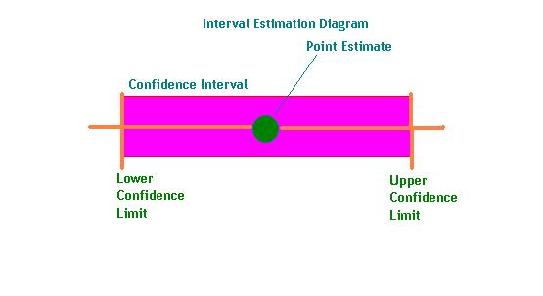
The method of constructing the confidence interval for the population parameters –mean and proportion is discussed next.

8.3 Confidence Interval for Population Mean and Proportion- Large Sample

Confidence Interval for Population Mean (σ Known)

The (1-α) Confidence Interval for the Population Mean μ is given by

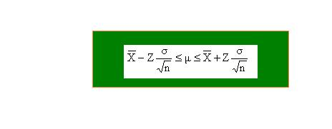
Where is the sample mean based on a random sample of size n and would vary for repeated random samples of the same size n.
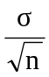 is the standard error of the distribution of sample mean . is the Population Mean.
Z is the value corresponding to the area of 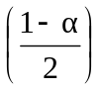 from the mean of the standard normal distribution. is the proportion in the tails of the standard normal distribution that is outside the range of the confidence interval.

The meaning of the confidence interval given in the above table is described below:
If you take repeated independent random samples of size n from a population with unknown mean but known standard deviation, the probability that the true population mean will fall in the interval 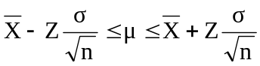 is (1-α). α is a measure of risk indicating the percentage times the true value of the population mean will fall outside this interval. Please note that the original population need not be normal. When the sample size is sufficiently large, the sampling distribution of the mean follows a normal distribution with mean and standard deviation (Central Limit Theorem). .
Example: A machine produces components, which have a standard deviation of 1.6 cm in length. A random sample of 64 parts is selected from the output and this sample has a mean length of 90 cm. What is the 95% confidence interval for the true mean length of all the components produced.?

Solution: You are required to work out the 95% confidence interval for the population mean (Here is the mean length of the components in the population). The formula for the confidence interval is . When you want 95% confidence level, the Z value is 1.96 form the standard normal distribution. See diagram below:
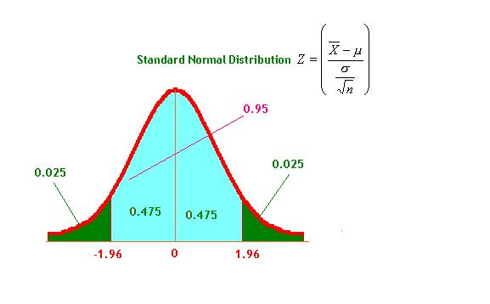
Hence 95% confidence interval for the population mean is given by 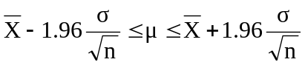
Now 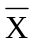 =90. =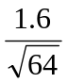=0.2. Substituting these values in the interval , we have 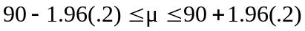 = 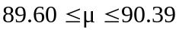. This implies that the probability that the true value of the population mean length of the components will fall in this interval of is 95%. For capturing the meaning of the confidence interval for the population mean for this example, please see diagram below:

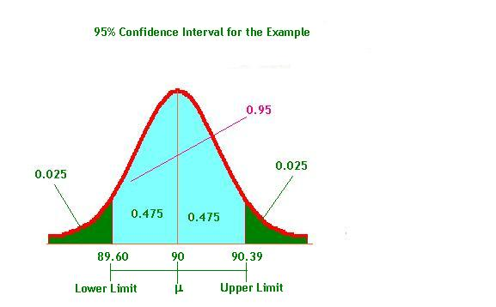
Using the function, stats.norm.interval() in scipy library, we can calculate the confidence interval of the population mean with the desired level of confidence.
Parameters for this function:
1. alpha - Desired Confidence Interval say 95% or 99%
2. loc - Sample mean
3. scale - Sample Standard Error of the mean

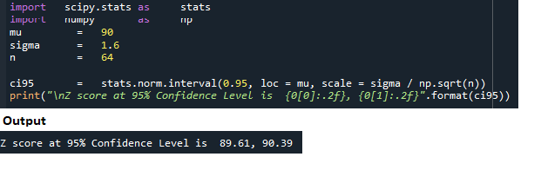
Inline Question:

For the same example discussed, if you want to establish the 99% confidence interval for the population mean ,

1) The Z value to be used is -------------.

2) The 99% confidence interval for is------------------

Solution:

- We calculate the Z score using the function stats.norm.ppf() in scipy library with 99% confidence level for the population mean. We have used .995 (= 0.99 + (half of 0.01) to represent a 99% significance level across two-tails.

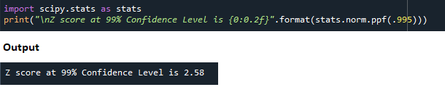
The answer is 2.58.

See diagram below:

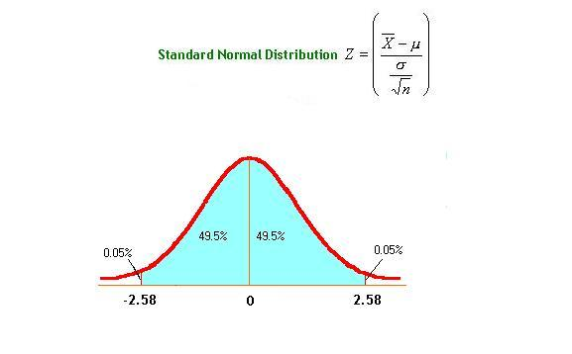
- Computing the 99% confidence interval for using Python
We calculate the Z score using the function stats.norm.interval() in scipy library with 99% confidence level for the population mean. We pass the parameters alpha = 0.99, loc = 90 (mean) and scale = Standard Error of Mean (sigma / square root of sample size).

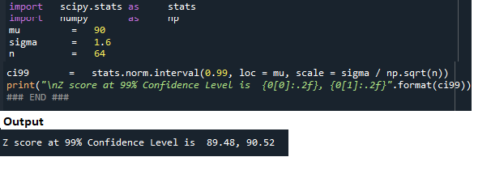
The 99% confidence interval for is given by the interval 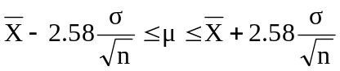. Now =90. ==0.2. Substituting these values in the interval , we have 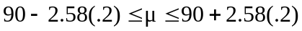= 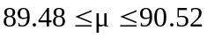. This means that the probability that the true value of the population mean length will fall in this interval of is 99%.

Confidence Interval for the Population Proportion-Large Sample

Please go through the discussion in this module on the concept of proportion before knowing how to set up the confidence interval for the population proportion.. Proportion is frequently used in survey research particularly in marketing research. The 1-α confidence interval for the population proportion is given below:

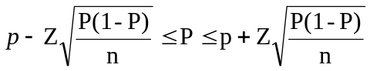

Where P is the population proportion
p is the sample proportion, Z is the value corresponding to the area of from the mean of the standard normal distribution. is the proportion in the tails of the standard normal distribution that is outside the range of the confidence interval.

Unfortunately this interval contains the term P, which is the population proportion that we are trying to estimate. It is a practice among the statisticians to use the sample proportion p in the place of P. Please note that p is an unbiased estimator of P. Hence, the (1-α) confidence interval for the population proportion P becomes

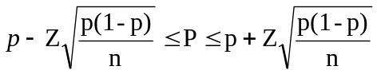. This confidence interval in particular for 95% and 99% confidence levels are given below:
Confidence Level | Confidence Interval for the Population Proportion P
95% | 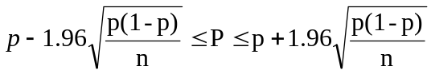
99% | 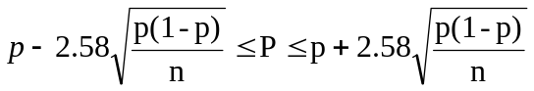

Example: In a health survey involving a random sample of 75 patients who developed a particular illness, 70% of them are cured of this illness by a new treatment. Establish the 95% confidence interval for the population proportion of all the patients who will be cured by the new treatment.

Solution:

The 95% confidence Interval for the population proportion is given by
.
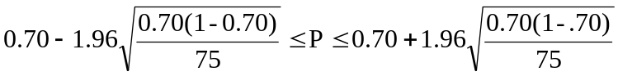. Upon simplification, this interval becomes 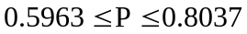. That is, the probability that the population proportion will fall in this interval of is 95%.

Inline Question: For the example above, the 99% confidence interval for the population proportion is

a) 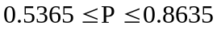
b) 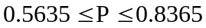
c) 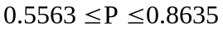

Answer: The correct choice is b). Applying the formula for the 99% confidence interval for the population proportion, we have the interval
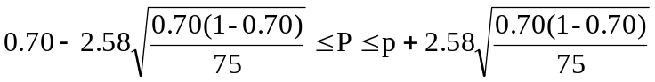. Simplifying, we get
.
8.4 Confidence Interval for Population Mean-Small Sample( t-Distribution)

How will you establish a 95% confidence interval for the population mean when the standard deviation is not known? How will you establish a 95% confidence interval for the population mean when the sample size is small? Both these questions can be answered by the t-distribution. William Gosset under the nickname Student discovered the t-distribution. Hence, it is called “Student’s t distribution. For better clarity, see the diagram below:

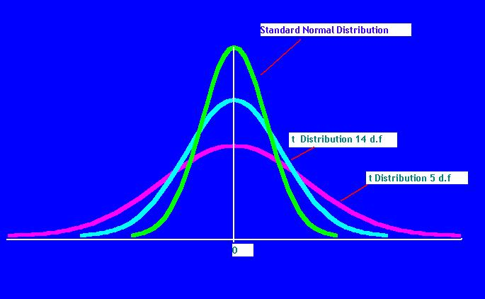

Characteristics of the t Distribution:

As you can see from the diagram, t distribution is also symmetrical like the normal distribution. However, the t distribution is flatter than the normal distribution. The
t distribution depends upon one more factor called the degrees of freedom. You can define the degrees of freedom as the number of unrestricted (independent) moments you can have out of the sample size n. In other words how many of the sample values are free to vary? In the case of t distribution, there are n-1 degrees of freedom. Intuitively the degrees of freedom suggests that if we know the values for n-1 terms, the nth term can be calculated. According to Ronald Fisher, the father of Statistics, degrees of freedom is a term borrowed from mathematics. In fact he explains the concept of degrees of freedom beautifully while deriving the Chi- Square distribution, which we will cover in the coming module. When n is large (Greater than or equal to 30), the t distribution looses its flatness and becomes a normal distribution. Hence we can use the normal approximation to t when n is greater than or equal to 30. For estimating population mean involving small sample, t distribution is the best choice.

Confidence Interval for Mean using t distribution:

The 1-α confidence interval for the population mean μ is given by

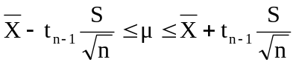 Where
is the sample mean based on independent random samples from a normal population and the sample size is small

S is the sample standard deviation =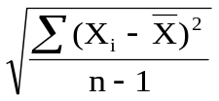
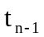 is the value of the t distribution with n-1 degrees of freedom for an area of α/2 in both the tails of the distribution.

Please note that the sample statistic t =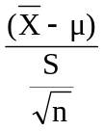 follows a t distribution with n-1 degrees of freedom (d.f)

Example: The average travel time taken based on a random sample of 10 people working in a company to reach the office is 40 minutes with a standard deviation of 10 minutes.
Establish the 95% confidence interval for the mean travel time of everyone in the company?

Solution:

The 1-α confidence interval for the population mean μ is given by . =40 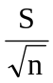 = 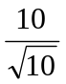=3.16
For a 95% confidence level, α/2 =.05/2 =.025. Each tail will have probability of .025. For what value of t is this value =. 025? Of course, the degrees of freedom is =9. Remember t distribution is symmetrical about its mean like the normal. It is enough if you look at the upper tail to answer the question. Even easier way out is to avoid looking at t-tables and get it from the Microsoft Excel. Using Paste Function in Excel, the t value for 9 degrees of freedom is 2.26(rounded to two decimal places). Substituting in the expression for the confidence interval all the relevant values, you get

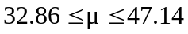. The probability that the true mean travel time of everyone in the office will fall in this interval of is 95%.
Inline Question: For the previous example, the 90% confidence interval for the population mean is -------------------------------------------

Solution: the t value for α =10% (90% confidence) for 9 d.f from Excel Paste Function is = 1.83. As before substituting the values of all the unknown terms in the interval , you get

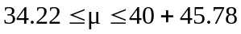

Discussion: Analyze, criticize, and explain the following statement:

“ If a confidence interval is constructed by adding and subtracting the same quantity to the sample statistic, you are assuming that the distribution of the original population is symmetric”.

8.5 How to Determine Sample Size using Confidence Interval

If you specify the sampling error(precision), the confidence level desired and the standard deviation of the original population, you can compute the optimal sample size. You can determine the sample size both for estimating the population mean as well as the population proportion. Please note that the sampling error is the difference between the estimate and the actual parameter.

Sample Size Determination-Population Mean

Please recall that 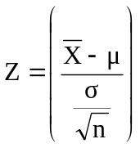

Sampling error E =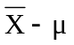. Squaring both sides and simplifying we have

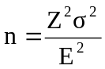. Z is the value corresponding to the area of from the mean of the standard normal distribution. In particular, if you want 95% confidence level, Z =1.96.
If you want 99% confidence level Z =2.58. You can get these values from Excel very easily.

Example: A marketing manager of a fast food restaurant in a city wishes to estimate the average yearly amount that families spend on fast food restaurants. He wants the estimate to be within Rs 100 with a confidence level of 99%. It is known from an earlier pilot study that the standard deviation of the family expenditure on fast food restaurant is Rs 500. How many families must be chosen for this problem?

Applying the formula , we have 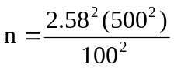 = 166.41 =166 rounded to the nearest integer.

Sample Size Determination-Population Proportion

Please recall 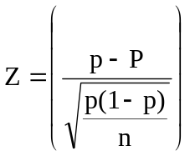

Sampling error E = 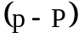 Squaring both sides and simplifying we have

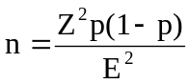. Z is the value corresponding to the area of from the mean of the standard normal distribution. In particular, if you want 95% confidence level, Z =1.96.
If you want 99% confidence level Z =2.58.

Example: A company manufacturing sports goods wants to estimate the proportion of cricket players among high school students in India. The company wants the estimate to be within 0.03 with a confidence level of 95%. A pilot study done earlier reveals that out of 80 high school students, 36 students play cricket. What should be the sample size for this study?

Solution: p=36/80 =0.45

Applying the formula for calculating the sample size we have
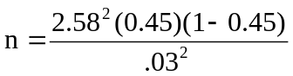 . Simplifying you get n =1831.

In summary, you can determine the sample size both for estimating the population mean and the population proportion if you know the precision, the confidence level, and the standard deviation of the original population.

8.6 Module Summary

In this module, you have been given a conceptual framework of statistical estimation, which is one of the three components of statistical inference. In particular, this module focused on the following:

- The definition and meaning of point estimation for the population mean and population proportion.

- The role of sample mean and sample proportion in estimating the population mean and population proportion with their property of unbiasedness.

- The conceptual framework of interval estimation with its key elements.

- The methodology for establishing the confidence interval for the population mean and the population proportion based on the sample mean and the sample proportion.

- Examples giving the 95% and 99% confidence interval for the population mean and the population proportion for large samples.

- Establishing confidence interval for small samples using the t distribution after explaining the role of degrees of freedom in computing the value of t.

- Determining the optimal sample size based on precision, confidence level, and a knowledge about the population standard deviation.

- As usual, this module has emphasized the role of Microsoft Excel in calculating the value of t based on the degrees of freedom by using the paste to function.

Glossary:
Confidence Interval: It is an interval in which the true value of the population parameter will fall with a certain probability.
Confidence Level: This is the probability that is associated with an interval estimation of a population parameter. This indicates how confident are we that the population parameter will fall in this interval.
Degrees of Freedom: Degrees of freedom is the number of unrestricted (independent) moments one can have out of the given sample size. In other words, degrees of freedom indicate how many of the sample values are free to vary.
Estimate: A particular value of an estimator
Estimator: A statistic that is used to estimate a population parameter
Interval Estimation: Interval Estimation establishes an interval consisting of a lower limit and an upper limit in which the true value of the population parameter is expected to fall.
Point Estimation: It deals with the task of selecting a specific sample value as an estimate for a population parameter.
Point Estimate: A specific value of a sample statistic that is used to estimate a population parameter.
Student’s t Distribution: A probability distribution discovered by William Gosset under the nickname Student. It is similar in structure to the normal distribution except that it depends on degrees of freedom. It is used when the sample size is small(<30) and the population standard deviation is unknown.
Unbiased Estimator: An unbiased estimator is one whose expected value is equal to the population parameter.

