**Choose the correct answer.**

1. R program uses a compiler to run its programs. This statement is
2. Always True
3. Always False
4. May or may not be true
5. I do not know the answer
6. User executes the functions via commands. This statement is
7. Always True
8. Always False
9. May or may not be true
10. I do not know the answer
11. R stores the results of statistical analysis in a fit object for subsequent interrogation by further R functions.
12. Always True
13. Always False
14. May or may not be true
15. I do not know the answer
16. When R is running, variables, data, functions, results, etc. are stored in the ___________ of the computer in the form of objects which have a name.
17. Active memory
18. Hard disk
19. All of the above
20. None of the above
21. Comment lines in R begin with the symbol “**#**”.
22. Always True
23. Always False
24. May or may not be true
25. I do not know the answer
26. The command **help(mean) does the following**.
27. ***It gives extra information about the mean function.***
28. ***It searches the complete documentation for the word mean***
29. Statement I is True and Statement II is false
30. Statement II is True and Statement I is false
31. Both the statements are False
32. Both the statements are true
33. If you are not sure about the name of the function you are looking for, you can perform a fuzzy search with the __________ function.
34. help()
35. apropos()
36. search()
37. None of the above
38. The function ________ in utils package run all the R code from examples part of R’s topic ***topic***.
39. example()
40. help()
41. All of the above
42. None of the above
43. R is a _______________, interpreted language.
44. Case-sensitive
45. Case-insensitive
46. All of the above
47. None of the above
48. The four main modes, which describe the basic type of elements of the object. They are:
49. ***Numeric***
50. ***Character***
51. ***_________***
52. ***Logical***
53. Binary
54. Complex
55. All of the above
56. None of the above
57. The following R code prints integers from 1 to 10:

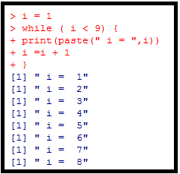

What is the output from the R code, if you remove the line **i = i + 1** from the above?

1. Infinite loop occurs and the program does not stop to produce output.
2. Error message
3. Warning message
4. None of the above
5. The following R code changes the value of its argument inside the function. What it is the value of x after running the below piece of R code:

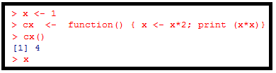

1. 4
2. 2
3. 1
4. None of the above
5. The output after running the following R code is



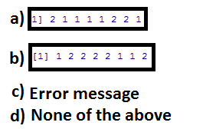

1. Find the function which is not visible (hidden through strike through) in the following R code:

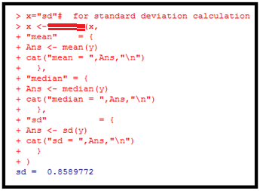

1. switch
2. select
3. All of the above
4. None of the above
5. What is the output of z from the following R code:

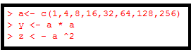

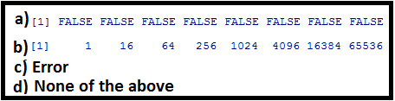

1. Which of the following is / are the correct piece of R code to produce z as shown below derived from the vector, a:

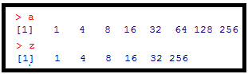

|  |  |
| --- | --- |
| a) |  |
| b) |  |
| c) | Both a) and b) |
| d) | Neither a) nor b) |

1. What is the output of the R code, b == b1 as given below:

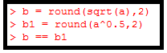

|  |  |
| --- | --- |
| a) |  |
| b) |  |
| c) | Neither a) nor b) |
| d) | I do not know |

1. Please observe the graph given below and the R code that has produced this.

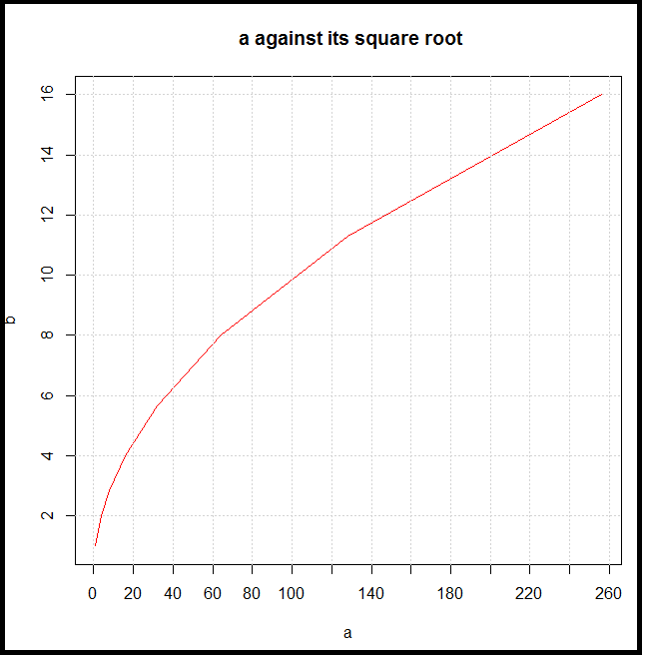

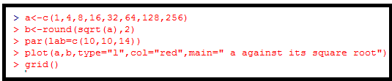

The sub-command par(lab=c(10,10,14)) modifies the default way that axes are annotated and specifies x and y that gives the approximate number of tick marks on the x-axis and y-axis.

What is the default value for the option lab?

a) Default is c(5,5,7)

b) Default is c(20,20,28)

c) Default is c(10,10,14)

d) There are no default values set

1. Which of the following statements are true:
2. ***To add to an existing plot use par(new = TRUE);***
3. ***To start a new plot, use the par(fig=starts)***

a) Statement i

b) Statement ii

c) All of the above

d) None of the above

1. What is the output produced by line 4 of the following R code?.

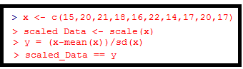

|  |  |
| --- | --- |
|  |  |
|  |  |
|  |  |
|  | None of the above |