1. Login to the SAS portal by using the link at <https://welcome.oda.sas.com/login>

The following screen appears.

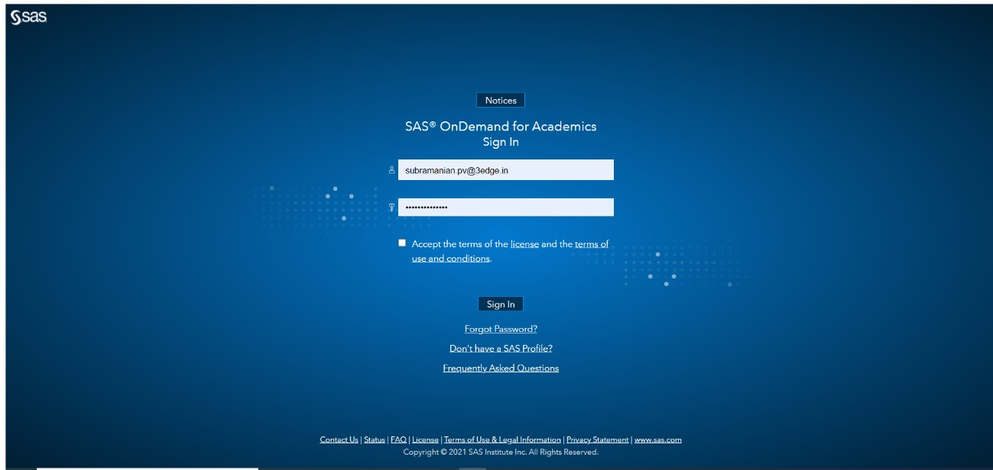

1. Enter your credentials (i.e., User ID & Password) and click on the checkbox for “**Accept the terms of the**[**license**](https://support.sas.com/ondemand/pdf/click_license.pdf)**and the**[**terms of use and conditions**](https://www.sas.com/en_us/legal/copyright.geo.html)” and click on **Sign In**

The following screen appears.

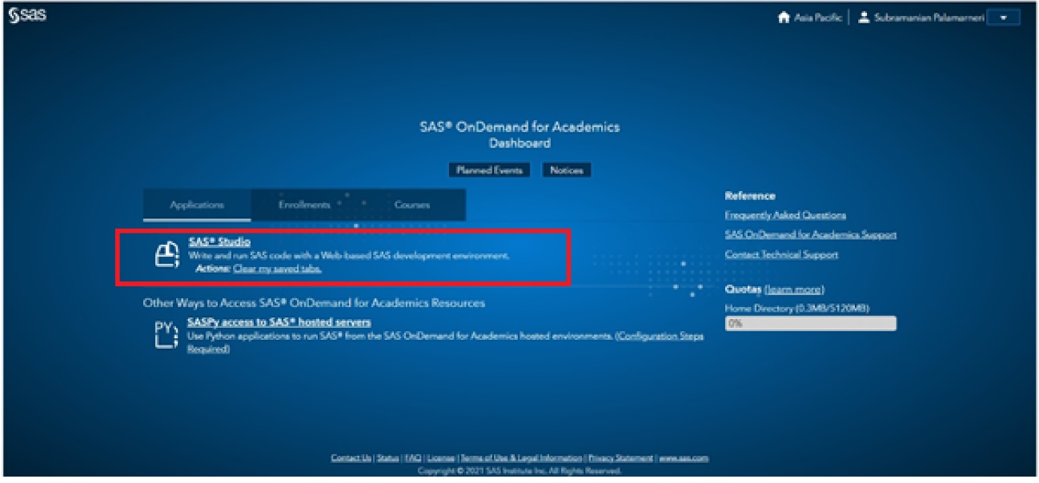

Click on the SAS Studio link as highlighted.

The system displays “Initializing” and after a few seconds, the following screen appears.

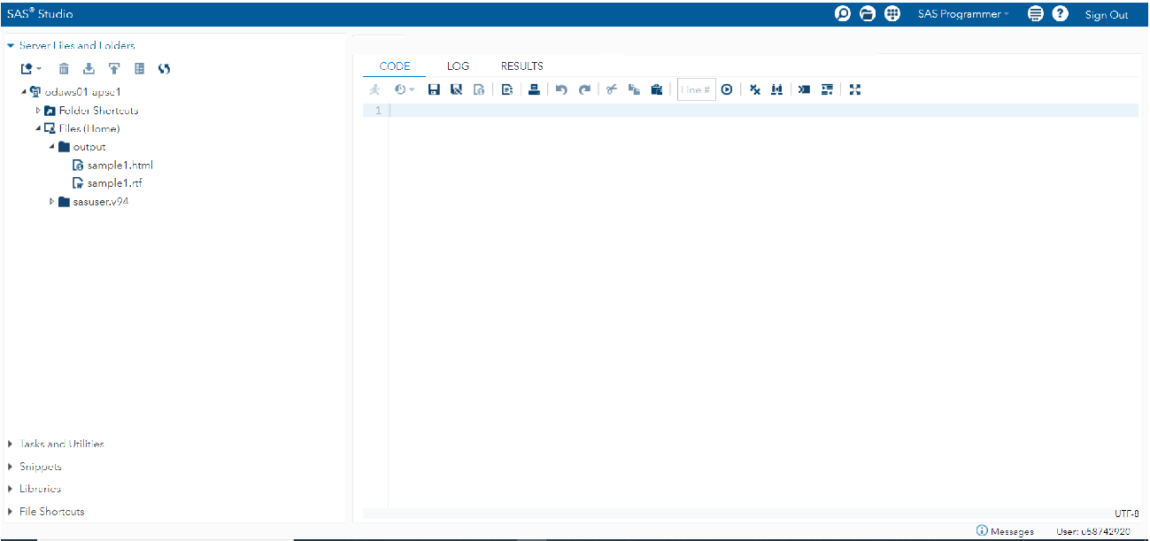

Please note the contents of the screen could be different based on your account.

1. **Create a number of folders such as myCode, data, output**

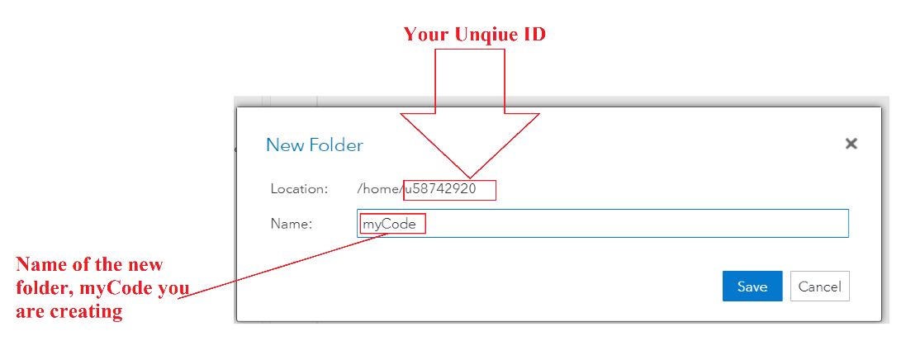

**After creating the folder, myCode, create other folders, data & output in the same way.**

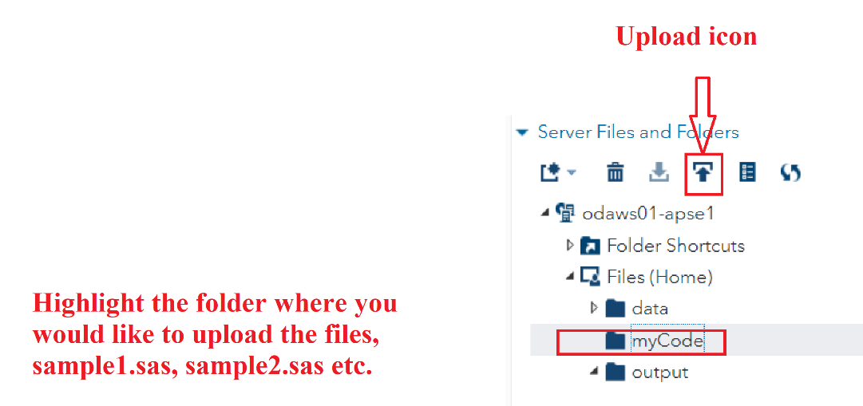

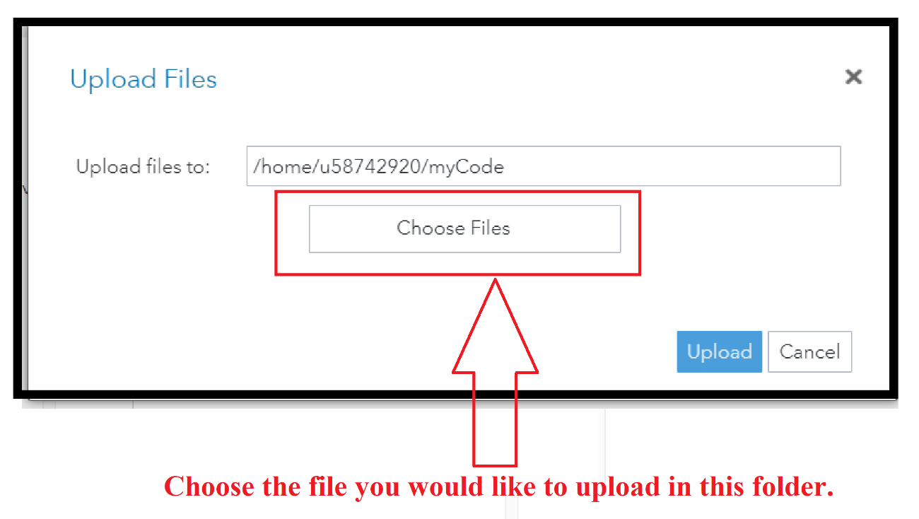

**Upload the SAS code files, sample1.sas as shown below:**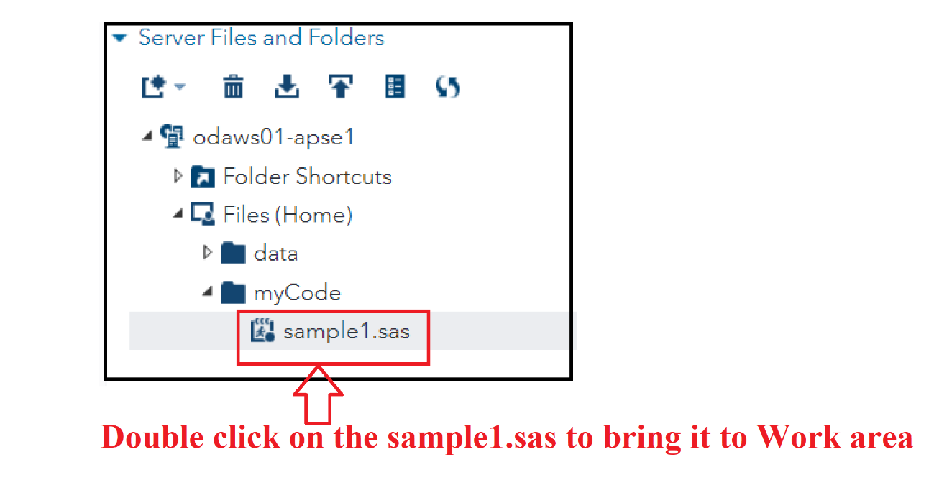

**In the same way, upload sample2.sas in the myCode folder.**

**Execute the code, sample1.sas as shown below:**

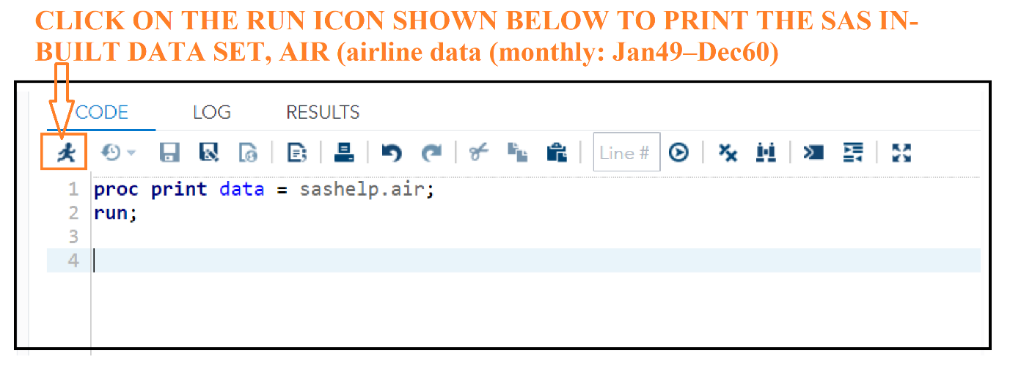

**Under the RESULTS tab, you will see this output**

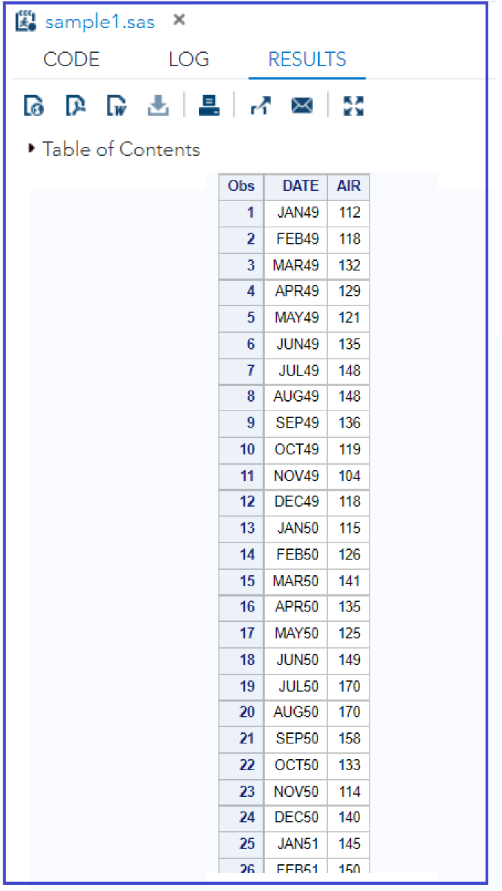

**Click on the LOG tab, you will see the following screen.**

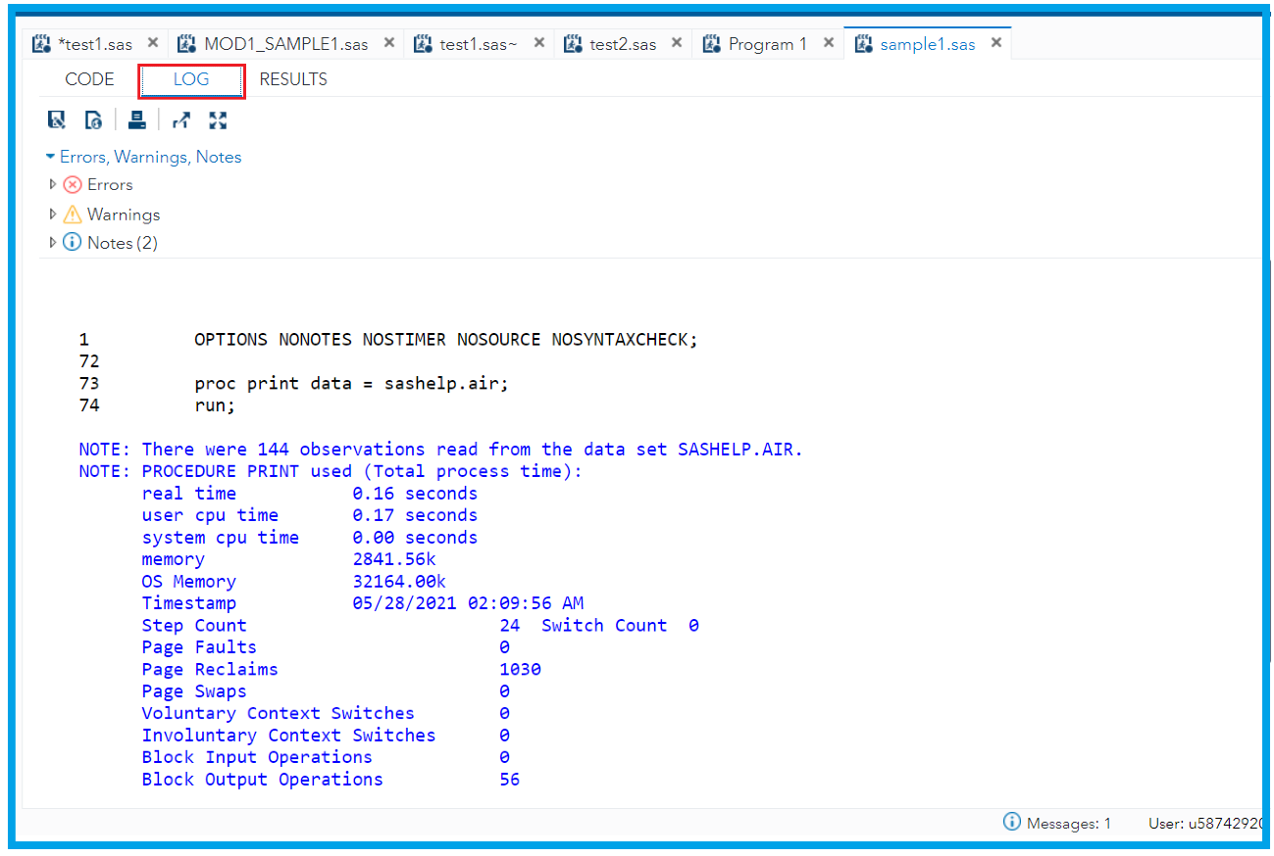

**The log tab contains notes about your SAS session. This tab contains any notes, errors, or warnings associated with your program as well as the program statements themselves will appear in the Log tab.**

**Upload the enclosed sample2.sas file* in the folder, myCode folder as described above and run the code and observe the LOG tab & RESULTS tab.**

**\* Make the following change in sample2.sas before uploading!**

