Contents

**1)** **Download PostgreSQL installer for Windows** 2

**2)** **Install PostgreSQL** 2

**3)** **Verify the installation** 7

**4)** **How to read a SQL file in PSQL using CLI?** 9

**5)** **Using Python, access the PostgreSQL** 10

**6)** **Access DB Tables through Python** 11

Since version 8.0, PostgreSQL offers an installer for Windows systems that makes the installation process easier and faster. For development purposes, we will install PostgreSQL version 14.4 on Windows 10.

**Three steps to complete PostgreSQL installation:**

# **Download PostgreSQL installer for Windows**

*From the command line run as administrator, give the following command:*

**start msedge** **<https://www.enterprisedb.com/downloads/postgres-postgresql-downloads>**

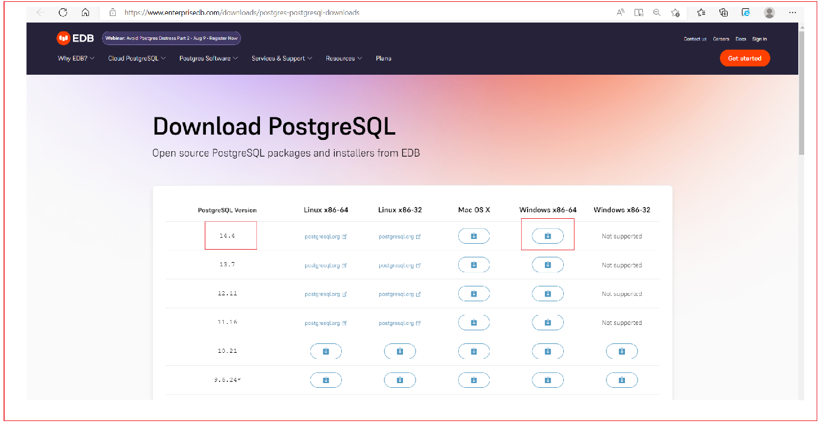

# **Install PostgreSQL**

To install PostgreSQL on Windows, you need to have administrator privileges.

Step 1: Double click on the installer file, an installation Wizard will appear and guide you through multiple steps where you can choose different options that you would like to have in PostgreSQL.

Step 2: Click on the **Next** button.

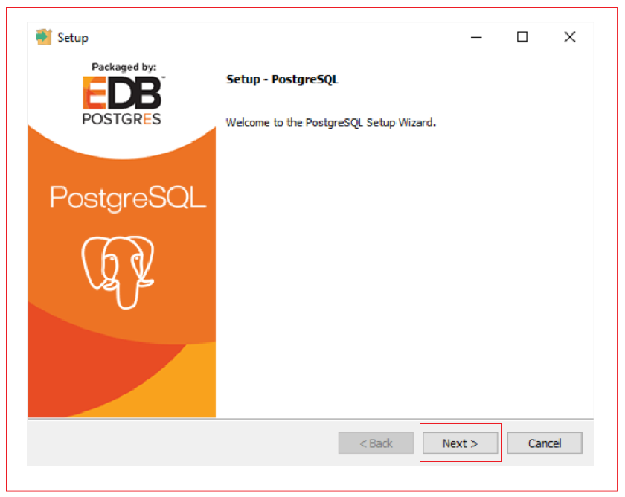

Step 3: Specify installation folder, C:\PostGreSQL and click on the Next button.

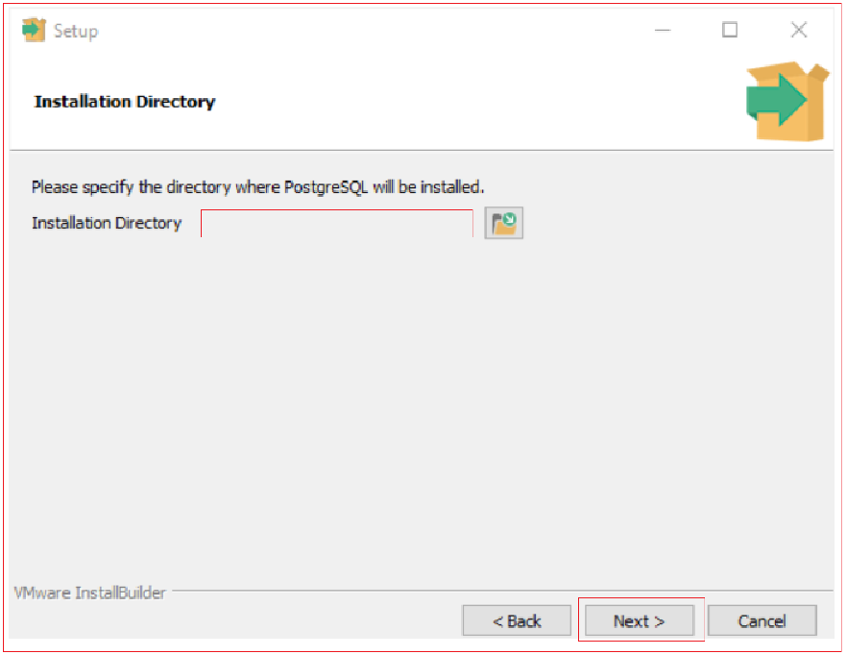

Step 4: Select software components to install:

a. The PostgreSQL Server to install the PostgreSQL database server.

b. pgAdmin 4 to install the PostgreSQL database GUI management tool.

c. Stack Builder provides a GUI that allows you to download and install drivers that work with PostgreSQL.

d. Command Line Tools to install command-line tools such as psql, pg_restore, etc. These tools allow you to interact with the PostgreSQL database server using the CLI.

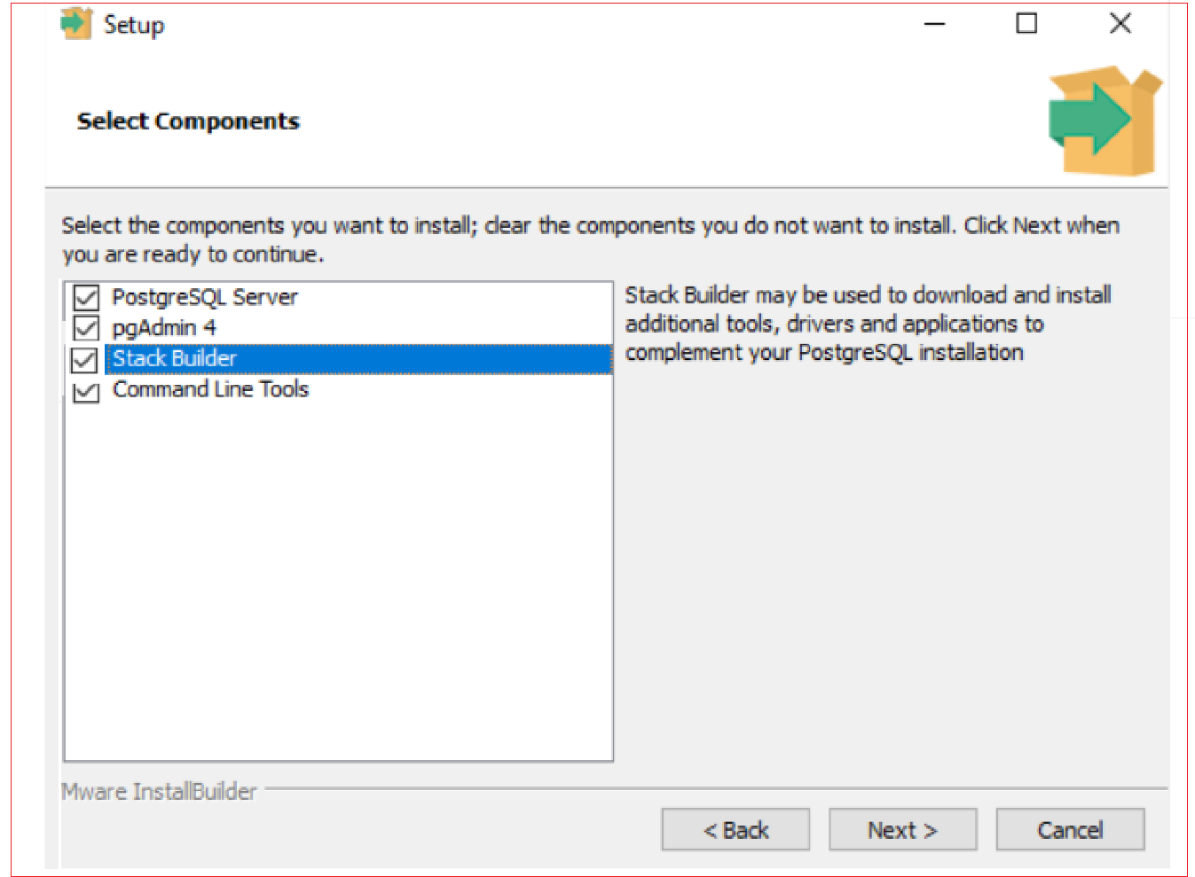

You can install all the component and click on the Next button to select the data directory.

Step 5: Select the database directory to store the data or accept the appropriate folder. And click on the Next Button to go to the next step.

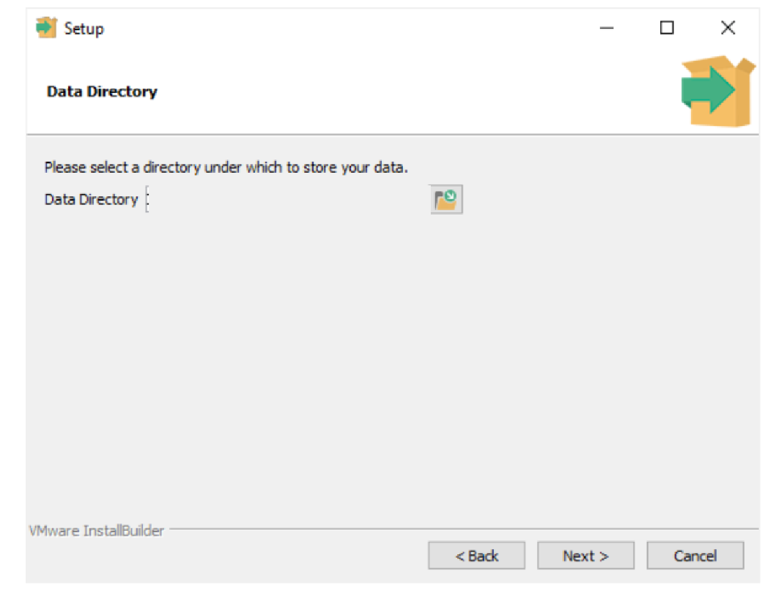

Step 6: Enter the password for the database superuser (postgres).

PostgreSQL runs as a service in the background under a service account named postgres. After entering the password, you need to retype it to confirm and click the next button.

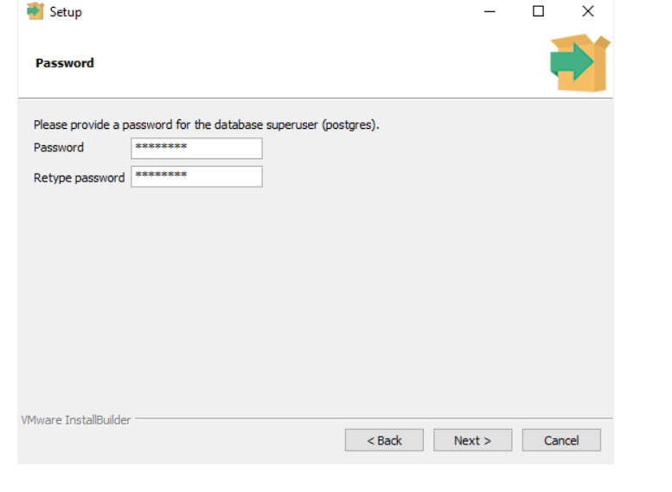

Step 7: Enter a port number on which the PostgreSQL database server will listen. The default port of PostgreSQL is 5432. You need to make sure that no other applications are using this port.

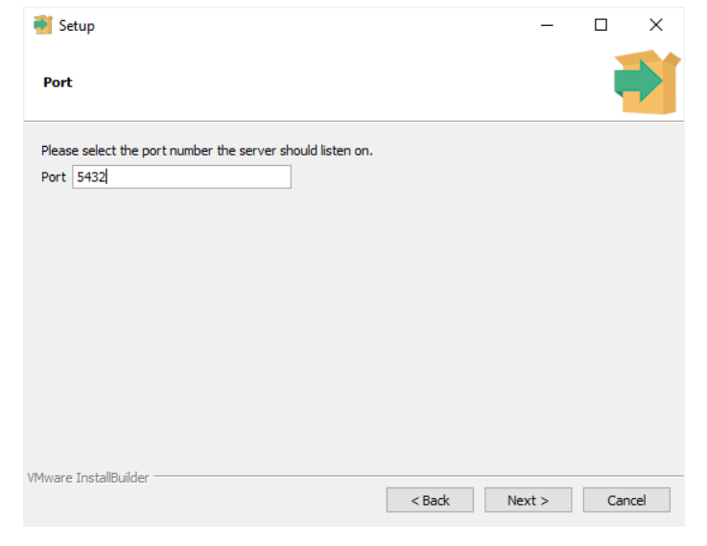

Step 8: Choose the default locale used by the PostgreSQL database. If you leave it as default locale, PostgreSQL will use the operating system locale. After that click on the Next button.

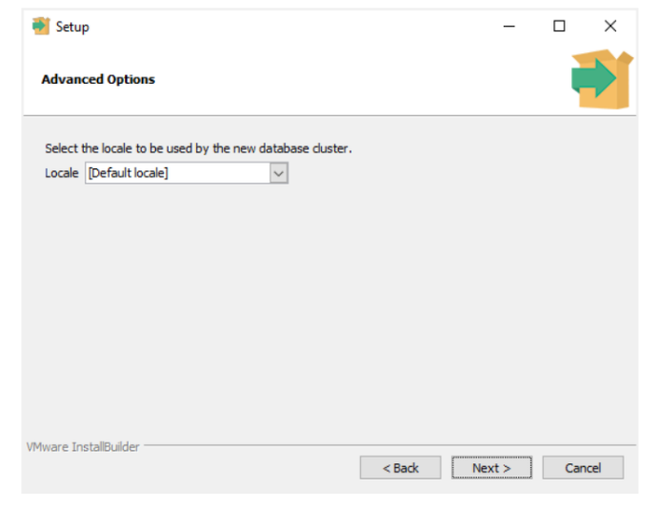

Step 9: The setup wizard will show the summary information of PostgreSQL. You need to review it and click on the Next button if everything is correct. Otherwise, you need to click on the Back button to change the configuration accordingly.

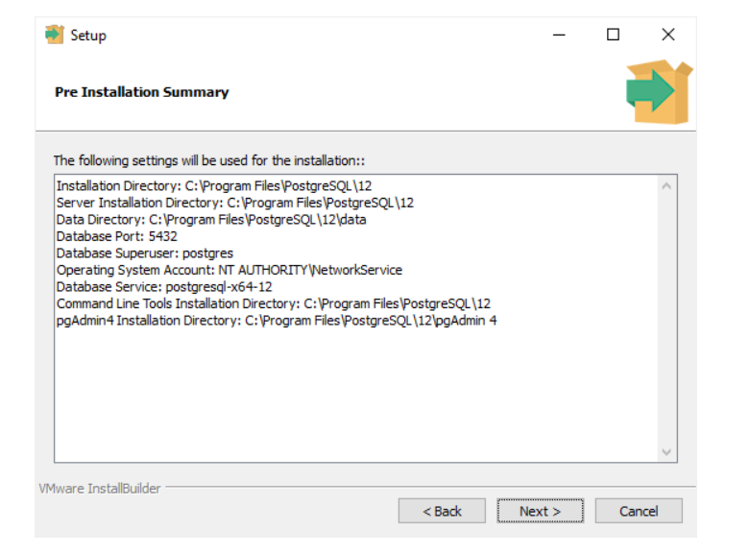

Now, you're ready to install PostgreSQL on your computer. Click on the Next button to begin installing PostgreSQL.

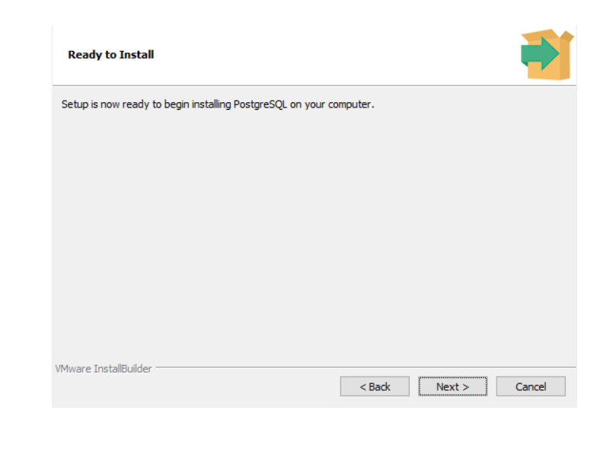

The installation may take a few minutes to complete.

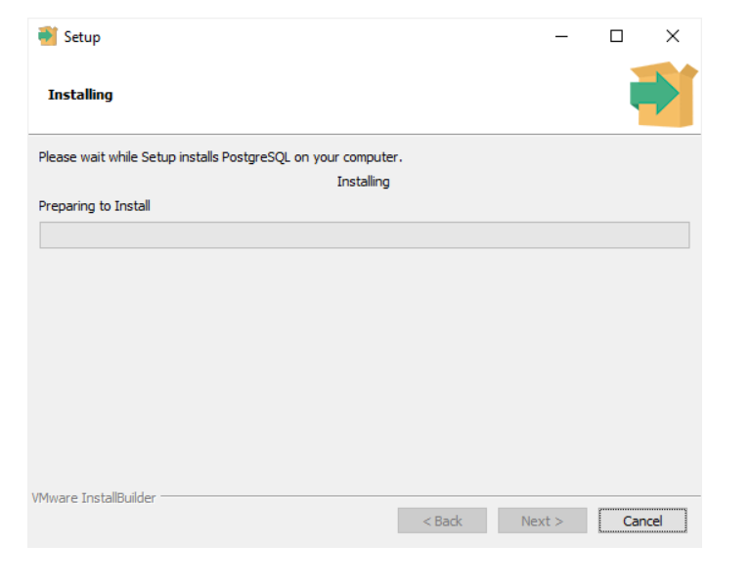

Step 10: Click on the Finish button to complete the PostgreSQL installation.

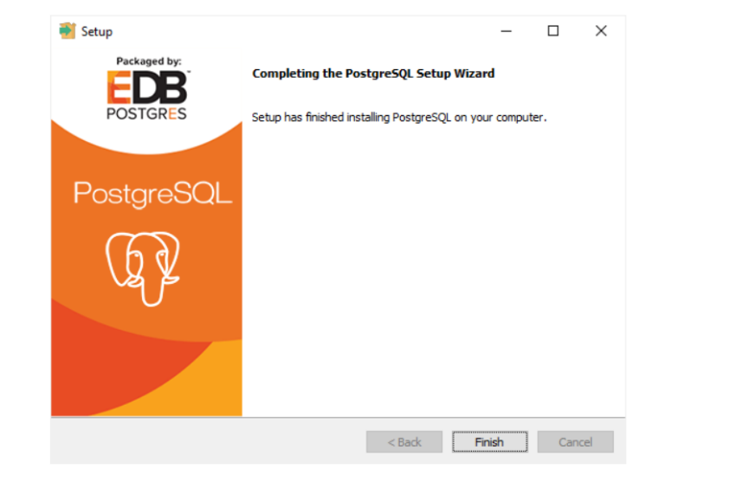

https://www.postgresqltutorial.com/postgresql-getting-started/install-postgresql/

# **Verify the installation**

There are several ways to verify the PostgreSQL installation. You can try to connect to the PostgreSQL database server from any client application e.g., psql and pgAdmin.

The quick way to verify the installation is through the psql program.

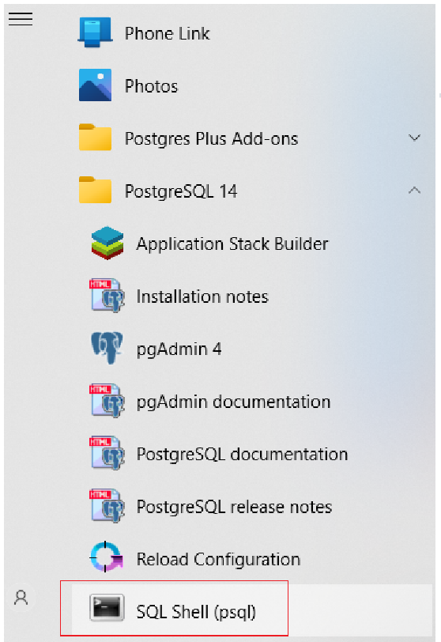

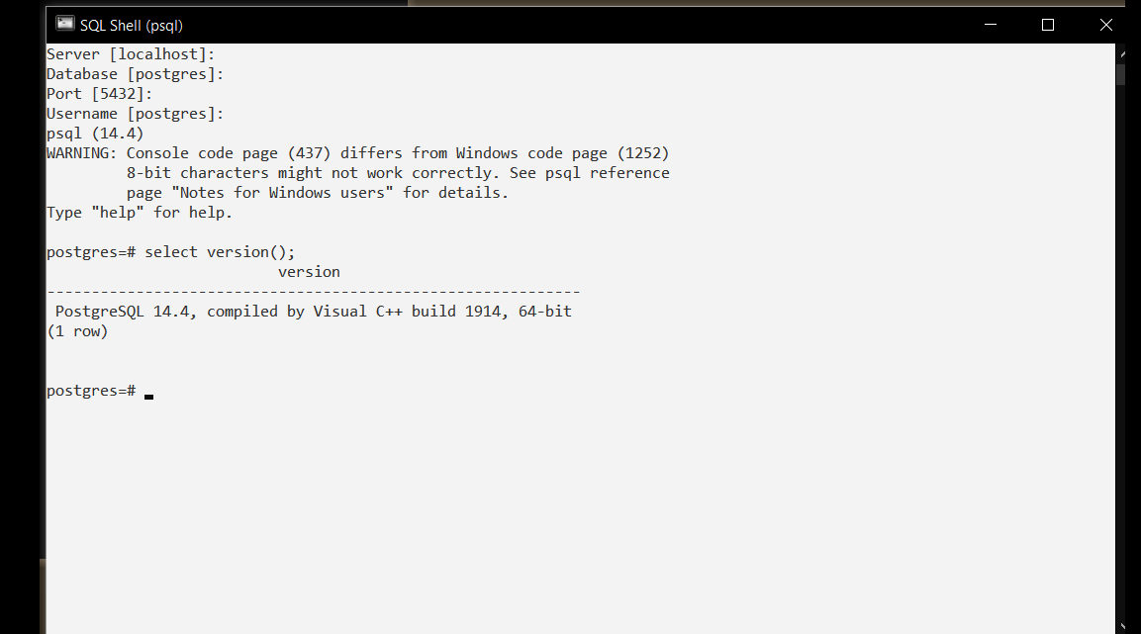

**You have installed the version 14.4 of PostgreSQL successfully.**

# **How to read a SQL file in PSQL using CLI?**

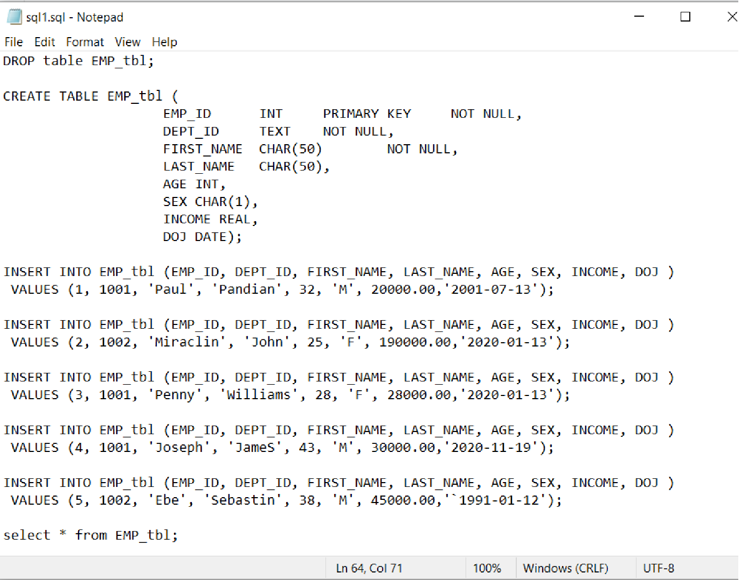

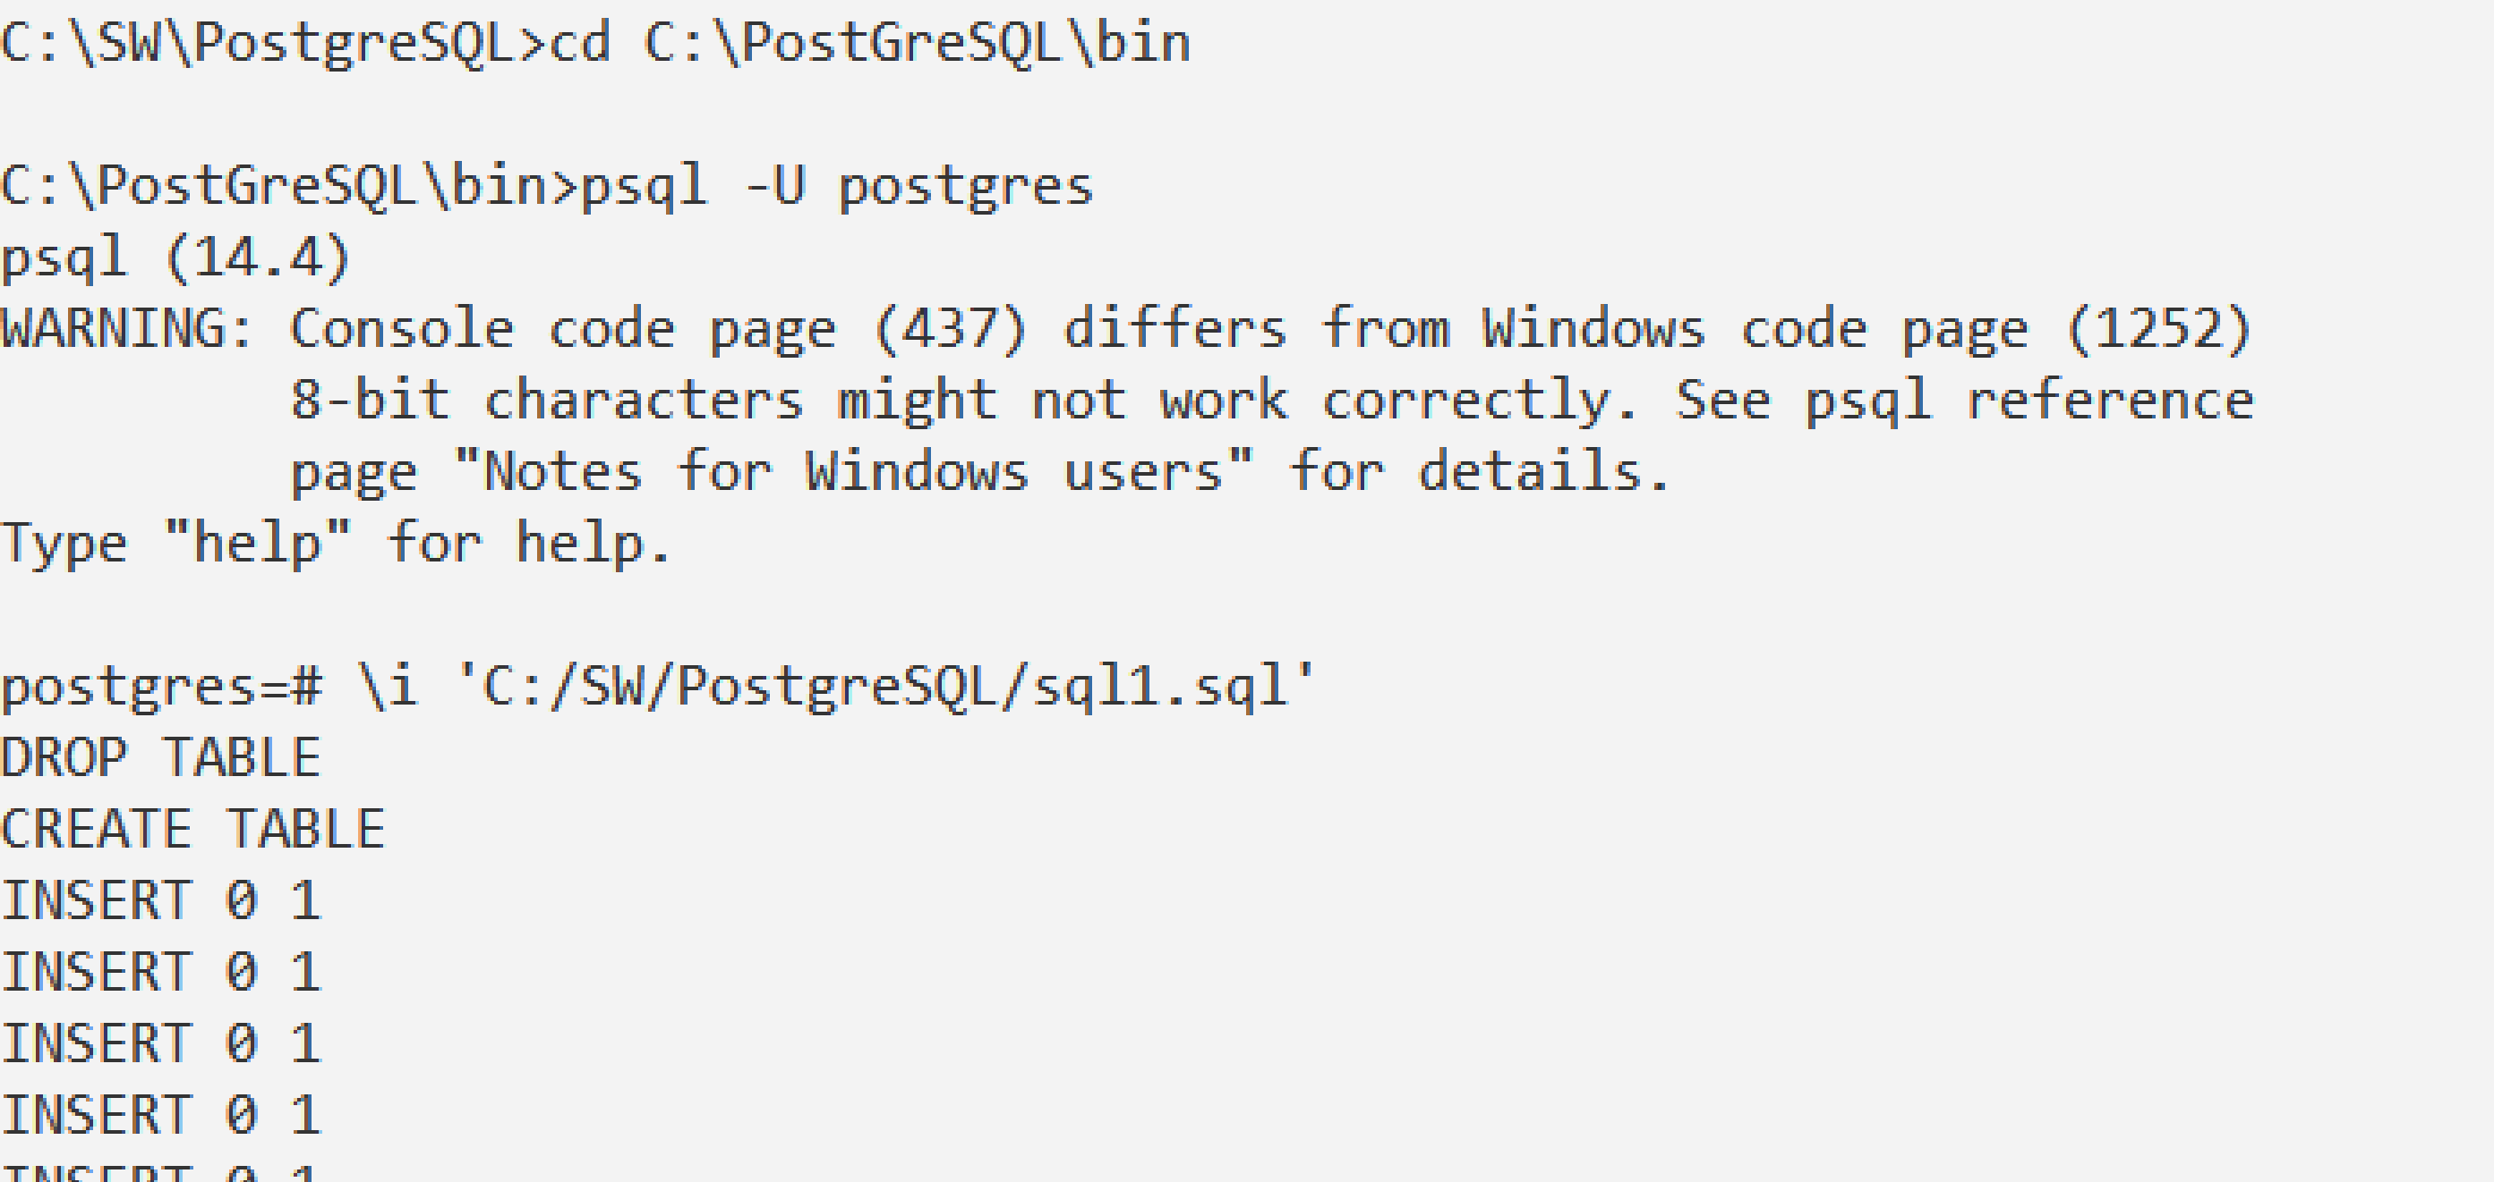

# **Using Python, access the PostgreSQL**

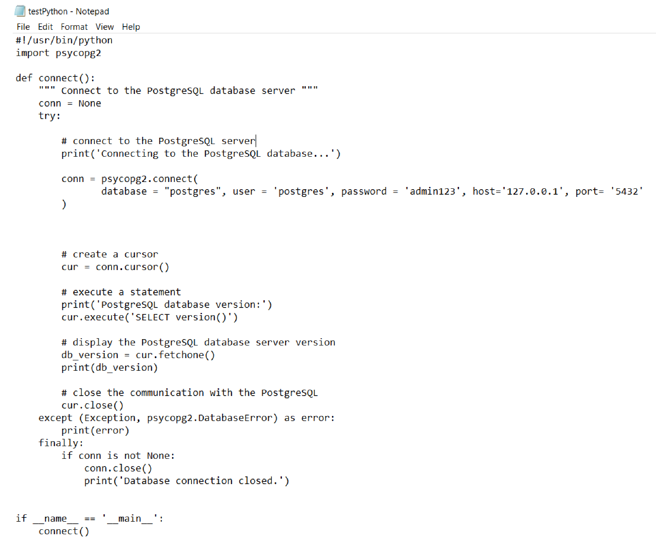

Output

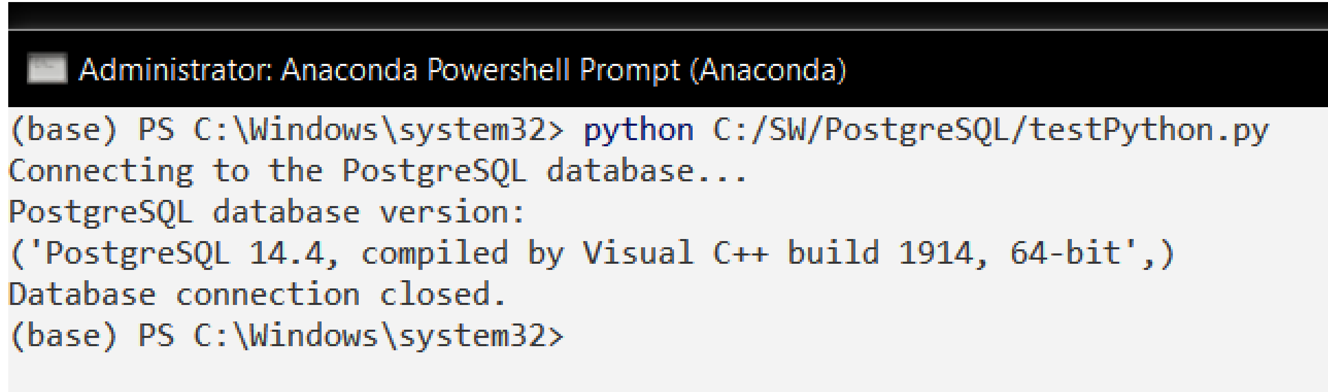

# **Access DB Tables through Python**

