**AHEAD Medicine Interview Questions**

**Bonus Question**

Below are plots of selected cell surface biomarkers of blood cell samples. Researchers are interested in picking out cells marked in yellow (accupying a high-density chunk at the bottom-right) for further analysis. How would you suggest a method to automatically identify these cells?

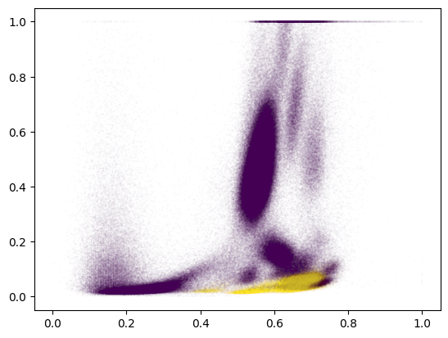

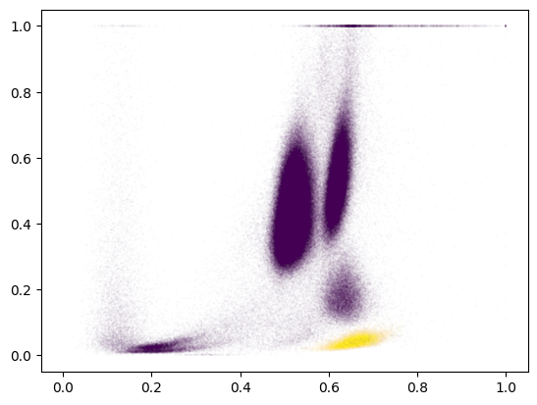

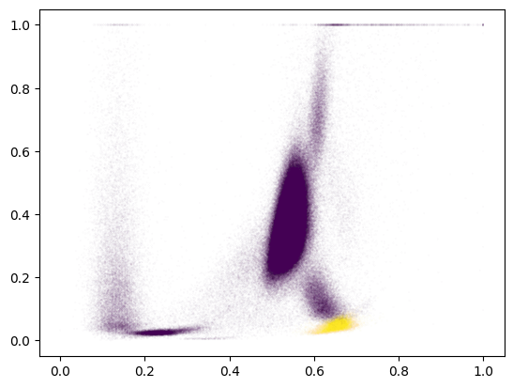

**Answer:**

I will build a segmentation model to automatically detect these cells.

The main procedures can be listed as follows.

1. Based on images, label them for segmentation task, and then export the data set

Augmentation can also be applied to created more new training samples.

1. Build deep learning model and train it on the generated data set
2. Test and validate the proposed model.