

drinkstore management report

C/C++ Programing

Lecturer: Phạm Hoàng Anh

Contents

1. Cover 0
2. Contents 0
3. General Introduction 1
4. [Process  
   a. Specification Requirement  
    i. System Requirements   
    ii. User Requirements](#_Toc324526964)   
   b. System Analysis and Design  
    i. Use-case diagarm   
    ii. Entities Relationship Diagram   
    iii. Class diagram   
    iv. Activity diagram   
    v. Sequence diagram   
   c. Coding   
   d. Testing and Validating
5. Interface  
   a. Login Form   
   b. Product Form   
   c. Import Form   
   d. Order Form   
   e. Staff Form
6. Demo Screenshots 1
7. References
8. Epilogue

# General Introduction

## Strategic Highlights

We created the program for managing employees and import/export products. Furthermore, the system collects customer information, order details and business transaction in order to create a Business report for Manager, help the company on improving the Business.

## Financial Highlights

The program saves the Order, Order details and makes a Statistic table.

## Looking Ahead

We hope we can upgrade the system with more functions and approach to more customers.

# Process

1. System Requirement:

* Everyone have to log in to the system, with different position the program will show different Form where they can work with.
* Different product has different Product ID. The same as Import ID and Category ID.
* Each product can have many Brand or Supplier.
* The system saves date and time of business transaction.
* In the end of the day, the system will make a report for the manager.

1. User Requirement:

* Manager creates accounts for all staffs. Only Manager can change password.
* All staffs can view Order and Order details. Only Manager can see the system report.

# System Analysis and Design

## Use-case diagram

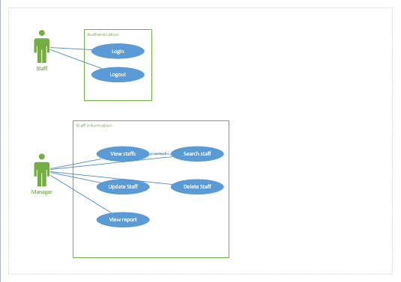

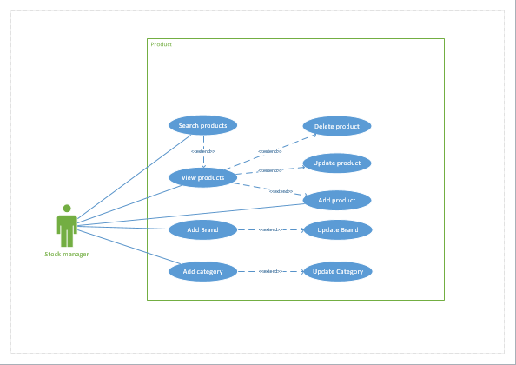

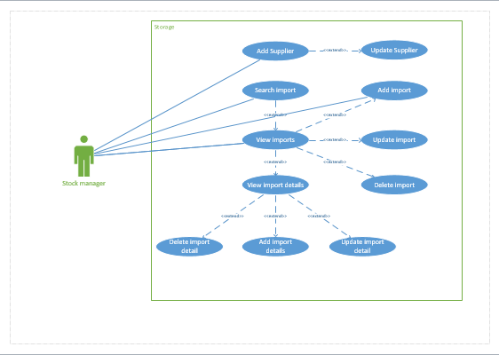

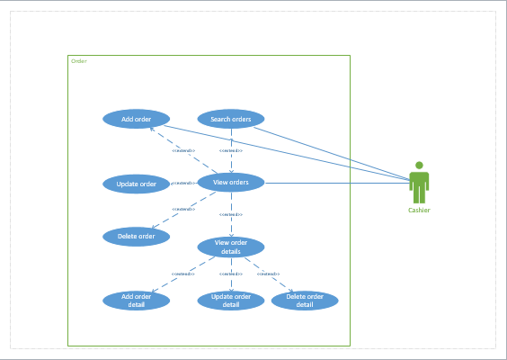

## entities relationship diagram

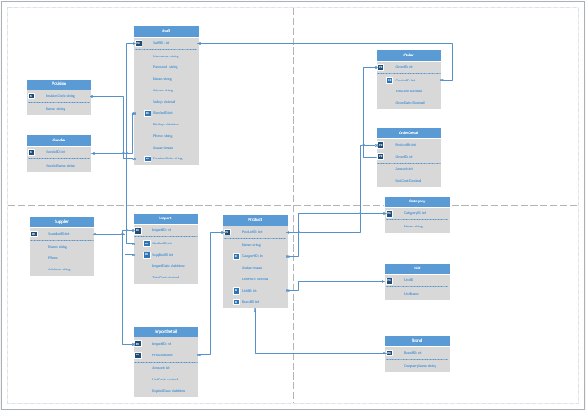

## Statement of Changes in Equity

# Notes to Financial Statements

## Accounts

When you have a document that shows a lot of numbers, it’s a good idea to have a little text that explains the numbers. You can do that here.

## Debt

Of course, we would all prefer to just have profits. But if you’ve got any debt, this is the place to make notes about it.

## Going Concern

Okay, you get the idea. If you’ve got notes to add about your financials, add them here.

## Contingent Liabilities

Keep in mind that some of these headings might not apply to your business (and you might have others to add). This one, for example, is about potential liabilities that could arise if something happens in the future, such as a pending legal decision.

## Takeaways

What would you like your readers to understand? Add notes on key takeaways here.

# Independent Auditor’s Report

* 1. Unqualified Opinion
  2. Qualified Opinion Report
  3. Adverse Opinion Report
  4. Disclaimer of Opinion Report
  5. Auditor’s Report on Internal Controls of Public Companies
  6. Going Concern

# Contact Information

To replace a photo with your own, right-click it and then choose Change Picture.

|  |  |  |  |  |
| --- | --- | --- | --- | --- |
| Name Title |  | Name Title |  | Name Title |
| Sample person image |  | Sample person image |  | Sample person image |
| **Tel** [Telephone]  **Fax** [Fax]  [Email Address] |  | **Tel** [Telephone]  **Fax** [Fax]  [Email Address] |  | **Tel** [Telephone]  **Fax** [Fax]  [Email Address] |

# Company Information

[Company]

[Street Address, City, ST ZIP Code]

**Tel** [Telephone]

**Fax** [Fax]

[Website]

