Udiddit, a social news aggregator

Introduction
Udiddit, a social news aggregation, web content rating, and discussion website, is currently using a risky and unreliable Postgres database schema to store the forum posts, discussions, and votes made by their users about different topics.

The schema allows posts to be created by registered users on certain topics, and can include a URL or a text content. It also allows registered users to cast an upvote (like) or downvote (dislike) for any forum post that has been created. In addition to this, the schema also allows registered users to add comments on posts.

Here is the DDL used to create the schema:

CREATE TABLE bad_posts (
id SERIAL PRIMARY KEY,
topic VARCHAR(50),
username VARCHAR(50),
title VARCHAR(150),
url VARCHAR(4000) DEFAULT NULL,
text_content TEXT DEFAULT NULL,
upvotes TEXT,
downvotes TEXT
);

CREATE TABLE bad_comments (
id SERIAL PRIMARY KEY,
username VARCHAR(50),
post_id BIGINT,
text_content TEXT
);

Part I: Investigate the existing schema
As a first step, investigate this schema and some of the sample data in the project’s SQL workspace. Then, in your own words, outline three (3) specific things that could be improved about this schema. Don’t hesitate to outline more if you want to stand out!

The schema stores usernames directly inside both the bad_posts and bad_comments tables instead of referencing a separate users table. The same usernames are repeated thousands of times. This violates normalisation principles. A dedicated users table with foreign keys would prevent duplication and support features such as user profiles and authentication.

The upvotes and downvotes columns contain comma separated usernames stored as text. This breaks normalisation rules and makes it very difficult to query or check voting behavior. A proper schema is required to store votes in a separate votes table where each vote is an individual record.

No foreign key constraints to link bad_comments with bad_posts. Introducing foreign keys ensures referential integrity and prevents comments being attached to non-existent posts.

Part II: Create the DDL for your new schema
Having done this initial investigation and assessment, your next goal is to dive deep into the heart of the problem and create a new schema for Udiddit. Your new schema should at least reflect fixes to the shortcomings you pointed to in the previous exercise. To help you create the new schema, a few guidelines are provided to you:

- Guideline #1: here is a list of features and specifications that Udiddit needs in order to support its website and administrative interface:
  - Allow new users to register:
    - Each username has to be unique
    - Usernames can be composed of at most 25 characters
    - Usernames can’t be empty
    - We won’t worry about user passwords for this project
  - Allow registered users to create new topics:
    - Topic names have to be unique.
    - The topic’s name is at most 30 characters
    - The topic’s name can’t be empty
    - Topics can have an optional description of at most 500 characters.
  - Allow registered users to create new posts on existing topics:
    - Posts have a required title of at most 100 characters
    - The title of a post can’t be empty.
    - Posts should contain either a URL or a text content, but not both.
    - If a topic gets deleted, all the posts associated with it should be automatically deleted too.
    - If the user who created the post gets deleted, then the post will remain, but it will become dissociated from that user.
  - Allow registered users to comment on existing posts:
    - A comment’s text content can’t be empty.
    - Contrary to the current linear comments, the new structure should allow comment threads at arbitrary levels.
    - If a post gets deleted, all comments associated with it should be automatically deleted too.
    - If the user who created the comment gets deleted, then the comment will remain, but it will become dissociated from that user.
    - If a comment gets deleted, then all its descendants in the thread structure should be automatically deleted too.
  - Make sure that a given user can only vote once on a given post:
    - Hint: you can store the (up/down) value of the vote as the values 1 and -1 respectively.
    - If the user who cast a vote gets deleted, then all their votes will remain, but will become dissociated from the user.
    - If a post gets deleted, then all the votes for that post should be automatically deleted too.

- Guideline #2: here is a list of queries that Udiddit needs in order to support its website and administrative interface. Note that you don’t need to produce the DQL for those queries: they are only provided to guide the design of your new database schema.
  - List all users who haven’t logged in in the last year.
  - List all users who haven’t created any post.
  - Find a user by their username.
  - List all topics that don’t have any posts.
  - Find a topic by its name.
  - List the latest 20 posts for a given topic.
  - List the latest 20 posts made by a given user.
  - Find all posts that link to a specific URL, for moderation purposes.
  - List all the top-level comments (those that don’t have a parent comment) for a given post.
  - List all the direct children of a parent comment.
  - List the latest 20 comments made by a given user.
  - Compute the score of a post, defined as the difference between the number of upvotes and the number of downvotes

- Guideline #3: you’ll need to use normalization, various constraints, as well as indexes in your new database schema. You should use named constraints and indexes to make your schema cleaner.

- Guideline #4: your new database schema will be composed of five (5) tables that should have an auto-incrementing id as their primary key.

Once you’ve taken the time to think about your new schema, write the DDL for it in the space provided here:

-- a) USERS TABLE

CREATE TABLE users (
id SERIAL PRIMARY KEY,
username VARCHAR(25) NOT NULL UNIQUE,
last_login TIMESTAMP NULL,
CONSTRAINT users_username_not_empty CHECK (username <> '')
);

CREATE INDEX idx_users_last_login ON users(last_login);

-- b) TOPICS TABLE

CREATE TABLE topics (
id SERIAL PRIMARY KEY,
name VARCHAR(30) NOT NULL UNIQUE,
description VARCHAR(500),
CONSTRAINT topics_name_not_empty CHECK (name <> '')
);

-- c) POSTS TABLE

CREATE TABLE posts (
id SERIAL PRIMARY KEY,
user_id INTEGER NULL,
topic_id INTEGER NOT NULL,
title VARCHAR(100) NOT NULL,
url TEXT,
text_content TEXT,
created_at TIMESTAMP NOT NULL DEFAULT NOW(),

-- Constraints
CONSTRAINT posts_title_not_empty CHECK (title <> ''),
CONSTRAINT posts_only_one_content CHECK (
(url IS NOT NULL AND text_content IS NULL)
OR (url IS NULL AND text_content IS NOT NULL)
),

CONSTRAINT fk_posts_user FOREIGN KEY (user_id)
REFERENCES users(id)
ON DELETE SET NULL,

CONSTRAINT fk_posts_topic FOREIGN KEY (topic_id)
REFERENCES topics(id)
ON DELETE CASCADE
);

CREATE INDEX idx_posts_topic ON posts(topic_id, created_at DESC);
CREATE INDEX idx_posts_user ON posts(user_id, created_at DESC);
CREATE INDEX idx_posts_url ON posts(url);

-- d) COMMENTS TABLE

CREATE TABLE comments (
id SERIAL PRIMARY KEY,
post_id INTEGER NOT NULL,
user_id INTEGER NULL,
parent_comment_id INTEGER NULL,
content TEXT NOT NULL,
created_at TIMESTAMP NOT NULL DEFAULT NOW(),

CONSTRAINT comment_not_empty CHECK (content <> ''),

CONSTRAINT fk_comments_post FOREIGN KEY (post_id)
REFERENCES posts(id)
ON DELETE CASCADE,

CONSTRAINT fk_comments_user FOREIGN KEY (user_id)
REFERENCES users(id)
ON DELETE SET NULL,

CONSTRAINT fk_comments_parent FOREIGN KEY (parent_comment_id)
REFERENCES comments(id)
ON DELETE CASCADE
);

CREATE INDEX idx_comments_post ON comments(post_id, parent_comment_id, created_at DESC);
CREATE INDEX idx_comments_user ON comments(user_id, created_at DESC);

-- e) VOTES TABLE

CREATE TABLE votes (
id SERIAL PRIMARY KEY,
post_id INTEGER NOT NULL,
user_id INTEGER NULL,
value SMALLINT NOT NULL,

CONSTRAINT vote_valid CHECK (value IN (-1, 1)),

CONSTRAINT unique_vote_per_user_per_post UNIQUE (post_id, user_id),

CONSTRAINT fk_votes_post FOREIGN KEY (post_id)
REFERENCES posts(id)
ON DELETE CASCADE,

CONSTRAINT fk_votes_user FOREIGN KEY (user_id)
REFERENCES users(id)
ON DELETE SET NULL
);

CREATE INDEX idx_votes_post ON votes(post_id);
CREATE INDEX idx_votes_user ON votes(user_id);
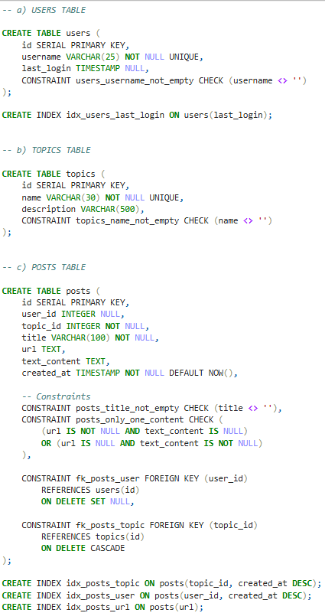
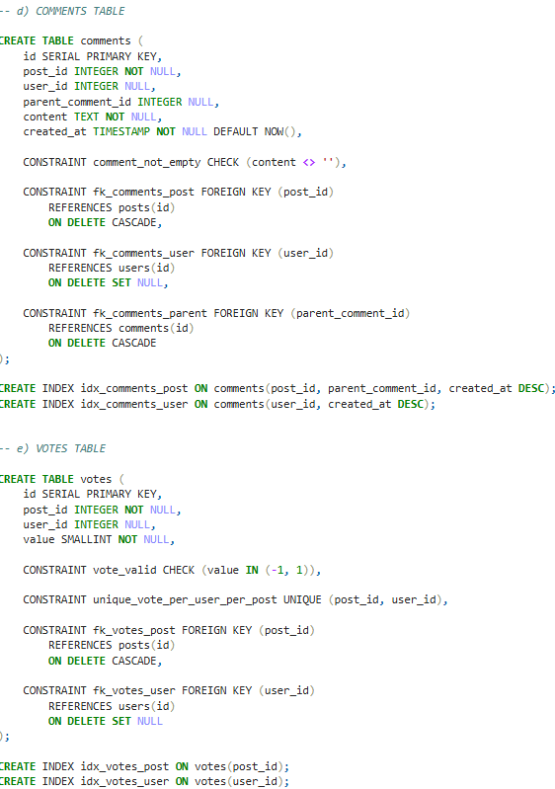

Part III: Migrate the provided data
Now that your new schema is created, it’s time to migrate the data from the provided schema in the project’s SQL Workspace to your own schema. This will allow you to review some DML and DQL concepts, as you’ll be using INSERT...SELECT queries to do so. Here are a few guidelines to help you in this process:

- Topic descriptions can all be empty
- Since the bad_comments table doesn’t have the threading feature, you can migrate all comments as top-level comments, i.e. without a parent
- You can use the Postgres string function regexp_split_to_table to unwind the comma-separated votes values into separate rows
- Don’t forget that some users only vote or comment, and haven’t created any posts. You’ll have to create those users too.
- The order of your migrations matter! For example, since posts depend on users and topics, you’ll have to migrate the latter first.
- Tip: You can start by running only SELECTs to fine-tune your queries, and use a LIMIT to avoid large data sets. Once you know you have the correct query, you can then run your full INSERT...SELECT query.
- NOTE: The data in your SQL Workspace contains thousands of posts and comments. The DML queries may take at least 10-15 seconds to run.

Write the DML to migrate the current data in bad_posts and bad_comments to your new database schema:

--Migrate Users

INSERT INTO users (username)
SELECT DISTINCT username
FROM (
-- authors of posts
SELECT LEFT(TRIM(username), 25) AS username
FROM bad_posts
WHERE username IS NOT NULL AND TRIM(username) <> ''

UNION

-- authors of comments
SELECT LEFT(TRIM(username), 25) AS username
FROM bad_comments
WHERE username IS NOT NULL AND TRIM(username) <> ''

UNION

-- voters from upvotes
SELECT LEFT(TRIM(voter), 25) AS username
FROM bad_posts bp,
regexp_split_to_table(bp.upvotes, ',') AS voter
WHERE bp.upvotes IS NOT NULL AND bp.upvotes <> ''

UNION

-- voters from downvotes
SELECT LEFT(TRIM(voter), 25) AS username
FROM bad_posts bp,
regexp_split_to_table(bp.downvotes, ',') AS voter
WHERE bp.downvotes IS NOT NULL AND bp.downvotes <> ''
) AS derived
WHERE derived.username IS NOT NULL AND derived.username <> '';

--Migrate Topics
INSERT INTO topics (name, description)
SELECT DISTINCT topic, ''
FROM bad_posts
WHERE topic IS NOT NULL AND topic <> '';

--Migrate Posts
INSERT INTO posts (user_id, topic_id, title, url, text_content)
SELECT
u.id,
t.id,
LEFT(bp.title,100),
bp.url,
bp.text_content
FROM bad_posts bp
JOIN users u ON u.username = bp.username
JOIN topics t ON t.name = bp.topic;

--Migrate Comments
INSERT INTO comments (post_id, user_id, content)
SELECT
p.id,
u.id,
bc.text_content
FROM bad_comments bc
JOIN users u ON u.username = bc.username
JOIN bad_posts bp ON bp.id = bc.post_id
JOIN users postowner ON postowner.username = bp.username
JOIN posts p
ON p.title = LEFT(bp.title,100)
AND p.user_id = postowner.id;

--Migrate Votes
WITH expanded AS (
SELECT bp.username AS post_owner, LEFT(bp.title,100) AS title,
regexp_split_to_table(bp.upvotes, ',') AS voter
FROM bad_posts bp
WHERE bp.upvotes IS NOT NULL AND bp.upvotes <> ''
)
INSERT INTO votes (post_id, user_id, value)
SELECT
p.id,
u.id,
1
FROM expanded e
JOIN users u ON u.username = e.voter
JOIN users postowner ON postowner.username = e.post_owner
JOIN posts p ON p.title = e.title AND p.user_id = postowner.id;

WITH expanded AS (
SELECT bp.username AS post_owner, LEFT(bp.title,100) AS title,
regexp_split_to_table(bp.downvotes, ',') AS voter
FROM bad_posts bp
WHERE bp.downvotes IS NOT NULL AND bp.downvotes <> ''
)
INSERT INTO votes (post_id, user_id, value)
SELECT
p.id,
u.id,
-1
FROM expanded e
JOIN users u ON u.username = e.voter
JOIN users postowner ON postowner.username = e.post_owner
JOIN posts p ON p.title = e.title AND p.user_id = postowner.id;

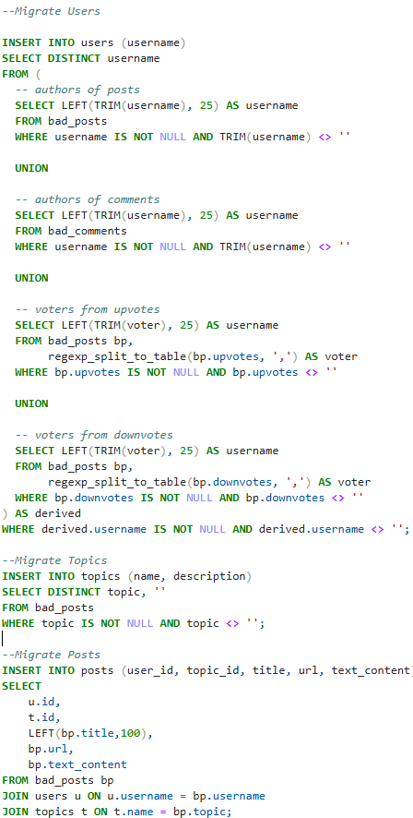
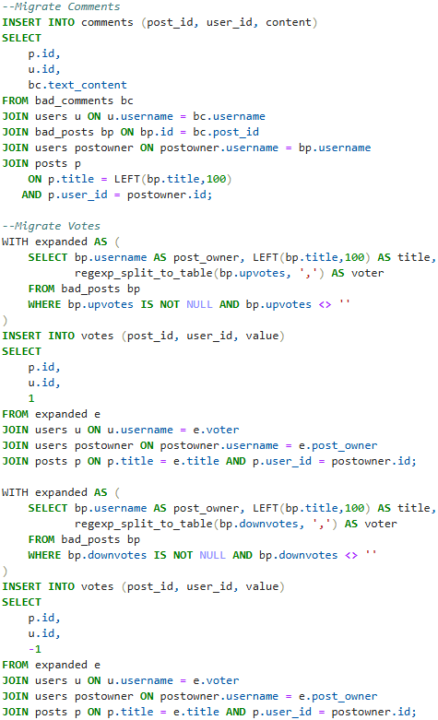

SELECT COUNT(*) FROM users;
SELECT COUNT(*) FROM topics;
SELECT COUNT(*) FROM posts;
SELECT COUNT(*) FROM comments;
SELECT COUNT(*) FROM votes;

