Name:
ID:
Date:
ITU, Computer Engineering Dept.
BLG527E, Machine Learning HW4
Due: Dec 13, 2016, 23:00 through Ninova.

Instructors: Yusuf Yaslan (yyaslan@itu.edu.tr)
Grading: You must complete the table below according to what you expect to get out of each question.

 |  | Q1- a | Q1-b | Q1-c | Q2 | Total
Grade | Max | 1 | 1 | 1 | 2 | 5 pts
Grade | Expected

Policy:

Please do your homeworks on your own. You are encouraged to discuss the questions with your class mates, but the code and the hw you submitted must be your own work. Cheating is highly discouraged for it could mean a zero or negative grade from the homework.

If a question is not clear, please let us know (via email or in class). Unless we indicate otherwise, do not use libraries for machine learning methods. When in doubt, email us.

There will be 5 homeworks this term. Each hw is worth 5 points and each question will be evaluated on a 0/1 basis.

In order to be able to take the final exam for BLG527E you have to have a weighted average score of 30 (over 100) for midterm and homeworks. Otherwise you will get a VF from the course.

HW4 CheckList
1) Make sure that you have filled up the EXPECTEDGRADE_HW4.xlsx and loaded it as an xlsx file
2) Make sure that you have a report file (docx) names studentID_Name_hw?.??? that contains the answers for the questions. Give the source code as appendices in the .docx.
3) Make sure that your name, number, HWnumber and date are written on the first page
4) If you submit handwritten homework questions, make sure that the scan/photo quality is good and make sure that you include them into your report file. Make sure that the images are rotated so that they are right side up. Do not upload scanned images (with nondescriptive names) as separate files.
5) Put the plots, outputs of your code into your report file.
6) Make sure that you have instructions on how to run your code in the report file.

Q1)
a) You are given a two class (a and b) dataset (q1a.mat) with one feature in [-15, 10] range. Estimate the p(x|c) by using parzen window with Gaussian kernel with h = 0.1, h = 0.5, h= 1, h =2 and find the posterior distribution p(c|x).

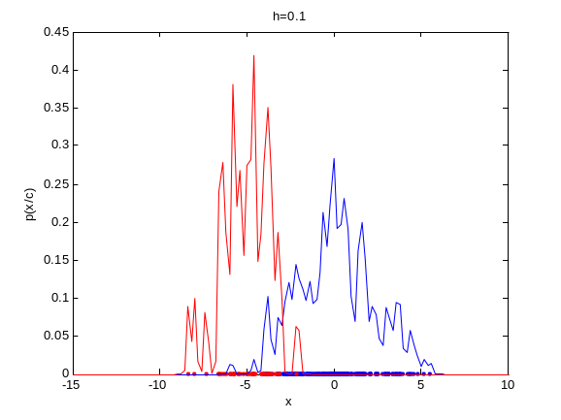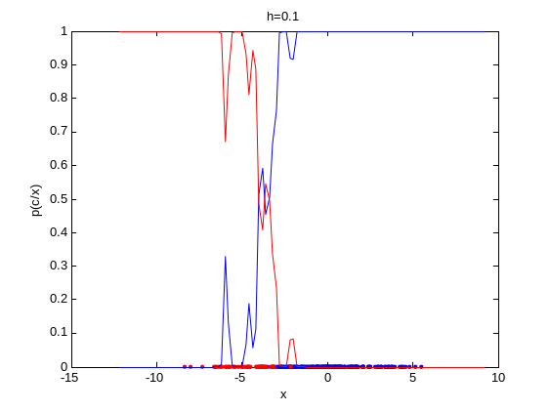

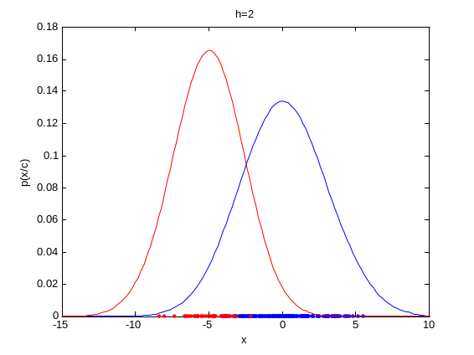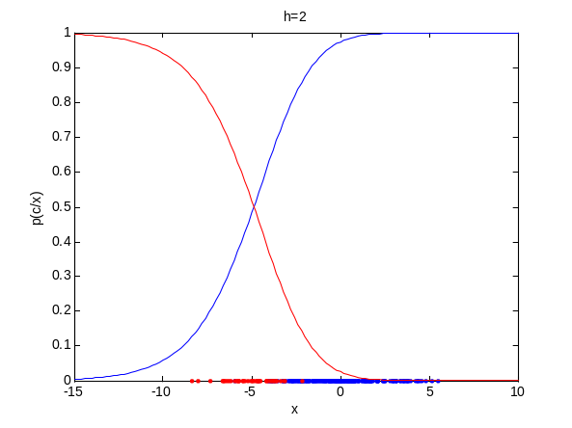
b)You are given a two class (a and b) dataset (q1b.mat) with two features. Each feature can take a value in between [-10, 10]. The probability densities for p(x|C = a) and p(x|C = b) are not known.
You will write a Parzen window estimator in order to do nonparametric density estimation.

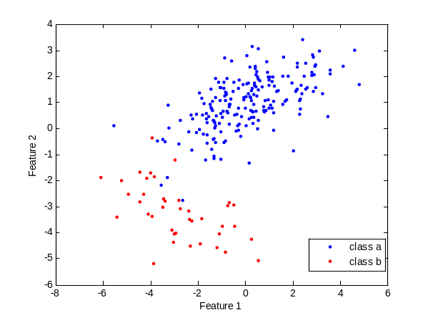

Estimate the p(x|c) by using parzen window using Gaussian kernel (Eq. 8.11 in the book). Find the posterior distribution for the given data (h = 2) and classify the data point x = [-10,-10].

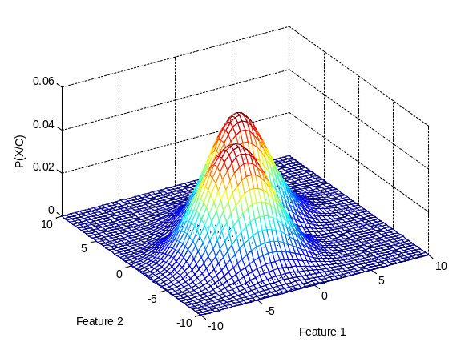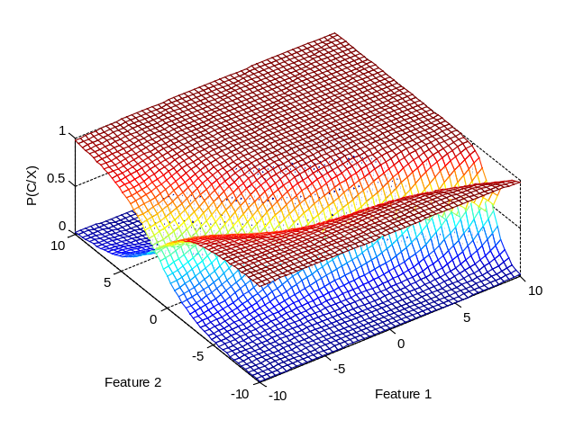
1 c) Estimate the p(x/c) by using parzen window using Gaussian kernel (Eq. 8.12 in the book). Find the posterior distribution for the given data (h = 2) and classify the data point x = [-10,-10]. Compare the results you have obtained in 1-b and 1-c. (Use the q1b.mat dataset)
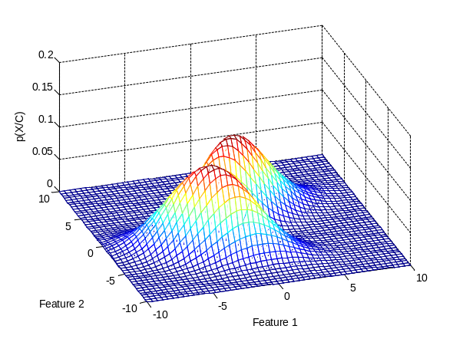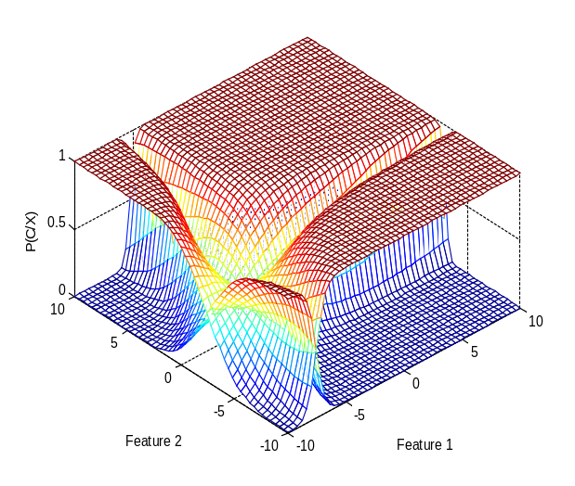

Q2) You will use the q2.mat dataset for this hw. The last column of the file shows the label (class -1 or class 1)

Use logistic discriminant algorithm (Alpaydın’s book Figure 10.6) to classify this dataset. Obtain 10 fold cross validation classification accuracy and report mean and standard deviation value of the accuracies.

Plot 1 folds’ training and test error versus number of iterations

