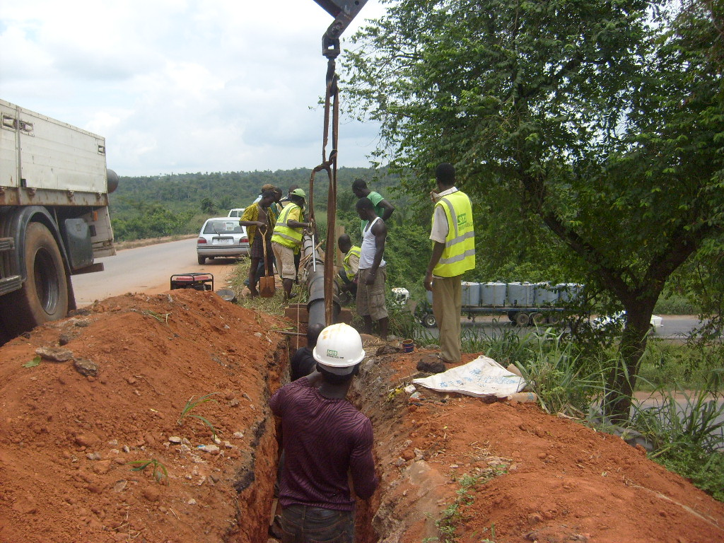
PICTURE SHOWING THE DRILLING RIG AND INGERSOLL ROAD COMPRESSOR 825CFM MODEL BY SATO ENGINEERING NIGERIA LIMITED

DRILLING WORK IN PROGRESS AT LADERIN ESTATE, ABEOKUTA BY SATO ENGINEERING NIGERIA LIMITED
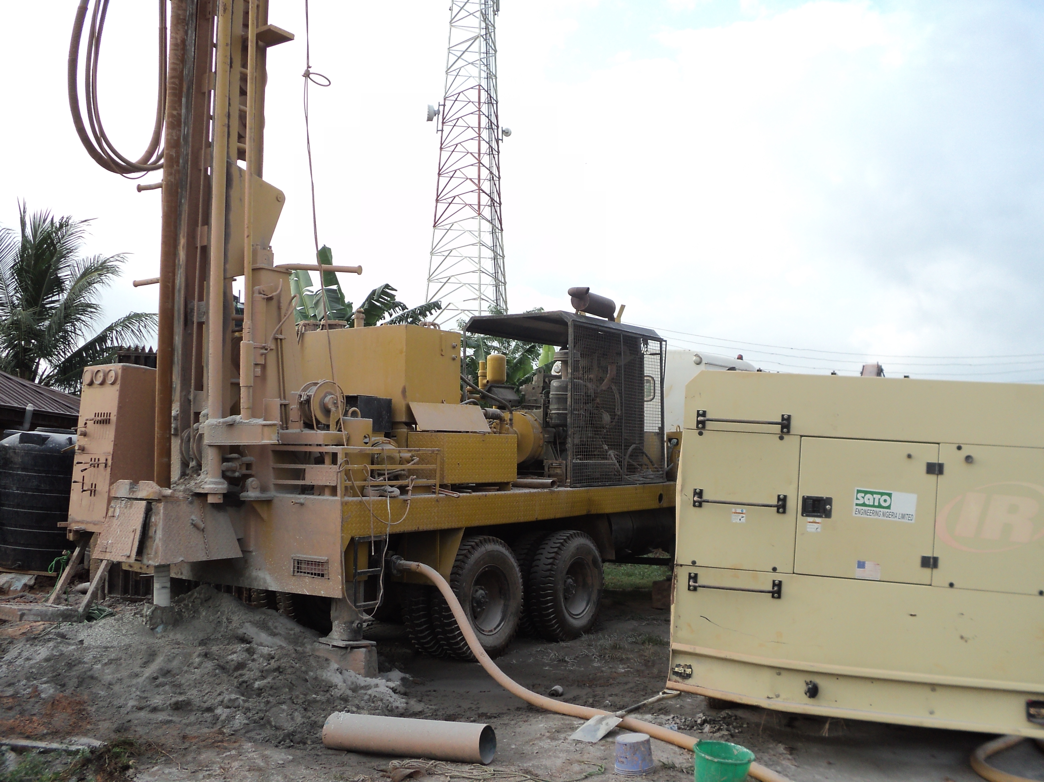
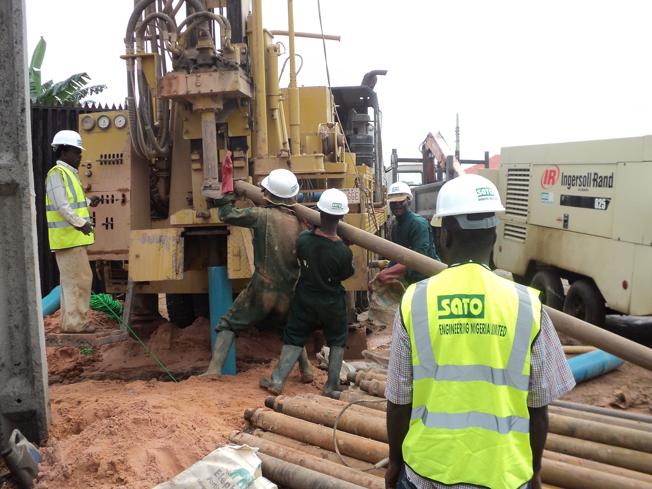
INSTALLATION OF ALUM DOZING PUMPS AT OGERE WATER SUPPLY SCHEME
REPAIR WORKS ON SAND FILTER NOW COMPLETED AT ARAKANGA WATER SCHEME
INSTALLATION OF LIME DOZING PUMPS AT OGERE WATER SUPPLY SCHEME

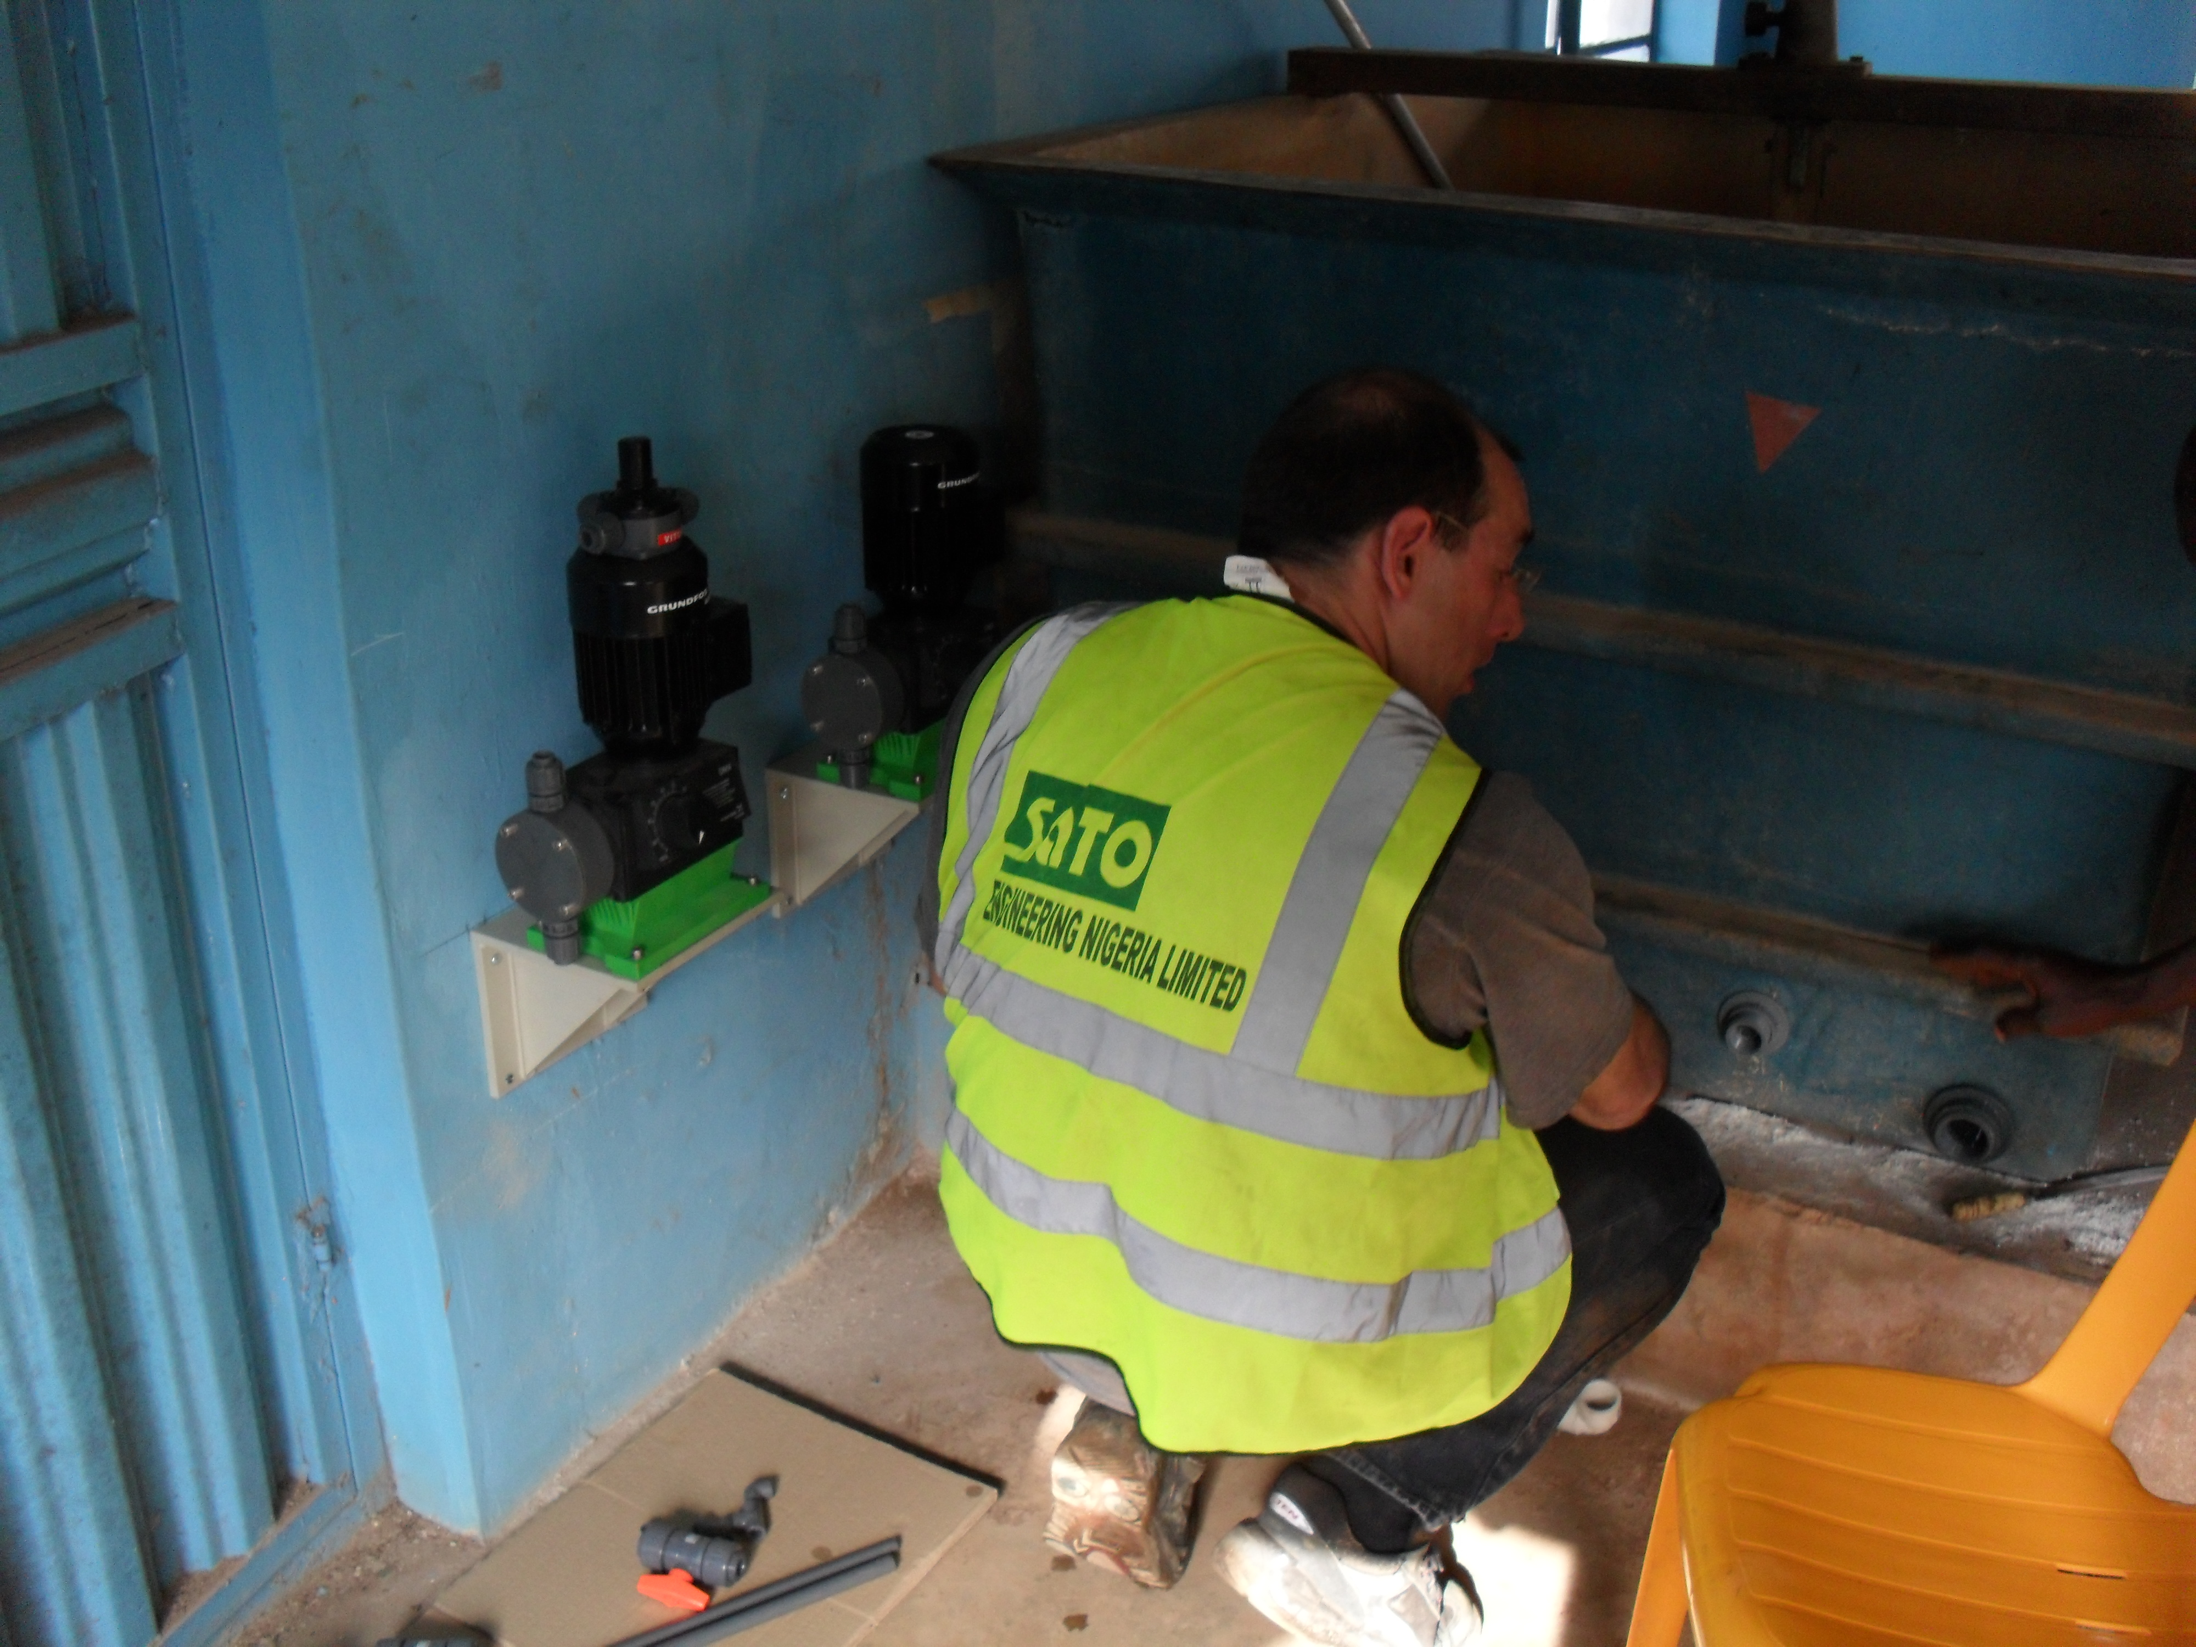
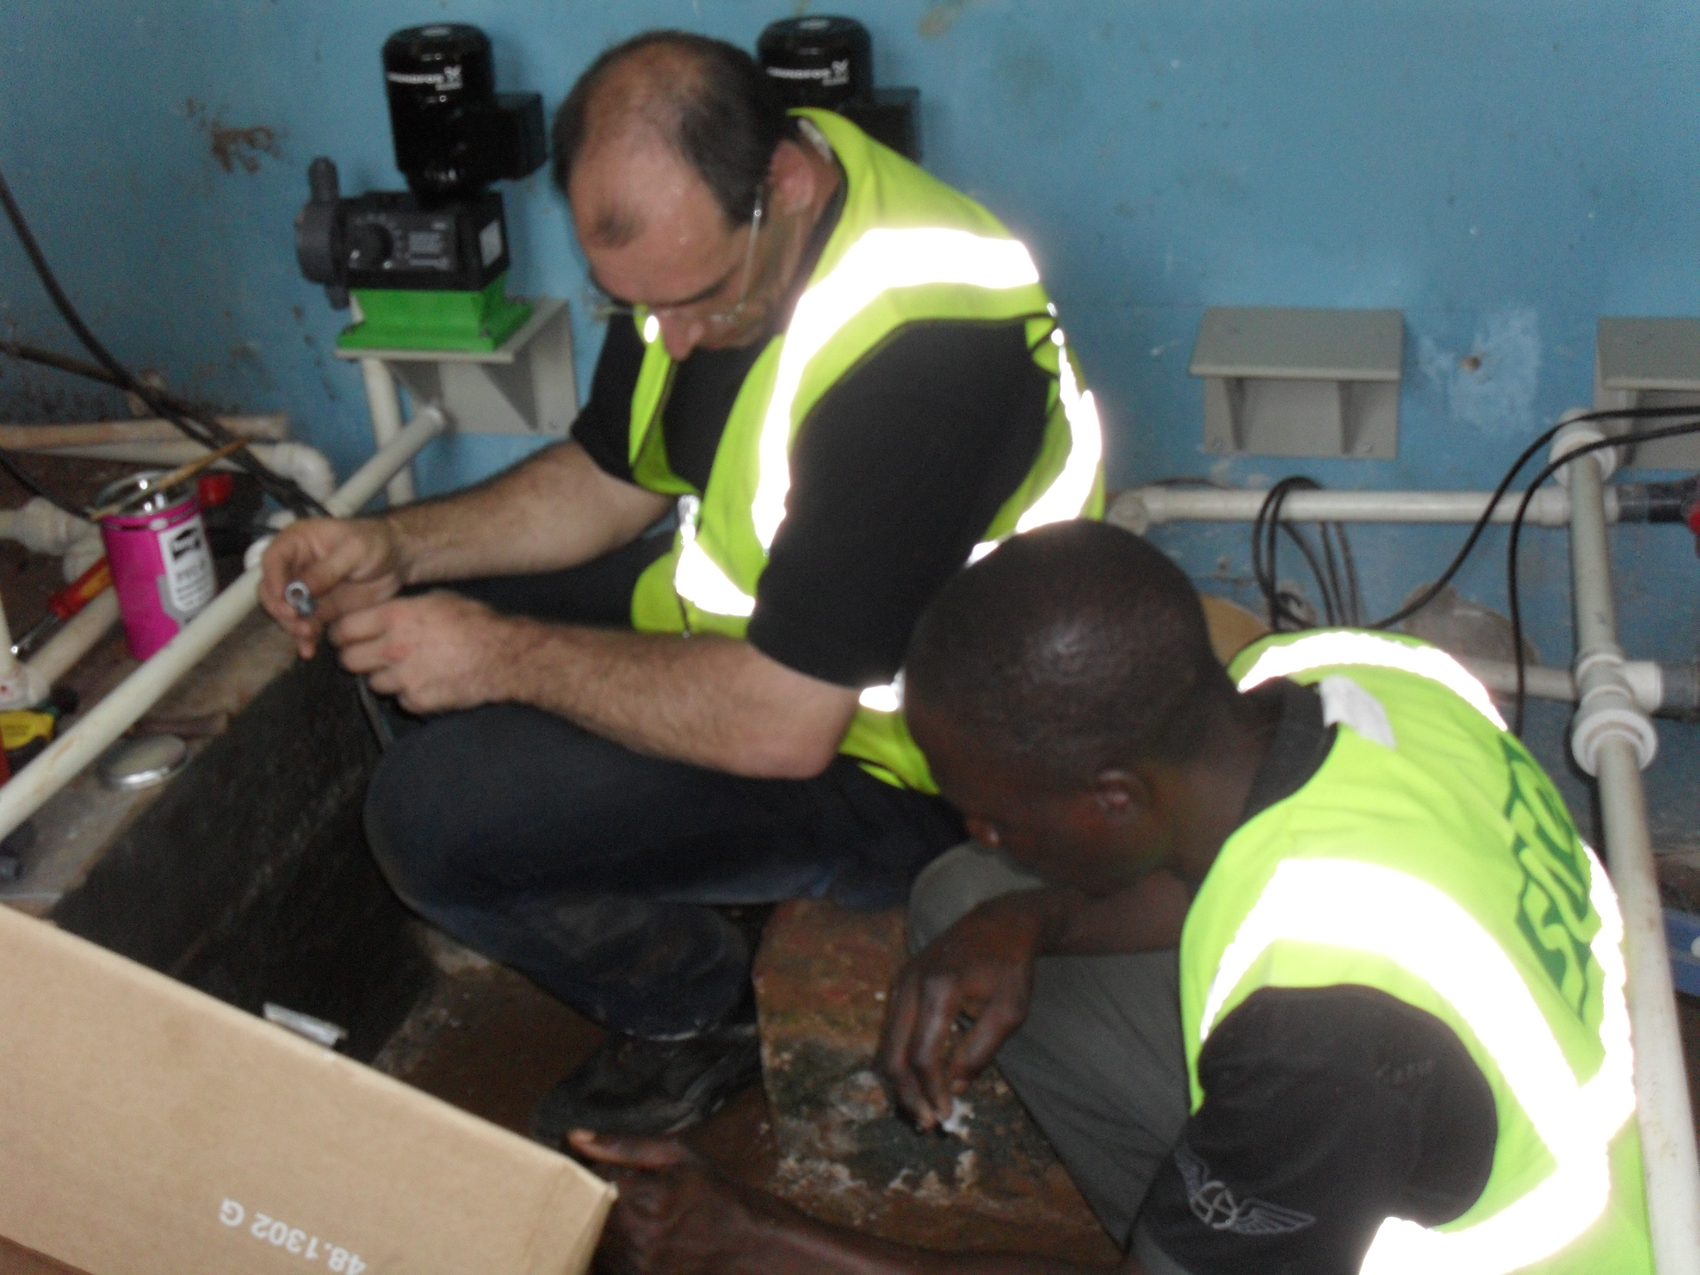
CONNECTION OF IRON DUCTILE PIPE AT OGERE

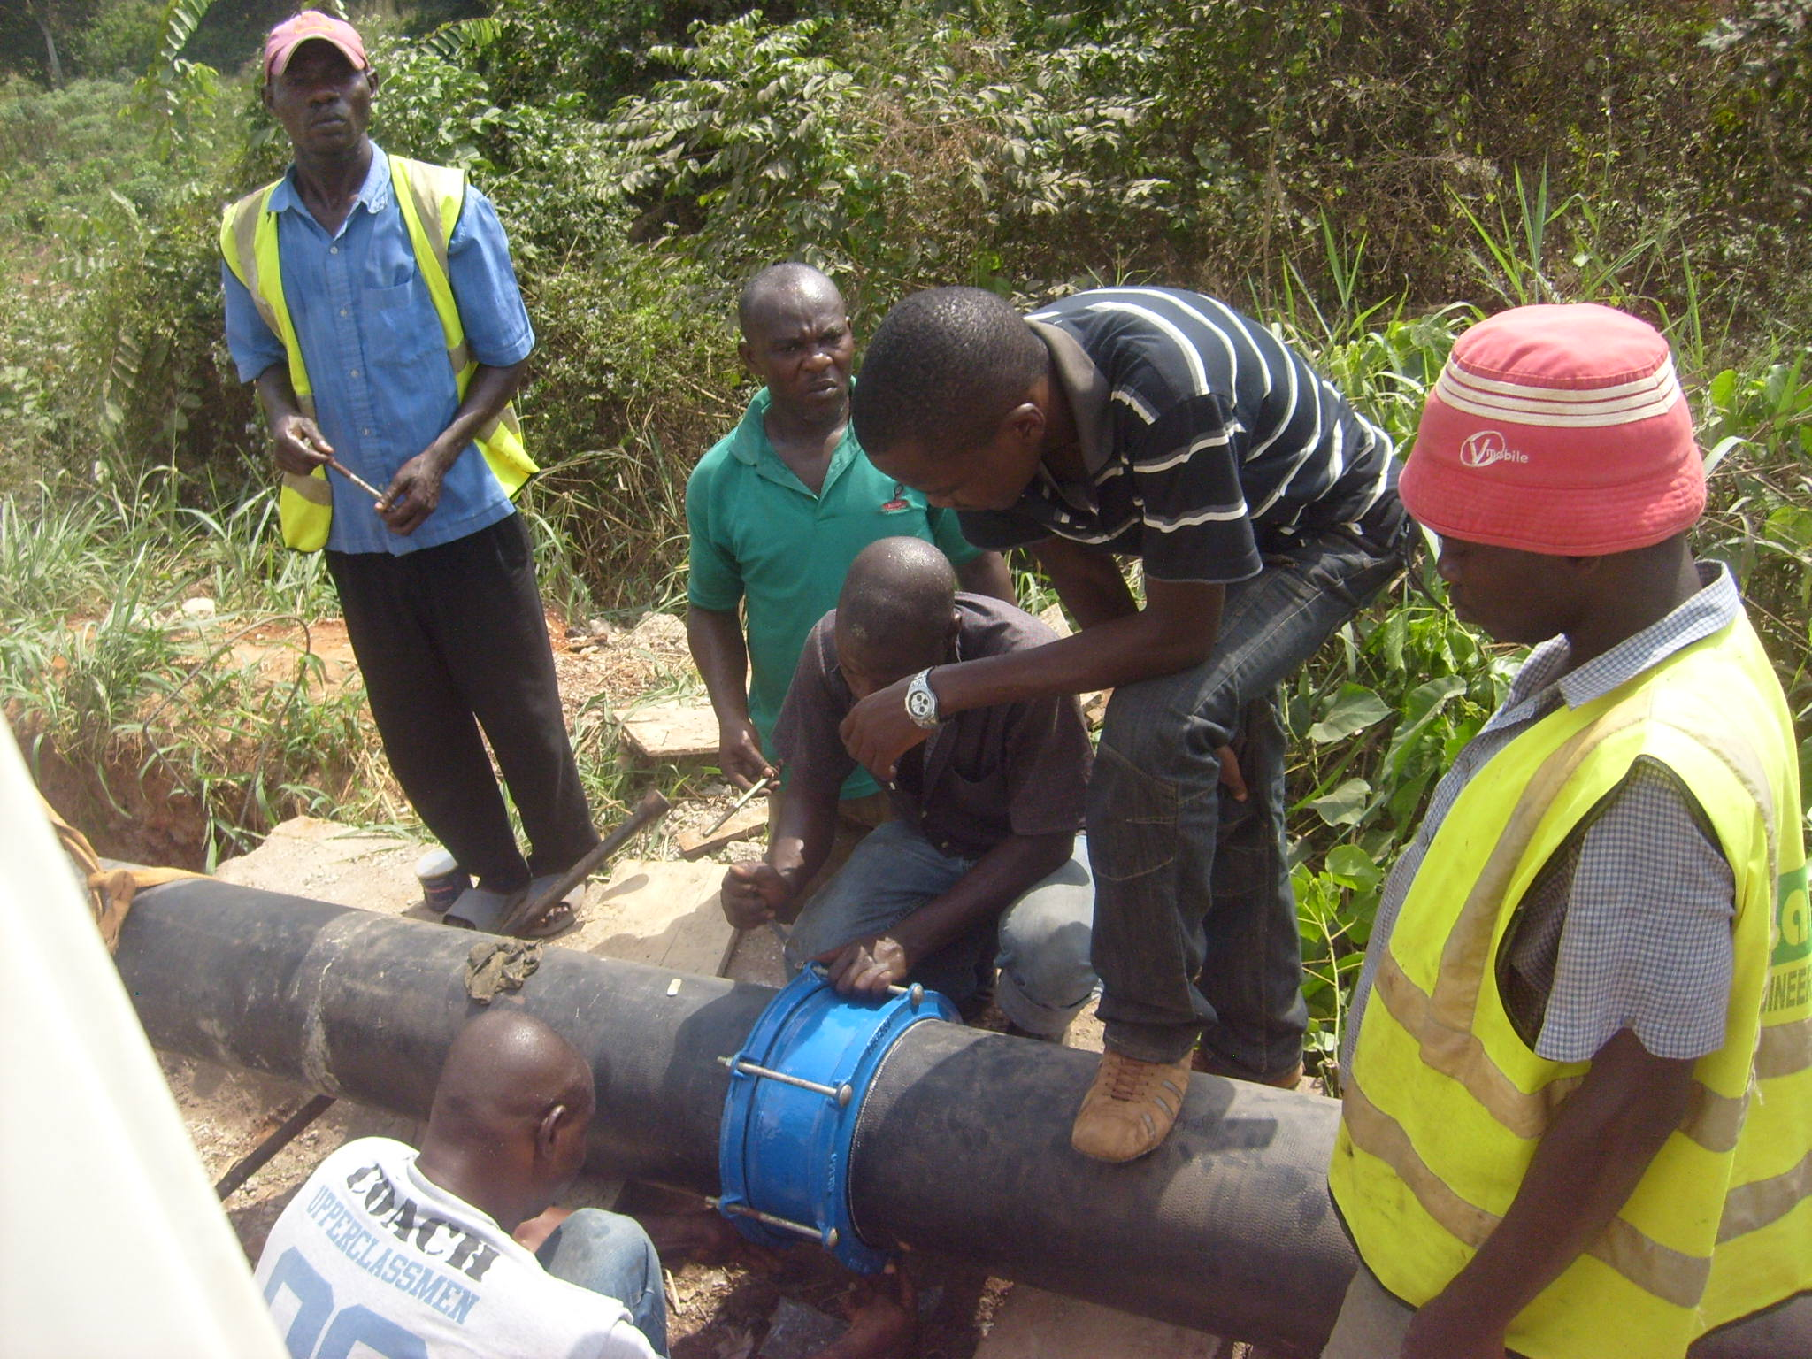
CASTING OF CONCRETE SUPPORT FOR PIPE BEND AT OGERE

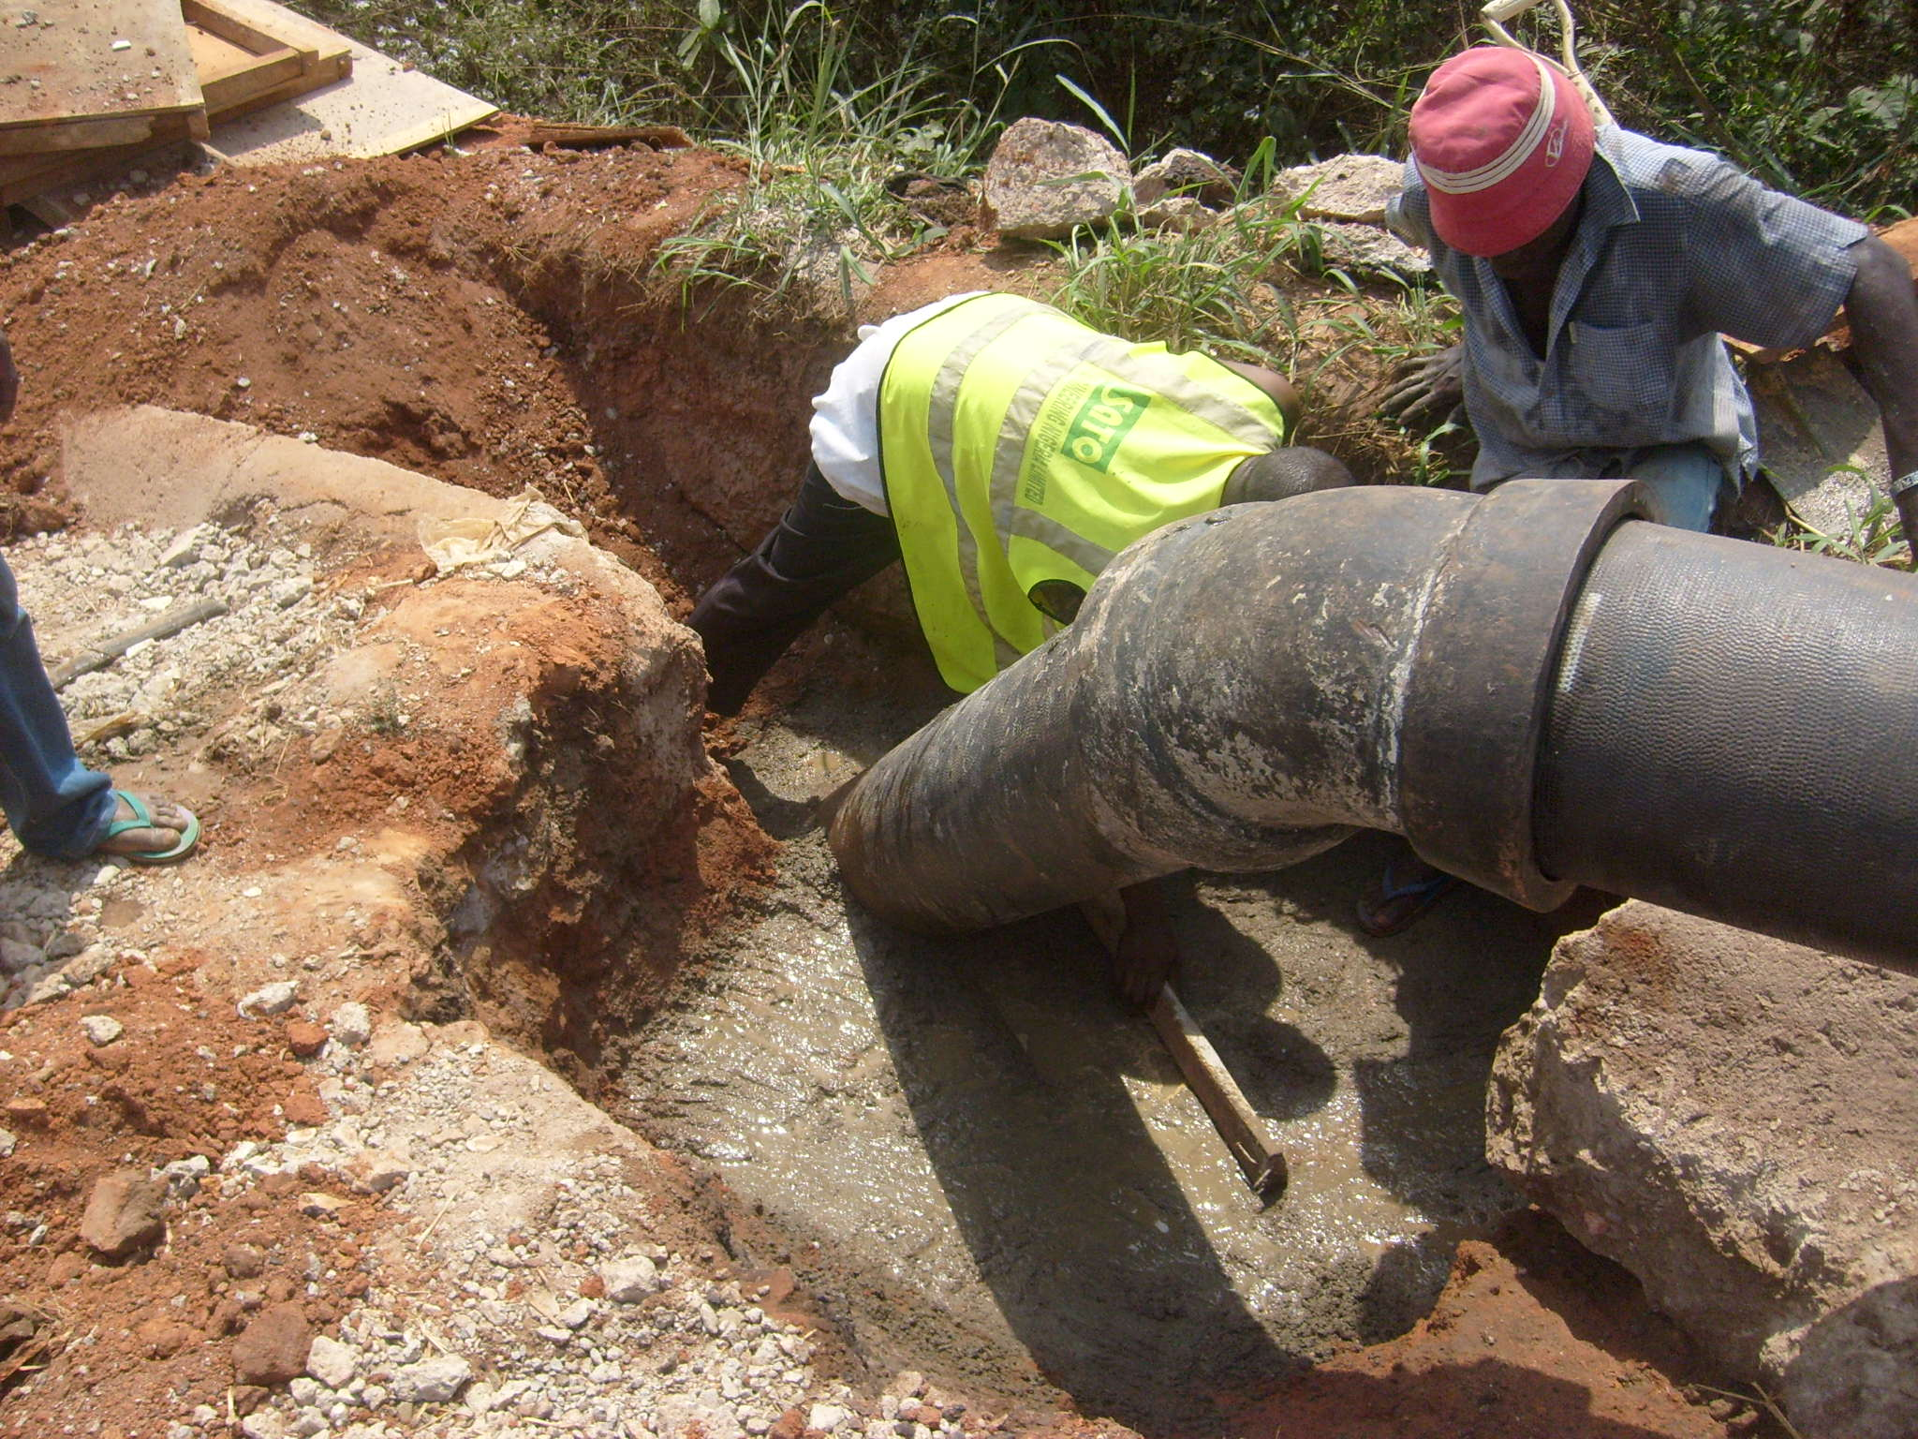
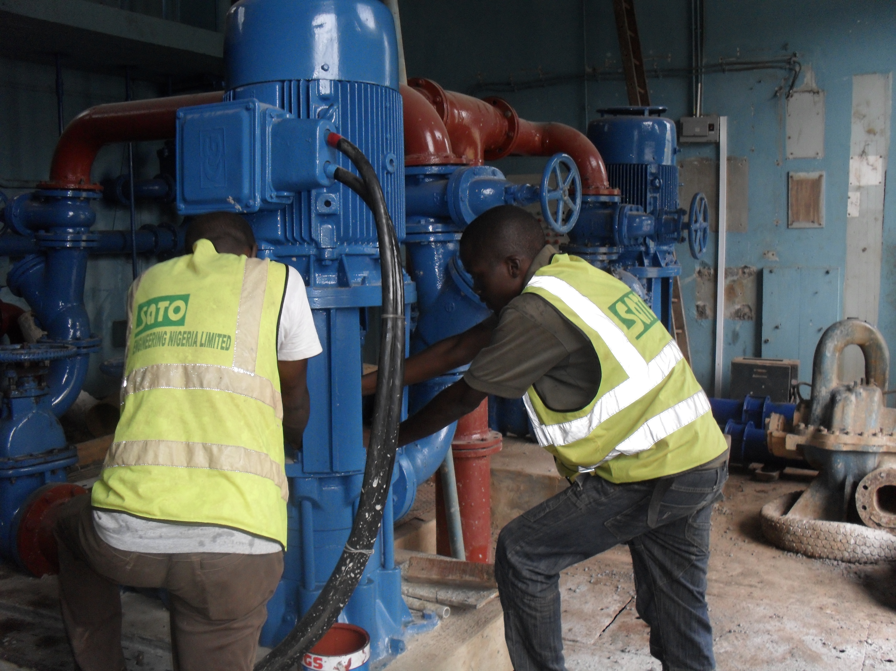
INSTALLATION OF HIGHLIFT PUMP IN PROGRESS AT OGERE
EXCAVATION OF TRENCH FOR PIPE LAYING IN PROGRESS AT OGERE
CONNECTION OF 300MM PIPE TO 150MM PIPE AT OSHITELU JUNCTION AT OGERE
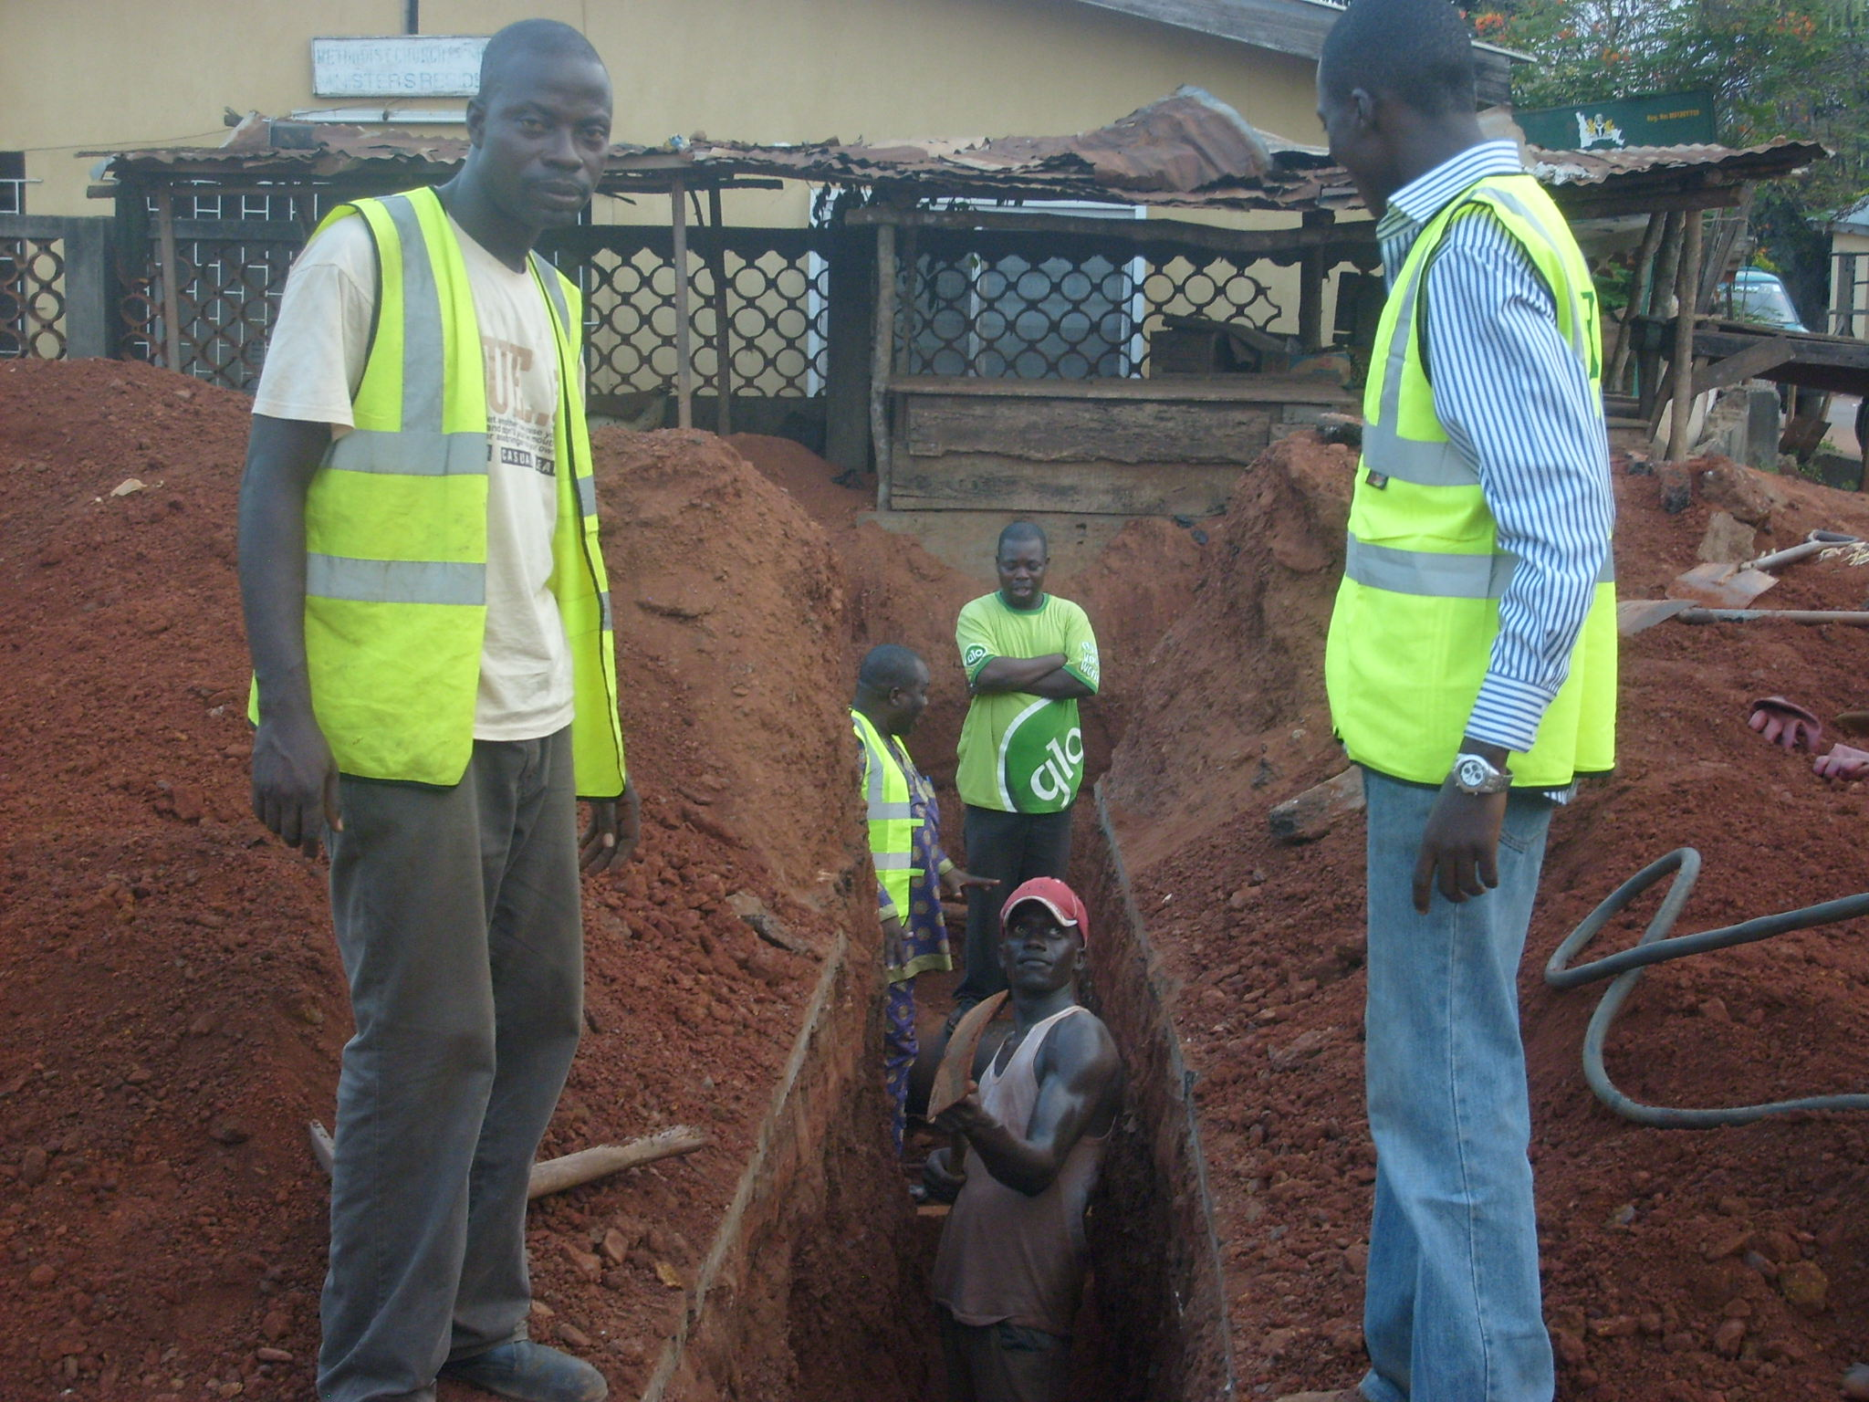
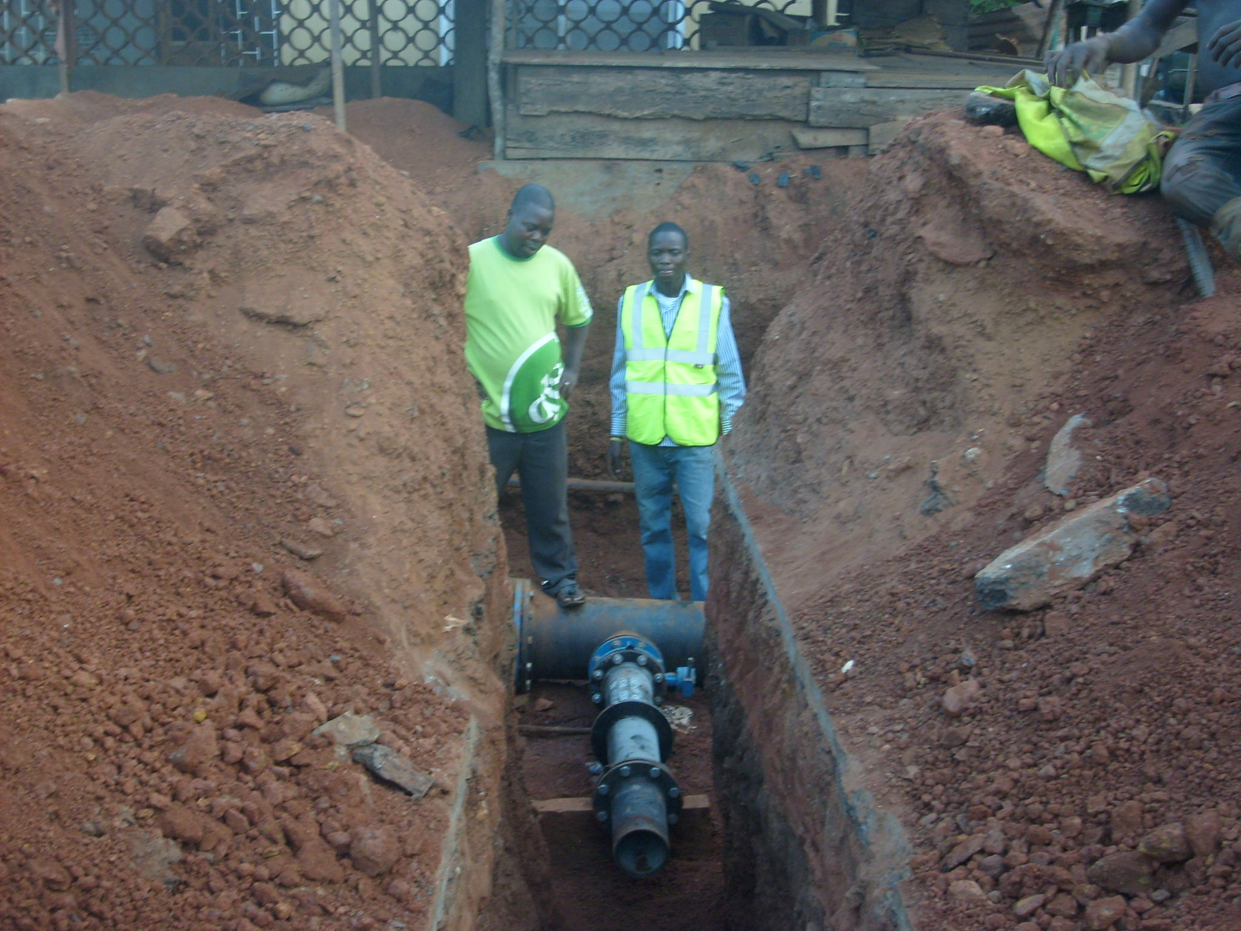
LAYING OF DUCTILE IRON PIPES IN PROGRESS AT OGERE

LAYING OF DUCTILE IRON PIPE IN PROGRESS AT OGERE

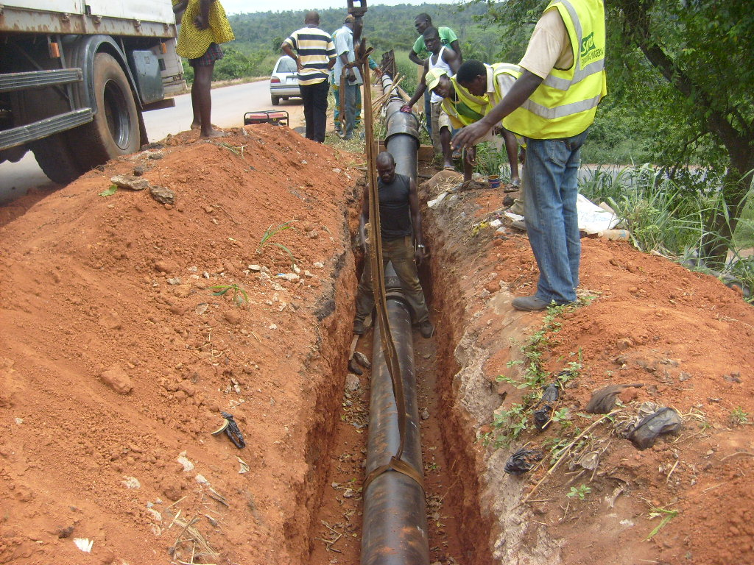
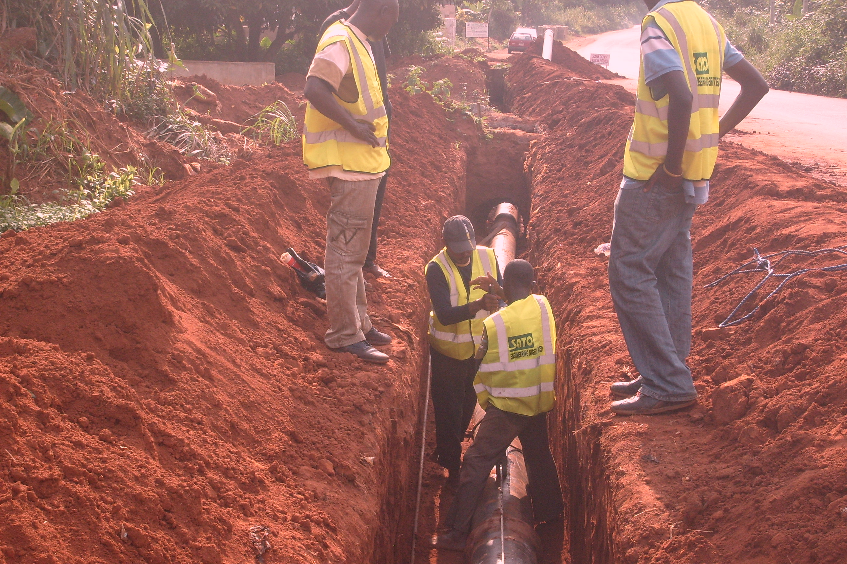
LAYING OF DUCTILE IRON PIPE AT OGERE

CONSTRUCTION WORK IN PROGRESS AT OGERE WATER SCHEME OGUN STATE

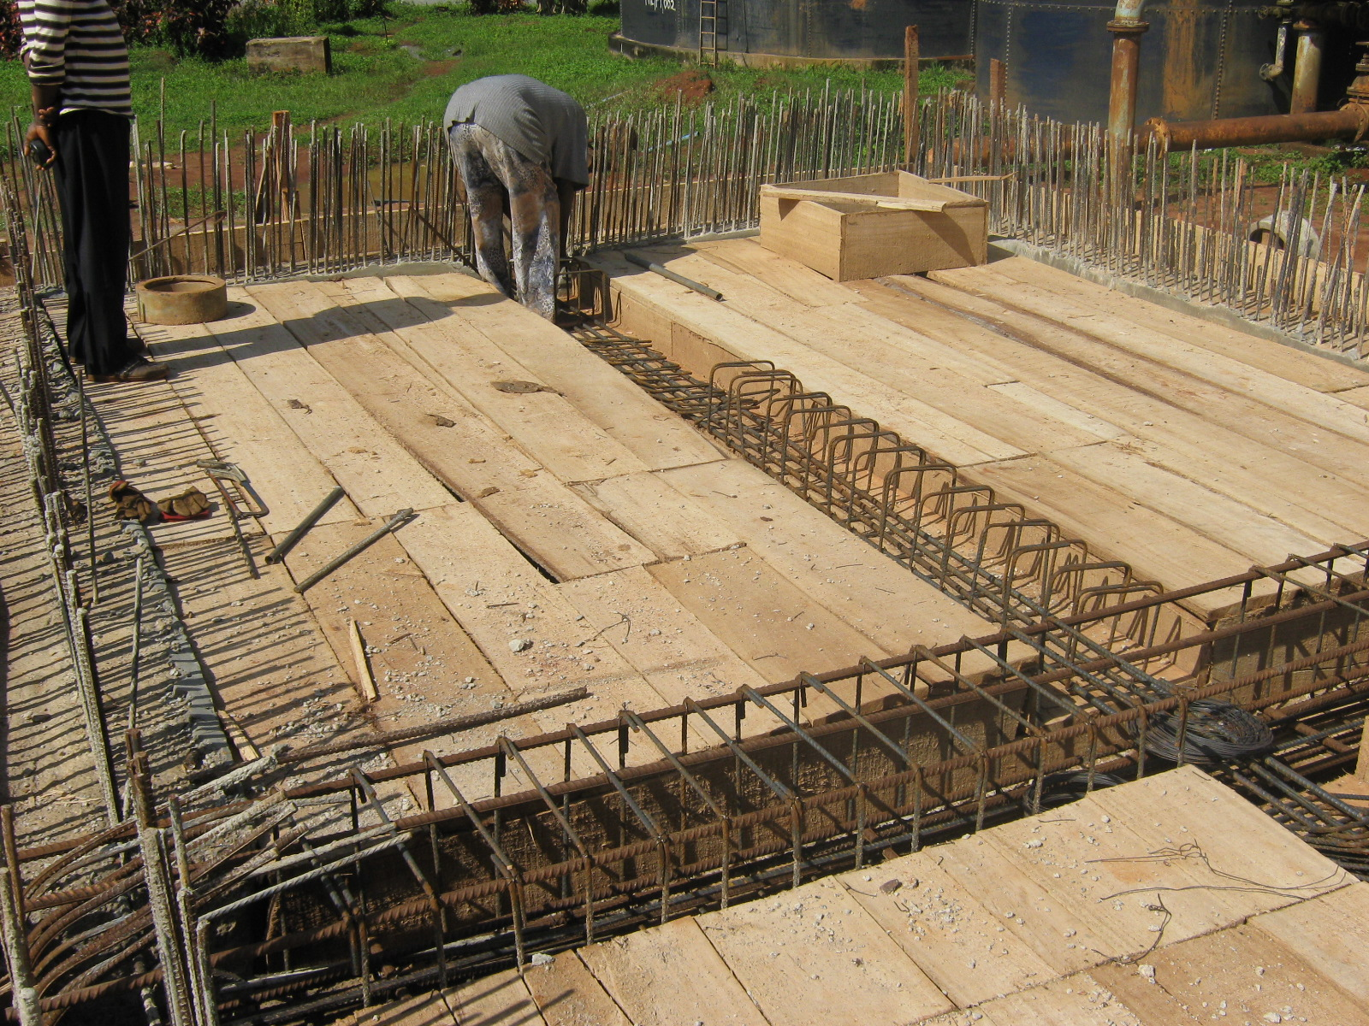
CONSTRUCTION WORK IN PROGRESS AT OGERE WATER SCHEME OGUN STATE
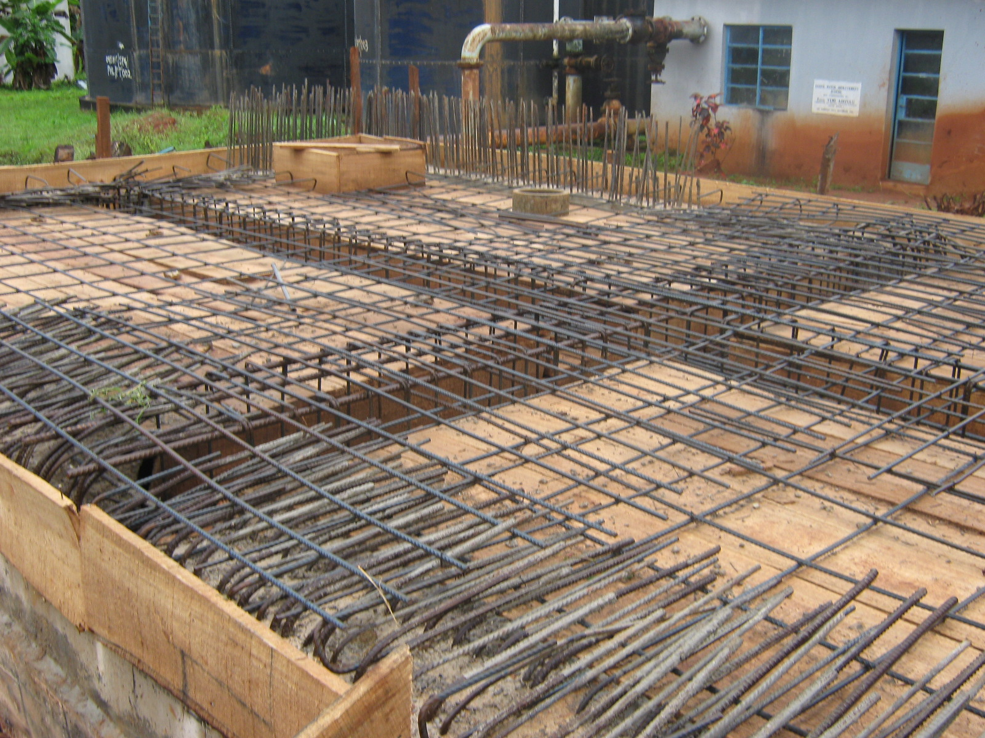
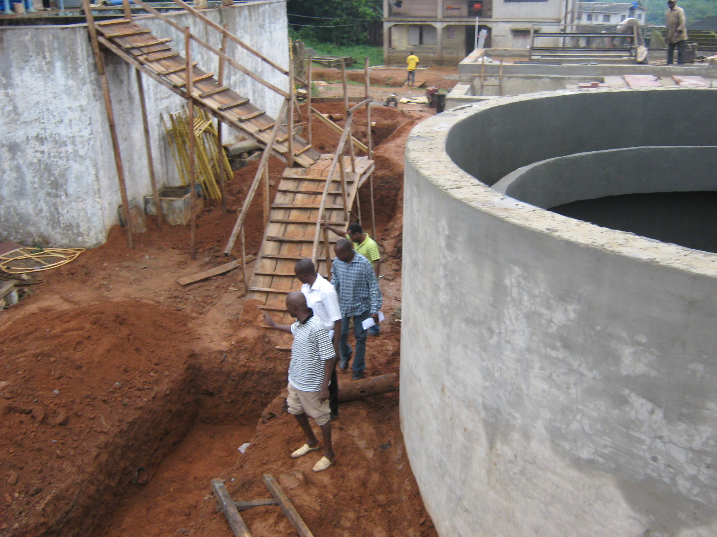
CONSTRUCTION OF GROUND TANK, BY SATO ENGINEERING NIGERIA LIMITED
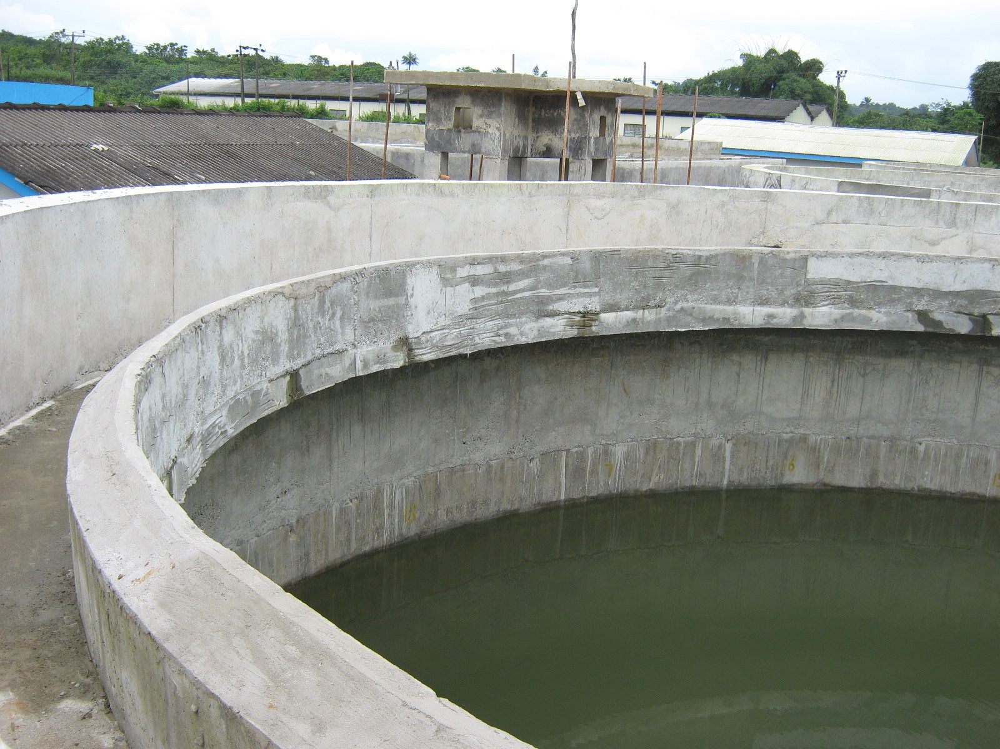
CONSTRUCTION OF GROUND TANK, BY SATO ENGINEERING NIGERIA LIMITED

CONSTRUCTION OF CLEAR WATER TANK IN PROGRESS AT THE OGERE WATER SUPPLY SCHEME

CONSTRUCTION OF CLEAR WATER TANK IN PROGRESS AT THE OGERE WATER SUPPLY SCHEME
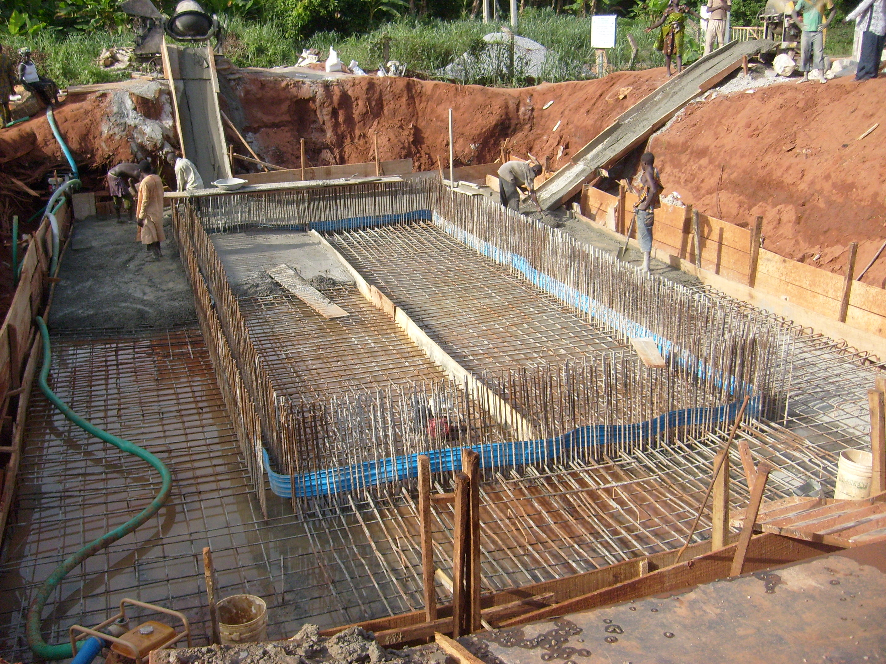
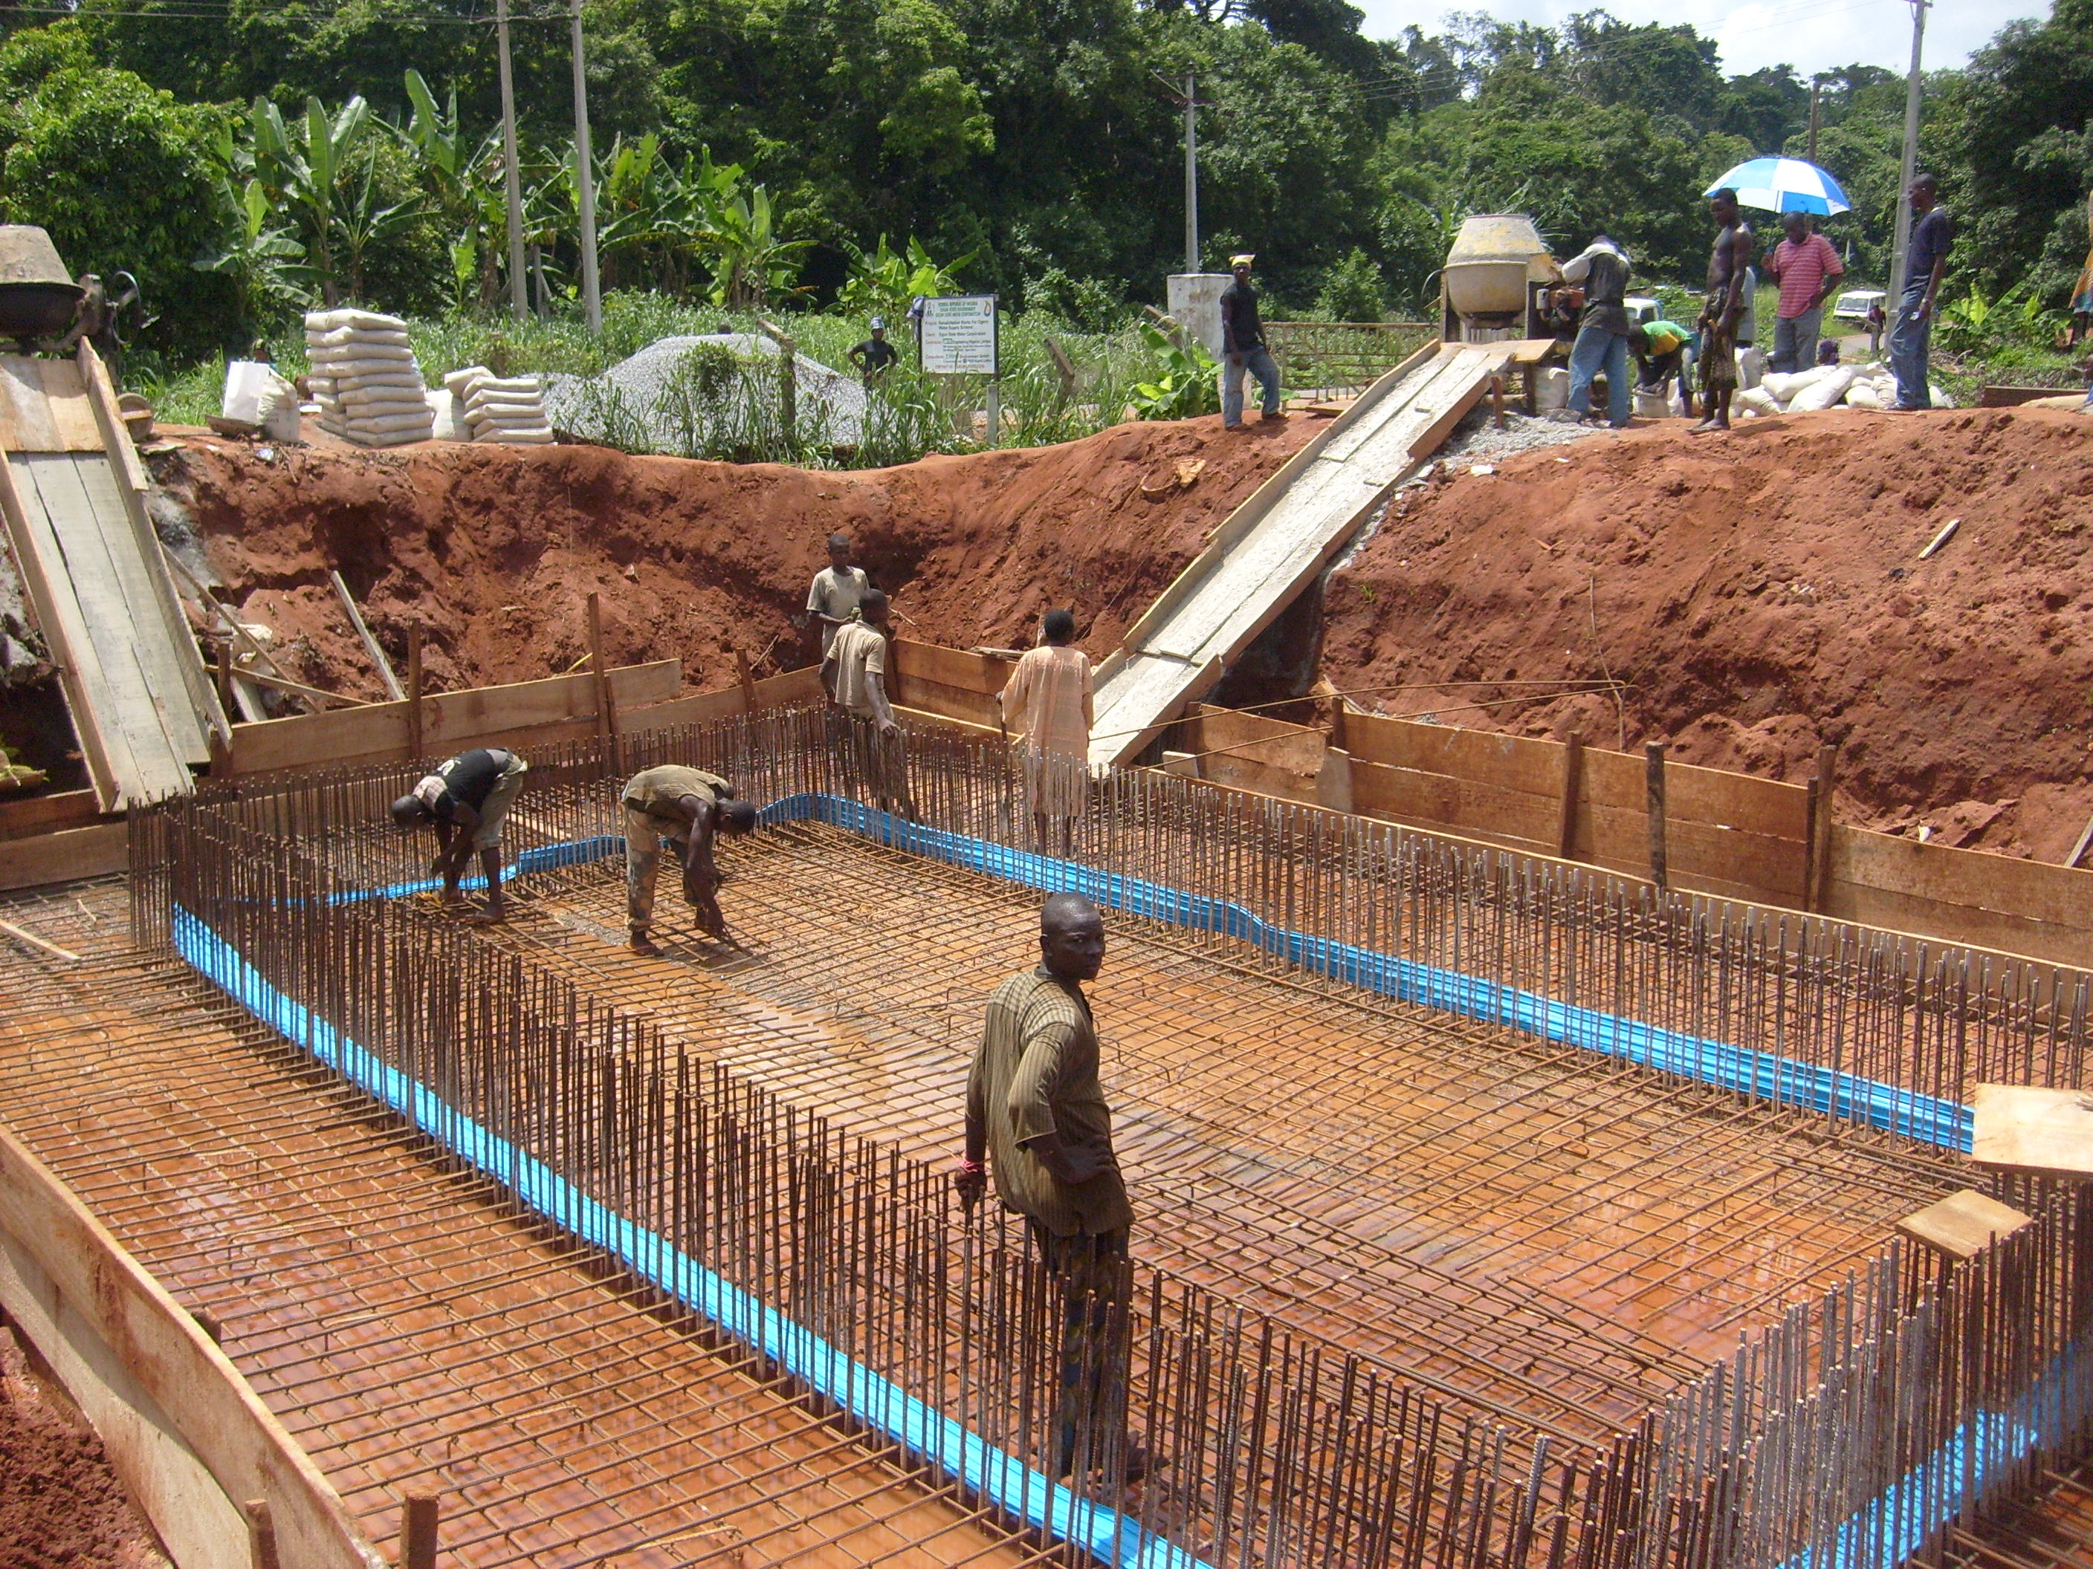
DUCTILE IRON PIPES BEING OFFLOADED AT OGERE WATER SUPPLY SCHEME BY OUR CRANE LORRY

ONGOING WORKS AT OGERE WATER SUPPLY SCHEME BY SATO ENGINEERING NIGERIA LIMITED

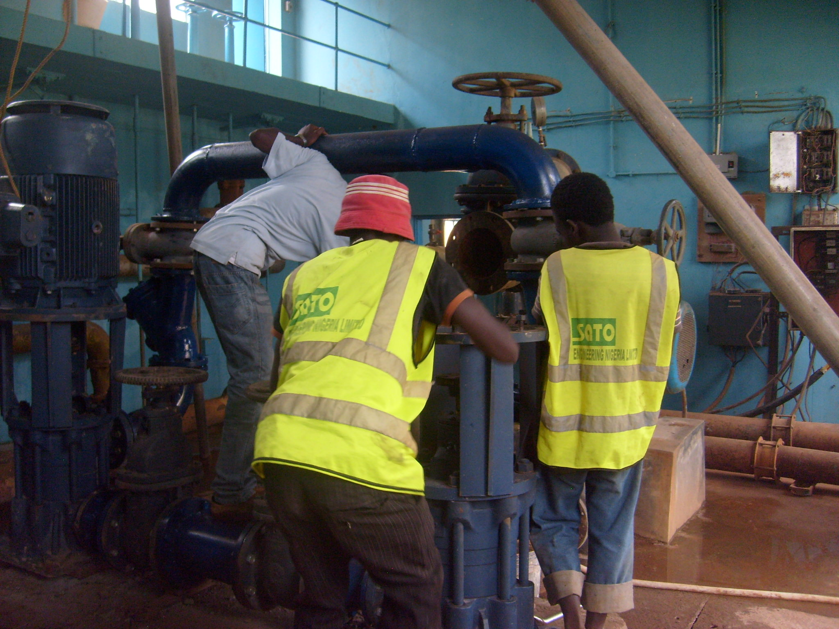
ONGOING WORKS AT OGERE WATER SUPPLY SCHEME BY SATO ENGINEERING NIGERIA LIMITED

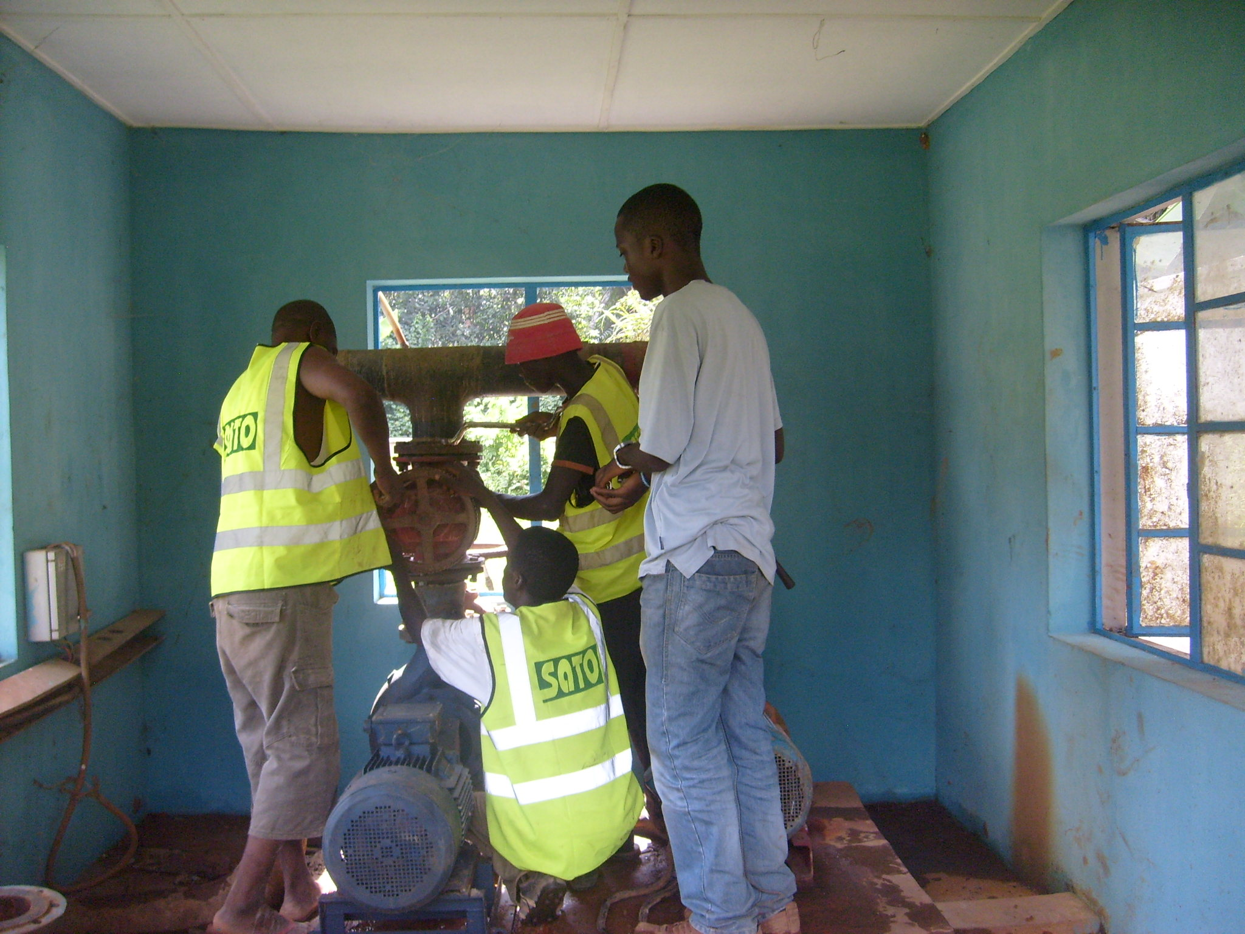

ONGOING WORK IN PROGRESS AT SAGAMU OGUN STATE BY SATO ENGINEERING NIGERIA LIMITED

CONSTRUCTION OF RAMP ACCESS TO 1ST SEGMENT OF CUT-OFF TRENCH EXCAVATION (FIDITI DAM)
PICTURE SHOWING COMPLETE SEGMENTS 1 & 2 OF FIDITI’S DAM CUT-OFF TRENCH EXCAVATION
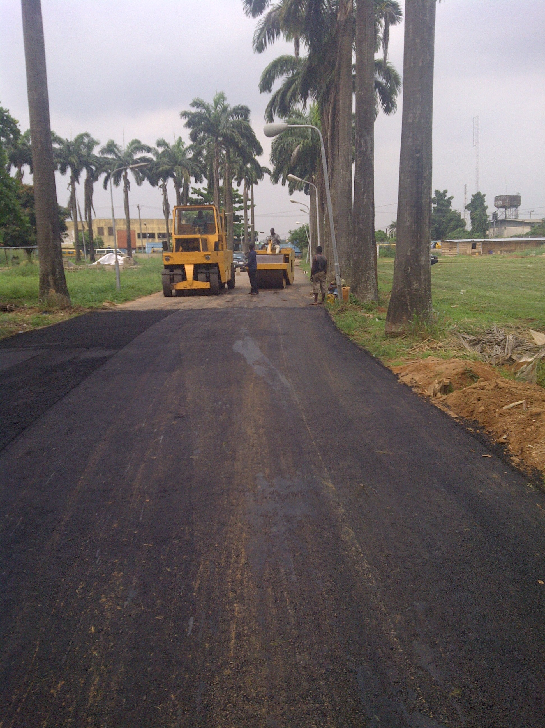
LAYING OF ASPHALT IN PROGRESS
PRIMING OF MC1 PRIOR TO LAYING OF ASPHALT
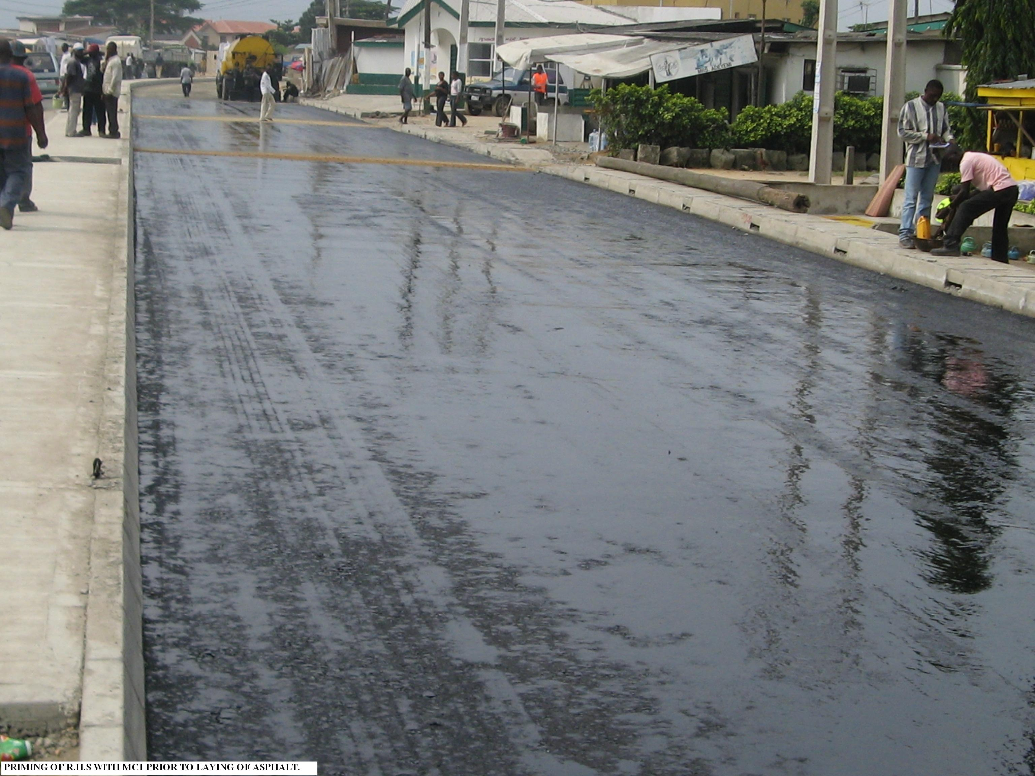
COMPACTION OF SUB-BASE MATERIAL IN PROGRESS
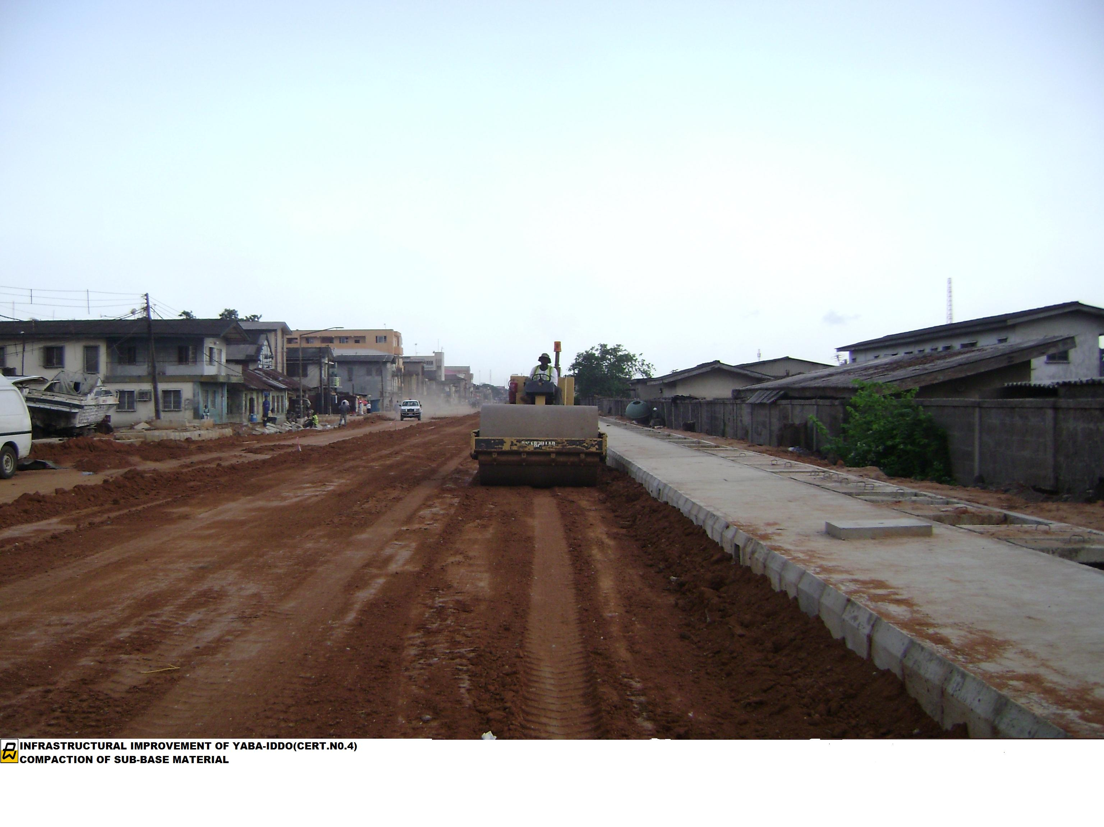
LAYING OF STONE BASE IN PROGRESS
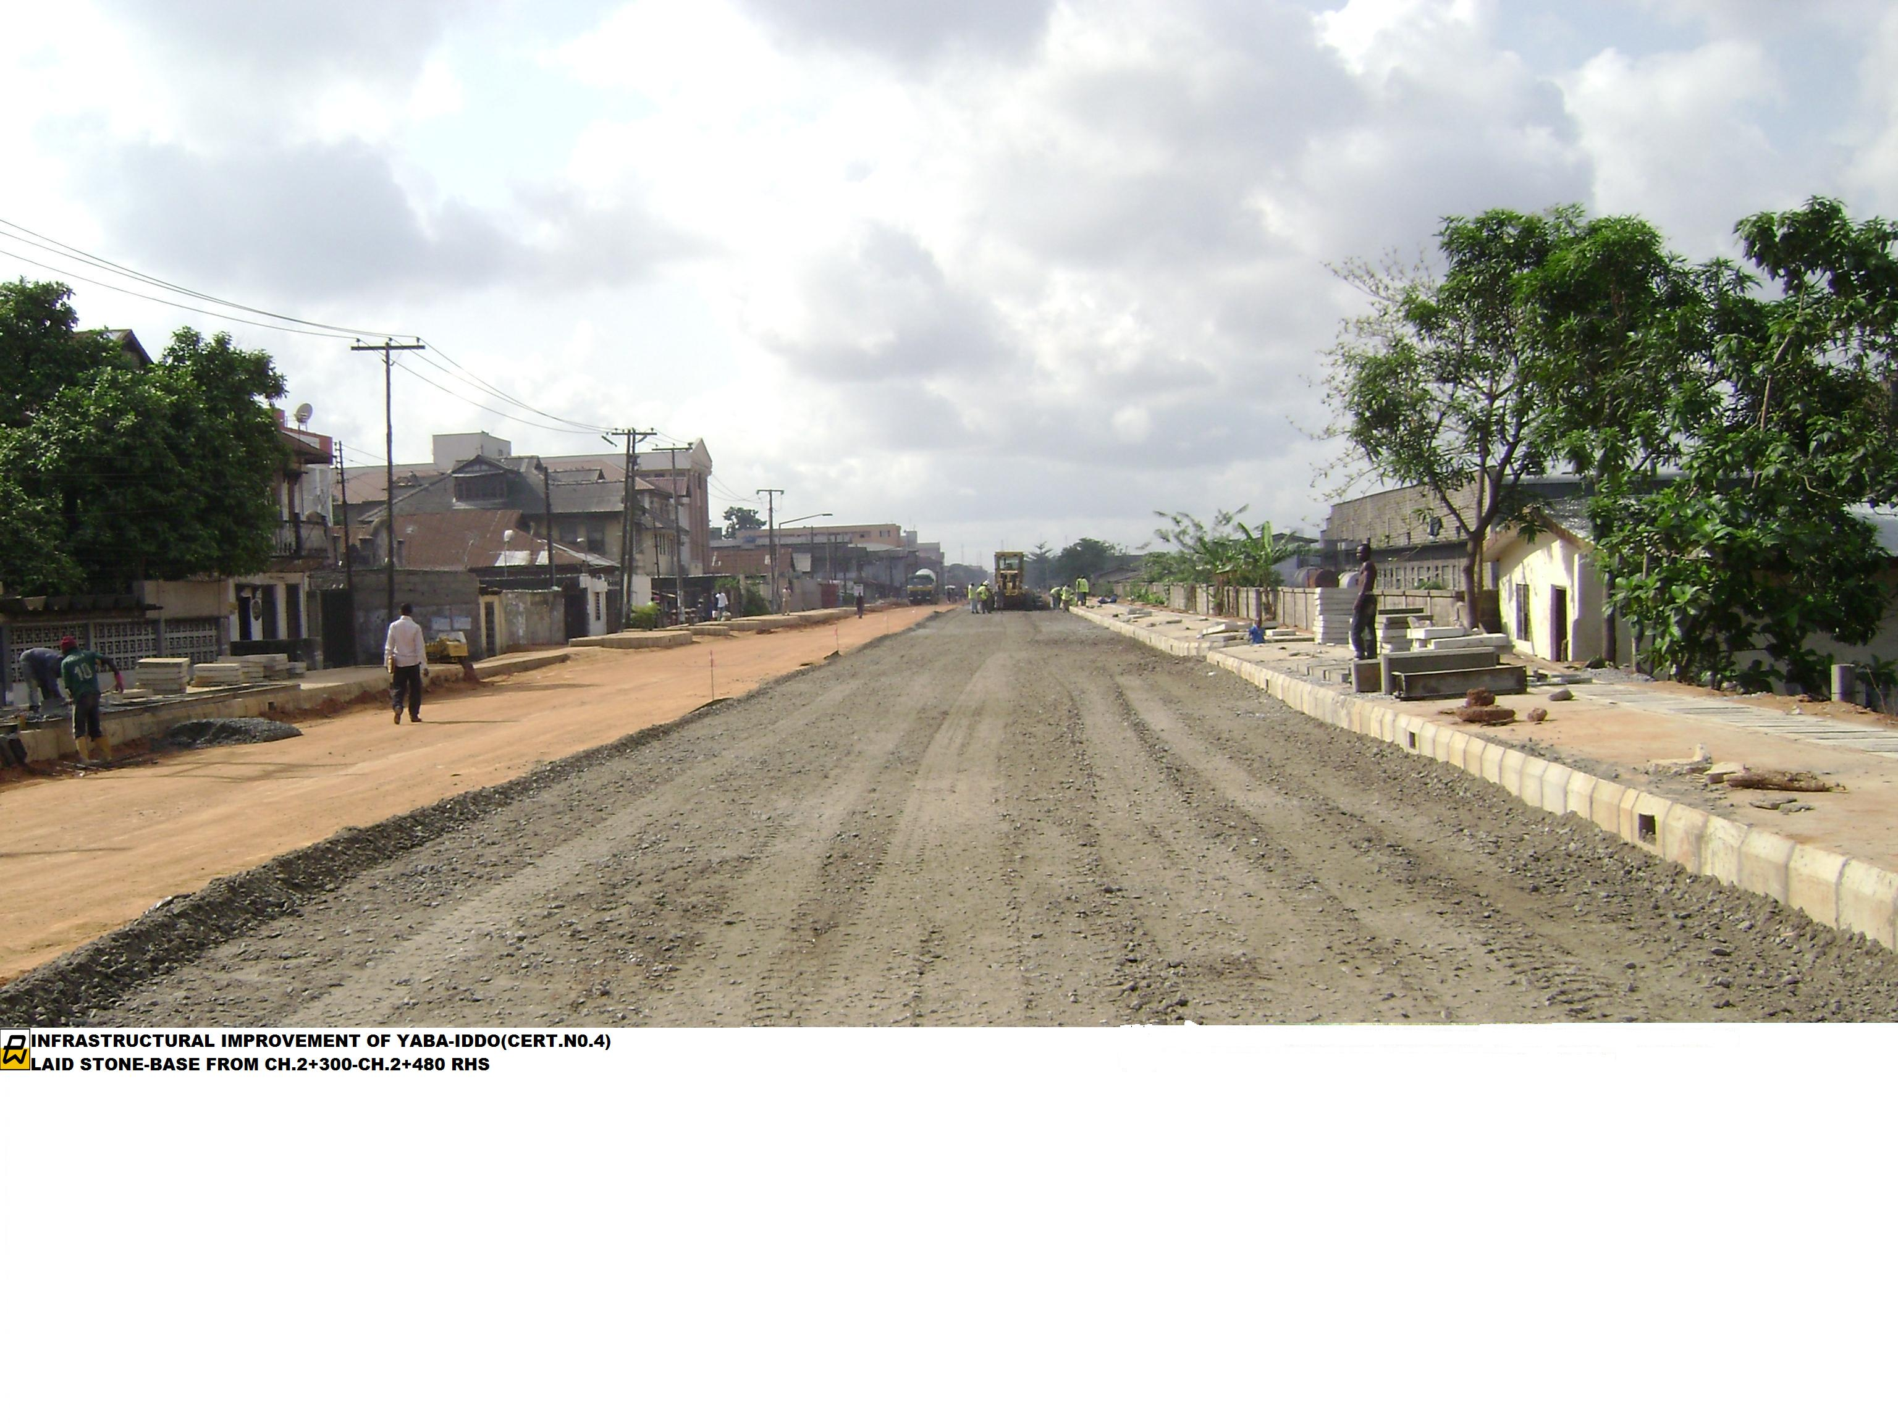
ASPHALT BEEN COMPACTED
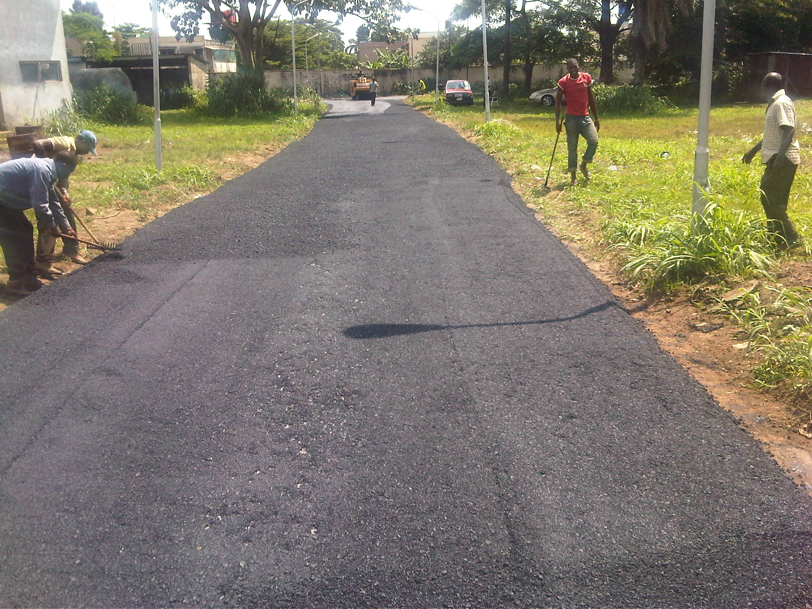
LAYING OF ASPHALT IN PROGRESS
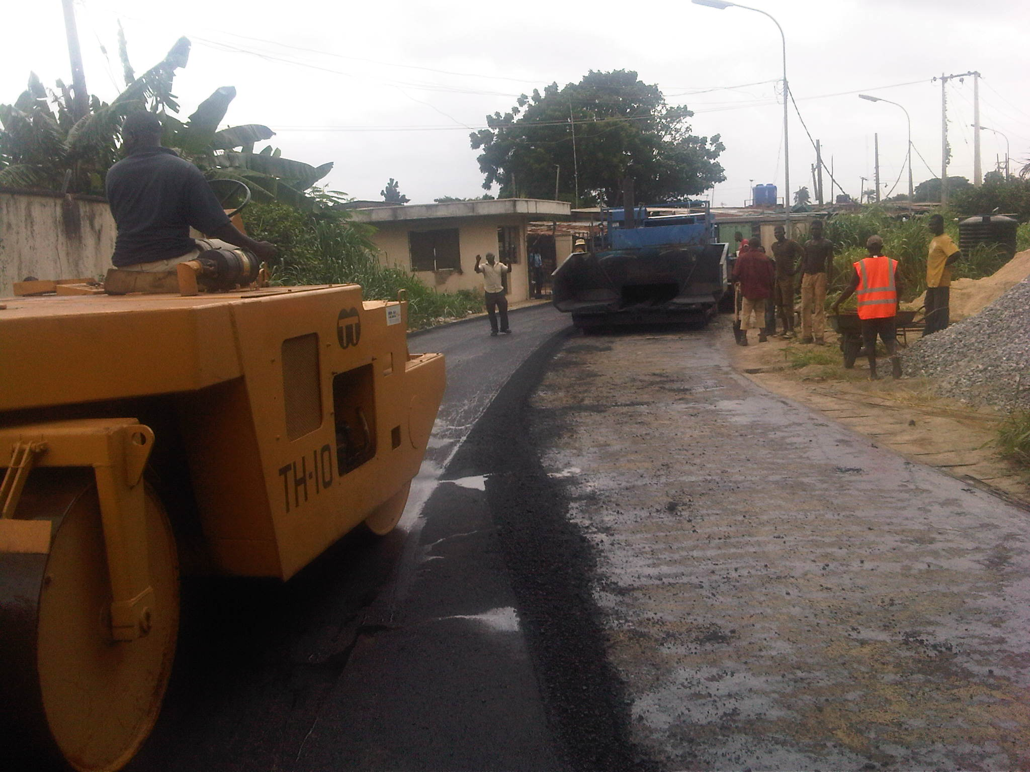
CONSTRUCTION OF ROAD BY SATO ENGINEERING NIGERIA LIMITED


