Pratik Walawalkar

667624808

**ECE 559: Homework 9 Report**

**Experimental setup:**

* Code is written in Python (attached at the end of report)
* 100 taken Input vectors of order R2: Randomly generated between (0,1)
* Radial basis function used: exp(-r2/2*variance2). Where variance=variance of all x input vectors, after updating centers using k means method.

**Reason for considering variance factor: PTA converges with better accuracy.**

* For PTA:
  + 20 Weights taken: Randomly generated between (-1,1)
  + 1 Theta taken. Randomly generated between (-1,1)
  + Learning rate =1
* RBF network and k means are run with 20 and 4 centers randomly selected (half centers in class +1 and other half in class -1)
* Decision boundary plotted when g(x) is approximately close to 0 i.e. between -0.05 and 0.05

**Color codes used in below graphs:**

* Class with desired output +1 (Sun and mountain): Green cross
* Class with desired output -1: Red cross
* Centers for Class with desired output +1 (Sun and mountain): Yellow circles
* Centers for Class with desired output -1: Black circles
* Decision boundary where g(x)=0: Blue line made up of dots

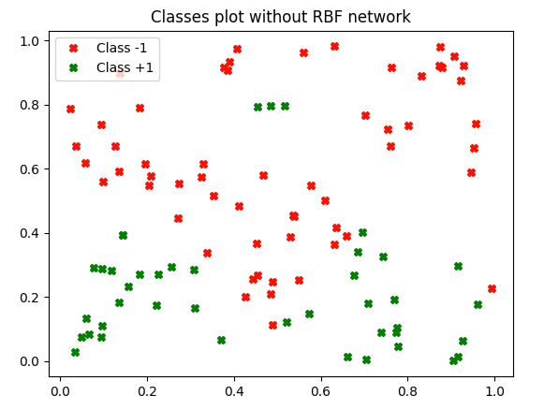

**Figure 1**

**Observation:**

1. **For 20 Centers: (Figure 2)**

* PTA converges with **100% accuracy** after 15 epochs.
* Both the classes are separated clearly with decision boundary.

1. **For 4 Centers: (Figure 3)**

* PTA doesn’t converges. Maximum **accuracy we get is 88%** after 1000 epochs.
* Both the classes aren’t separated clearly with decision boundary.

1. **Difference between two plots**:

* By observing both figure 2 and figure 3 plots we can see that classes are separated for RBF with 20 centers but not for 4 centers.
* Reason:

1. As we chose center randomly from both classes, the probability of getting atleast one center in sun area decreased for 4 center case. From figure 3 there is no center in sun region and 2 centers in mountain region. Thus depending on center location, decision boundary is plotted only around mountain and not around sun.
2. Also depending on initial weights, theta and learning parameter choice, PTA doesn’t converge at all for 4 center case. Whereas due to 100% convergence for 20 centers case, class separation is possible.
3. **Lessser accuracy of PTA and less no. of center choice degrades the class separaton using RBF network.**

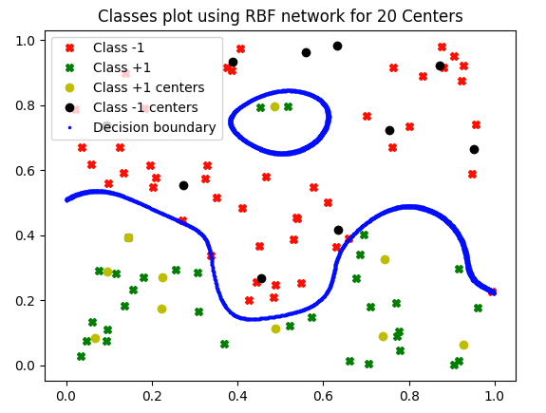

**Figure 2**

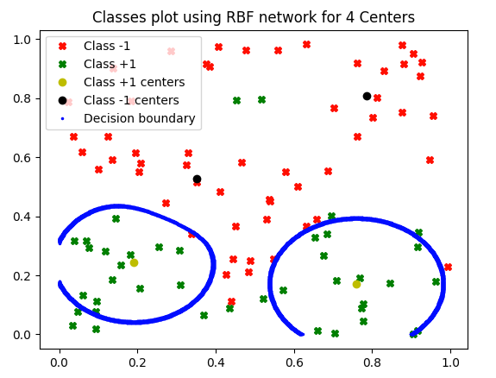

**Figure 3**