Pratik Walawalkar

667624808

**ECE 559: Homework 3**

**Q2) Report:**

**(b)**

**Gradient decent method:**

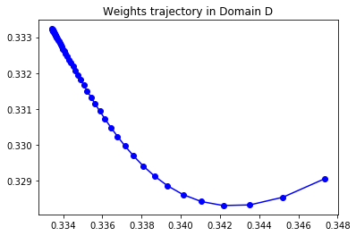

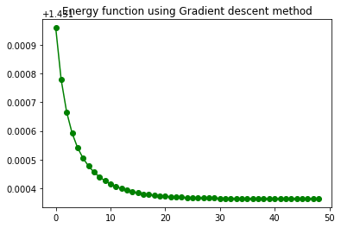

**(c) Newton’s method**

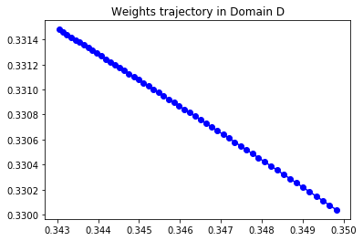

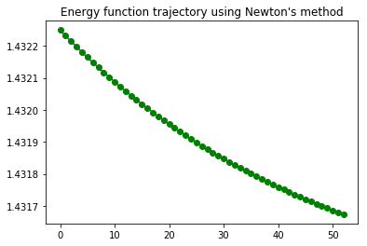

Number of iterations using Newton’s method = 53

**Observation:**

|  |  |  |  |  |  |
| --- | --- | --- | --- | --- | --- |
| **Method** | **Initial weights** | **Final weights** | **Eta** | **Threshold** | **Iterations** |
| Gradient descent | 0.35, 0.33 | 0.3343, 0.3323 | 0.01 | 0.0001 | 25 |
| Newton’s | 0.35, 0.33 | 0.3250, 0.3314 | 0.01 | 0.0001 | 53 |

* Iterations for gradient descent is less than newton’s method for chosen values of initial weights, eta and threshold.
* Also, the computation speed of gradient descent is faster than newton’s method
* When compared initial and final weights for both methods, newton’s has least global minimum co-ordinate
* However it is not guaranteed that gradient descent always yields global minima. It may also give local minima

Q3)

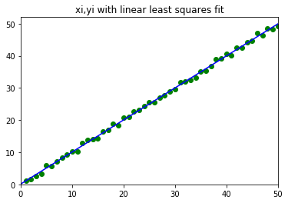

We get **w0: 0.114086291588; w1: 0.99628592177**

Here **y = w0 + w1x** line is the linear least squares fit for (xi,yi) points where i=1,50