1. MainMenu is the main class. Enter it to run the program as per the below.

1. Main Menu will then be displayed. Enter 5 to see if a filepath is set.

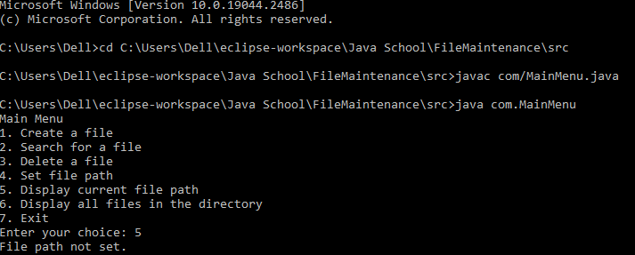

1. Enter 4 to set a file path.

1. Enter 5 to confirm the filepath.

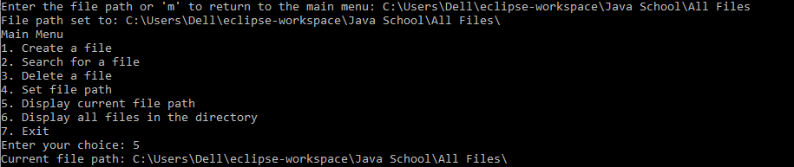

1. Enter 6 to display all the files in the directory.

1. Return to the main menu and enter 1 to create a new file.

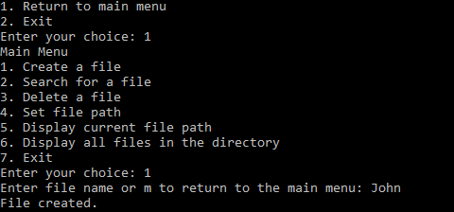

1. Go back to the main menu and enter 2 to search a file.

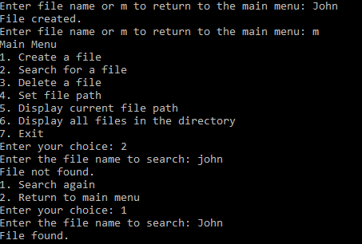

1. Go back to the main menu and enter 3 to delete a file.

